**Streamlyne IRB & Committee Module Tip Sheet**

# *How to Create & Submit a Renewal*

Renewals can be submitted by the PI or the protocol creator at any time after initial approval has occurred. However, the timeline for submitting a Renewal depends on both the expiration date and institutional business practices. The review process for Renewals is like the review process for initial submissions. This section will only cover the differentiators that are specific to creating and submitting a protocol for Renewal.

You can access the protocol you would like to renew through various Lookups. However, the recommended way to initiate a Renewal is through IRB Actions > Amend or Renew IRB Protocol. Clicking this menu option will display all protocols available to the user that currently qualify for an amendment or renewal.

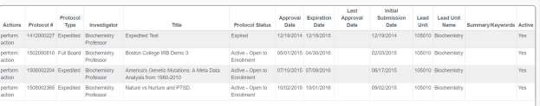

**Navigation**

**Main Menu > IRB > IRB Actions > Amend or Renew IRB Protocol**

1. Locate the protocol you wish to renew.
2. Click the corresponding perform action hyperlink.

**Result:** Streamlyne will open the protocol to the Protocol Actions > Request an Action section.

1. Click the Show button next to Create Renewal  without Amendment.

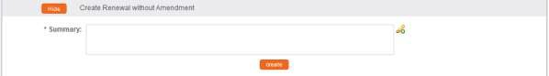

1. Describe the progress of the project and the purpose of the renewal in the **Summary** field. If necessary, click on the edit button  to access a text editor with character count.
2. Click the Create button. 

**Result:** This will open a new Renewal in Progress document.

**Note:** Your institution may have chosen to configure a Renewal Questionnaire. If so, you will need to complete this questionnaire before submitting the document.

1. When ready to submit, navigate back to Protocol Actions > Request an Action> Submit for Review.
2. Click the Show button next to Submit for Review. 
3. Complete the required fields of **Submission Type** (e.g., Continuing Review/Continuation without Amendment) and **Submission Review Type** (e.g., Full Board).

**Note:** For Exempt and Expedited protocols, a Checklist will display. Select all categories that apply to your submission.

1. Click the Submit button to submit your protocol into workflow. 

**Result:** The delivered Data Validation routine will display any errors or warnings that pertain to this document. If necessary, fix the errors and click the Submit button again to revalidate and submit.

Otherwise, the system will change the Document Status to Submitted to IRB.



See Understanding Streamlyne Amendments & Renewals for what Renewal details will be made available in the Summary & History sec

# Creating & Submitting a Renewal with Amendment

While the system will allow a PI or the protocol creator to submit a Renewal with Amendment protocol at any time after initial approval, the timeline for submitting a Renewal depends on both the expiration date on the protocol and institutional business practices. The review process for Renewals with Amendments is similar to the review process for initial submissions. This section will only cover the differentiators that are specific to creating and submitting a protocol for both renewal and amendment.

The recommended way to initiate an amendment is from within the existing, active protocol: IRB Actions > Amend or Renew IRB Protocol. Clicking this menu option will display all protocols available to the user that currently qualify for an amendment or renewal.



**Navigation**

**Main Menu > IRB > IRB Actions > Amend or Renew IRB Protocol**

1. Locate the protocol you like to renew and amend.
2. Click the corresponding perform action hyperlink.

**Result:** Streamlyne will open the protocol to Protocol Actions > Request an Action panel. The Available Actions section will display multiple options for you.

1. Click the Show button next to Create Renewal  with Amendment.

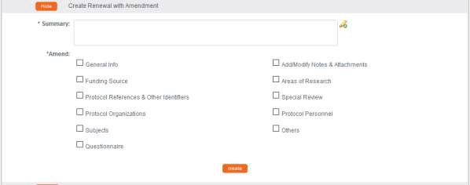

1. Describe the purpose and content of the amendment in the **Summary** field. If necessary, click on the edit button  to access a text editor with character count.
2. In the **Amend** section, check all boxes for sections you wish to amend. Protocol sections with checked boxes will be opened for editing. Those not selected will remain read-only.
3. Click the Create button. 

**Result:** Streamlyne will open a new Renewal In Progress. You will be able to make edits in the areas you selected in Step 5.

1. If you would like to re-select the boxes to be able to edit further sections, navigate back to Protocol Actions > Request an Action > Available Actions.
2. Click the Show button next to Modify Amendment Sections.

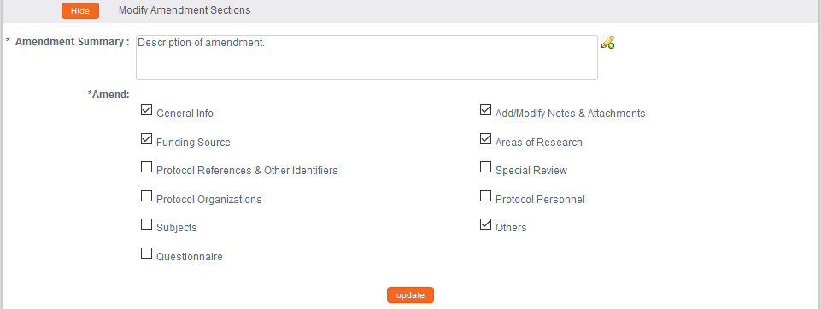

1. Select the applicable sections and click the Update button. 
2. Make all applicable changes to the information displayed on the protocol document as needed.

**Note:** Your institution may have chosen to configure an Amendment Questionnaire, a Renewal Questionnaire, or both. If so, you will need to complete these questionnaires before submitting the document.

1. When ready to submit, navigate back to Protocol Actions > Request an Action> Submit for Review.
2. Click the **Show** button next to Submit for Review. 
3. Complete the required fields of **Submission Type** (e.g., Continuing Review/Continuation with Amendment) and **Submission Review Type** (e.g., Full Board).

**Note:** For Exempt and Expedited protocols, a Checklist will display. Select all categories that apply to your submission.

1. Click the Submit button to submit your amended protocol for the required workflow approvals. 

**Result:** The delivered Data Validation routine will display any errors or warnings that pertain to this document. If necessary, fix the errors and click the Submit button again to revalidate and submit.

Otherwise, the system will change the Document Status to Submitted to IRB.



See Understanding Streamlyne Amendments & Renewals for what details will be made available in the Summary & History section.