**Streamlyne IRB & Committee Module Tip Sheet**

***How to approve a student protocol as the research advisor***

Once a student researcher has initiated and submitted an IRB protocol in Streamlyne, the protocol will route to the faculty member selected as the Faculty Advisor in the student’s Personnel section of the application. Note: the student researcher must select ‘Faculty Advisor’ as both the **Protocol Role** and the **Affiliation Type** for the faculty member.

Upon the student Submitting for Review, the protocol will appear in the advisor’s Action List for their approval. To access the protocol, click on the number in the **Id** column. (“6204” in the example below)

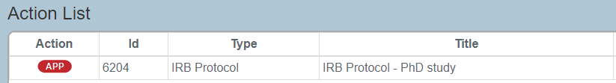

Once in the protocol, you can review the answers provided in the **Questionnaire,** and all **Notes & Attachments**, by using the menu items on the left hand side of the page. If you are satisfied with the application as submitted, click on **Protocol Actions**. You will then find an Approve button at the bottom of the page. Click “Approve” and the protocol will be routed to the IRB for review.

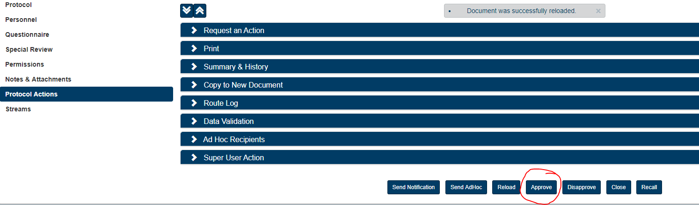

If you are not satisfied with the application as submitted, you can return the protocol to the researcher by clicking on the “Disapprove” button at the bottom of the page.

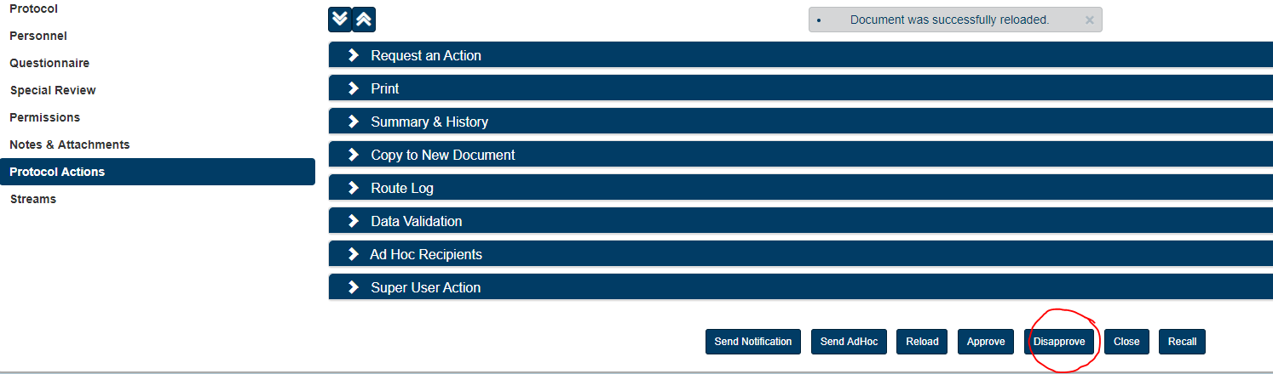

If you select “Disapprove”, you will be asked to enter a reason in the text box on the next page.

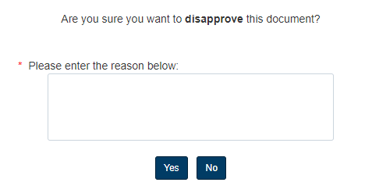

Once a reason has been noted and “Yes” has been selected, the protocol will be returned to the researcher to make necessary adjustments based on the reason given. The student can revise as needed and resubmit when they are ready. The protocol will go through the same approval process again at that time.

Note: if more than one Faculty Advisor is assigned to the protocol, each advisor will need to approve before the protocol is sent to the IRB for review.