**Streamlyne IRB & Committee Module Tip Sheet**

***Adding Personnel to your IRB Protocol (before final action is taken)***

All personnel that, by definition, are engaged in the research project, must be listed on your IRB Protocol.

*Individuals are engaged in the research project if they (1) obtain data about the subjects of the research through intervention or interaction with them; (2) have access to identifiable private information about the subjects; or (3) obtain informed consent of human subjects for the research.*

**Adding UNC Affiliated Personnel (Faculty, students, or staff)**

1. 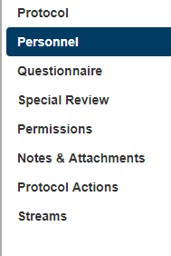Within your protocol, go to the Personnel page.
2. With the bubble next to **Internal User Name** selected, do one of the following:
   1. If you know the researcher’s first.last or student ID (ex. Abcd1234), type it into the text box and then hit Tab. This will populate the person below; OR

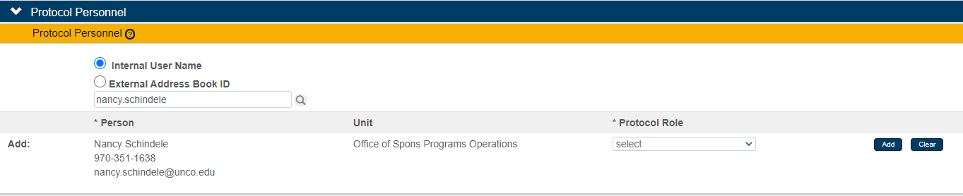

* 1. Click on the magnify glass to the right of the text box.
  2. 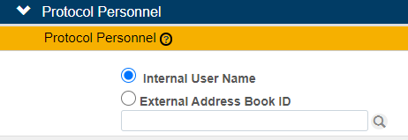

The Person Lookup page will open. It is recommended that you complete just one or two of the search fields. You can also use an * before or after any amount of text to assist in your search.

Click on Search.

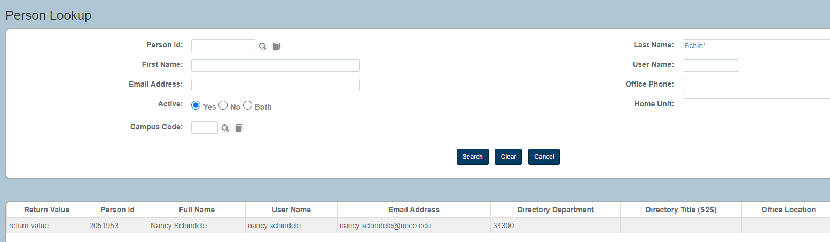

Locate the person you need to add and click on ‘return value’ to the left of their name. You will be taken back to the Personnel page where you will find the researcher listed.

1. 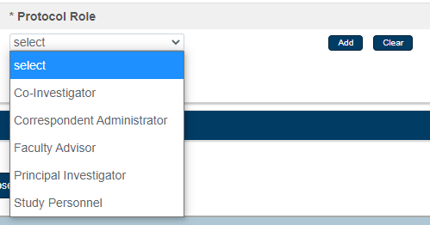Select their Protocol Role from the drop down menu. Then click Add.
2. Repeat these steps for each research personnel.
3. After all personnel have been added, open up each of their records, by clicking on the > next to their name.
4. Click ‘Show’ next to Person Details.
5. You will need to select the Affiliation Type for each person from the drop down menu.

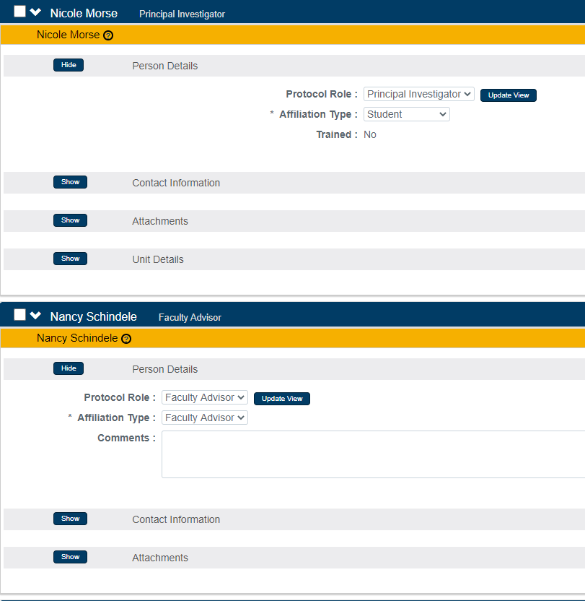

A couple of notes regarding affiliation types:

Note 1: If the PI is a student, their Affiliation Type must indicate so and their advisor’s must be indicated as Faculty Advisor.

Note 2: If there are any students listed as personnel on the project, no matter their Protocol Role, at least one faculty member on the project will need to have the Affiliation Type of Faculty Advisor.

**Adding Personnel from outside UNC**

Our Streamlyne Research Modules are specific to UNC. Therefore, anyone who is not employed by or a current student of UNC, will need to be added to the External Address Book. At this time, only Office of Research & Sponsored Programs staff can add entries to the External Address Book. Please email [Research.Compliance@unco.edu](mailto:nicole.morse@unco.edu) with the name, email address, and institution/company name for each individual you need to add to your protocol. Once the address book entry is made, you will be notified via email. From there, please follow these steps to add external personnel to your protocol.

1. Within your protocol, go to the Personnel page.
2. With the bubble next to External Address Book ID, click on the magnify glass to the right of the text box. 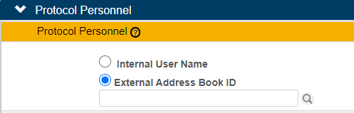

The Non-Organizational Address Book Lookup will open. It is recommended that you complete just one or two of the search fields. You can also use an * before or after any amount of text to assist in your search. Then click the Search button.

1. Locate the person you need to add and click on ‘return value’ to the left of their name. You will be taken back to the Personnel page where you will find the researcher listed.
2. Select their Protocol Role from the drop down menu. Then click Add.
3. Repeat these steps for each external research personnel.
4. After all personnel have been added, open up each of their records, by clicking on the > next to their name.
5. Click ‘Show’ next to Person Details.
6. In the Affiliation Type drop down menu, select ‘Non-Affiliate’ for each external person.
7. Next, click ‘Show’ next to Attachments. Please select ‘Training Certificate’ from the Attachment Type drop down menu, add a short description, and then attach proof of Human Subjects training by clicking on ‘Choose File’. Once the file is attached, click ‘Add’.

