Dashboard – Hourly Employees
How to Enter Retro hours and Sick Leave
Detailed Screens follow instructions.
- All Retro hours (hours you worked outside the dates on the timesheet).
  - must be entered using the Earn Code “Retro Current Year”.
  - All retro hours are entered on the first day of the current pay period. DO NOT spread the Retro hours over different days; use the first day. If you have more than 23 hours, you can use the 2nd day as well.
- If you have hours already entered for the first day of the pay period
  - You will need to click on blue “ ADD Earn Code” found in the middle of the timesheet. This will add another Earn Code below your current one; click on the drop down menu to choose Retro Current Year; add all hours on this day.
- If you don’t have hours entered on the first day than use the drop down menu and choose “Retro Current Year”.
- Add your hours
Call Payroll Office or your supervisor for additional assistance

Screens
If you have regular hours on the first day already
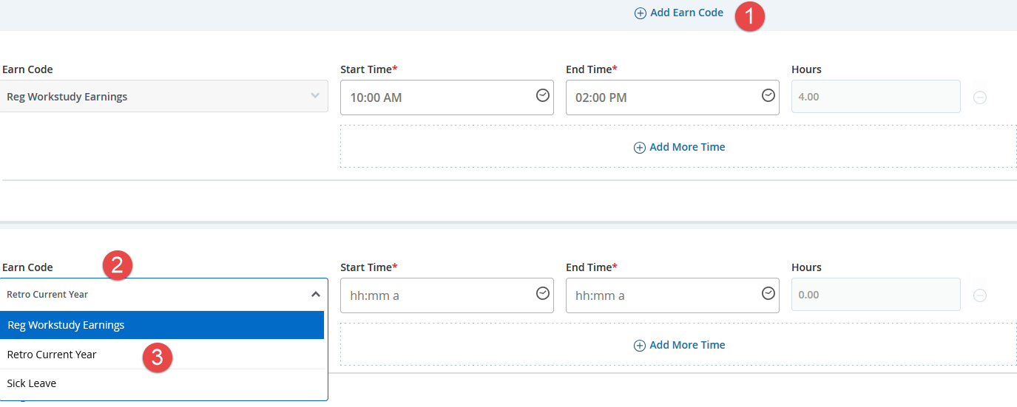

If you don’t have any regular hours on the first day; click on the drop down menu by Earn Code and Choose Retro Current year. Enter all hours on this day.
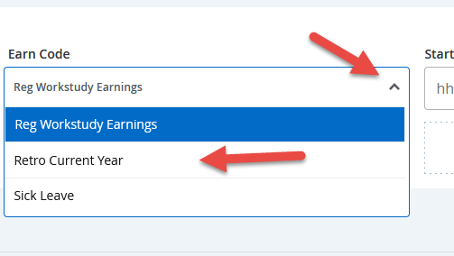
How to Enter Sick Hours
To use Sick leave; you must have been scheduled to work that day.
Sick hours are entered on the day you were scheduled to work but was not able to.
Earn Code: Sick Leave
If you did not work that day and need to enter only Sick Leave for that day; use the drop down menu for Earn Code and choose Sick Leave.
  - Enter the scheduled hours you were sick on the Start and End times
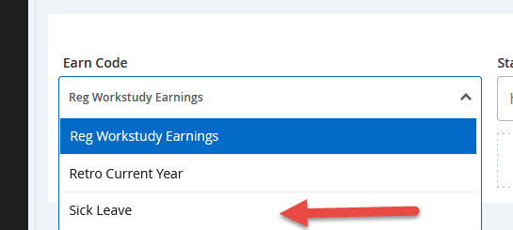

If your worked and left sick; then you will enter both Regular hours for the time you worked and the Sick hours you didn’t work.
To Add an Earn Code
  - Click on blue “ ADD Earn Code” found in the middle of the timesheet. This will add another Earn Code below your current one; click on the drop down menu to choose Sick Leave add hours you were sick. Again these are entered on the day you were sick and scheduled to work.
Call Payroll Office or your supervisor for additional assistance
