Prefix & Course Number: Course Title
Information and Policies
Use colorful graphics, photos, and inspiring quotes throughout.
Little by little, one travels far.
- J.R.R. Tolkien
General Guidelines:
Except for headers, avoid ALL CAPS, Boldface, and Underline because it reads as YELLING.
Avoid jargon: syllabus, learning objectives/outcomes, assessment, academic integrity, etc.
If your document is long, please consider including a table of contents.
On the first day of class, take the time to go through this document: explain your policies, normalize the struggles students might face, encourage them to reach out for help, and engage them in a partnership that will lead to success in your class.

Course Information
Term
Time
Location
Credits
Instructor Information
Name (pronouns)
Office #
Phone
Email
Student Hours
Building & Room #
Hours
By Appointment

Welcome
Explain why you like teaching the course and what you hope students will gain from it.

Course Description (from the UNC Catalog)
Here is the course description from the UNC catalog:
The sections below will give you the details you need to know.

What will this course cover? (Course Overview)
Expand on your course description in approachable language.
- Describe the main themes of the course and the course organization.
- Bullet points are easier for students to digest than long paragraphs.

Why is this course important? (Course Purpose)
Briefly explain why you think this course is fun/important, what challenges the students might face, and why it is worth the effort.

What will I need? (Course Materials)
Textbook
Insert Photo of cover
Title, Author, Publisher, Year/Edition, ISBN
Reserve: UNC Call Number
Link for Ordering
Other Required materials or access (Additional books, Technology, Equipment)

What will I be able to do by the end of this course?
- List three to six goals.
- Avoid jargon.
- Use action verbs (Evaluate, Analyze, Apply, Understand, Communicate). Refer to Bloom’s taxonomy but don’t put this in your document: 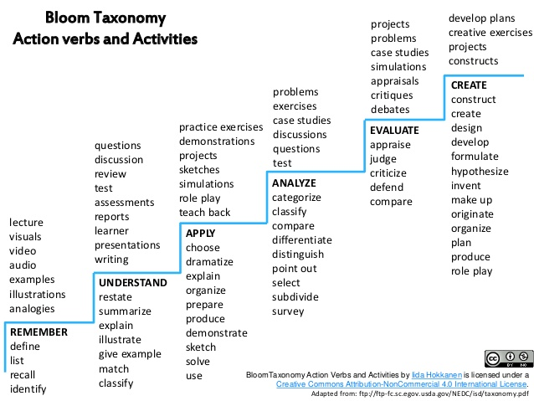

How will I be evaluated? (Be specific but encouraging. Share the reasons behind your policies. Normalize struggle. Allow for mistakes.)
- Overview of assignments (Homework, projects, quizzes, tests)
If you skip class once a week, it is like buying a dozen donuts and throwing four in the trash.
- Outline of your policies
  - Attendance: Briefly explain the reasons for your attendance policy (Life Skill of Punctuality, Building Community, Getting value for your tuition, etc.)
  - Missed/Late Assignments: Briefly explain the reasons for your attendance policy (Life Skill of Responsibility)
  - Phones/Computers in class (Life Skills of Focus, Listening)
- Explanation of how you expect students to participate in class whether in person or online.
Would you want the lawyer who cheated on the Bar exam to defend you in court? Would you want a doctor who cheated on Medical Board Exams to perform your surgery?
Strong nations are built on academic integrity.
Be a part of nation building.
- Include something about requiring students to do their own work and incentives for academic integrity.

Here is a breakdown showing the weight of each type of assignment.
Consider making this visual using a table or pie chart.

Grading Scale (Consider using a chart rather than a list of numbers)
Your grade reflects your performance in this class.
It is not a reflection of your worth as a human being.
Using the traditional 0 - 100% grading scale allots 60% to failure and only 40% to success. With this scale, it is nearly impossible for students to recover from zeros received for assignments missed early in the semester. Research shows this de-motivates students. Alternatives: 1) a 4-point scale akin to GPA calculations. 2) a 50 – 100% scale where no student can earn less than 50%, even for a missed assignment. Both methods can be combined with weighting assignments according to their importance in your class. For questions, go to https://gradingforequity.org/

4-Point Scale
Excellent | 4
Good | 3
Average | 2
Struggling | 1
Missing | 0

50% - 100% Scale
Excellent | A (90 – 100%)
Good | B (80 – 89.99%)
Average | C (70 – 79.99%)
Struggling | D (60 – 69.99%)
Failing/Missing | F (50 – 59.99%)

What should I do to succeed? (Give some friendly ideas about how to study, examples below.)

Before Class
Do the reading.
Read the Study Guide.
Flag difficult concepts.
Add reminders in your calendar for due dates.

During Class
Put your phone away.
Take notes.
Ask questions.
Participate.

After Class
Recopy your notes.
Think of questions.
Study like there is a test every week.

- Come to class. Every day.
- Ask questions. Lots of questions.
- For an average grade, expect to spend 3 hours per week (including class time) for every credit hour earned. For instance, you would spend 9 hours per week on a 3-credit class. If you want a higher grade, you may need to spend more time outside class.
- Come talk to me! If none of my regular Student Hours work for you, let me know and we will find another time. Feel free to bring a friend.
- Read the study guide at the beginning of the unit and try to explain everything on it. This will give you an idea of what you already know and what you still need to learn.
- Take notes and then recopy them in your own words after each class. This might seem like a lot of work, but it will help you review as you go along so that you will need less study time for tests. It will also help you think of questions you want to ask.
- Pretend there is a test every week.
- Take advantage of free tutoring services:
https://www.unco.edu/tutoring/

Where can I go for help?
Add a statement here about how you care for your students’ well-being and want to give them every resource to succeed. You can find all the official syllabus statements at https://www.unco.edu/center-enhancement-teaching-learning/syllabus_statements.aspx but consider modifying them so they are more easily digestible. Examples below.

Equity and Inclusion
I honor the inherent dignity of each individual and welcome everyone’s unique world views. In class, we will work together to create an environment where everyone is free to share diverse perspectives and experiences. I am not afraid to be caught learning. If I do anything that makes you feel excluded or uncomfortable, please trust that you can tell me that openly. If you want to report an incident related to identity-based discrimination or harassment, please visit www.unco.edu/institutional-equity-compliance.

Disability Resource Center
Disabilities are not a reflection of your intelligence or who you are, but how your brain or body works. If you need some accommodations, it is best to contact the Disability Resource Center. This will help you gain access to resources and let me know how I can best accommodate your needs. I am also happy to talk to you about what this entails if you’re not sure that it’s for you.
Disability Resource Center (DRC):
- (970) 351-2289
- Michener Library L-80
- www.unco.edu/disability-resource-center

Food Insecurity and Basic Needs
UNC helps students facing food insecurity through the Bear Pantry:
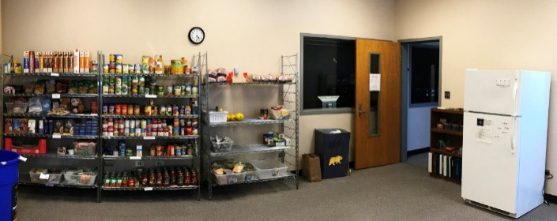
- University Center 2166A
- www.unco.edu/bear-pantry
The Student Outreach and Support Office (SOS) can assist students during difficult times, which may include medical, mental health, personal or family crisis, illness, or injury.
SOS - Dean of Students Office
- 970-351-2001
- dos@unco.edu

Title IX: Discrimination and Harassment
The University of Northern Colorado is committed to providing a safe learning environment for all students that is free of all forms of discrimination and sexual harassment, including sexual assault, domestic violence, dating violence, and stalking. Students who have experienced (or who know someone who has experienced) any of these incidents should know that they are not alone. UNC has staff members trained to support students to navigate campus life, to access health and counseling services, to provide academic and housing accommodations, to help with legal protective orders, and more.
- UNC’s Assault Survivors Advocacy Program (ASAP): 24 Hr. Hotline 970-351-4040 or http://www.unco.edu/asap
- UNC Counseling Center: 970-351-2496 or http://www.unco.edu/counseling
- UNC Psychological Services: 970-351-1645 or http://www.unco.edu/cebs/psych_clinic
- Students who are survivors, who are concerned about someone who is a survivor, or who would like to learn more about sexual misconduct or report an incident, can visit www.unco.edu/sexual-misconduct. Students may also contact the Office of Institutional Equity and Compliance (OIEC) at 970-351-4899 or email titleix@unco.edu.

What was here before UNC? (Land Acknowledgement)
I encourage you to learn about the rich history of the tribes, whose territory the University of Northern Colorado currently occupies. These native peoples lived in harmony with the land for generations before it was “settled” by those of European descent.

Ute https://www.southernute-nsn.gov/history/
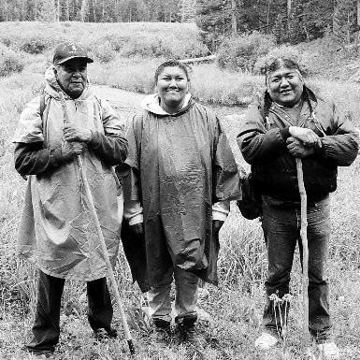
The Ute people are the oldest residents of Colorado, inhabiting the mountains and vast areas of Colorado, Utah, Wyoming, Eastern Nevada, Northern New Mexico and Arizona. They would travel and camp in familiar sites and use well established routes such as the Ute Trail that can still be seen in the forests of the Grand Mesa, and the forerunner of the scenic highway traversing through South Park, and Cascade, Colorado.

Cheyenne: https://www.legendsofamerica.com/na-cheyenne/
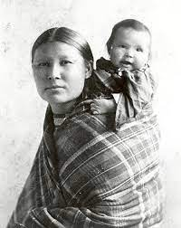
The Cheyenne tribe originally lived in stationary villages in what is now Minnesota until they migrated to the high plains in the early 1800s. They were divided into the Northern Cheyenne and Southern Cheyenne and ranged from the Missouri River to the Arkansas River. They valued their freedom and relationship with the created world. After acquiring horses, they relied on hunting buffalo and migrated with the herds, living in portable tents called tepees.

Arapaho
https://www.tribalpedia.com/us-tribes/a-l/arapaho-tribe/
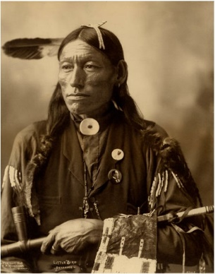
The Arapaho are a tribe of Native Americans historically living on the eastern plains of Colorado and Wyoming. They were close allies of the Cheyenne tribe. We don’t know exactly how and when Arapaho bands entered the Great Plains, but they probably lived in Minnesota and North Dakota before migrating to what is now Colorado. They were buffalo hunters of the plains but also have traditions of a time when they lived in the east and planted corn.

