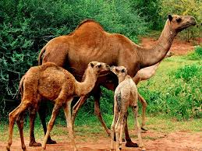

Animal Traits and Characteristics That Help Them Survive

Grade Level: 1st Grade
Teacher Candidate: XXX
Mentor Teacher: XXX
UNCO Supervisor: XXX
Dates Taught: March 22nd - April 8th

Ivy Stockwell Elementary School
Thompson Valley School District

Table of Contents
Title Page 1
Table of Contents 2
Rationale Statement 3
Introduction 3
Community School and Classroom 5
Meeting the Colorado State Standards 10
Assessing Student Learning 13
Pre-Assessment 13
Formative Assessment 13
Summative Assessment 14
Unit Goal 15
Lesson Plans 16
Lesson 1 16
Lesson 2 20
Lesson 3 22
Lesson 4 27
Lesson 5 35
Extensions, Modifications, and Adaptive Activities 39
Instructing Students and Supporting Learning 41
Resources 49
Evaluative Essay 52
Reflective Essay 60

Rational Statement:

Introduction
In a year with so little ability to explore the world around us, I knew choosing a Capstone unit I could stretch and bend into many different types of learning experiences for my students was at the top of my priorities. Animal traits and characteristics is a unit full of excitement for young learners and is a topic that can lend itself to a multitude of engaging activities and practices. This unit is valuable to not only teach students about the importance of specific traits that helps animals like polar bears, or you and I survive, but is especially important this year because students have been forced into a learning environment that does not support collaborative learning in the traditional sense. It is important to me that my students get to experience and practice using their scientist brains in multiple ways. Creating lessons that provide multiple means of representation and means of response will give my students opportunities to learn through different styles.

Lesson one: In this lesson, students focus on and use important vocabulary to add on to what they already know about animals. Students come to us with different understandings of every topic, so discussing vocabulary and exploring their background knowledge will help bring my students up to similar starting points.

Lesson two: It would be unsafe to bring real animals into the classroom, so this lesson provides students a safe opportunity to learn through touch. All students learn differently, and this lesson gives students the chance to feel like what we are learning about is real, not just a bunch of slides.

Lesson three: There are so many resources in the world for kids to learn about animals and that makes this an opportunity for students to practice idea gathering skills. Learning to gather and then organize that information is a valuable skill for kids to practice.

Lesson four: Science incorporates different skills such as observing, hypothesizing, and mathematics. In this lesson, students will get to see the overlap in science and math as well as practice their math skills in correlation to scientific simulations/experiments.

Lesson five: Solving real world problems is a skill all students need to practice to fully grab hold of the information and make it their own. This lesson does just that. Students will get to use the knowledge they have gained from our unit to design a solution to real world problems.

Demographics

Community
Ivy Stockwell Elementary School is in the small town of Berthoud, Colorado. They are a part of Thompson School District. Thompson School District has 31 schools ranging from pre-schools all the way up to high schools. This district's population has 110,219 families of students above the poverty line and 10,280 below. Berthoud is a small town that is growing quickly in population and there is talk of a new elementary school opening in the area to give them a total of three elementary schools. Berthoud is a residential town with only a few local businesses, this means that most of the families residing here have jobs in the larger cities around them. The average cost of living in Berthoud is at a 129.2 whereas the average cost of living in Colorado is a 121.1.

School
This school, because of the community's way of life and the living expense of the town itself means Ivy Stockwell’s diversity is low in comparison to other schools around Colorado, this can be seen in their population graphs as well. There are 375 students attending Ivy Stockwell, and School Digger says 84% of students are white, 12.8% are Hispanic, and 1.9% are considered other, and states that 24.5% of students are on Free and Reduced Lunches. There are 38 employees working at Ivy, all but four are women, and all but one is white. They have a teacher to student ratio that is 20 to 1 but is going up slowly as students who were online slowly move back into face-to-face learning. This school has before and after school care, so students have a place to stay while parents are still at work for a few more hours. They have a computer lab, library, cafeteria/gymnasium, STEM lab, music room, art room, gifted and talented room, and special education rooms. This is a school that in the past few years became a STEM school, so they are working towards enhancing their science teaching practices with technology, curriculums, and professional development opportunities for their teachers to take part in.

Class
In Mrs. Preusse’s first grade class, we have a total of 22 students. All of them are Caucasians. We don’t have any ELL students; however, we do have two students with speech apraxia and one student who is verbally around the level of a three-year-old. We have ten girls and twelve boys in our class. My students' economic status differs between each of them, however I would say that 80% of my students are middle class or higher, whereas 20% of my students would be considered lower class. I have two students whose families struggle with food insecurity and are given packs full of food to take home each week. These two students are also living with their mothers at their grandparents’ homes and have past trauma we need to be thoughtful of and considerate of daily. Multiple of our students have parents that are separated or divorced, but only two of our students are in the middle of custody battles that are causing stress and bringing out behaviors from their children. One student is on the Autism spectrum and does well in school with explicit instructions, no sudden changes, and help with reading and writing and is on an IEP. We have a couple other students with IEPs and 504s that are for things like learning disabilities with reading, writing, and speech. All their needs however are very small however and are easily accommodated and modified for. We have one student who is struggling immensely with his parent’s divorcee (as mentioned above) and has behaviors we monitor closely and support, however he is academically very capable and usually will do his work very well if you are there to redirect him when he gets distracted. We have about three students who are at the top of our group. They have very good family lives and support at home in comparison to some of our kiddos. These three students are who I kept in mind while making my extension activities.
Our classroom is like many others right now due to Covid. Students are seated in rows and columns about two feet away from each other all facing forward. In the front of the room there is a white board and a Promethean board that rarely works for anything more than a projector. To the right of where students sit, there is a second white board used for phonics practice, scribing for one of our students to copy from, and the collecting of table group behavior points. Next to this white board is a backpack rack used to store the students individual leveled book bags and stem bags. At the back of the classroom is the classroom sink and fountain, the “Turn in” basket Mrs. Preusse’s desk, and a table for working in a teacher-led small group. This table is used when we do rotations in the morning, and we work with individual groups of students. Then finally, to the left of the students is the frequently used words “Word Wall” that stays up all year, the class library which is currently not allowed to be in use, and the iPad charging station. Each student has their own iPad provided to them by the school to use throughout their time in the Thompson School District, this side of the room is also where we store the students Remote Learning Kits for if the school goes online again.

Picture of the front of the classroom: 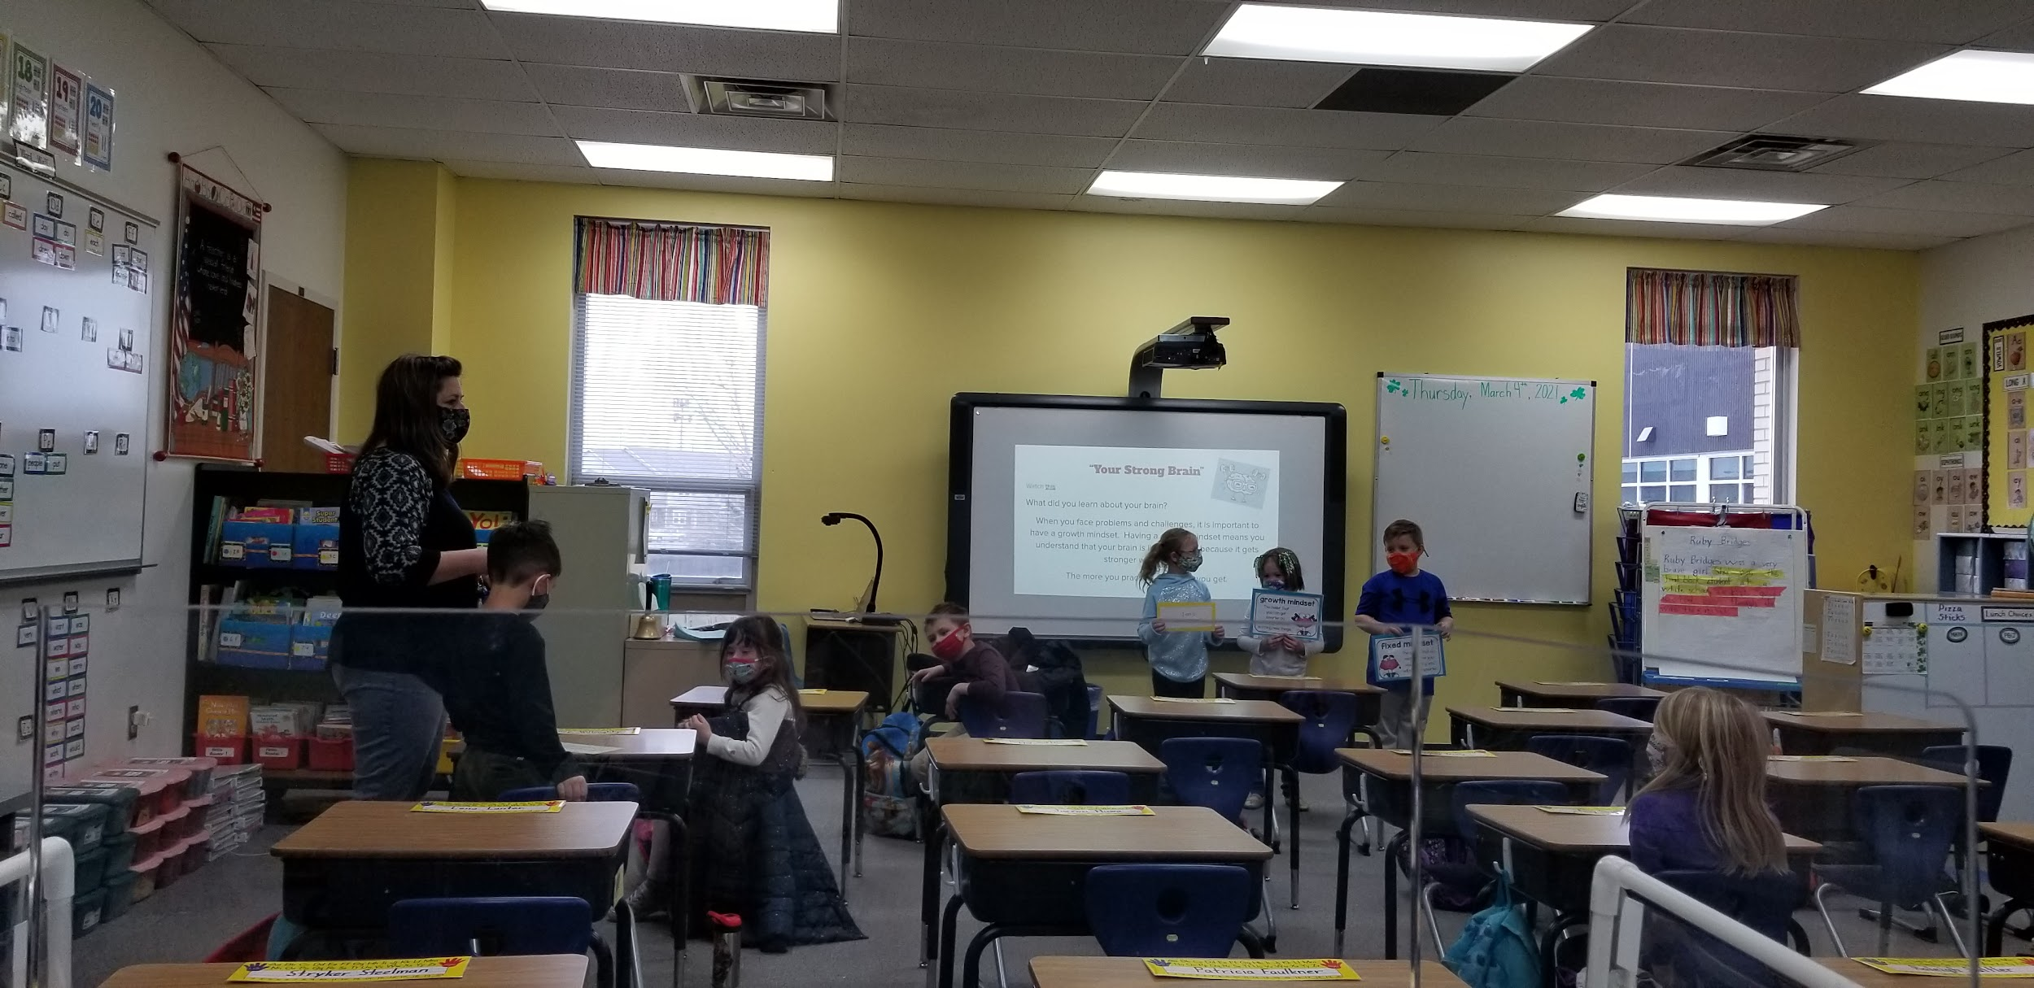

Image of left side of the classroom: 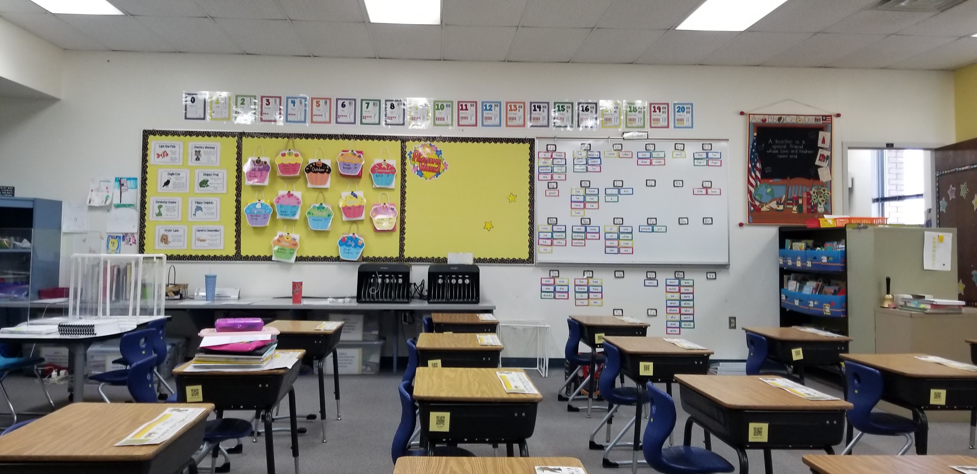

Image of right side of the classroom:
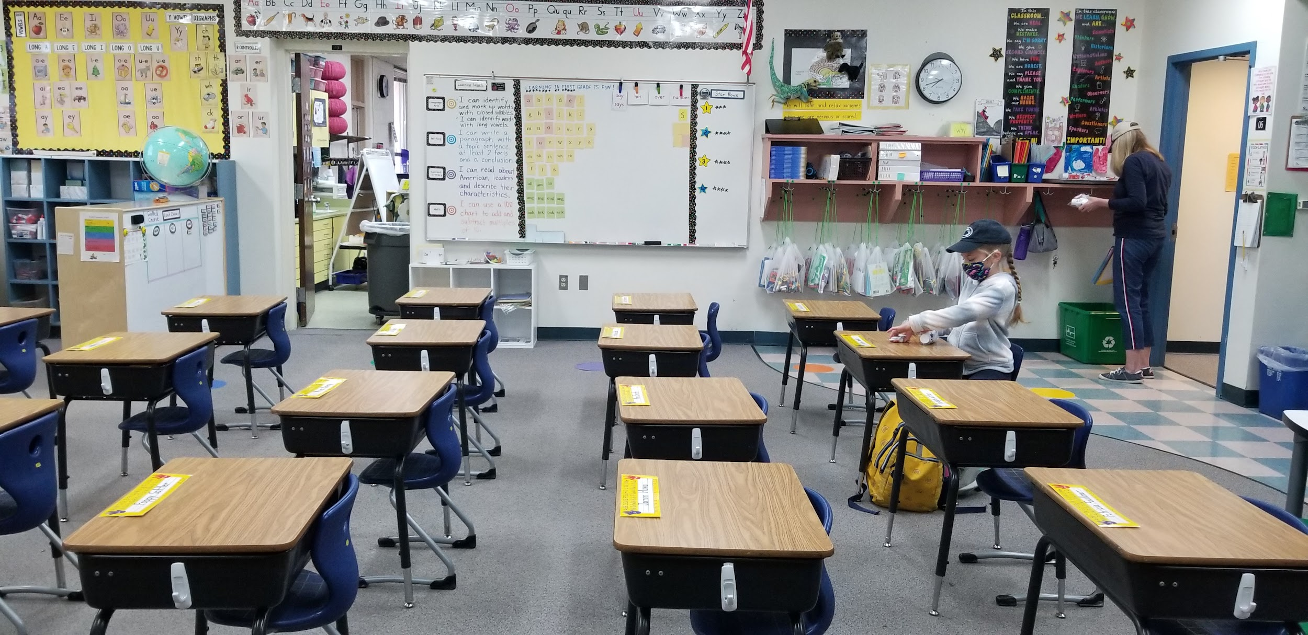
Closer image of Leveled Book Bags and Stem Bags on the right side of the classroom: 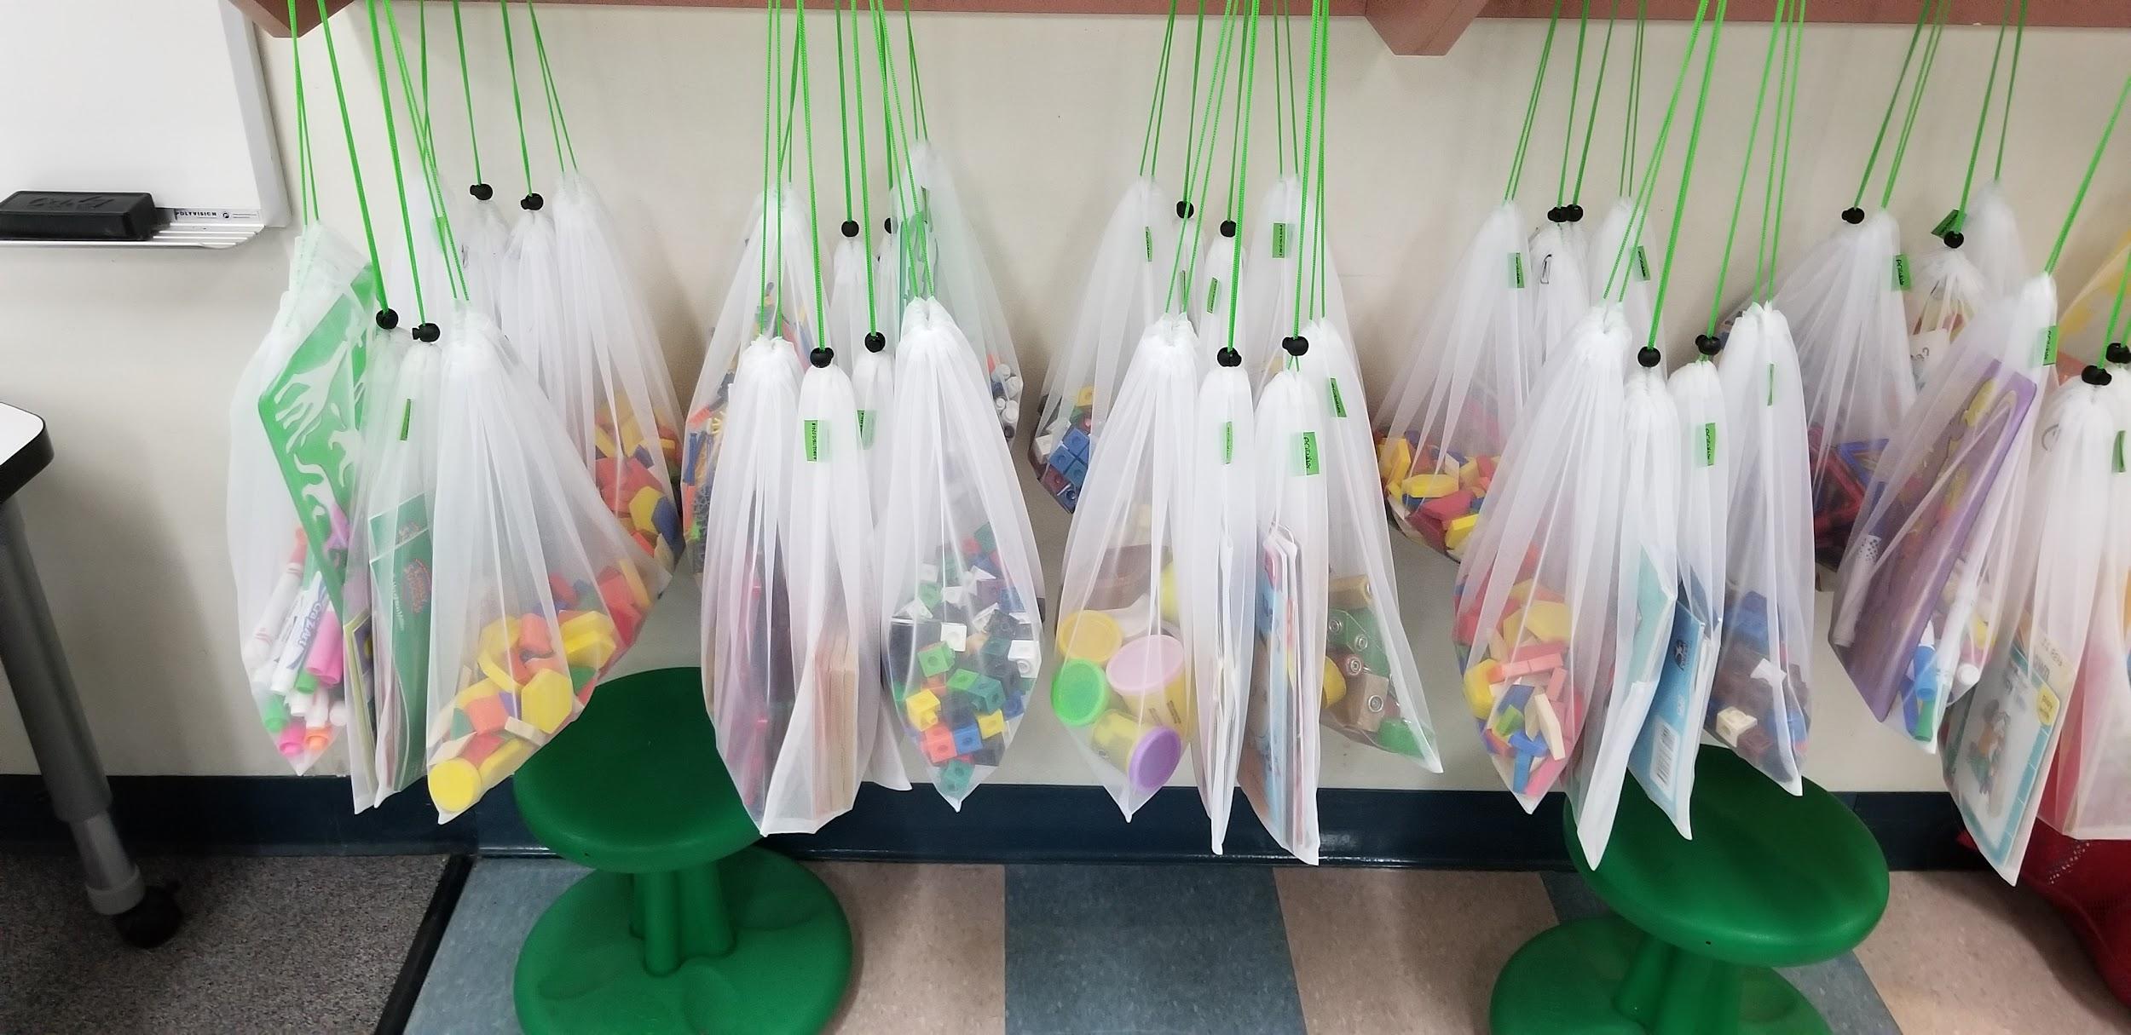

Image of the back of the classroom:
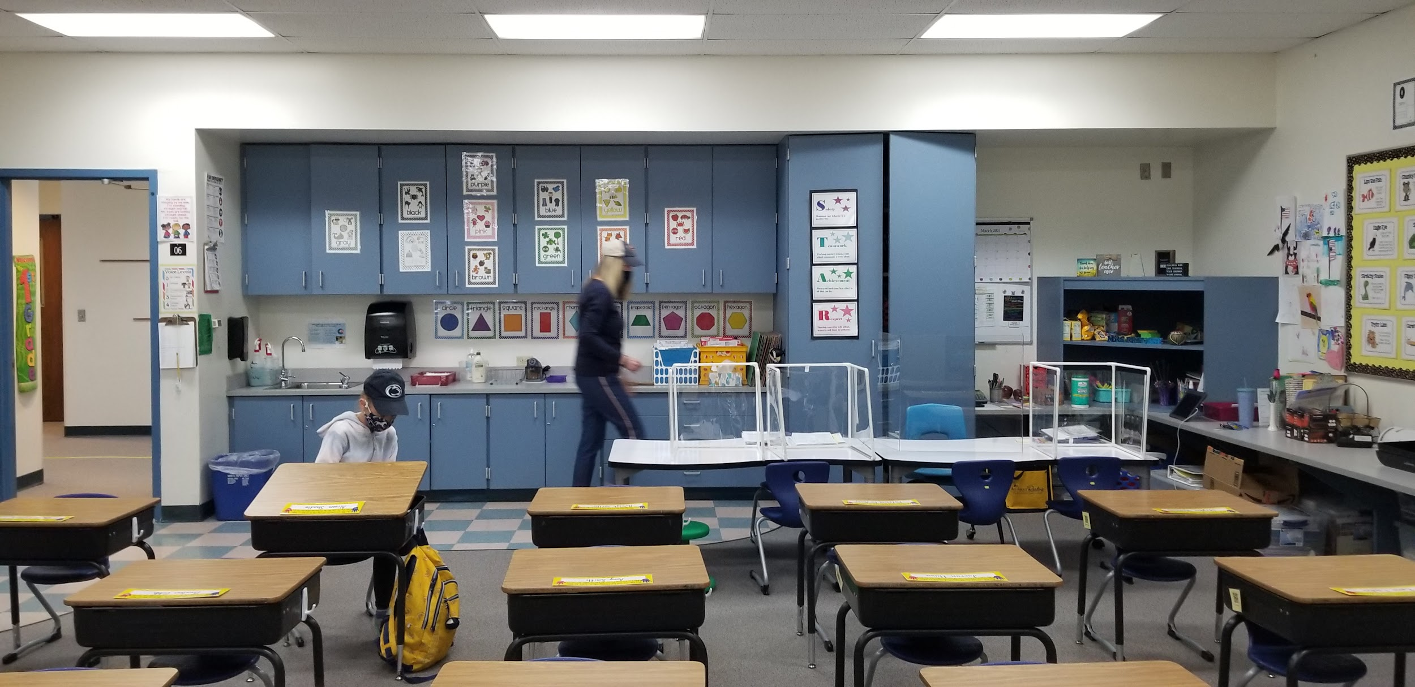

Meeting the Colorado State Standards

Content Area: Science
Standard 2. Life Science: All organisms have external parts that they use to perform daily functions.

A: Use materials to design a solution to a human problem by mimicking how plants and/or animals use their external parts to help them survive, grow, and meet their needs. (1-LS1-1)

- Objective: Students will be able to use what they learned about animal characteristic functions to design a solution to one of Akua’s problems and answer the following three questions orally 1. What problem of Akua’s are you solving with this invention? 2. What animal part did you pick? 3. How would your solution help Akua? And earn a ¾.

Content Area: Science
Standard 2. Life Science: All organisms have external parts that they use to perform daily functions.

B: Read texts and use media to determine patterns in behavior of parents and offspring that help offspring survive. (1-LS1-2)

- Objective: Students will be able to write one fact on their Venn Diagram about the similarities or differences behaviorally between adult animals and their young that help offspring survive as measured by a 0-2 point on a rubric to score a 1.

Content Area: Science
Standard 2. Life Science: Young organisms are very much, but not exactly, like their parents, and resemble other organisms of the same kind.

A: Make observations to construct an evidence-based account that young plants and animals are like, but not exactly like, their parents. (1-LS3-1)

- Objective: Students will be able to use a Venn Diagram to write two similarities and differences between adult animals and their young as measured by a 0–2-point rubric to score a 2.

Content Area: Science
Standard 2. Life Science: All organisms have external parts that they use to perform daily functions.

A: Use materials to design a solution to a human problem by mimicking how plants and/or animals use their external parts to help them survive, grow, and meet their needs. (1-LS1-1)

- Objective: Students will be able to name different animal parts on a Plicker Quiz and score an 80%.

Content Area: Reading, Writing and Communicating
Standard 3. Writing and Composition: Use appropriate grammar, spelling, capitalization, and punctuation.
A: Demonstrate command of the conventions of Standard English grammar and usage when writing or speaking. (CCSS: L.1.1)
- Objective: Using our unit Word Wall, our “Living Thing Hunt”, and the sentence frame, students will be able to write one sentence identifying a living organism of their choosing as measured by scoring at least a 7/12 on a rubric focusing on spelling, capitalization, punctuation, and weather it makes sense.

Content Area: Mathematics
Standard 3: Data, Statistics, and Probability: Measurement & Data: Represent and interpret data.
A: Organize, represent, and interpret data with up to three categories; ask and answer questions about the total number of data points, how many in each category, and how many are in one category than in another. (CCSS: 1.MD.C.4)
- Objective: Students will be able to graph data gathered through an experiment with an appropriate title, appropriate x and y axis labels, y measure numbers, and data that corresponds with their Tracker sheet to receive at least an 8 out of 11 (72%).

Assessing Student Learning

Pre-Assessment
The students I am teaching are in first grade, so I have created a detailed assessment that is also very kid friendly by using multiple choice questions with pictures to circle as well as a word bank for them to use on a labeling diagram question. I will give this assessment to most of the class at one time, but I have three students who I will pull later to be assessed in a smaller group as they will need extra support with the writing question at the very end. For the writing question, I will have them dictate while I scribe for them, or I will help them “Tap” out spelling words. To ensure I am seeing only what each individual student knows, each student will be given an “office” so that they cannot see each other's answers. We will work through the pre-assessment together at the same pace so I can read them questions one at a time.
I will give this assessment on March 12th. This is the day before Ivy Stockwell starts their Spring Break. This will give me time to go over the assessments and adapt, modify, or extend my lesson plans based on what my student’s pre-test shows their areas of understanding and areas for growth are. Giving the pre-test on the 12th also means we have more days for our lessons and provides us with a buffer day that will let me extend lessons if need be or add extra practice I might see necessary as I reflect on the lessons and my students’ assessments. To see assessment click on this link.

Formative Assessment
I have broken this section into two parts, the main formative assessments of each lesson, and the supporting formative assessments. In this paragraph, I will discuss the main formative assessments I have implemented in my five lessons. In lesson one, students write a sentence stating one creature that is a living thing and why it is a living thing. For instance, a person is a living thing because we grow and move. Then, in the second lesson, students use technology and complete a Plicker Quiz to assess their understanding of animal parts. Lesson three uses a graphic organizer to assess their understanding of the similarities and differences between adult animals and their young by having them complete an independent Venn diagram on owls. Lesson four is very fun and assesses their graphing skills after a few days of experimentation that helps students learn about animal characteristics and their cool functions. Lesson five has students use their knowledge of animal part functions to create a viable solution to real world problems. In this lesson they are to create a diagram of their solution and then orally explain their solution on camera answering three questions.
The supporting formative assessments include assessments that are used for diagnostics, participation, as well as the usual smaller scale formative assessments. I use a KWL chart that students first do independently, then we do as a whole class throughout the rest of the unit. They will do an activity that I will collect called the “Living Thing Hunt” where they color in all the pictures that are living things and leave the non-living things blank to assess they are understanding of what a living thing is before we move on to the lesson’s main formative assessment. As a diagnostic, I have an activity where they match the baby animals to their grown-ups to see if students can identify what animals will grow up to look like and see if they can identify them even though there are similarities and differences. Students will use sticky notes to write down personal “I notice…” and “I wonder…” statements before we dive into discussion on what they are observing. During the experiment lesson, students will do multiple exit tickets to show me if they are understanding the topic discussed and experimented on that day. Students will also do one practice graph independently before they do their main graph as my assessment for lesson four. As a means of monitoring participation in a lesson that is a lot of talking and observing, I will pull every student's name stick during a slide show to assess their understanding of similarities and differences between parents and their young as well as between siblings.

Summative Assessment
The post-assessment, or summative assessment, will be administered on April 9th to the whole group in the same way the pre-assessment was given. I will read the questions aloud to the whole group as we work through the test. I will pull my three students who need extra support with writing for the written question. For them, I will scribe as they dictate, they will know to state when there is a capital or punctuation mark as they dictate, or I will help them “Tap” out spelling words. All students will be given an “office”, so I am only seeing their thoughts and ideas.
The summative assessment again, is the same as the pre-assessment. It has twelve questions and is worth 26 points. There are five multiple choice questions, and only one of which is not answerable by circling a picture. These are worth one point each. There are four True or False questions that are color coded, so students don’t get confused about which problem we are on that are also worth one point each totaling to four points possible. There is one fill in the diagram using the word bank that is worth seven points (one point per each black). There is a “circle all that apply” question that is worth six points, one point for each of the three correct answers and a point for not circling each of the incorrect pictures. And finally, one short answer question at the very end where they must write one sentence using correct capitals, spelling and punctuation that is worth four points (a point for a correct capital, a point for correct spelling, a point for correct punctuation, and a point for answering the question with an answer that makes logical sense). To receive the point for spelling, they must spell all the words on our unit Word Wall correctly as well as any words on our class Word Wall that is up all year round and are words, we focus a lot on in our writing block. I will not take away their point for misspelled words that are not focus words like the words on the Word Walls. To be considered accomplished with the standards, students will need to get an 88% or 23 correct out of the 26 possible points. I’ve chosen such a high percentage for them to reach because they scored very high on the pre-test. I believe that they can and will surpass this goal. To see the assessment click on this link.

Unit Goal
In this unit, students will have safe opportunities to collaborate with their peers, investigate the world they live in, document their ideas and understanding of scientific information in their own words, as well as use what they’ve learned to design solutions to real world problems just like scientists. They will explore the world of animals and learn that adults and their offspring are similar but not the same, and that baby animals have different behaviors that help them survive. Students will also learn that animals have characteristics that help them live in the wild. In other school subjects, students will practice their graphing skills, both understanding them and creating them, as well as work towards using better conventions in their writing.
I will teach my students using Next Generation Science Standards crosscutting concepts like observing patterns as well as implementing activities that contain multiple means of representation and response. Students will discuss, write, draw, graph, test, evaluate data from experiments, and design solutions to real world problems to wrap their minds around the lessons and practice using what they have learned to become experts.

Lesson Plans

Lesson 1: Getting Familiar
ELEMENTARY STANDARD LESSON PLAN
ACADEMIC STANDARDS
- First Grade. Reading, Writing, and Communication: 3: Writing and Composition: 4. Use appropriate grammar, spelling, capitalization, and punctuation. A: Demonstrate command of the conventions of Standard English grammar and usage when writing or speaking. (CCSS: L.1.1)
SPECIFIC OBJECTIVES TO ATTAIN LEARNING GOALS
- Using our unit Word Wall, our “Living Thing Hunt”, and the sentence frame, students will be able to write one sentence identifying a living organism of their choosing as measured by scoring at least a 7/12 on a rubric focusing on spelling, capitalization, punctuation, and weather it makes sense.
MATERIALS NEEDED
Before:
- “Winter’s Tail” by Juliana Hatkoff
Day of:
- Science Kids Mailbox Slideshow: Woo-Ling letter: https://docs.google.com/presentation/d/1HYo5owCZOYBdNpi4XQ5PiYqgOtd_zBqWcVmEIhA1bwk/edit?usp=sharing
- KWL Chart (Teacher’s)
- KWL Chart (Students’) https://docs.google.com/document/d/19syG7DtX3rkDY9fbNCVdd8lKiSU3LNVS1DLPDC0IH2k/edit?usp=sharing
- Word Wall (print and cut slides from slideshow below)
- Word Wall slide show https://docs.google.com/presentation/d/1yBxC3Rfy1qii7IY9lUE7vKK-TSnM7PCUxfd9B27Urfs/edit?usp=sharing
- Living thing Slide Show https://docs.google.com/presentation/d/1uK1mwtxeIThnEgua3QYi87VmqpJVuYbQm6JYwukxiV4/edit?usp=sharing
- “Living Thing Hunt” https://docs.google.com/document/d/17gE1wFZLGFyMXHw66cmns-0AB7Q16P-t2HwXW441fyY/edit?usp=sharing
- Lined paper for student response
- “Epic” Library
- Rubric: https://docs.google.com/document/d/1xZG0QSgT0o1xAdDKtgl22ul1i_047QfarhhQ0y2l_II/edit?usp=sharing
From Students:
- Pencil
- Crayons
- iPad with “Epic” application or Unit Texts
ANTICIPATORY SET
Day One
- Read “Winter’s Tail” by Juliana Hatkoff to build background knowledge and to bring up their thoughts about animals over all. (This is a long book. I would recommend starting this book once the kiddos are done with their pre-assessment before this lesson and then finish the book before introducing the unit fully.)
- Read Woo-Ling’s letter! Show where China is on the world map. https://docs.google.com/presentation/d/1HYo5owCZOYBdNpi4XQ5PiYqgOtd_zBqWcVmEIhA1bwk/edit?usp=sharing
- Provide time for students to complete a personal KWL Chart about all the things they know and want to know about animals. Collect their personal KWL Charts then have them raise their hands to tell you some of the things they wrote about, add all these comments onto a large poster version of the KWL Chart in the classroom. Collect this to keep for the entire unit. https://docs.google.com/document/d/19syG7DtX3rkDY9fbNCVdd8lKiSU3LNVS1DLPDC0IH2k/edit?usp=sharing
PROCEDURES FOR LESSON
- After the KWL chart is complete, hang it up in a spot you can get to frequently.
- Use the slide show to talk about the words on the Word Wall and have students practice the words. Talk about why these words are important and explain that they should utilize the Word Wall to learn and use these important words. https://docs.google.com/presentation/d/1yBxC3Rfy1qii7IY9lUE7vKK-TSnM7PCUxfd9B27Urfs/edit?usp=sharing
Day Two
- Remind students of their goal by rereading Woo-Lings letter to them.
- Review the Word Wall to refresh.
- Focus on the Word “Organism” and “Living thing”. Explain that living things need energy, grow, and reproduce.
- Use the slide show to have students vote yes or no on pictures of living and nonliving things to practice identifying what is and isn’t a living thing in whole group. (Go to the left side of the classroom if yes, the right if no.) https://docs.google.com/presentation/d/1uK1mwtxeIThnEgua3QYi87VmqpJVuYbQm6JYwukxiV4/edit?usp=sharing
- Then, have students complete the “Living Thing Hunt”. https://docs.google.com/presentation/d/1uK1mwtxeIThnEgua3QYi87VmqpJVuYbQm6JYwukxiV4/edit?usp=sharing
- Use the sentence frame, “A ________ is an organism because it _________." to have students name a living thing and identify why it is a living thing independently.
CLOSURE
- Have students add on to the KWL Chart.
- Review what a living thing (an organism) is as well as any other vocabulary that you used frequently in this lesson.
EXTENSION ACTIVITIES
- Have early finishers go on to “Epic” on their iPad and choose one of the books under the premade “Animals section”. They will be able to choose level appropriate books that let them explore animals of their choosing to help scaffold learning for the next lessons.
ASSESSMENT
- Diagnostic
  - KWL Chart
- Formative
  - “Living Think Hunt”
  - Factual sentence
ADAPTATIONS
- Building background knowledge techniques
  - Read aloud
  - KWL Chart
  - Word wall
- Whole group practice before independent practice
- Sentence frame
- Scribing written work for my 504 and IEP students
- The “Epic” application supplies books that are read-to-self as well as audio picture books to support all levels of readers.
RESOURCES
- Hatkoff, J., Hatkoff, I., Hatkoff, C., & Yates, D. (2011). Winter’s Tail: How One Little Dolphin Learned to Swim Again. New York: Scholastic.
- Roberts, B. V. (2021, February 23). Word Wall Slide Show [PDF]. Berthoud: Bethan Roberts.https://docs.google.com/presentation/d/1yBxC3Rfy1qii7IY9lUE7v
- KK-TSnM7PCUxfd9B27Urfs/edit?usp=sharing
- Roberts, B. V. (2021, February 23). Science Kids Mailbox Slide Show [PDF]. Berthoud: Bethan Roberts.https://docs.google.com/presentation/d/1HYo5owCZOYBdNp
- i4XQ5PiYqgOtd_zBqWcVmEIhA1bwk/edit?usp=sharing
- Roberts, B. V. (2021, February 23). Student KWL Chart Document [DOC]. Berthoud: Bethan Roberts.https://docs.google.com/document/d/19syG7DtX3rkDY9fbNCVdd8 lKiSU3LNVS1DLPDC0IH2k/edit?usp=sharing
Books on Epic
- Anderson, S. (2011). What can live in the ocean? Minneapolis: Lerner Publications.
- Anderson, S. (2011). What can live in a desert? Minneapolis: Lerner Publications.
- Boothroyd, J. (2012). Shells. Minneapolis: Lerner.
- Borgert-Spaniol, M. (2014). Spiders. Minneapolis, MN: Bellwether Media.
- Carroll, M. (2009). Peck, peck, peck. Vero Beach, FL: Rourke Pub.
- Frisch, A. (2015). Frogs. Paw Prints.
- Kids, N. G. (2014). National geographic kids’ readers: Swim, fish! National Geographic Kids.
- Knudsen, S. (2017). From tadpole to frog. Vienna, VA: Library Ideas, LLC.
- Loh-Hagan, V. (2017). Top 10: Moms. Ann Arbor: Cherry Lake Publishing.
- Lundgren, J., & Learning, B. D. (2013). Run, Swim, Fly. Chicago: Britannica Digital Learning.
- Meister, C. (2013). Sea stars. Minneapolis, MN: Jump!
- Silverman, B. (2010). Do you know about insects? Minneapolis: Lerner Publications.
- Silverman, B. (2010). Do you know about mammals? Minneapolis, MN: Lerner Publications.
- Statts, L. (2017). Newts. Minneapolis, MN: Abdo Zoom.
- Stephen, D. (1962). Do you know about birds. Collins.
- STOCKDALE, S. (2021). SPECTACULAR SPOTS. S.l.: PEACHTREE.
- Tuchman, G. (2010). National Geographic Readers: Safari. National Geographic Society.
- VanVoorst, J. F. (2018). Who lives on a mountain? Minneapolis, MN: Tadpole Books are published by Jump!
- Walker, A. (2018). Ouch! snakes that bite. Melbourne Beach, FL: Blue Door Publishing, FL.
- Zobel, D. (2012). Ducks. Minneapolis, MN: Bellwether Media.

Lesson 2: Expand on Prior Knowledge
ELEMENTARY STANDARD LESSON PLAN
ACADEMIC STANDARDS
- First grade. Science: 2: Life Science: 1: All organisms have external parts that they use to perform daily functions. A: Use materials to design a solution to a human problem by mimicking how plants and/or animals use their external parts to help them survive, grow, and meet their needs. (1-LS1-1)
SPECIFIC OBJECTIVES TO ATTAIN LEARNING GOALS
- Students will be able to name different animal parts on a Plicker Quiz and score at least an 80%.
MATERIALS NEEDED
Before:
- Kids need to be asked to bring a stuffed animal from home that is an actual animal, it must be small enough to fit in their backpacks.
Day of:
- Science Kids Mailbox Slideshow: Arleth letter: https://docs.google.com/presentation/d/1HYo5owCZOYBdNpi4XQ5PiYqgOtd_zBqWcVmEIhA1bwk/edit?usp=sharing
- Animal Parts Slide Show https://docs.google.com/presentation/d/18p-_GmpIfU-8q6iuc1phfGrf9jd6xzKAmN6UFhuiO70/edit?usp=sharing
- Plicker quiz https://www.plickers.com/packs/603fe57b1ae6490012db59cc
- Sticky notes
ANTICIPATORY SET
- Read the letter from Arleth. https://docs.google.com/presentation/d/1HYo5owCZOYBdNpi4XQ5PiYqgOtd_zBqWcVmEIhA1bwk/edit?usp=sharing
- KWL Chart, give students sticky notes to write one “I wonder” to add to the KWL Chart.
PROCEDURES FOR LESSON
- Watch this Animal Parts YouTube video to build understanding. https://www.youtube.com/watch?v=lNd6wQ3S38s
- Start Animal Parts slide show, have students raise their hands to label different parts of each animal. Dog: head, eyes, ears, mouth, teeth, tongue, nose, skin with fur, legs, tail. Bird: Head, beak with nose holes, ear holes, eyes, chest, tail, feet, claws, skin with feathers etc. Turtle: Shell like armor, head, eyes, nose, ear holes, skin, feet, mouth, etc. https://docs.google.com/presentation/d/18p-_GmpIfU-8q6iuc1phfGrf9jd6xzKAmN6UFhuiO70/edit?usp=sharing
- Have students pull out their stuffed animals and ask them to stand up if the animal their stuffy is has a head. Two legs. Four legs. Beak. Ears. Claws. Teeth. A shell. Wings. Hands. Etc.
- Plicker quiz that asks students to label animal parts. https://www.plickers.com/packs/603fe57b1ae6490012db59cc
CLOSURE
- KWL Chart
- Animal parts are important to know, but as we are going to learn in the lessons coming up, they each have a purpose that help animals survive in the wild!
HOMEWORK/ASSIGNMENTS/EXTENSION ACTIVITIES
- Students can draw a picture of their stuffed animal and label the different parts it has on a piece of paper to “Mail” back to Arleth.
ASSESSMENT
- Plicker quiz where students must select the correct label for each animal part with an arrow.
ADAPTATIONS
- KWL Chart
- Word Wall
- Read aloud any words.
RESOURCES
- Roberts, B. V. (2021, March 3). Animal Parts [PDF]. Berthoud: Bethan Roberts. https://docs.google.com/presentation/d/18p-_GmpIfU-8q6iuc1phfGrf9jd6xzKAmN6UFhuiO70/edit?usp=sharing
- Roberts, B. V. (2021, February 23). Science Kids Mailbox [PDF]. Berthoud: Bethan Roberts.https://docs.google.com/presentation/d/1HYo5owCZOYBdNpi4XQ5PiYqgOtd_zBqWcVmEIhA1bwk/edit?usp=sharing
- Roberts, B. V. (2021, March 3). Animal Parts Quiz [Plicker]. Berthoud: Bethan Roberts. https://www.plickers.com/packs/603fe57b1ae6490012db59cc
- Turcotte, M. (2010, April 6). YouTube. Retrieved March 4, 2021, from https://www.youtube.com/watch?v=lNd6wQ3S38s

Lesson 3: Observations of Patterns, then Conversations
ELEMENTARY STANDARD LESSON PLAN
ACADEMIC STANDARDS
- First grade. Science: 2: Life Science: 2: Young organisms are very much, but not exactly like their parents, and resemble organisms of the same kind. A: Make observations to construct an evidence-based account that young plants and animals are like, but not exactly like, their parents. (1-LS3-1)
- First grade. Science: 2: Life Science: 1: All organisms have external parts that they use to perform daily functions. B: Read texts and use media to determine patterns in behavior of parents and offspring that help offspring survive. (1-LS1-2)
SPECIFIC OBJECTIVES TO ATTAIN LEARNING GOALS
- Students will be able to use a Venn Diagram to write two similarities and differences between adult animals and their young as measured by a 0–2-point rubric to score a 2.
- Students will be able to write one fact on their Venn Diagram about the similarities or differences behaviorally between adult animals and their young that help offspring survive as measured by a 0-2 point on a rubric to score at least a 1.
MATERIALS NEEDED
Day of:
- Science Kids Mailbox Slideshow: Zasha letter: https://docs.google.com/presentation/d/1HYo5owCZOYBdNpi4XQ5PiYqgOtd_zBqWcVmEIhA1bwk/edit?usp=sharing
- KWL Chart
- Word Wall
- Generation Genius video https://www.generationgenius.com/videolessons/animals-help-their-babies-survive-video-for-kids/
- Traits Slide Show https://docs.google.com/presentation/d/1cJkDQ6P42sLOMO8mT-PXVJpfHh5YB4uMVMZAJjCl7hI/edit?usp=sharing
- Alligator Slide Show https://docs.google.com/presentation/d/1V-bSmZcaApxpbLarM4NoT00T6oYS7pBAIOebVTqKSnw/edit?usp=sharing
- Large Venn Diagram for whole group
- Owl Slide Show https://docs.google.com/presentation/d/1l4IK3N64WabPACZb5tAvGIlo1WWCrfMcy8ncAW99XJo/edit?usp=sharing
- Owl Fact Booklet https://www.teacherspayteachers.com/Product/Owl-Fact-Booklet-and-Activities-with-Digital-Activities-2103451
- Individual Venn Diagrams for each student https://docs.google.com/document/d/1D7twLCsjGcuec6y2wFHklgW3t5odCvjOcY9UGH8JEuM/edit?usp=sharing
- Owl Craft supplies
  - Teacher example
  - 16x11 inch paper : Dark Blue for background
  - 11x85 inch paper : Yellow for owls’ eyes
  - Half a sheet of 11x8.5 inch paper : Black for owls’ pupils
  - Two sheets of 11x8.5 inch paper : Light Brown and Dark Brown for body
- Venn Diagram Rubric https://docs.google.com/document/d/1SycPguOnvwmTGEyXxJqXQEEq2dF6aylzgxzn3 DIBow0/edit?usp=sharing
From Students:
- Pencil
- Glue stick
- Scissors
- Student journal
ANTICIPATORY SET
Day one
- Read Zasha’s Letter. Locate Russia on the world map. https://docs.google.com/presentation/d/1HYo5owCZOYBdNpi4XQ5PiYqgOtd_zBqWcVmEIhA1bwk/edit?usp=sharing
- Ask the question, “How are you similar to and different from your parents?” to start a whole group discussion that gets the kids thinking about patterns between adult animals and their young.
- Have the students complete the “Match the Baby Animals to Their Grown Up” page. https://www.exploringnature.org/db/view/4910 or https://docs.google.com/document/d/1T4Qi8uh7xQ1U43v5BZYgqKBdhWmb2OVlTbugnyxJNLU/edit?usp=sharing
- Ask the students how they knew which baby animals matched with which parents.

PROCEDURES FOR LESSON
- Talk about the words: offspring, traits, and inherit from the Word Wall. Go into detail about traits and how we inherit them from our parents. Use the picture of a litter of puppies in this lessons slide show to talk about the similar and different traits between the puppies and their parents, as well as between the siblings. https://docs.google.com/presentation/d/1cJkDQ6P42sLOMO8mT-PXVJpfHh5YB4uMVMZAJjCl7hI/edit?usp=sharing
- Move through the rest of the slide show to show pictures of baby animals and their parents. Ask students to think about what they notice between them, have them use the phrases “They are similar because…” and “They are different because…”. Pull sticks to ensure every student speaks (2-4 kids per slide).
- Add to class KWL Chart.
Day two
- Review Zasha’s Letter.
- Watch the Generation Genius Video on traits and behaviors that are similar and different between adult animals and their young and have students jot down an interesting fact they learned from the video on a sticky note. https://www.generationgenius.com/videolessons/animals-help-their-babies-survive-video-for-kids/
- Use the Alligator Slide Show resources to provide pictures, videos, and facts about alligators and their young (include facts from the Generation Genius video). Take notes together on alligators. https://docs.google.com/presentation/d/1V-bSmZcaApxpbLarM4NoT00T6oYS7pBAIOebVTqKSnw/edit?usp=sharing
- Explain what a Venn Diagram is and have the students help you complete a Venn Diagram on Adult Alligators and Baby Alligators using their observations and facts from the list you created together.
Day three
- Review Zasha’s letter.
- Do a See, Think, Wonder journal entry with the picture in the Owl Slide Show. https://docs.google.com/presentation/d/1l4IK3N64WabPACZb5tAvGIlo1WWCrfMcy8ncAW99XJo/edit?usp=sharing
- Rewatch clip about owls from Generation Genius. https://www.generationgenius.com/videolessons/animals-help-their-babies-survive-video-for-kids/
- Read the Owl Facts Booklet, then have students start comparing adult owls and baby owlets. https://www.teacherspayteachers.com/Product/Owl-Fact-Booklet-and-Activities-with-Digital-Activities-2103451 https://docs.google.com/presentation/d/1l4IK3N64WabPACZb5tAvGIlo1WWCrfMcy8ncAW99XJo/edit?usp=sharing
- Do a brainstorm and put up as many of the facts the students can come up with about adult and baby owls on the board.
- Have students work independently to create and fill in their own Venn Diagram between adult owls and their young. https://docs.google.com/document/d/1D7twLCsjGcuec6y2wFHklgW3t5odCvjOcY9UGH8JEuM/edit?usp=sharing
- After students are finished with their Owl Venn Diagram, have the students work on an Owl Family Craft for them to practice their direction following, gluing, cutting, and organizing skills.
CLOSURE
- Use the guiding question from the start of this lesson, “How are you similar to and different to your parents?”, to ask them questions about what they now know about the similarities and differences between adult animals and their young both physically and behaviorally that helps them survive to fill in the KWL Chart some more.
- Reiterate that adults and their young are similar but also different because of their inherited traits and that adults and babies behave differently to survive.
HOMEWORK/ASSIGNMENTS/EXTENSION ACTIVITIES
- Have students compare themselves to one of their guardians on a Venn Diagram.
ASSESSMENT
- Diagnostic
  - KWL Chart
  - “Match the Baby Animals to Their Grown Up” page in their Animal Unit Booklets.
- Formative
  - Pulling sticks
  - Venn Diagram
ADAPTATIONS
- Accessing background knowledge
  - KWL Chart
  - Word wall
  - Jumping off question to get into the right headspace
- Whole group practice before independent practice
- Sentence frame
- The “Epic” application supplies books that are read-to-self as well as audio picture books to support all levels of readers.
- Brainstorm notes
- Scribing written work for my 504 and IEP students
- Graphic organizer
RESOURCES
- Amsel, S. (n.d.). Match the Baby Animals to Their Grown Up. Retrieved February 22, 2021, from https://www.exploringnature.org/db/view/4910
- Alligator Biology. (n.d.). Retrieved from https://www.louisianaalligators.com/alligator-biology-and-behavior.html
- Animals Help Their Babies Survive: K-2 Science Video. (2019, November 12). Retrieved February 22, 2021, from https://www.generationgenius.com/videolessons/animals-help-their-babies-survive-video-for-kids/
- Family, Parenting, Pet, and Lifestyle Tips That Bring Us Closer Together. (n.d.). Retrieved from https://littlethings.com/pets/facts-about-owl-babies/3081436-9
- Roberts, B. V. (2021, February 23). Alligator Slide Show [PDF]. Berthoud: Bethan Roberts. https://docs.google.com/presentation/d/1V-bSmZcaApxpbLarM4 NoT00T6oYS7pBAIOebVTqKSnw/edit?usp=sharing
- Roberts, B. V. (2021, February 23). Student Venn Diagram [DOC]. Berthoud: Bethan Roberts. https://docs.google.com/document/d/1D7twLCsjGcuec6y2wFHklgW3t5od
- CvjOcY9UGH8JEuM/edit?usp=sharing
- Roberts, B. V. (2021, February 23). Owl Slide Show [PDF]. Berthoud: Bethan Roberts. https://docs.google.com/presentation/d/1l4IK3N64WabPACZb5tAvGIlo1
- WWCrfMcy8ncAW99XJo/edit?usp=sharing
- Roberts, B. V. (2021, February 23). Science Kids Mailbox [PDF]. Berthoud: Bethan Roberts.https://docs.google.com/presentation/d/1HYo5owCZOYBdNpi4XQ5PiYqgOtd_zBqWcVmEIhA1bwk/edit?usp=sharing
- Roberts, B. V. (2021, February 23). Traits Slide Show [PDF]. Berthoud: Bethan Roberts. https://docs.google.com/presentation/d/1cJkDQ6P42sLOMO8mT-PXVJpfHh5YB4uMVMZAJjCl7hI/edit?usp=sharing
- T. (2020, July 18). Owl Fact Booklet and Activities with Digital Activities. Retrieved March 28, 2021, fromhttps://www.teacherspayteachers.com/Product/Owl-Fact-Booklet-and-Act ivities-with-Digital-Activities-2103451
- Vgiannetto. (2013, September 25). Kindergarten Owlets. Retrieved February 27, 2021, from http://youngschoolart.blogspot.com/2013/09/kindergarten-owlets.html

Lesson 4: Experimentation and Contemplation
ELEMENTARY STANDARD LESSON PLAN
ACADEMIC STANDARDS
- First grade. Mathematics: 3: Data, Statistics, and Probability: 1.MD.C: Measurement & Data: Represent and interpret data. A: Organize, represent, and interpret data with up to three categories; ask and answer questions about the total number of data points, how many in each category, and how many are in one category than in another. (CCSS: 1.MD.C.4)
SPECIFIC OBJECTIVES TO ATTAIN LEARNING GOALS
- Students will be able to graph data gathered through an experiment with an appropriate title, appropriate x and y axis labels, y measure numbers, and data that corresponds with their Tracker sheet to receive at least an 8 out of 11 (72%).
MATERIALS NEEDED
Before:
- Ears experiment supplies
  - Five different sounds
  - Whole class log and chart
  - Animal Ears Two paper cups with the bottom cut off. Ex: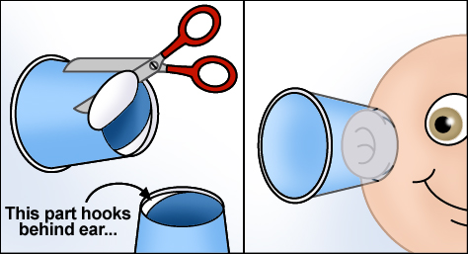
- Beak experiment supplies
  - Straw tweezers for each child
  - Paper plate for each child
  - Bowl for each child
  - A baggie for each kid
    - 10 gummy worms
    - 10 chocolate kisses
    - 10 jellybeans
  - Log and graph
- Camouflage experiment supplies
  - Rainbow Goldfish Crackers (a larger box)
  - log and graph
  - Clipboard per kiddo
  - Baggie per kiddo
Day of:
- Science Kids Mailbox Slideshow: Cody & Sheila letter: https://docs.google.com/presentation/d/1HYo5owCZOYBdNpi4XQ5PiYqgOtd_zBqWcVmEIhA1bwk/edit?usp=sharing
- Word Wall
- KWL Chart
- I Wonder… I Notice... Sheet https://docs.google.com/document/d/1fBVad137GHXzuOo6B4JpGr53JvUXZbAqZQGvbGmODtI/edit?usp=sharing
- Bird Beak exit ticket
- Read alouds
  - “A Frog Has a Sticky Tongue” by Pamela Graham
  - “Who Lives in the Arctic?” by Susan Canizares
  - “Animal Armor” by Cathy Smith
  - “What If You Had an Animal Nose!?” by Sandra Markle
  - “What If You Had Animal Teeth!?” by Sandra Markle
  - “What If You Had Animal Ears!?” by Sandra Markle
- Teacher paper for Ears graph
- Horse or Human Ears? Exit Ticket https://docs.google.com/document/d/18YtJuYdLAmVuPkFbImy6cBDBLxJTqoQq9kRkK_KYsQ0/edit?usp=sharing
- Bird Beaks Link https://www.youtube.com/watch?v=xEbRZs1L59E
- Beaks log and graph https://docs.google.com/document/d/17T2mNo12u5ckCRvlnMLCiCZBQftlKRCzuhLjdnUu0bg/edit?usp=sharing
- I Spy Slide Show https://docs.google.com/presentation/d/1DvzDJAM9-PziV6PnB3Bme2GpW0Q5y1omI88lHKjDPYY/edit?usp=sharing
- Camouflage log and graph https://docs.google.com/document/d/17T2mNo12u5ckCRvlnMLCiCZBQftlKRCzuhLjdnUu0bg/edit?usp=sharing

From Students Supplies:
- Pencils
- Crayons
ANTICIPATORY SET
Day one
- Read Science Kids letter from Cody and Sheila. https://docs.google.com/presentation/d/1HYo5owCZOYBdNpi4XQ5PiYqgOtd_zBqWcVmEIhA1bwk/edit?usp=sharing
- Lead in with the fact that animals have different parts that help them survive in the wild.
- Read the book, “A Frog Has a Sticky Tongue” by Pamela Graham. As you read aloud, ask students to write down or draw two “I wonder why…” statements in their I Wonder… I Notice… Sheet about the different parts these animals have and what they might do. Ex: “I wonder why elephants have such huge ears.” https://docs.google.com/document/d/1fBVad137GHXzuOo6B4JpGr53JvUXZbAqZQGvbGmODtI/edit?usp=sharing
- Ask them about their “I wonders…” and add them to the KWL Chart. Start a discussion as you put them up.
PROCEDURES FOR LESSON
- Ask students to remind you what a “trait” is in their own words (if they struggle, direct them to the word wall). Then talk about what a characteristic (or part) is. Ex: A characteristic of all cheetahs is that they all have spots on their fur. A trait is specific to one cheetah and comes from their parents. Cheetah Luisia is very fast because her dad passed on the speedy fast trait to her, but Luisia’s brother didn’t get their dad’s speedy fast trait so he’s not as fast at running as Luisa.
- Talk about skin, what do you think animals’ different types of skin does to help animals survive? Open the floor to see what ideas students have. Write those ideas up on the white board as a brainstorm.
- Read: “Animal Armor” by Cathy Smith and talk about the helpful things the skin of these animals does. Have students write down one “I notice…” statement on the I Wonder… I Notice... sheet.
- Then read, “Who Lives in The Arctic?” by Susan Canizares and Pamela Chanko and do the same thing. Have students write one more “I notice…” statement.
- Collect then discuss their I Wonder… I Notice… Sheets. Ask them what they think animal skin coverings do to help animals. (Keep them warm, keep them dry, keep them protected from the sun, etc.)
- Ask students what inventions we’ve created to help humans handle cold weather, hot weather, windy weather, wet weather, etc.
- Add to KWL Chart.
Day two
- Reread Cody’s and Sheila’s letter as a refresher. https://docs.google.com/presentation/d/1HYo5owCZOYBdNpi4XQ5PiYqgOtd_zBqWcVmEIhA1bwk/edit?usp=sharing
- Ask students what they think ears help animals do.
- Read the book, “What if You Had Animal Ears!?” by Sandra Markle.
- Have a mini discussion (Pair Share if allowed) on why different types and shapes of ears are important. (They can warm up/ cool down animals, hear in different directions, hear things miles away, hear sound waves human ears can’t hear! etc.)
- Provide each student with a set of “ears”.
- Have students mess around with their new ears around the classroom then ask them what they noticed, and what they wonder while using their ears.
- Have them take off their animal ears and explain that you are going to do an experiment to see which ears help us hear sounds better, horse ears or human ears. Have students close their eyes and focus on the sounds in this video. Have them listen first without ears, then rewind the video to start the same sound again and have them listen to the sounds with their animal ears on. Have students vote on whether they could hear better with the animal ears on or off. You will hit a chime as well as other sounds (students will listen with and without their animal ears. Document the results on a large paper so the students can see the results of each test. https://www.youtube.com/watch?v=n1m4h79JZso
- Once your experiment is finished, have the students help you create a graph to represent the data you collected as a class.
- Ask what they notice and wonder about the graph. Then ask them to talk about what they think the data is telling them about whose ears hear small sounds better humans or horses.
- Return to the classroom. Complete the KWL Chart.
- Once you’ve returned to the classroom, close out the ears part of this lesson by having students answer a single question on an exit ticket. “Circle the animal that our experiment showed could hear small sounds the best. Humans or Horses.” https://docs.google.com/document/d/18YtJuYdLAmVuPkFbImy6cBDBLxJTqoQq9kRkK_KYsQ0/edit?usp=sharing
Day three
- Remind of Cody’s and Sheila’s letter and the kiddos goal. https://docs.google.com/presentation/d/1HYo5owCZOYBdNpi4XQ5PiYqgOtd_zBqWcVmEIhA1bwk/edit?usp=sharing
- Ask students how they eat food. Listen to their responses and then have them pair share how they think other animals eat, how ants eat, how frogs eat, how birds eat.
- Switch-pair-share what kind of animals they think can eat the bugs that live deep inside trees. Then discuss in whole group. Use probing questions and challenging questions to expand their thinking.
- Have students raise their hands to add “I wonder…” statements to the KWL Chart.
- Read them sections of the books, “What if You Had Animal Teeth!?” and “What if You Had an Animal Nose!?” by Sandra Markle.
- Talk about what they learned from the books. “I learned…” “I noticed...”
- Give each student a paper bowl with 10 jellybeans, 10 gummy worms, 10 chocolate kisses, and tweezers (a straw bent in half will work fine). Tell the students they are going to do an experiment to learn about bird beaks and what kind of food this beak shape can eat.
- Have students mix all their goodies into their bowl. Tell them they will have 30 seconds to use their tweezers to pick out as many candies as they can and move them successfully to their paper plate. Tell them they will find some candies easier than others and to just try getting as many as they can. Set the timer and have them start. At the end have them put their candies into like groups. They need to add up how many they collected of each candy in that time and write it down in their Data Log for this activity. https://docs.google.com/document/d/17T2mNo12u5ckCRvlnMLCiCZBQftlKRCzuhLjdnUu0bg/edit?usp=sharing
- Once the experiment is finished and they have all documented their data in their log, model creating your graph so they can do their own semi-independently. https://docs.google.com/document/d/17T2mNo12u5ckCRvlnMLCiCZBQftlKRCzuhLjdnUu0bg/edit?usp=sharing
- Have students talk about their data and what they think it means.
- After a good discussion of their own ideas as to what the experiment means, show them the YouTube video about different types of bird beaks: https://www.youtube.com/watch?v=xEbRZs1L59E
- Ask the kids to raise their hands to add on to our KWL Chart.
- Have students take a counted blind vote on which type of bird beak they think our tweezers represented in our experiment as explained by the YouTube video clip. (Straight Beak)
Day four
- Reread Cody’s and Sheila’s letter. https://docs.google.com/presentation/d/1HYo5owCZOYBdNpi4XQ5PiYqgOtd_zBqWcVmEIhA1bwk/edit?usp=sharing
- Ask students why they think being able to blend into the world around them is important.
- Introduce the word camouflage on the Word Wall and explain what camouflage is and that it is used to hide either from someone trying to eat you or from the food you’re trying to eat.
- Use the “I Spy” slide show to engage students and get them thinking about the characteristic camouflage. https://docs.google.com/presentation/d/1DvzDJAM9-PziV6PnB3Bme2GpW0Q5y1omI88lHKjDPYY/edit?usp=sharing
- Lead students outside into a grassy spot with their clipboards, log and graph sheet, and a baggie. Have them spread out and explain that they are going to pretend to be hawks hunting for their food to eat. Spread handfuls of goldfish around a grassy area and determine boundaries for the experiment. Make sure they understand where they should stay for the whole experiment. Set a timer for 60 seconds for students to dash around collecting as many goldfish as they can (have them put their goldfish in their baggie: DO NOT EAT). After 60 seconds have them sort what they found into their four-color groups.
- Count the number of greens, yellows, reds, and oranges found and write them down in their data log. https://docs.google.com/document/d/17T2mNo12u5ckCRvlnMLCiCZBQftlKRCzuhLjdnUu0bg/edit?usp=sharing
- Have students create a graph of their data independently. https://docs.google.com/document/d/17T2mNo12u5ckCRvlnMLCiCZBQftlKRCzuhLjdnUu0bg/edit?usp=sharing
- Ask them what they found the most of, what they found the least of and why they think that was. Then after that discussion, ask them what they predict they would have found the most of, if we had scattered the goldfish on brown dirt.
CLOSURE
- Fill out the KWL Chart with what students learned and still wonder about how specific characteristics help animals survive in the wild.
HOMEWORK/ASSIGNMENTS/EXTENSION ACTIVITIES
- Choose one of the six read aloud videos I have recorded to listen to and think about. QR codes for these videos are in the Animals Unit Booklet, have them circle the animal they think would win after the read aloud.
  - “Who Would Win? Rhino VS. Hippo” by Jerry Pallotta
  - “Who Would Win? Tarantula VS. Scorpion” by Jerry Pallotta
  - “Who Would Win? Whale VS Giant Squid” by Jerry Pallotta
  - “Who Would Win? Jaguar VS. Skunk” by Jerry Pallotta
  - “Who Would Win? Killer Whale VS. Great White Shark” by Jerry Pallotta
  - “Who Would Win? Alligator VS. Python” by Jerry Pallotta
ASSESSMENT
- Formative
  - Exit ticket
  - Heads down vote
  - Final graph
ADAPTATIONS
- Building background knowledge
  - KWL Chart
  - Read Alouds
  - Word Wall
- Modeling
- I do, we do, you do. Scaffolding
RESOURCES
- Bush, S. (2017, December 31). Bird Beaks- What do Birds Eat? Retrieved from https://www.youtube.com/watch?v=xEbRZs1L59E
- Canizares, S., & Chanko, P. (1998). Who Lives in the Arctic? New York, NY: Scholastic.
- Graham, P. (2002). A Frog Has a Sticky Tongue. Australia: National Geographic Society.
- Guess the Sound Game | 20 Sounds to Guess. (2019, April 07). Retrieved from https://www.youtube.com/watch?v=n1m4h79JZso
- Hidden Animals. (2021, February 10). Retrieved from https://kids.nationalgeographic.com/wacky-weekend/article/hidden-animals
- Markle, S., & McWilliam, H. (2017). What if you had an animal nose!? New York: Scholastic.
- Markle, S., & McWilliam, H. (2017). What if you had animal teeth!? New York, NY: Scholastic.
- Markle, S., & McWilliam, H. (2017). What if you had animal ears!? New York, NY: Scholastic.
- Pallotta, J., & Bolster, R. (2014). Alligator vs. Python. New York, NY: Scholastic.
- Pallotta, J., & Bolster, R. (2014). Jaguar vs. Skunk. New York, NY: Scholastic.
- Pallotta, J., & Bolster, R. (2014). Killer Whale vs. Great White Shark. New York, NY: Scholastic.
- Pallotta, J., & Bolster, R. (2014). Rhino vs. Hippo. New York, NY: Scholastic.
- Pallotta, J., & Bolster, R. (2014). Tarantula vs. Scorpion. New York, NY: Scholastic.
- Pallotta, J., & Bolster, R. (2014). Whale vs. Giant Squid. New York, NY: Scholastic.
- Roberts, B. V. (2021, February 20). Humans Or Horses [DOC]. Berthoud: Bethan Roberts.https://docs.google.com/document/d/18YtJuYdLAmVuPkFbImy6cBDBLxJTqoQq9kRkK_KYsQ0/edit?usp=sharing
- Roberts, B. V. (2021,March 2). I Spy [PDF]. Berthoud: Bethan Roberts.https://docs.google.com/presentation/d/1DvzDJAM9-PziV6PnB3Bme2GpW0Q5y1omI88lHKjDPYY/edit?usp=sharing
- Roberts, B. V. (2021, February 23). Science Kids Mailbox [PDF]. Berthoud: Bethan Roberts.https://docs.google.com/presentation/d/1HYo5owCZOYBdNpi4XQ5PiYqgOtd_zBqWcVmEIhA1bwk/edit?usp=sharing
- Roberts, B. V. (2021, March 3). Logs and Graphs [DOC]. Berthoud: Bethan Roberts. https://docs.google.com/document/d/17T2mNo12u5ckCRvlnMLCiCZBQftlKRCzuhLjdnUu0bg/edit?usp=sharing
- Smith, C. (2002). Animal Armor. Washington, D.C.: National Geographic Society.
- Stay-at-Home Science: Distance Learning. (2020, April 08). Retrieved from https://science.discoveryplace.org/stay-at-home-science/bird-beak-buffet

Lesson 5: Engineering and Problem Solving
ELEMENTARY STANDARD LESSON PLAN
ACADEMIC STANDARDS
- First grade. Science: 2: Life Science: 1: All organisms have external parts that they use to perform daily functions. A: Use materials to design a solution to a human problem by mimicking how plants and/or animals use their external parts to help them survive, grow, and meet their needs. (1-LS1-1)
SPECIFIC OBJECTIVES TO ATTAIN LEARNING GOALS
- Students will be able to use what they learned about animal characteristic functions to design a solution to one of Akua’s problems and answer the following three questions orally 1. What problem of Akua’s are you solving with this invention? 2. What animal part did you pick? 3. How would your solution help Akua? And earn a ¾.
MATERIALS NEEDED
Before:
- Teacher example
Day of:
- Science Kids Mailbox Slideshow: Akua letter: https://docs.google.com/presentation/d/1HYo5owCZOYBdNpi4XQ5PiYqgOtd_zBqWcVmEIhA1bwk/edit?usp=sharing
- KWL Chart
- Plain white idea paper for each student
- Large paper for each child
- Unit Books from “Epic” or unit library to sift through if need be
- Student tablets to record kiddos
- Sign-up sheet
- Epic
From student supplies:
- Pencils
- Markers

ANTICIPATORY SET
Day one
- Review the KWL Chart making sure to address each overarching topic we’ve covered over the whole unit (aka: animals are like their parents and siblings because of inherited traits, and animals have characteristics that help them survive in the wild.)
- Read Science Kids Letter from Akua. https://docs.google.com/presentation/d/1HYo5owCZOYBdNpi4XQ5PiYqgOtd_zBqWcVmEIhA1bwk/edit?usp=sharing
PROCEDURES FOR LESSON
- Have students brainstorm the different problems that Akua is struggling with. Put these ideas on the board, just the problems they could solve not the inventions kids might already be thinking up.
- Show your teacher example of what they are going to be doing using a different example. Ex: Kimberly kept falling over on her roller skates, so I invented a set of turtle shell inspired knee pads and elbow pads for her. Show that the invention diagram is labeled to explain what things are. Write the three questions students will need to be able to answer orally and model answering these questions with your teacher example. 1. What problem of Akua’s are you solving with this invention? 2. What animal part did you pick? 3. How would your solution help Akua?
- Give the students a blank piece of paper and let them use the paper however they need to process their own ideas about what they could make to help Akua. This is their time to plan and think. Five-minute plan time!
- When students are ready give them a large piece of paper and let them design.
Day one and a half
- During rotations, pull each child one at a time to discuss their ideas for their project. Take notes as to what you hear them saying and the questions you probe their thinking with. This is a check in with each student, so you understand where your students are and to support the needs of specific students.
  - Have each kiddo bring you their plan sheet and ask them to explain their idea. Then do a mini practice by asking them the three questions they are going to be answering later for their final project demonstration.
Day two
- Reread Akua’s letter and remind them of the goal and what they were working on yesterday. https://docs.google.com/presentation/d/1HYo5owCZOYBdNpi4XQ5PiYqgOtd_zBqWcVmEIhA1bwk/edit?usp=sharing
- Explain their to do list:
  - Finish their poster
  - Put their name on the sign-up sheet so I know who to pull next to video their presentation.
  - While they wait for their turn, read books from “Epic”.
  - Record their video.
  - Work on their letter to Akua telling him about their invention.
- Let them jump into working.
- Pull students who have put their name on the sign-up sheet and pull them into the hall to video record them presenting their design for Akua on their iPad. Have them answer these questions on camera: 1. What problem of Akua’s are you solving with this invention? 2. What animal part did you pick? 3. How would your solution help Akua?
  - Once you have recorded every student's project, compile them into one easy to share file to show them on the review day before the post-test.
CLOSURE
- Ask students about the different inventions students came up with to solve Akua’s problems. Ask students if they think they can use the skill they practiced to help people in their community as well as around the world to solve problems.
- Finish up with adding to their KWL Chart, look at how much it has grown and changed over the unit!
HOMEWORK/ASSIGNMENTS/EXTENSION ACTIVITIES
- Write Akua a letter back explaining their invention to help him. Make sure students use a letter format.
ASSESSMENT
- Formative
  - Conference with each student
  - Diagram
  - Video explanation of their diagram
ADAPTATIONS
- Background knowledge
  - KWL Chart
  - Word Wall
- Letter was read aloud
- Teacher example
- Scribing work for my student with difficulties speaking to practice with you and then repeat what they say for the camera.
- Prompted questions so they know what they are going to include on their diagram as well as their video presentation.

RESOURCES
- Roberts, B. V. (2021, February 23). Science Kids Mailbox [PDF]. Berthoud: Bethan Roberts.https://docs.google.com/presentation/d/1HYo5owCZOYBdNpi4XQ5PiYqgOtd_zBqWcVmEIhA1bwk/edit?usp=sharing
- Using Animal Adaptations to Solve Human Problems: Educator Resource Center. (n.d.). Retrieved February 28, 2021, from https://dx.cooperhewitt.org/lessonplan/using-animal-adaptations-to-solve-human-problems/
Books on Epic
- Anderson, S. (2011). What can live in the ocean? Minneapolis: Lerner Publications.
- Anderson, S. (2011). What can live in a desert? Minneapolis: Lerner Publications.
- Boothroyd, J. (2012). Shells. Minneapolis: Lerner.
- Borgert-Spaniol, M. (2014). Spiders. Minneapolis, MN: Bellwether Media.
- Carroll, M. (2009). Peck, peck, peck. Vero Beach, FL: Rourke Pub.
- Frisch, A. (2015). Frogs. Paw Prints.
- Kids, N. G. (2014). National geographic kids readers: Swim, fish! National Geographic Kids.
- Knudsen, S. (2017). From tadpole to frog. Vienna, VA: Library Ideas, LLC.
- Loh-Hagan, V. (2017). Top 10: Moms. Ann Arbor: Cherry Lake Publishing.
- Lundgren, J., & Learning, B. D. (2013). Run, Swim, Fly. Chicago: Britannica Digital Learning.
- Meister, C. (2013). Sea stars. Minneapolis, MN: Jump!
- Silverman, B. (2010). Do you know about insects? Minneapolis: Lerner Publications.
- Silverman, B. (2010). Do you know about mammals? Minneapolis, MN: Lerner Publications.
- Statts, L. (2017). Newts. Minneapolis, MN: Abdo Zoom.
- Stephen, D. (1962). Do you know about birds. Collins.
- STOCKDALE, S. (2021). SPECTACULAR SPOTS. S.l.: PEACHTREE.
- Tuchman, G. (2010). National Geographic Readers: Safari. National Geographic Society.
- VanVoorst, J. F. (2018). Who lives on a mountain? Minneapolis, MN: Tadpole Books are published by Jump!
- Walker, A. (2018). Ouch! snakes that bite. Melbourne Beach, FL: Blue Door Publishing, FL.
- Zobel, D. (2012). Ducks. Minneapolis, MN: Bellwether Media.

Extensions, Modifications, and Adaptive Activities

Extensions
In lesson one, I wanted to continue building onto the students’ background knowledge by providing the extension activity of exploring books in the unit library on “Epic”. Having level appropriate material to read about the topic we are learning about and having the choice of which books to read helps students expand on their own interests and provides them with a more stable bank of information to pull from as we go through the unit.
Students will have their stuffed animals in lesson two, so I wanted to let them push their learning by having them use what they learned in the lesson and apply it to their own stuffed animal. Students will draw a picture of their stuffed animal and label all the animal’s parts they can to send back to Arleth, the little girl we were trying to help in this lesson.
Lesson three is all about comparing and contrasting animals and their young and to bring my students thinking back around to themselves, I have chosen to have my students create a Venn diagram comparing themselves to someone in their family. This is extra practice using the graphic organizer we focus on in this lesson, continues their thinking on comparing and contrasting two things, and pushes them to think about how humans are animals too.
In lesson four, students will have the opportunity to listen to a read aloud from the fun kid book series “Who Would Win?” and use their reasoning skills to decide which animal would win in a fight based on the information given in the text. There are multiple books in this series, but I have chosen a few from my own collection so they have a choice of which one to investigate.
My students are really becoming wonderful little writers, so as my final extension in my unit, I will have my students write Akua, the little boy who needed our help in this lesson, a letter explaining the design they’ve created to help Akua. This is to practice their writing skills in a fun letter format and their written explanation skills. They should have an easier time writing their explanations since they will have just recorded their oral explanations with me for their main formative assessment.

Modifications
I have a few students who will need lessons modified to support their learning and there are many students who benefit from adaptations. In lessons that require writing, I have three students who will dictate their sentences to me or Mrs. Preusse to scribe in a yellow pen for them to copy afterwards. I think it is important that they still copy and write what they said as a means of practice. For the lesson one assessment, I have a sentence frame for them to fill in the blanks. I am grading them on their spelling and if their ideas make sense as opposed to how I’m grading the other students (capitalization, spelling, punctuation, and if it makes sense). They have wonderful ideas and can easily answer the questions asked, they just struggle with writing down those ideas so these two modifications will help them shine. For these three students, I will modify their graphing assessment in lesson four to have them fill in the bar graph title and data information, but not include points for labeling the axis’ as they will be a guided labeling for this group. Their rubrics will be scored without grading those aspects to focus on whether they accurately transferred their data from their logs to their graph. I have one student who struggles severely with speech, so for the lesson five assessment I will work one on one with him to dictate his answers to the oral questions ahead of time in our “conference” so that he can practice and so I can accurately assess his ideas without the speech barrier. When we record this friend, if speaking is difficult to understand, casually repeat their answers.

Adaptations
To adapt my lessons and my pre- and post-assessment, I will read every written thing we use. We will address and use the KWL chart in every lesson as well as other graphic organizers like the Venn diagram throughout this unit. We will also have a Unit Word Wall for students to refer to in every lesson. In lessons where students must produce a certain outcome like in the Venn diagram lesson or the graphing data lesson, I will use the “I do, we do, you do” scaffolding where I model the expectation before sending them off to practice themselves. To add on to this, I have also made sure to have teacher examples of projects completed for students to see beforehand. I have included videos, readings, pictures, questions, experiments, built in movement, tangibles, and more to ensure that multiple learning styles are touched during this unit. Every student learns differently so it is important to include a plethora of diverse learning opportunities.

Instructing Students and Supporting Learning

Capstone Question #1: Other than what is stated in the lesson plan, what occurred immediately prior to and after the lesson that is important to know in order to understand and interpret the interactions between and among your students?
Student attitudes were positive coming into class on the first day of the lesson, but on the second day one of our higher need’s students had tried to run away when it was time to line up to come back inside from recess and it had concerned the other students. This altered the usual energy in the room to one that felt a little less “ready to learn” and a bit more “down with the system.” I joke, of course, but the behaviors on the second day were abnormal.
Students come to our science block straight from recess and are usually a mixture of worn-out and restless as it is the last hour of the day. Students come in and as per the Covid rules at Ivy Stockwell they must wash their hands after every recess. This usually takes fifteen minutes, then once they have washed their hands, they are allowed to have their snack. As my students came into the classroom for both days of this lesson, I had the lights off to keep the environment calm and I praised them for coming in quietly and appropriately. I then used positive classroom management techniques such as attention calls to begin delivering directions for hand washing and for their snack time. I adapted my lesson by having students read to self from our collection of animal books on Epic while they washed their hands and ate their snack. This gave them some time to settle in after recess and fill their tummies. I reinforced positive behaviors both days by using cues like, “Thank you ______ for showing me you’re ready to learn by sitting at your desk nice and quiet.”, “Eyes on me in 3...2...1”, and “Good listening ears”.
After they had finished washing their hands and eating snack, I explained the purpose of our upcoming lesson by reading the objective and Akua’s letter. On the second day, we revisited the objective and Akua’s letter, but I instead told them we were going to have a “Working Snack”, this means that they are going to work on our to do list while they finish their snack. I wrote and explained a menu on the board for them to use to help guide them on to their next task while I recorded final projects.
The end of the first day went smoothly as I cued their end of day routines. My students were very excited to share with me and their classmates their ideas for their projects, so their energy was very positive and chatty. The second day was far “squishier”. My Mentor Teacher hadn’t been in the room to help me support a more positive learning environment while I was assessing students one-on-one in the hall and by the end of the lesson, students were extra squirrely. I cued clean up and time to pack up and the transition was not as smooth as it usually is. One of my students ended the day needing a hug and to talk about how he was feeling because he had a bit of an outburst as we were packing up for the day. However, he left the classroom smiling after we talked.

Capstone Question #2: In this lesson how did you further student's knowledge and skills and engage them intellectually in understanding the subject matter? Provide examples from the lesson to show you addressed all student's needs.
I created my unit to build off prior knowledge so that they could use what they learned for this final lesson project. This means that I had to incorporate some strategies to support student learning by bolstering their “enduring understanding”. Here are some ways I furthered student knowledge and engaged them in the subject matter.
To start my lesson off, we discussed the unit KWL Chart. This supported their learning because the more times we talk about what we’d learned the more likely they are to remember and utilize the information. This lesson was all about using what they learned to solve problems for our friend Akua so it was especially important that my kiddos had the opportunity to remember the things they had learned in the unit. We had the class chart up for everyone to see, and then later we came back to add more information to it.
I made a point of reminding the students of our purpose in this lesson four times. I read the objective at the start of both days and read Akua’s letter multiple times with the letter up on the promethean board for everyone to see. I prompted questions while reading Akua’s letter to ensure their understanding, including questions like, “can anyone tell the class what an invention is?” After reading the letter, we delved in, and the students brainstormed what some of Akua’s problems were based on the text. During our mid lesson assessment conferences, which was an adaptation from my original plan, I reiterated the purpose again and explained one-on-one to each of my students. I was able to adapt how I explained and could ensure I knew that every child understood the purpose and project fully with these individual conferences.
In this lesson, it was vital that I support their idea development. Students were prompted to use their leveled Epic books to help them if they were struggling coming up with a solution. This helped students grab on to an idea they could use by allowing them time to think with the support of informative texts. I also supported their idea development by asking them to pair share with their neighbors. The most valuable tactic I used to help my students develop their ideas about how to use an animal part to help Akua solve one of his problems was giving them a planning sheet. They could use this sheet however they wanted, some students wrote their idea in words, others drew a compilation of ideas, while others filled the entire page with one idea, they were passionate about. For my more visual learners, I made a teacher example and referred to it from start to finish and even used it in my one-on-one conferences with my kiddos. The teacher example was a solution to a problem Akua didn’t have so the students wouldn't be able to copy my thinking but were still supported with a visual example of what was expected.
This lesson was built so my students could work like real scientists, that means being able to collaborate in large groups, small groups, and partnerships, as well as independently. In this lesson, my students were working in what I affectionately call a “Hive”. In a “Hive” everyone is available to support others, but each person is aware of their job and working on what they need to do. A good “Hive” is accompanied with the sounds of focused chit chat. Scientists need to be able to bounce their ideas off each other so providing a very realistic work environment for them was important to me. I believe this realistic environment supported my students’ engagement and learning because they could reach out to friends or me if they felt stuck, move at their own pace, take extra time, use resources of their own choosing, or could work alone if they preferred.

Question #3: Describe strategies to monitor student learning during the lesson as shown. cite 1-2 examples of what students said or did in lesson or assessment that indicates progress toward meeting standard at proficiency.
This lesson is a PBL lesson, so my students were given a lot of freedom with their ideas and thinking. However, I still made sure to monitor their learning in a few different ways. To start, I utilized a KWL Chart that they had been adding too since day one of our unit. Every time they learned a new fact or concept, they added it to the KWL chart. We referred to this chart throughout this lesson as well. One example of student learning and understanding of the standards is that when I asked my students this question about a note on the KWL Chart, “Could babies survive without their parents?” my students shouted out, “No!”.
Another way I monitored their learning was by rotating around the room and working with students one-on-one as they worked on their plan sheets. The day after our first lesson, I had my students conference with me one-on-one. They brought their plan sheet back to me and they talked about what their idea was, how it would work, and the animal parts they used. In these one-on-one meetings, I was able to assess my students' understanding and misconceptions. One misconception I saw a few times was how bunny ears help cool rabbits down. One student said they are like a fan, while another talked about the blood vessels. In these conversations, I could tell that my student with the fan idea didn’t quite understand the content whereas the other student understood that it was the blood vessels in the rabbit ears that did the cooling, not the ears themselves. Another student I talked to said, “Wolverine ears are very good at hearing, so they could hear the animals underground.”. In this student’s conference, I could assess that he understood the standard more clearly and could show that knowledge.

Question #4: Reflect on your instruction and children's learning, discussing how the instruction and learning reflect your philosophy of how children learn.
After discussing theories with Holly Mitchell, I can confidently say that I am a teacher who falls into the constructivist category. I believe that student understanding is something that is built by the student and their experiences. As a teacher, I believe my job is to provide experiences where students explore and create their own knowledge. This shows in my unit and especially in this lesson. I built this unit plan like a spiral. I taught smaller ideas and then spiraled out into more complex concepts, ending finally with a project-based learning lesson that incorporated all the standards we covered in past lessons. This teaching style reminds me very much of Brunner in the sense that I spiraled my unit and gave a challenging but still age appropriate and student-centered project as a means of teaching.
I hadn’t realized I taught like this, but it is very clear to me that I plan lessons and how I teach falls squarely into this constructivist teaching style. I plan on looking more into this theory and seeing if there are other activities or techniques, I can practice making my teaching more effective for my students.

Question #5: Explain how you scaffold curriculum, instruction, and assessment in ways to contribute to understanding and facilitating students' construction of knowledge.
I took care to scaffold my lesson in a multitude of ways. To explain them, I am going to take you from start to finish to be as clear and concise as I can be. An important note before I begin is that this lesson was carefully planned to build on what my students had already learned in the past lessons. This was the end of the “spiral” so to speak.
At the start of lesson five, I directed students' attention to the unit KWL Chart. We reviewed what we had learned throughout the lesson and discussed some of the pieces of information that would aid them in this lesson’s objective. Then, we went forward to read the objective for the lesson and the letter from Akua naming the project’s purpose. I posted the letter from Akua on the promethean board so all the students could follow along as I read the letter to them aloud. As we read, I asked clarifying questions including “Does anyone know what an invention is?” to support their understanding and learning as well as to assess areas that may need support. We also brainstormed the potential problems the students could try and solve for Akua on a chart they could refer to as needed. From there, I let my students collaborate with seat mates in a pair-share to help their thinking so they could later use their blank sheet of paper to lay out their plan. They were encouraged to use their leveled Epic books to research and inspire their thinking as well. In their Epic library there were different leveled books as well as options that included audio. For my more visual learners, I created a teacher example of what their final project was going to look like and include based on a different problem so they wouldn’t be able to use my idea for their project. I explained this teacher example with very clear expectations and referred to it many times throughout the lesson.
Those were some resources I used to scaffold their learning, but I also took care to scaffold in other ways. For instance, I rotated around the room and gave one-on-one support to students throughout their planning process by asking probe questions that made them think in different ways as well as answering clarifying questions or just being a bouncing board for their ideas. For the second and third day of this lesson, I provided a menu to help streamline their work, so they knew easily what they were expected to do next during their independent work time. Another way I scaffolded their learning was by holding one-on-one conferences with each child to assess their understanding of the project expectations as well as the reasoning behind their solution.
The final assessment I did for this lesson was also scaffolded to support student learning. Instead of having students write about their invention, I videotaped them answering three questions orally about their project. This was helpful in a few ways in supporting their understanding. One: they drew their ideas and could refer to their drawing as a means of supporting them during their recording. Two: they were talking about their projects, not writing, which many of my students struggle with and meant that I could really get an idea of what they understood. And three: we used these videos to study for their test that Friday.

Question #6: (From grading rubric) Candidate establishes a positive class environment that supports and enhances student learning.
I had to adapt to make the start of my lesson smoother right off the bat. My students come in from recess directly before their science block. When they come in, they must wash their hands and are then allowed to eat their snack. To make this lengthy process work, I decided to have my students read from the unit library in Epic while I called rows to wash their hands and eat their snack. I made sure to keep the lights off during this time, so the classroom environment stayed calm and positive while I waited to start teaching.
I am a teacher who truly believes the power of positive reinforcement, so as soon as my students walked through the door into class, I began praising all the positive behaviors I observed. I made comments like, “Thank you for getting out your Epic and reading nice and quietly.” so my students knew what kind of behavior I was looking for. I make it a point to model my expectations and I did that by pointing out students who were showing the behaviors I liked, and I did so myself by modeling respectful behaviors. I also modeled what the product would look like and made students feel safe by having them practice what they would say to the camera during our one-on-one conferences.
This project was built to push my students. This means that I needed to give them more freedom with how they went about reaching their final project. They could discuss ideas with their peers, they could read and process ideas with Epic books, and students were able to use the plan sheet in any way they wanted to support their thought process. Some students drew, some wrote full sentences explaining their plan, while others just jotted bullet notes. Also, this was a drawn project which appealed to most of my students because they like being artistic, and if we are being honest, they liked it because it wasn’t a writing assignment. For a project with the need for such a high level of thinking, it was important that they were supported positively in other ways such as more freedom.
A final note on how I upheld a positive classroom environment during this lesson was by giving my students timed warnings, so they knew how much longer they had to work. For many of my students, this is a must. I have a handful of students who will break down if they are told to put their pens down while they are mid-thought, which is completely fair. I likely wouldn’t enjoy that either. Providing timed warnings helps all my students know the game plan is about to switch to something else, whether that be finishing their snack, moving on to partner work, or packing up for the day.

Resources
Teacher
- Alligator Biology. (n.d.). Retrieved from https://www.louisianaalligators.com/alligator-biology-and-behavior.html
- Family, Parenting, Pet, and Lifestyle Tips That Bring Us Closer Together. (n.d.). Retrieved from https://littlethings.com/pets/facts-about-owl-babies/3081436-9
- Hidden Animals. (2021, February 10). Retrieved from https://kids.nationalgeographic.com/wacky-weekend/article/hidden-animals
- Preusse, J. (Spring 2020 and Spring 2021). Berthoud: Jennifer Preusse.
- Stay-at-Home Science: Distance Learning. (2020, April 08). Retrieved from https://science.discoveryplace.org/stay-at-home-science/bird-beak-buffet
- Using Animal Adaptations to Solve Human Problems: Educator Resource Center. (n.d.). Retrieved February 28, 2021, from https://dx.cooperhewitt.org/lessonplan/using-animal-adaptations-to-solve-human-problems/
- Vgiannetto. (2013, September 25). Kindergarten Owlets. Retrieved February 27, 2021, from http://youngschoolart.blogspot.com/2013/09/kindergarten-owlets.html

Student
- Amsel, S. (n.d.). Match the Baby Animals to Their Grown Up. Retrieved February 22, 2021, from https://www.exploringnature.org/db/view/4910
- Guess the Sound Game | 20 Sounds to Guess. (2019, April 07). Retrieved from https://www.youtube.com/watch?v=n1m4h79JZso
- T. (2020, July 18). Owl Fact Booklet and Activities with Digital Activities. Retrieved March 28, 2021, fromhttps://www.teacherspayteachers.com/Product/Owl-Fact-Booklet-and-Act ivities-with-Digital-Activities-2103451
- Roberts, B. V. (2021, February 23). Alligator Slide Show [PDF]. Berthoud: Bethan Roberts. https://docs.google.com/presentation/d/1V-bSmZcaApxpbLarM4 NoT00T6oYS7pBAIOebVTqKSnw/edit?usp=sharing
- Roberts, B. V. (2021, March 3). Animal Parts [PDF]. Berthoud: Bethan Roberts. https://docs.google.com/presentation/d/18p-_GmpIfU-8q6iuc1phfGrf9jd6xzKAmN6UFhuiO70/edit?usp=sharing
- Roberts, B. V. (2021, February 20). Humans Or Horses [DOC]. Berthoud: Bethan Roberts.https://docs.google.com/document/d/18YtJuYdLAmVuPkFbImy6cBDBLxJTqoQq9kRkK_KYsQ0/edit?usp=sharing
- Roberts, B. V. (2021,March 2). I Spy [PDF]. Berthoud: Bethan Roberts.https://docs.google.com/presentation/d/1DvzDJAM9-PziV6PnB3Bme2GpW0Q5y1omI88lHKjDPYY/edit?usp=sharing
- Roberts, B. V. (2021, March 3). Logs and Graphs [DOC]. Berthoud: Bethan Roberts. https://docs.google.com/document/d/17T2mNo12u5ckCRvlnMLCiCZBQftlKRCzuhLjdnUu0bg/edit?usp=sharing
- Roberts, B. V. (2021, February 23). Owl Slide Show [PDF]. Berthoud: Bethan Roberts. https://docs.google.com/presentation/d/1l4IK3N64WabPACZb5tAvGIlo1
- WWCrfMcy8ncAW99XJo/edit?usp=sharing
- Roberts, B. V. (2021, February 23). Science Kids Mailbox Slide Show [PDF]. Berthoud: Bethan Roberts.https://docs.google.com/presentation/d/1HYo5owCZOYBdNpi4XQ 5PiYqgOtd_zBqWcVmEIhA1bwk/edit?usp=sharing
- Roberts, B. V. (2021, February 23). Student KWL Chart Document [DOC]. Berthoud: Bethan Roberts.https://docs.google.com/document/d/19syG7DtX3rkDY9fbNCVdd8 lKiSU3LNVS1DLPDC0IH2k/edit?usp=sharing
- Roberts, B. V. (2021, February 23). Student Venn Diagram [DOC]. Berthoud: Bethan Roberts. https://docs.google.com/document/d/1D7twLCsjGcuec6y2wFHklgW3t5od CvjOcY9UGH8JEuM/edit?usp=sharing
- Roberts, B. V. (2021, February 23). Traits Slide Show [PDF]. Berthoud: Bethan Roberts. https://docs.google.com/presentation/d/1cJkDQ6P42sLOMO8mT-PXVJpfHh5YB4uMVMZAJjCl7hI/edit?usp=sharing
- Roberts, B. V. (2021, February 23). Word Wall Slide Show [PDF]. Berthoud: Bethan Roberts.https://docs.google.com/presentation/d/1yBxC3Rfy1qii7IY9lUE7vKK-TSnM7PCUxfd9B27Urfs/edit?usp=sharing
Books on Epic
- Anderson, S. (2011). What can live in the ocean? Minneapolis: Lerner Publications.
- Anderson, S. (2011). What can live in a desert? Minneapolis: Lerner Publications.
- Boothroyd, J. (2012). Shells. Minneapolis: Lerner.
- Borgert-Spaniol, M. (2014). Spiders. Minneapolis, MN: Bellwether Media.
- Carroll, M. (2009). Peck, peck, peck. Vero Beach, FL: Rourke Pub.
- Frisch, A. (2015). Frogs. Paw Prints.
- Kids, N. G. (2014). National geographic kids’ readers: Swim, fish! National Geographic Kids.
- Knudsen, S. (2017). From tadpole to frog. Vienna, VA: Library Ideas, LLC.
- Loh-Hagan, V. (2017). Top 10: Moms. Ann Arbor: Cherry Lake Publishing.
- Lundgren, J., & Learning, B. D. (2013). Run, Swim, Fly. Chicago: Britannica Digital Learning.
- Meister, C. (2013). Sea stars. Minneapolis, MN: Jump!
- Silverman, B. (2010). Do you know about insects? Minneapolis: Lerner Publications.
- Silverman, B. (2010). Do you know about mammals? Minneapolis, MN: Lerner Publications.
- Statts, L. (2017). Newts. Minneapolis, MN: Abdo Zoom.
- Stephen, D. (1962). Do you know about birds. Collins.
- STOCKDALE, S. (2021). SPECTACULAR SPOTS. S.l.: PEACHTREE.
- Tuchman, G. (2010). National Geographic Readers: Safari. National Geographic Society.
- VanVoorst, J. F. (2018). Who lives on a mountain? Minneapolis, MN: Tadpole Books are published by Jump!
- Walker, A. (2018). Ouch! snakes that bite. Melbourne Beach, FL: Blue Door Publishing, FL.
- Zobel, D. (2012). Ducks. Minneapolis, MN: Bellwether Media.
Both
- Roberts, B. V. (2021, March 3). Animal Parts Quiz [Plicker]. Berthoud: Bethan Roberts. https://www.plickers.com/packs/603fe57b1ae6490012db59cc
- Smith, C. (2002). Animal Armor. Washington, D.C.: National Geographic Society.
- Turcotte, M. (2010, April 6). Youtube. Retrieved March 4, 2021, from https://www.youtube.com/watch?v=lNd6wQ3S38s
- Hatkoff, J., Hatkoff, I., Hatkoff, C., & Yates, D. (2011). Winter’s Tale: How One Little Dolphin Learned to Swim Again. New York: Scholastic.
- Animals Help Their Babies Survive: K-2 Science Video. (2019, November 12). Retrieved February 22, 2021, from https://www.generationgenius.com/videolessons/animals-help-their-babies-survive-video-for-kids/
- Bush, S. (2017, December 31). Bird Beaks- What do Birds Eat? Retrieved from https://www.youtube.com/watch?v=xEbRZs1L59E
- Markle, S., & McWilliam, H. (2017). What if you had an animal nose!? New York: Scholastic.
- Markle, S., & McWilliam, H. (2017). What if you had animal teeth!? New York, NY: Scholastic.
- Markle, S., & McWilliam, H. (2017). What if you had animal ears!? New York, NY: Scholastic.
- Pallotta, J., & Bolster, R. (2014). Alligator vs. Python. New York, NY: Scholastic.
- Pallotta, J., & Bolster, R. (2014). Jaguar vs. Skunk. New York, NY: Scholastic.
- Pallotta, J., & Bolster, R. (2014). Killer Whale vs. Great White Shark. New York, NY: Scholastic.
- Pallotta, J., & Bolster, R. (2014). Rhino vs. Hippo. New York, NY: Scholastic.
- Pallotta, J., & Bolster, R. (2014). Tarantula vs. Scorpion. New York, NY: Scholastic.
- Pallotta, J., & Bolster, R. (2014). Whale vs. Giant Squid. New York, NY: Scholastic.
- Canizares, S., & Chanko, P. (1998). Who Lives in the Arctic? New York, NY: Scholastic.
- Graham, P. (2002). A Frog Has a Sticky Tongue. Australia: National Geographic Society.

Evaluative Essay
General Overview
Below is a chart of my students' scores throughout this unit. I have included the pre and post assessment scores, the change between the two, and all five formative assessments in the chart. Across the top, you can see the labels of which lesson it was and the goal of how many points I was hoping they could achieve formatted like this, “One= 7/12”, this means in the assessment for lesson one, my students were aiming to score at least a 7/12 points. You will see absences in orange, scores that reach or surpass expectations in green, scores that did not meet expectations in red, and the last two columns at the end state the change in points between the pre and post assessment and the total points the students earned through the unit. A yellow bar means the student was very close to meeting expectations and blue means that the student missed an assignment due to being absent and the data therefore isn’t the most reliable. The last thing I want to point out about the chart is that some of the boxes have a “M” next to the students’ score. The “M” is to indicate that I modified this assessment for the student in some way and their score is based on their work with the modification.
I was in the lucky position of having no students in quarantine during my three-week unit, so I only had to worry about “random” absentees. This allowed me to gather more consistent data to assess over the unit. As you can see by my graph below, I did have one student who was absent more than once and missed two assignments. He was being pulled for IEP testing consistently for about a week and a half of this unit. I made the decision not to push him to do the two assignments he missed because by the time he had rejoined the class fully, he already had make-up work to do and my biggest concern was that I understood what he did and didn’t know about the content, not that he had his assignments submitted.
I had all but one of my students present to take the post assessment. This student has high behaviors that are triggered easily by the thought of being behind. I knew that since he had missed the assessment with the rest of the students that if I were to pull him to take it almost a week later when he returned, he would have a meltdown and the data from his assessment would be inaccurate because he wouldn’t be in the right headspace. I therefore decided not to give him the post assessment to save him the trauma for an assessment that wouldn’t provide me accurate feedback anyway.

Student Scores: Animal Unit
Student | Pre-Assessment out of 26 | One= 7/12 | Two= 8/10 | Three= 3/4 | Four= 8/11 | Five=  3/4 | Post-Assessment 23/26 | Change in points between Pre and Post Assessment | Total Points= 52/67
1 | 23 | 10 | 8 | 4 | 10 | 4 | 25 | 2 | 61
2 | 26 | 9 | 8 | 3 | 9 | 4 | 26 | 0 | 55
3 | 24 | 11 | 10 | 4 | 11 | 3 | 25 | 1 | 61
4 | 22 | 8 | 8 | 2 | 11 | 4 | 25 | 3 | 54
5 | 21 | Absent | Absent | 4 M | 10 M | 3 | 24 | 3 | 38
6 | 20 | 8 | 10 | 2 | 11 | 4 | 24 | 4 | 55
7 | 21 | 8 | 10 | 4 | 11 | 3 | 22 | 1 | 55
8 | 21 | 7 | 8 | 3 | 7 | 4 | 22 | 1 | 51
9 | 20 | 10 M | 10 | 4 M | 10 M | 3 | 23 | 3 | 57
10 | 17 | 10 M | 8 | 4 M | 1 M | 4 | 23 | 6 | 46
11 | 15 | 6 | 10 | 2 | 11 | 4 | 24 | 9 | 58
12 | 22 | 7 | 10 | 4 | 11 | 4 | 25 | 3 | 61
13 | 23 | 11 | 10 | 2 | 11 | 4 | 26 | 3 | 64
14 | 23 | 11 | 10 | 4 | 11 | 3 | 25 | 2 | 61
15 | 18 | 8 | 8 | 1 | 7 | 3 | 22 | 4 | 46
16 | 20 | 8 | 10 | 2 | 11 | 3 | 25 | 5 | 56
17 | 19 | 12 | 10 | 4 | 11 | 4 | 26 | 7 | 63
18 | 25 | 7 | 10 | 4 | 11 | 4 | 26 | 1 | 58
19 | 23 | 8 | 10 | 4 | 9 | 3 | 24 | 1 | 55
20 | 25 | 7 | 10 | 4 | 11 | 4 | 25 | 0 | 61
21 | 22 | 11 | 10 | 3 | 11 | 4 | 24 | 2 | 59
22 | 22 | 10 M | 10 | 4 M | 8 M | 3 | Absent | ----- | 32

Student Evaluation
I created what I thought was a well-rounded and challenging summative assessment, but when I gave it to my students as the pre-test, I realized very quickly that my students knew far more than I’d anticipated. The lowest score being a 15 out of 26 and the highest being a 26 out of 26. I knew there was still room for all my students to grow, but this assessment helped me understand that I needed to ensure I was still challenging the minds of my highflyers.
The pre-test average was 21 out of 26. The posttest average was 24 out of 26. Overall, my students did amazingly, every student but two showed growths between the pre and posttest. The two that showed no growth received the same score as they did the first time, student #2 scored a 26 both times and therefore couldn’t grow, and student #20 received a 25 both times and missed one point on the writing portion both times.
I have included three students to use as examples for my evaluation of my students' mastery of the standards. I picked who I considered to me my high, middle, and low students based on the number of points they earned throughout the unit as well as the level they tend to be in the rest of their academics. Student 15 is my low, student 11 is my middle, and student 13 is my high. Below are photos of their post assessments.

Student 15-Low

Student 11-Middle

Student 13-High

Student 15’s score from the pre-assessment was 18. She scored a 22 on the post assessment which was one point beneath my goal for them by the end. She improved by four points. She gained two of those points in the true / false section. She clearly now understands that living things have offspring and that baby animals and their families are similar but aren’t always the same. Something she still hadn’t mastered by the posttest was the fact that living things need energy. I remember walking around the class during the test and her raising her hand to ask what energy was. Student 15 is one of my students who struggles with writing quite a bit and her scores in this area reflects her struggle. She scored one point on both the pre and posttest and what is interesting is that her letter flipping is actually worse on the posttest than it was on the pre-test.
Her scores on the formative assessments were all either below expectation or just barely at or above expectation. On the lesson one assessment I was quite proud of her because she made the decision to use the given sentence frame to support her developing writing skills and was able to reread her work because of it (here is the image of her work). She received an 80% on the second assessment which was the goal for my students. Lesson three’s assessment was much more of a challenge for her. She scored below the target goal with a 1 out of 4 instead of a 3 out of 4. I believe she found this assignment more difficult because the writing had to come from her own mind. I didn’t ask for complete sentences, but she struggled writing her ideas and organizing them on the Venn diagram independently. When discussing with her where she believed her chosen facts should go, she couldn’t correctly identify where to place them consistently. She scored one point below the target goal in lesson four’s assessment. She had documented her data incorrectly, and she had forgotten a label (here is the image for her work). I have written notes in my journal reflecting on this lesson that she was very distracted and needed a lot of redirecting during this assignment. Lesson five’s assignment was a good assessment for me to review and get to know her level of understanding. She did a good job picking and explaining her animal part solution and reached the target goal. The only point she missed was from not labeling her drawing. She may not have shown very high scores on her assignments, but she clearly has a good understanding of the science standards we studied together according to her test score.
She ended the unit with a total of 46 points out of 67 possible. That was the lowest total in the class, however I believe she still reached mastery of most of the content. Her test shows she understands what a living thing is and two of the three facts that make a living thing such, she also has a good understanding of animal structures and that they help animals survive as shown on her test and her lesson five assignment. The areas I believe she has yet to reach mastery are graphing and understanding data and writing conventions.
If I were to teach this unit again, I would make sure to find ways to motivate my students who dislike writing. After getting to know student 15, I think I could have motivated her more by sitting her nearer to one of our higher achievers. If she is left to her own devices during writing time, she will daydream and avoid her work looking at what other students are doing. However, as seen through observation, if she is close to motivated students who like writing, her enthusiasm rises as well as her effort.
Student 11 is who I chose as my middle student. She has some confidence issues when it comes to academics and is usually scored in the lower half of the middle in other subjects. She scored the lowest out of the class in the pre-test with a 15 out of 26. She sky rocketed to a 24 out of 26 for the post assessment, showing 9 points worth of improvement. She showed her newfound mastery on her posttest in all areas except for the labeling section. I have a feeling the line for the label “legs” threw her off because she didn’t know where to put the label for the “skin covering”. I can also assume this because she didn’t miss any points from the labeling section on the pretest. She grew so much from her pre assessment to her post assessment.
Student 11 scored one point below expectation for lesson one’s assignment (here is her writing). In this lesson she didn’t use any punctuation and was hit and miss with her use of capitals. However, she really showed her skills as a writer in her posttest when she didn’t miss a single point on the writing question. This little girl enjoyed the interactive and technologic aspect of lesson two and scored 100% on the assessment. Later, she almost reached the goal for lesson three’s assessment. It was clear she had brilliant ideas to work with and understood many facts that made adult owls and their young similar and different, but she didn’t include a fact about their behaviors. Lesson four let her show her fabulous organization skills on her graphing assignment, she scored 100% again. Student 11 has a very creative mind and excels when she lets herself feel confident and show what she’s learned. I believe the assignment for lesson five was perfect for her because she was able to show her understanding using her drawing and her own words (here is her work). I could tell she wasn’t nearly as anxious talking with me about what she knew than she usually is when we put a worksheet in front of her to complete. I can confidently say that student 11 has reached mastery of the science standards taught in this lesson as well as the math and literacy standards based on her final test score.
Something I would do differently to support students like her with such high anxiety in class is to give her opportunities to talk with me before she starts her assignments. This way, I could let her talk about what she knows, boost her confidence by complimenting her brilliant brain, then letting her show us what she knows.
I picked student 13 as my representation for my high students because he scored a 23 out of 26 on the pre-test and scored a 100% on the post assessment. He grew by three points between the two. On his pre-test, he only missed points on the writing section. Student 13 missed a point for having a capital in the middle of his sentence and for having a random word mixed in that made his writing confusing. In the post test, however, he showed me his improvement by writing a sentence that made sense and had no capitals out of place. Given his ability, I commented that he should push himself in the next writing assignment because his sentence was good but also rather simple. I must add that his handwriting improved as well.
Student 13 surpassed the target goals for each lesson except for lesson three’s assignment (here is his assignment and rubric). In lesson three’s activity, he provided accurate facts on his Venn diagram but forgot to add a similarity or difference that involved behavior. This student’s score on his assignments and his summative assessment shows me that he has reached mastery of the standards taught in this unit.
After going over all my students' scores for lesson three’s assignment, I have assessed that most of the points lost on this assignment were because they didn’t add a behavioral fact, just like student 13. Something I would do differently to help students understand the fact that behaviors are different between adult animals and their young to help babies survive is provide more direct instruction for it. In this lesson, we used many resources for my students to practice their research and fact gathering skills. Next time I would find a recourse to share with my students to explain behavioral differences more extensively.

Whole Class Evaluation
Below is a graph showing how many of my students reached the target goals of the five main formative assessments throughout the unit. By studying the data, I can see that my students were overall very successful in reaching the goals laid out for them. I would like to say that one reflection I’ve had while evaluating my students' growth and my teaching is that I should have set up more difficult rubrics or tasks for my students. I found that my students did far better than I had anticipated, which is never a bad thing, but in lesson five of this unit I should have had less students reaching the target goal than I did. As I was grading my students PBL’s, I realized very quickly that I needed more categories on the rubric and that I needed to be more specific because my students were getting four out of fours when they shouldn’t have. My rubric included four expectations, a point for a picture that has the animal part labeled, a point for stating which of Akua’s problems they were solving with their solution, a point for stating their animal part, and a point for explaining how their solution would work to help Akua. The issue was that this was far too vague and resulted in all my students meeting the target goal when many of my students' reasons for how their solution would work were not scientific but were still in part logical enough to pass the rubric’s standards. I should have clarified on the rubric that students needed to be able to explain how the animal part works in nature to help the animal and then to explain how that function could also help Akua. This is a change I would make if I were to teach this unit again.
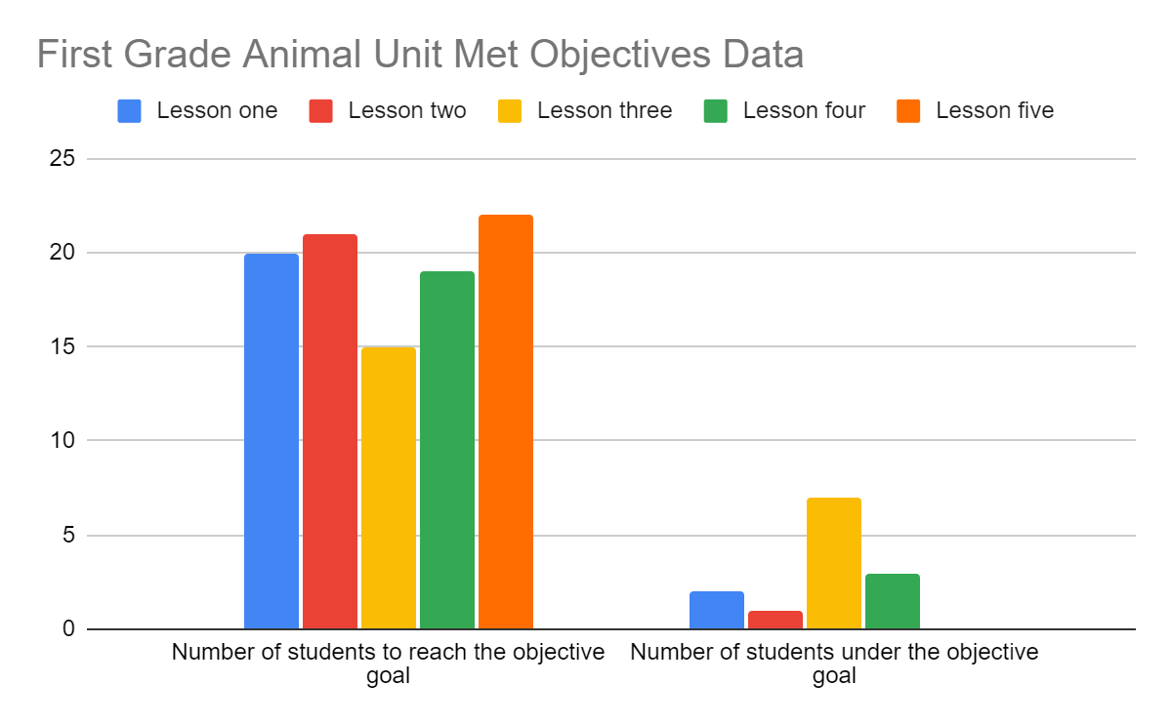
I am going to change gear to evaluate the whole classes' mastery of the standards by looking at the pre and post assessments scores. The average score on the pretest was 80%, which is very high for a pretest in general and in my opinion would suggest that the students were already approaching mastery if they weren’t already there. The average score on the posttest was 92%, which again is quite high. This is an increase of 12% between the pre and posttest. I have compiled a graph to show what standards they missed on their post assessment to evaluate the classes level of mastery of each standard. I have broken the standards into their different parts to be more specific.
By looking at the graph below, we can see that my students mastered all the standards we practiced in this unit except for writing conventions. I had a total of fifteen students miss at least one point on the writing question. That is over half of my class. The mistakes they made were mostly spelling without tapping and random capitals in the middle of their sentences. However, as compared to their pretest, they have improved in their writing conventions. In their pretest, students were making mistakes in punctuation, starting capitalization, and many more spelling mistakes were made. Even though most of my students still lost a point or two on the writing question on the posttest, they still grew as writers. Other than the writing section, my students only missed a total of 8 points. These points were from standards like graphing, animal parts, and the functions of animal structures.
Which Standards did Students Struggle with According to the Post Assessment
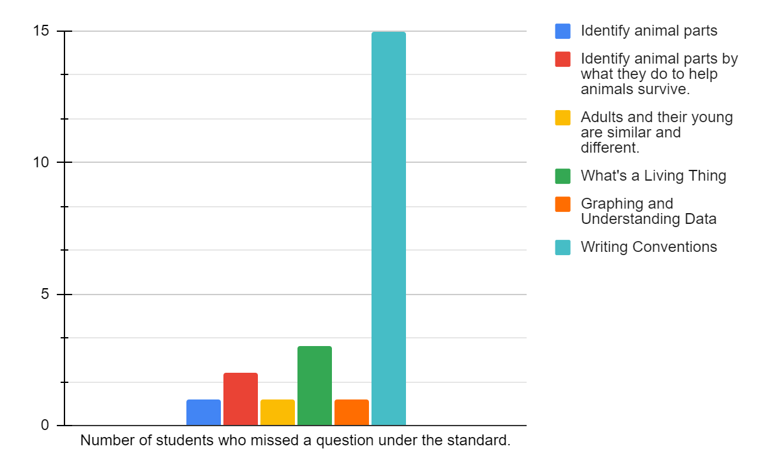

Reflective Essay
Contemplating how my Student Teaching experience has gone and reflecting on my growth as a teacher, and as a person, is something I have taken time to focus on throughout this semester in my Student Teaching Journal. Despite the complications of working in a school during a pandemic, losing a family member, and awaiting news on a possible cross country move, I can say without hesitation that this experience has been one of the most rewarding and enlightening of my life. Not to say that every lesson I taught went perfectly or that every interaction I had with a student or colleague turned out seamless, but that every day, no matter the events or outcome, I felt like I was thriving being a real teacher. I took constructive comments from my mentor teacher, my supervisor, and myself to dissect and understand the type of teacher I am and the type of teacher I can be with some thoughtful reflection and intentional practice and realized that there is genuinely nothing else on this earth I’d rather do. This semester has been hard, both emotionally and physically. The heaviness of grief, the fear of change, the stress of a degree giving or taking Capstone, the mental rigamarole of trying to stay healthy and happy in a world just getting its feet back underneath it took its toll on many of us, but no matter what, I showed up to school every day with a fire in my heart and a goal in mind.
I had the opportunity of teaching with Mrs. Preusse for my first practicum in the spring of 2020 and was invited to join her once more in the spring of 2021 for my Student Teaching. I had to think about the pros and cons of accepting her offer as it meant I wouldn’t have the chance to observe and practice under a school and teacher I’d never met before. However, after thinking about the implications of teaching during a pandemic, I decided I would really like the opportunity to teach alongside a teacher I was already comfortable with and who already knew who I was as a teacher. To me, returning to Mrs. Preusse was a wonderful way to forgo the beginning awkwardness of meeting a new teacher, learning their teaching style and classroom procedures, and reassuring them that you really weren’t there to mess up their classroom rhythm. Mrs. Preusse and I knew each other, and knew we worked well together. She and I agreed that our chemistry meshed well, that we were both comfortable giving and receiving feedback to each other, and that I would be able to push myself as a teacher under her guidance and provided freedoms. Having already taught alongside Mrs. Preusse, she was happy to pass responsibilities to me very early on in this Student Teaching experience which has given me much more time to grow and learn.
Comparing my experience with this unit plan to the student learning cycle I can safely say I started with “planning”. I looked at the standards necessary for this unit, then decided what I wanted my students to be able to accomplish by the end of it. Once I had created my unit summative assessment, I worked backwards and puzzled together the order the lessons should occur. This took a lot of juggling around because by this time I was already having lots of ideas of how to effectively teach these lessons in engaging ways. Finding the perfect order in which to spiral off was important to me. After I had a plan, I felt good about, I went onto gathering texts that would support my planning as well as their learning throughout the unit and thought up big questions and topics that would provide my students with the most. Then, of course, I planned my lessons.
I moved on to the “engage” stage of the learning cycle once I began teaching my students the unit. Some different things I incorporated into my lesson plans to engage my students was the use of technology, drawing, talking, writing, reading, math, social study standards, helping others around the world, science experiments, indoor and outdoor experiences, tangible learning experiences with their own stuffed animals, inquiry-based techniques, PBL final project, as well as KWL Charts that were done both independent and as a whole group. My students were exposed to a plethora of opportunities that were unique and tapped on different subjects throughout.
I was in the “monitor” stage from the moment I started teaching. I assessed student understanding from the start with their pre-assessment and their individual KWL Charts. I monitored their progress with their mid lesson assessments and their formative assessments, and I was able to see their final growth when I compared their pre and post assessments.
I also found myself in the “adjust” stage repeatedly in this whole unit. For instance, for my three kiddos who struggle with writing, I quickly adjusted how I was going to support them for assessments that involved writing by pulling them into a small group and scribing for them to trace while talking about why I put a period where I did and “circle the capitals in the sentence when you’re done.” I adjusted when my students weren’t understanding, and I altered course when they were faster to understand an idea than I had anticipated. I adapted to ensure my lessons went smoothly and to make sure my students were receiving the best I could give them.
This is just the overarching learning cycle; however, I’d argue that I ran through this cycle many times during my unit, just on a smaller scale. For example, I would assess my students’ understanding of the last lesson, adjust as needed to support or challenge my learners, plan accordingly, then engage them with my new ideas, just to start all over again!
This unit both went as I expected and didn’t. I had believed my students would strive and learn a lot about animals, and they did, but I thought my assessments would be more challenging than some of them ended up being. Being a teacher in my own classroom someday, I will know my students' abilities more intimately and will be able to create valid assessments that challenges them as well as show me what they do and don’t understand. I can say with great understanding that some of my assessment goals and rubrics were far too easy. I was able to assess that they did know the information we were working towards, which is valuable, but I could have gotten more out of them and stretched their minds more if my target goals were a bit higher. I am going to continue learning about assessment as I grow as a teacher and by researching best practices to create the best assessments I can.

Quality Teacher Standards
Quality Standard 1: Teachers develop and implement lessons that connect to a variety of content areas/disciplines and emphasize literacy and mathematics.

This unit was all about the animal science standards for first grade, so every lesson revolved around the three science standards in this content area. That being said, I included a variety of different subjects throughout including, math, reading and writing, and social studies.
I implemented math standards into this science unit to support the graphing unit we were working on in our math block at that time. In lesson four of my unit, students were able to see me represent and talk about data from an experiment, then had two opportunities to practice graphing and understanding the data with varying levels of support so they really could get the hang of graphing. They benefited from using these math skills in our science lessons and came to understand the trend and tether between science and math.
In lesson one of this unit, I had my students work towards practicing better writing conventions. They were focused on using correct capitalization, punctuation, and made sure to tap out unknown words to practice their spelling. There were many opportunities for me to model tapping out unknown spellings myself throughout this unit. They had multiple opportunities to work towards their writing conventions throughout this unit. In this unit students wrote on personal KWL charts, for lesson one's assignment, on their Venn diagrams, in multiple extension activities, as well as in mid lesson assessments with written “I notice...” and “I wonder…” statements. In addition to writing standards, we also practiced reading skills with our read alouds and read alongs. I provided all read alouds so every student could follow along as I read, and they were asked to read aloud as well with texts more age appropriate for each student.
As a theme through my unit, we started each lesson by opening the Science Kids’ Mailbox slide show. In the mailbox we would receive a letter from students all around the world asking for my kids help understanding an animal concept or help solving a problem. This theme is seeded in social studies and included standards about geography, culture, as well as creating solutions to help people around the world and in their community. Students were kept in the mindset of learning with a goal of helping others and were enthusiastic to be able to use what they learned to teach others. The slide show starts with the outside of an envelope with the name of the sender, the name of the country they live in, and a real stamp from that country that has an animal that is important to that country. I asked my students why they think this animal is important to that country. The next slide is a kid friendly map of the world with animals from each region included. On this slide I ask my kiddos where they think our new friends' country is. Then I show them the country and ask them what animals live there based on the map. I also asked what they thought the weather was like there and if anyone’s been there or knows anything about it. It is important to me that my students get to help widen other kids' understanding with their own experiences and knowledge.

Quality Standard 2: Teachers engage students as individuals, including those with diverse needs and interests, across a range of ability levels by adapting their teaching for the benefit of all students.

During this three-week unit I adapted my teaching, activities, mid lesson assessments, modifications, and more to make sure all my students were supported and inspired to do their best learning. The following are some examples of this.
We started a whole class KWL chart on the very first day of the unit and we used it all the way through to the day of the post- assessment. Not only did we have the whole class KWL chart, but they were given opportunities to fill in their own occasionally as we went. By using the KWL chart throughout the unit, I gave students the opportunity to express their understanding and any questions they had. This gave students the chance to talk about the inquiries they had about animals and to hone into their own interests in the subject. KWL charts are wonderful because they provide the teacher with an understanding of where your students are at and where you may need to give extra support as well as helps you understand where the students’ interests lay. On their personal KWL charts, they could write or draw. This made sure that students at all levels could express their understanding and questions in some way. For my few students who did draw on their KWL charts, I made sure to go to them when they were finished and had them tell me orally what they added to their chart.
I also adapted and modified lessons and assessments as we went to ensure my kiddos were engaged and participating. One adaptation that I made during the very first lesson was that I would pull my students who needed extra support to the back table to double explain the expectations for the assessments and monitor their progress or for spots of confusion more closely. This allowed them to have the extra help they needed to really showcase what they knew instead of getting stuck and giving up because they didn’t know what they were doing, or I didn’t get to them quick enough. They are brilliant students; they just needed a little help showing it and having our little group sitting together really gave them the confidence to ask questions and talk through what they were thinking with me more freely because they were facing away from the other kiddos and could see their group mates trying hard as well.
Another adaptation I made that I feel particularly pleased with was in my fifth lesson. In my original lesson plan for lesson five, I had decided to have students turn in their planning sheets for me to assess their understanding. However, I didn’t end up collecting them because we were out of time, and I knew most of them didn’t have their name on. Bad planning on my part, I know, but because I missed this opportunity to assess their plan sheets I came up with a different idea. The next day, I pulled each student to the back table for a quick conference. I took notes on their ideas, misconceptions, as well as areas they may be confused on regarding the project we were working on. I was able to see and hear what my students' ideas were and they got to practice answering the three questions they were going to answer for me and the video camera. This adaptation was far more enlightening and valuable than what I had planned originally for a mid-lesson assessment. I will definitely be using conferences more often, especially when it comes to larger projects.
I included a social studies theme throughout my unit that taught kids about different cultures and encouraged students to think of ways they could help people all around the world. In this unit we read the book “Winter’s Tail” by J. Hatkoff about a dolphin who lost her tail when she got caught up in some fishing net. This prompted a very valuable discussion I hadn’t expected about people and animals with disabilities and diversities and how they are just like us and deserve to be treated as such. I’ll admit, it was a hard concept for some students to grasp but I’m glad they were exposed to it in this unit in a positive and appropriate way. It came up a few times. One of our Science Kid Mailbox letters was from a little girl in Russia named Zasha and the picture of her was of her in her wheelchair. This brought the kids back to thinking about the fact that some people look different or need different things than we do and that is okay. We should be nice and treat everyone with respect. This was a topic I thought was important to talk about because a few of my boys commented on how “weird” Zasha looked and I knew that we had to introduce them to more people who were not just like themselves to teach them empathy and kindness.

Quality Standard 4: Teachers link professional growth to their professional goals.

A goal of mine since the start of my student teaching was to better my time management skills in lessons. I’ve struggled to keep my lessons short enough to finish in the allotted time and I really wanted to focus in and see what kind of growth I could attain during this experience. Having good time management in teaching is very important, it keeps students engaged in the flow and keeps lessons from being chopped off at the knees. It also ensures that you have thought through your semester so that you can teach all the standards that are needed and that you’ve provided enough time to each standard to teach them effectively.
I was given a unique opportunity to teach a very simple unit in three weeks (“simple unit” as in there are only three standards in the CDE for it). This meant that I had a lot of time to have my students explore and delve into the content in different ways. I took this flexibility as my opportunity to learn and grow in my time management skills. I believe I learned something valuable about myself as a teacher and the importance of buffer days.
When I was planning out my unit, I intentionally built in three buffer days. These three days were implemented to be used to complete assignments that took longer than anticipated, to let students explore and investigate questions of their own about animals, as well as allowed me to pull small groups to target areas of growth for them. Having these three buffer days really helped me feel at ease while teaching since I knew that if I had bitten off more than I could chew for a specific lesson, I wouldn’t be d-railing my entire unit. It also helped me feel like a more effective teacher because I was able to focus in on my student’s needs whether that be extra support or a bigger challenge.
I learned that I really appreciate the flexibility built in buffer days gives you as a teacher while also providing your students time for real exploration into their own interests around the subject. This feels like professional growth for me because I was under the impression that every day had to be filled to the brim with activities when the act of allowing flexibility and buffer days in your unit is far more helpful and effective for me as a teacher. Being a flexible teacher who can give her students time to practice their own genius is by far one of my top goals, and this experience has helped me work towards becoming the teacher who can provide that type of learning environment.

