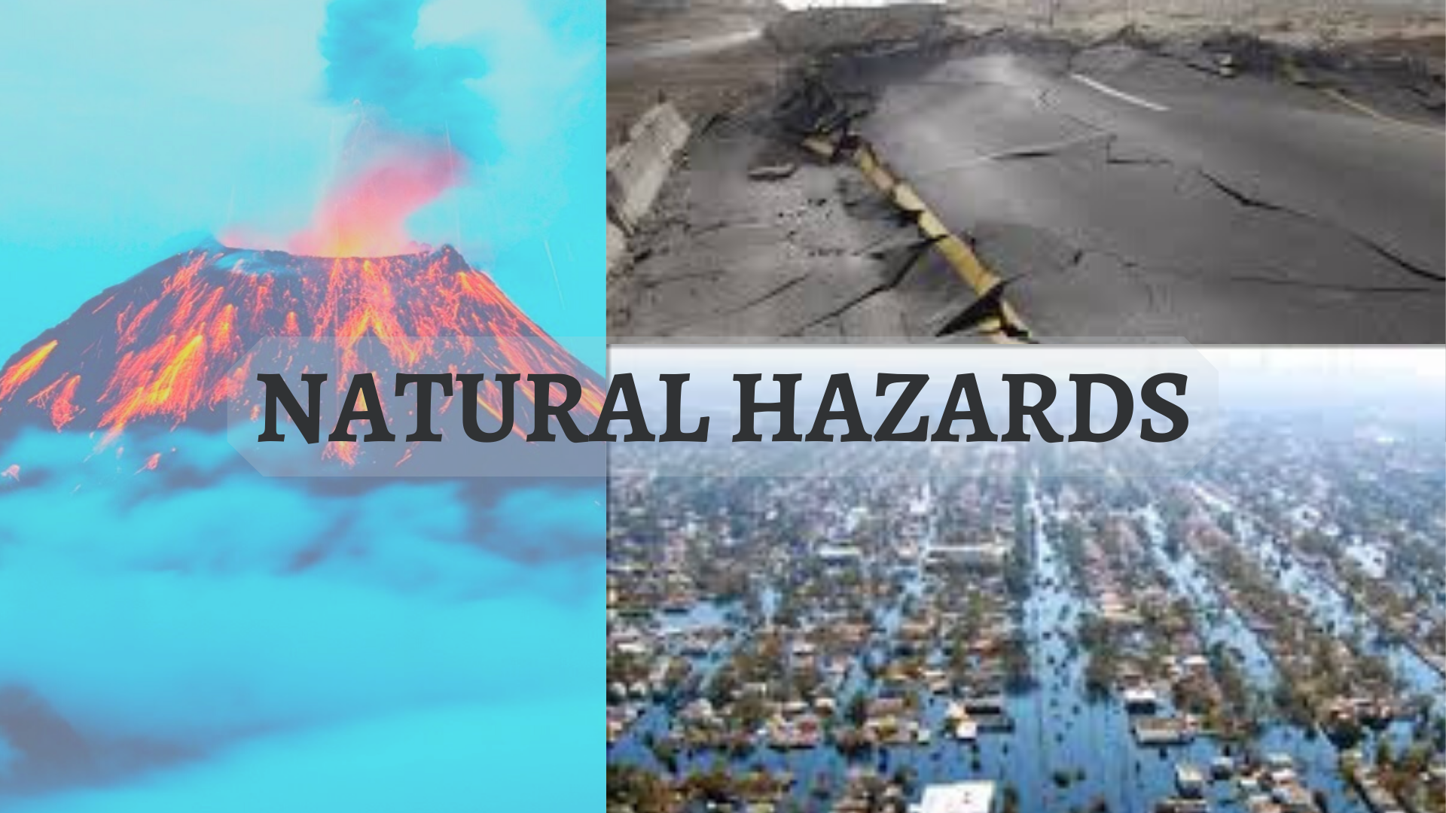

Natural Hazards and their Impacts
4th Grade
XXX
XXX
Dates: March 4th-April 3rd
Blue Mountain Elementary
St. Vrain Valley School District

Table of Contents-

Rationale Statement | pg. 3
Introduction | pg. 3
Community, School, and Classroom Setting | pg.3
Meeting the Colorado Model Content Standards  Science  Reading, Writing, and Communicating  Math | pg. 6  pg. 6  pg. 7  pg. 7
Assessing Student Learning | pg. 8
Unit Goal | pg. 11
Lesson Plans  Lesson 1: Earthquakes  Lesson 2: Volcanoes  Lesson 3: Floods  Lesson 4: Creating and Understanding Graphs  Lesson 5: Brochures | pg. 12  pg. 12  pg. 16  pg. 23  pg. 26  pg. 30
Extension, Modification & Adaptive Activities | pg. 33
Instructing Students and Supporting Learning | pg. 35
Resources Used | pg. 38
Evaluative Essay | pg. 42
Reflective Essay | pg. 45

Rationale Statement-
Introduction:

When choosing a topic for my Capstone, science became an instant forerunner. Although at Blue Mountain classroom teachers do not teach science, it was clear my students wanted more knowledge in this area. At the time I was planning, the science fair committee decided that students could not submit earth science projects. My students were incredibly upset so I decided to use this unit as an opportunity to teach earth science concepts. Aside from academics, students in our class were having behavior difficulties. I wanted to also use this unit to integrate time for students to practice collaboration, problem solving, and empathy.

Lesson 1: The ReadyGen Unit taught before my capstone was literature all about earthquakes. Using one lesson in my capstone about earthquakes allowed me to dive deeper into the concepts since my students already had the necessary background knowledge. I wanted students to be problem solvers in coming up with a strong earthquake resistant building, as well as collaborate with their kindergarten buddies.

Lesson 2: There are a lot of different aspects of Volcanoes that are interesting and engaging. I wanted students to be able to access all this information, so I chose to do 6 stations that focused on creation, parts, types, impacts, and solutions.

Lesson 3: I also wanted to bring relevance into my unit. Since Blue Mountain is in Longmont, I took the opportunity to educate the students on the 2013 Longmont Floods. I used primary resources to help students gain real empathy and understanding of the event.

Lesson 4: In my capstone I wanted to tie in ideas and curriculum that would mirror and accentuate what the students were learning in other subjects. As we were preparing for CMAS my mentor teacher expressed she wanted the students to get more practice with graphing. I figured graphing is also a great way for students to visualize the impact natural hazards can have.

Lesson 5: I believe project-based learning and assessment is a great way to keep students engaged and present them with a unique way to present their knowledge. Creating brochures allowed for me to provide structure but still provided students with space to be creative.

Community, School, and Classroom Setting:

Blue Mountain Elementary is in the Meadow Mountain Neighborhood in Longmont. The average household income based on the zip code that the school is in is $125,500. Most of my students have one stay-at-home parent and one or more siblings. All my students have access to the internet at home, and most have their own personal devices (phones or tablets). Students often walk, bike, or skateboard to school.

Blue Mountain was opened in 2008, making it 12 years old. There have been renovations since to help support the increase in students seen in the last few years. The school focus is science, technology, and inquiry. One big difference I see at Blue Mountain opposed to other schools is their take on science. For most of the year, classroom teachers do not teach science as a core subject. Instead, students attend science class for an hour once a week. Teachers will then supplement the science instruction in the class as it pertains to their other curriculum. Blue Mountain also has a whole school movement every day from 9:55-10:15. Classrooms are on a rotating schedule which has them “moving” around different parts of the school each day. Finally, Blue Mountain is a green star school. Each classroom has a compost and kids can join the extracurricular green team. This is where students can learn about how to help our planet and plan ways to implement “green practices” in the school.

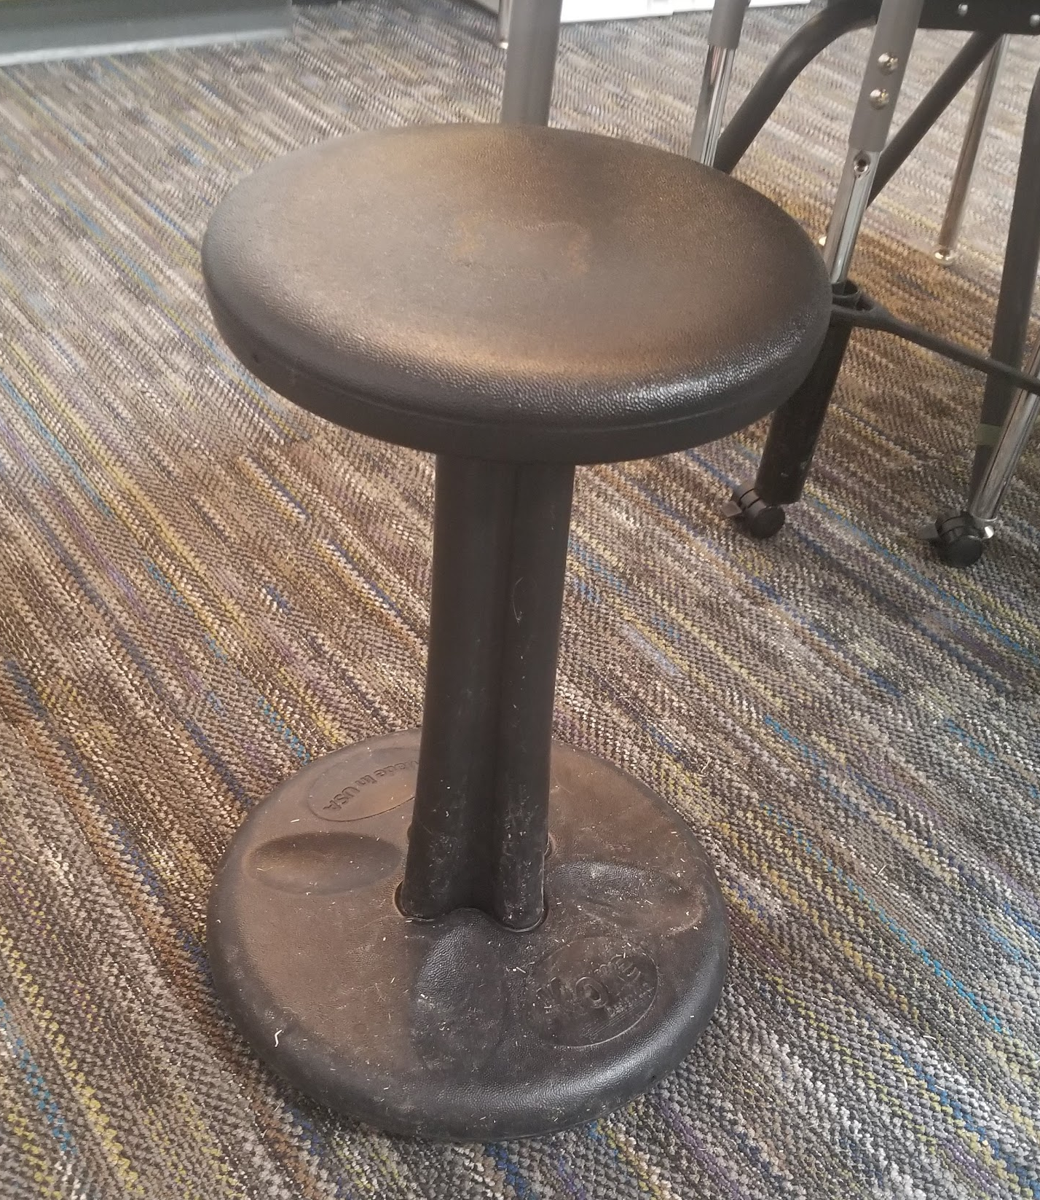
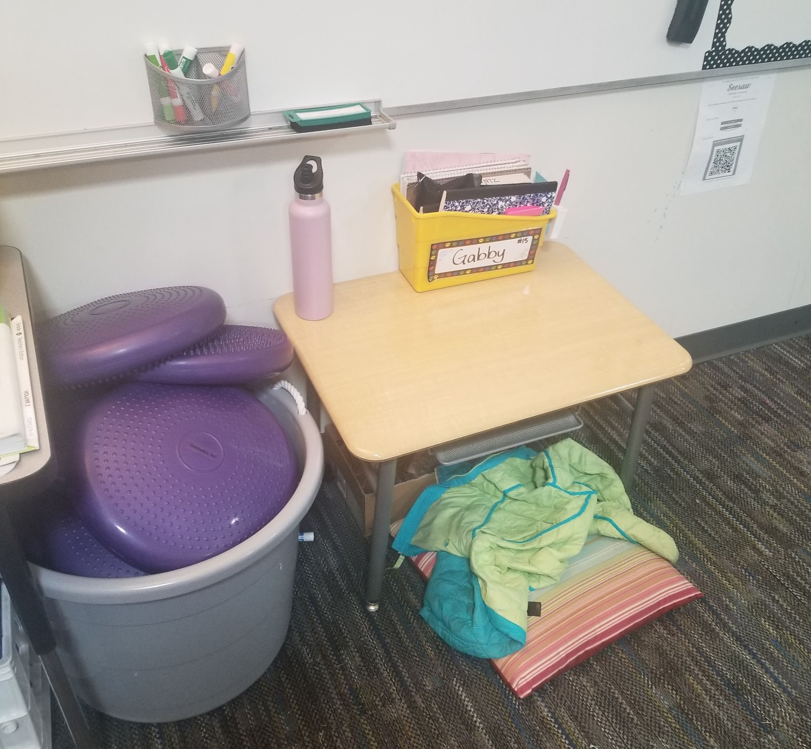
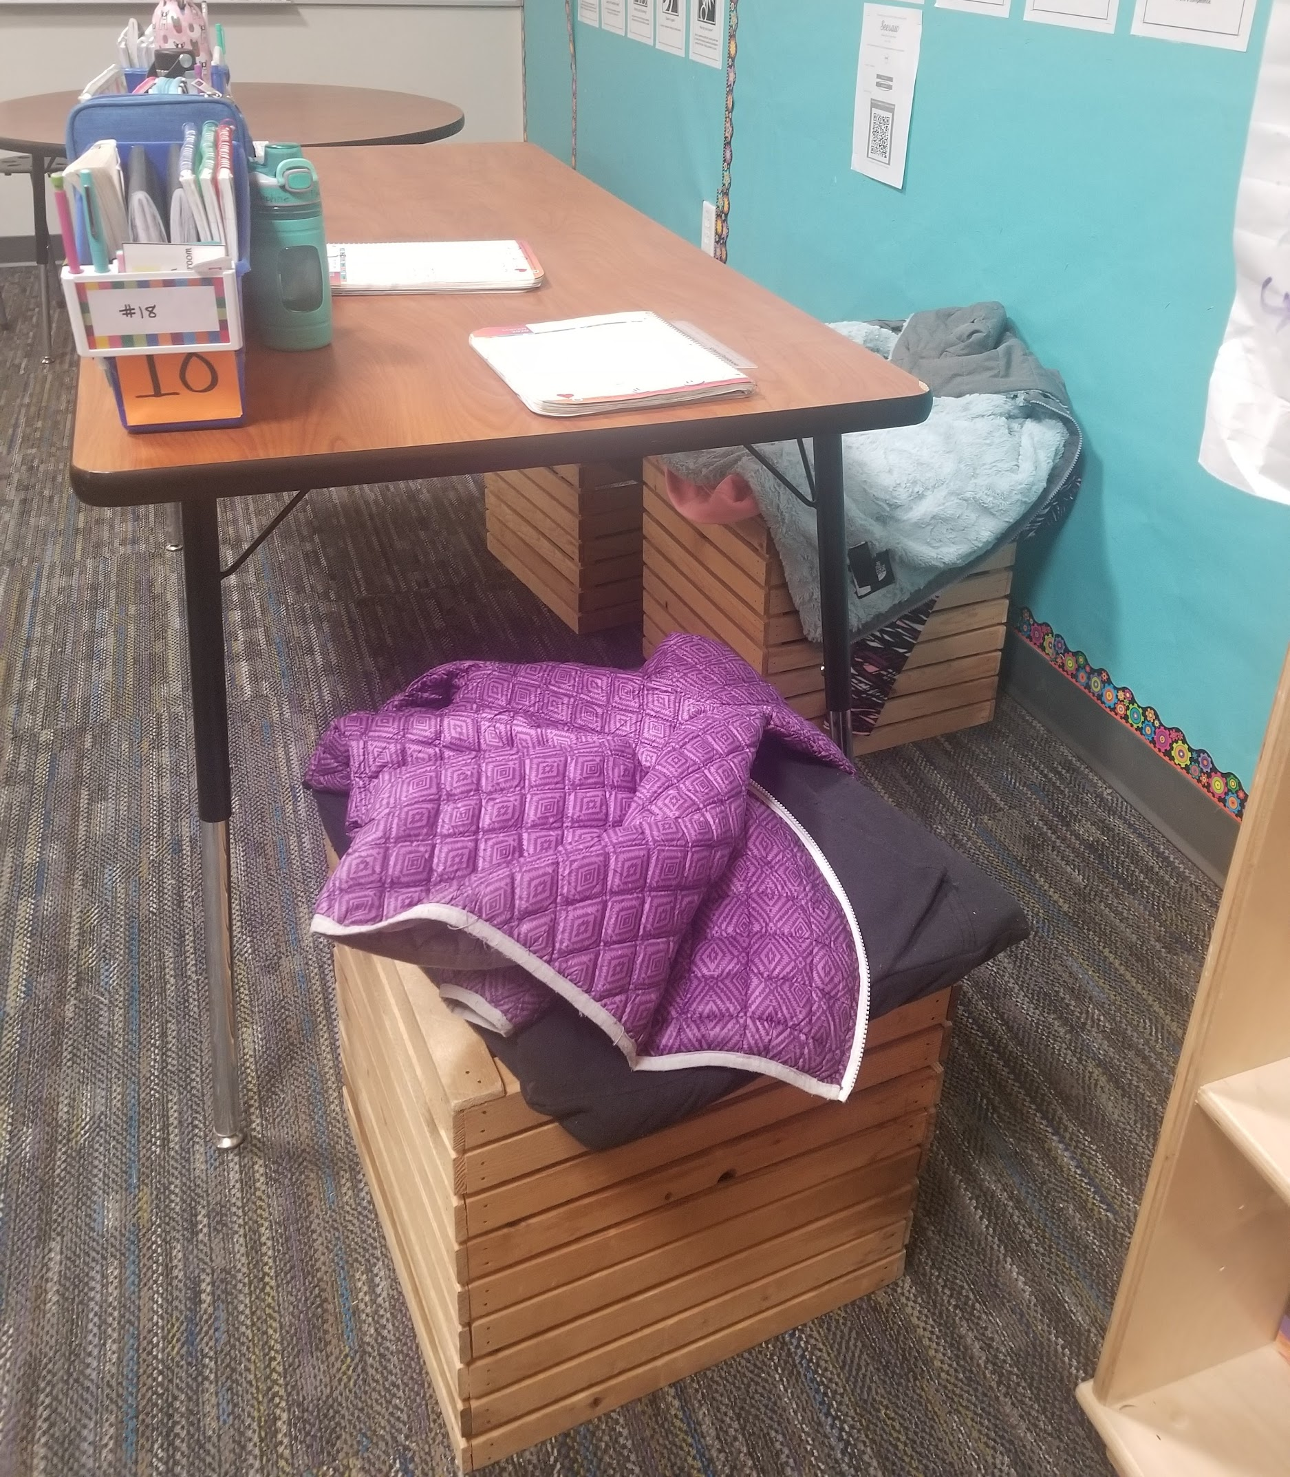
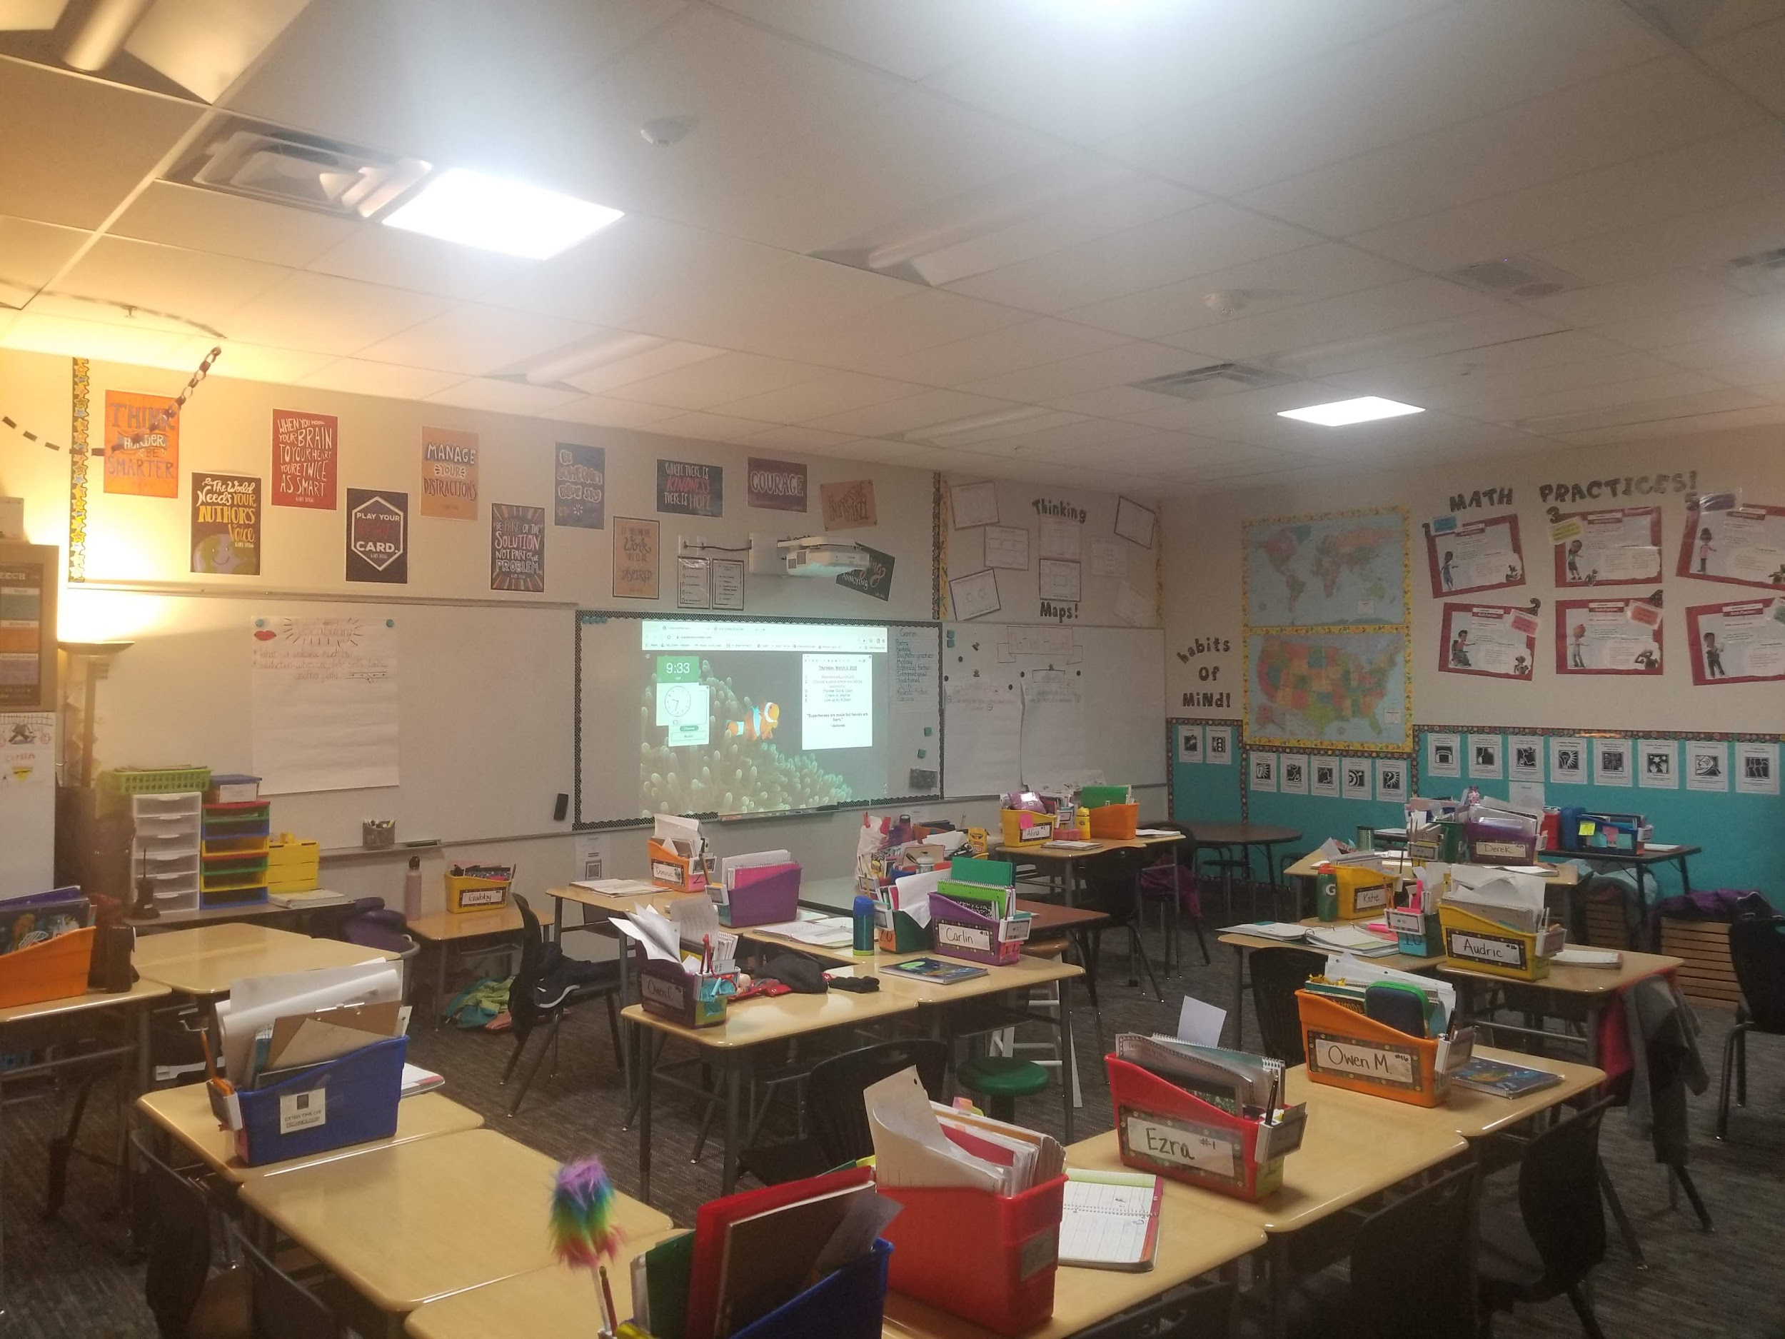
My class was comprised of 29 students. We have a male heavy class with 18 males and 11 females. Our class was divided heavily in this aspect, boys only liked sitting with boys and girls only liked sitting with girls. I had families from France, China, Singapore, India, and Japan. Languages spoken by my students are French, Chinese, Japanese, Hindi, and Telugu. Although only one student is considered an ELL and is receiving support. I had 3 IEP’s and 2 504 plans. We also had one student with severe trauma considerations after the death of a parent right before winter break. Included below are pictures of what the classroom arrangement looked like for 3 out of 5 of my lessons. It is important to note that the “classroom setting” for the last two lessons was the students' own home due to the closure of schools for COVID-19. In the classroom students have access to flexible seating which includes choosing their spot for the day and a variety of chair options (normal chairs, stools, crates, wobble stools). The technology available for my class varied from day to day. We had 10 iPads to our class, but it is not uncommon for teachers to ask to borrow each other's iPads to make a class set. The four 4th grade classes share one Chromebook cart which can be reserved. Going into my capstone, I also had some behavior concerns. Students had very little respect or empathy for one another, especially between genders. There were a handful of students who could spiral the entire class with little effort. Students who enjoyed arguing and making others upset. We also experienced some bullying.

Meeting the Colorado Model Content Standards:

Science-
Standard: 4) Fourth Grade 3) Earth and Space Science 5) A variety of hazards result from natural processes; humans cannot eliminate natural hazards but can reduce their impacts’ effect.

Objectives:

Students will demonstrate how to help reduce the effects of earthquakes as measured by writing two reflective statements on an exit ticket after attempting to build earthquake-resistant buildings.
Volcano Stations objectives:
- Station 1- Students will explain how volcanoes are formed as measured by placing steps in correct numerical order
- Station 2- Students will identify the parts of a volcano as measured by labeling 10 pieces a volcano diagram with 80% accuracy
- Station 3- Students will summarize the effects volcanoes have on humans as measured by 3 accurate details included in a paragraph
- Station 4- Students will analyze how different strategies are used to reduce the impacts of volcanic eruptions on humans as measured by creating an evacuation plan with at least 4 steps
- Station5- Students will compare famous volcanic eruptions and their effects as measured by completing a written T-chart with 4 comments in each of the sections.
- Station 6- Students will identify four types of volcanoes by filling out a characteristic chart for each type with 3 details in each
Students will identify in a brochure three natural hazards, provide 3 details about each, and create a solution to help reduce the impacts of one natural hazard as scored on a rubric.

Reading, Writing, and Communicating-
Standard: 4)Fourth Grade 3) Writing and Composition 2) Write informative/explanatory texts using text structures appropriate for the purpose and developed through facts, definitions, concrete details, precise language, and domain-specific vocabulary.
Objective: Students will create a self-designed, informative brochure including 6 out of 8 text feature components.

Standard: 4) Fourth Grade 4) Research Inquiry and Design 1b) Recall relevant information from experiences or gather relevant information from print and digital sources
Objective: Students will demonstrate knowledge of how floods happen and how the 2013 Colorado Floods impacted the area we live in now as measured by making an informational PowerPoint slide that includes 5 facts about the Longmont floods.

Math-
Standard: 4) Fourth Grade, Standard 3. Data, Statistics, and Probability b) Measurement & Data: Represent and interpret data
Objective: Students will represent data related to natural hazards as measured by creating a graph that contains 4/6 key aspects of a graph and 2 true statements about the data shown

Assessing Student Learning:

Pre-assessment:
My pre assessment will be a given as a google form. Students will be required to submit their student number and then answer the 11 questions. The google form answers are linked to an excel spreadsheet where I can see all their answers. Students will be graded out of 20 points.

Questions and Rubric: (Questions appear on the google form exactly as they do here)
Question: | Points:
Name 3 natural hazards | 1 point awarded for every natural hazard named (max 3)
How can we reduce the effects of earthquakes? | 1 point awarded for providing one realistic way humans can reduce the effects of an earthquake
What steps create a volcano? | 4 points awarded for choosing all 4 correct answers  3 points awarded for choosing 3-4 correct answers and 0-1 incorrect answer  2 points awarded for choosing 2-3 correct answers and 0-2 incorrect answers  1 point awarded for choosing 1-2 correct answers and 0-2 incorrect answers  0 points awarded for choosing all the answers or 0 correct answers
Name 5 parts of a volcano | 3 points awarded for naming 4 or more parts  2 points awarded for naming 3 parts  1 point awarded for naming 1-2 parts  0 points awarded for not naming any parts
List one effect a volcano has on humans | 1 point awarded for providing one realistic way humans are affected by Volcanoes
List one strategy used to reduce the effects of a volcano | 1 point awarded for providing one realistic way humans can reduce the effects of a volcano
Name one famous volcano and a fact about it | 2 points awarded for naming a famous volcano and 1 fact about it  1 point awarded for naming a famous volcano  0 points awarded for not naming a famous volcano and 1 fact about it
Name two different types of volcanoes | 1 point awarded for naming 1 or more type of volcano  0 points awarded for not naming a type of volcano
What natural hazard occurred in Longmont in 2013? | 1 point awarded for naming “flood”  0 points awarded for anything else
Name two important features to include on a graph | 1 point awarded for naming 1 or more  0 points awarded for not naming one
Name three text features used in a brochure | 2 points awarded for naming 2 or more features  1 point awarded for naming 1 feature  0 points awarded for not naming a feature
Total: | /20 points

Link to Google Sheet where data will be tracked and graded: https://docs.google.com/spreadsheets/d/1RlRvrE8RHyB4RI4YR7FdXvQfPkxCNUUpY3UQt7Oh3V0/edit?usp=sharing

Formative Assessment:
Earthquake Lesson-
- Students brainstorm everything they know about earthquakes on sticky notes and add them to our anchor chart with names on back
- Ms. Kuntz tracks student participation in ways of tally marks during lesson
- Teacher circulates and quickly reads students notes, may read aloud, or reiterate key details students have already written down
- Teacher asks students to explain the thinking and design behind their building models before they are allowed to build to ensure they are on the right track
- Students reflect on an exit ticket at the end of the lesson
Volcano Lesson-
- Teachers facilitate discussions with students when they arrive at their station asking students to rephrase what they have learned so far
- Students turn in packets after the first half of rotations so teacher can skim through and find any misconceptions students might have and address after lunch before the rest of the rotations
- Students brainstorm everything they learned about volcanoes on sticky notes and add them to our anchor chart with names on back
Flood Lesson-
- 1 on 1 conference with each student during their research time (twice). Given a 1,2,3 based on their engagement level on the task.
- Students brainstorm everything they learned about floods on sticky notes and add them to our anchor chart with names on back
- PowerPoint slides are graded based on rubric
Creating and Understand Graphs Lesson-
- Students brainstorm what they already know about graphs and post onto Seesaw
- Students create their own graph
- Students comment on classmates’ posts explaining what they learned
- Students fill out exit ticket (as a google form) after the lesson
Creating a Brochure Lesson-
- Students post on a padlet what they remember about our 3 natural hazards and make connections to other students
- I check in with students during zoom conferencing on their progress and answer any questions
- Students fill out exit ticket (as a google form) after the lesson

Summative Assessment:
I had two summative assessments for this unit
- Students create an informative brochure summing up the information learned about natural hazards and create an impact solution
- Students take their post assessment test. Questions and rubrics are the same as the pre-test.
Link to Google Sheet where data will be tracked and graded: https://docs.google.com/spreadsheets/d/1ILPTI_UNJYILk7dY9YIyrHAiVrtGOlT5LaRkQ4rXYvM/edit?usp=sharing

Unit Goal-

There are three main areas of focus for my students to learn about this capstone. First, the natural hazards. Students will learn about earthquakes, volcanoes, and floods. Students will not learn the same exact thing for each one due to previous background knowledge and relevance. Second, creating and understanding graphs. Students will learn to represent data pertaining to natural hazards. Finally, students will learn how to show everything they have learned in a brochure format.

Students will engage in several different activities to learn. For each lesson students will be adding to our class anchor charts to use as a reference later when creating their brochure. Students will engage in hands-on activities that often require teamwork and collaboration. Such as creating an evacuation plan or designing and building an earthquake safe building. Students will be required to do their own research in which best technology practices will be expected. Students will listen to presentations and examine primary resources. Students will also engage in online discussions with classmates.

Lesson Plans
Lesson 1: Earthquakes
ACADEMIC STANDARDS
4) Fourth Grade 3) Earth and Space Science 5) A variety of hazards result from natural processes; humans cannot eliminate natural hazards but can reduce their impacts’ effect.
SPECIFIC OBJECTIVES TO ATTAIN LEARNING GOALS
Students will demonstrate how to help reduce the effects of earthquakes as measured by writing two reflective statements on an exit ticket after attempting to build earthquake-resistant buildings.
MATERIALS NEEDED
- Popsicle sticks
- Duct tape
- Scissors
- A prototype cart
- Spaghetti
- Marshmallows
- Printed articles
- Earthquake packets
- Writing utensils
MOTIVATIONAL TECHNIQUES
As a class, we will read our learning target for the day. “I can demonstrate how to help reduce the effects of an Earthquake by creating earthquake-resistant buildings and reflecting” Students will be asked to recall information they already know about earthquakes. Students will have time to add sticky notes to our anchor charts- “Earthquakes-Main Ideas/ Details” (students will put their name on the back of sticky note). Teacher will review what was put onto the posters quickly with the whole class
PROCEDURES FOR LESSON
- Ask students why they think Earthquake resistant buildings are important
- Pass Out “Earthquake Packet”
- As a class watch- How we design buildings to survive earthquakes and Why are triangles strong
  - Remind students of the toothpick and gumdrop experiment they did with their kindergarten buddies, ask what made the structure strong enough to hold the textbook
  - Students should take notes on the first page of their packet- whatever they think will be helpful when they go to build their houses (Teacher may model)
- Students will then have time to research methods and figure out what they want to do. They can do online research, and I will also have some printed articles that they can use as well
- When students are done researching, they should fill out page two of their packet- drawing their model and listing the materials they will need
  - Buildings need to be at least 3 stories high
- Students will be allowed to start creating their design in the classroom (10-15 minutes)
- Students will move to the Design Den and meet up with kindergarten class
  - Kinders will have their buddies’ names signs so finding each other is quick and efficient
- Teacher will inform Kinders what we are learning about and explain how they will be building an earthquake-safe building with their buddies
- Students will have work time to build (10-15 minutes)
  - They should explain to their buddy why they made the decisions they did first
  - Kinders are required to add on one aspect to the building
- Buildings will be tested on the Earthquake table
  - Students will record how long (in seconds) their building lasted. (Max time allowed will be 30 seconds)
CLOSURE
Students will reread I can statement, reminding them of what their goal for this lesson was. Have a few students share what they learned about how to help reduce the effects of earthquakes.
- Ask student #2 (who wants to be an architect) if he thinks he will ever want to build in an Earthquake zone
HOMEWORK/ASSIGNMENTS/EXTENSION ACTIVITIES
No Homework will be assigned
Extension- students can continue to research more about earthquake-resistant buildings and create a PowerPoint of their findings. Possible prompts for students to answer:
- Why do houses that are built along faults where earthquakes happen not have basements?
- What technique of building earthquake-resistant buildings is the most effective? Why?
ASSESSMENT
Students brainstorm everything they know about earthquakes on sticky notes and add them to our anchor chart with names on back

Ms. Kuntz tracks student participation in ways of tally marks during lesson
Teacher circulates and quickly reads students notes, may read aloud, or reiterate key details students have already written down

Teacher asks students to explain the thinking and design behind their building models before they are allowed to build to ensure they are on the right track
Students will complete two reflective statements about their success or failure of their earthquake building with their Kinder buddy
https://docs.google.com/document/d/1-IAug792Vm7_DLQEg9e2okObV4vWn-b_FY7v_O6v-hE/edit?usp=sharing
Rubric:
✓- | Student only provides one statement or statements show misconceptions/ confusion of concepts
✓ | Student provides required two statements that show full understanding of concepts
✓+ | Student provides required two statements that show an in-depth understanding of concepts

ADAPTATIONS
- Writing -
  - Students can draw/sketch note notes
  - IEP students can have a partner or teacher scribe their thoughts on an exit ticket. They also can fill out the 2nd question only
- Dyslexia-
  - Student can opt into filling out their exit ticket on a google doc (Screens are easier to read) and use text to speech
- Trauma-
  - Student can leave and see the counselor at any time or take a quick break
- Movement-
  - If needed teacher can add it a quick movement break by having students do a 3-minute gallery walk to view others work
- Fine motor skills-
  - Availability of materials differed in size to cater to the fine motor skills of all students, including the kindergartners
RESOURCES
Base isolation facts for kids. (2020, March). Retrieved from https://kids.kiddle.co/Base_isolation

Earthquake. (2006, January). Retrieved from https://academickids.com/encyclopedia/index.php/Earthquakes

Gaur, S. (2015, April 28). Tips for Making Your Home Earthquake Resistant. Retrieved from https://www.proptiger.com/guide/post/tips-to-make-your-house-earthquake-resistant

How We Design Buildings To Survive Earthquakes. (2016). Retrieved from https://www.youtube.com/watch?v=c4fKBGsllZI

Tuned mass damper. (2005, June). Retrieved from https://academickids.com/encyclopedia/index.php/Tuned_mass_damper

Why Are Triangles Stronger Than Squares? (2016). Retrieved from https://www.youtube.com/watch?v=AoS0UvVfxRQ

Lesson 2: Volcanoes
ACADEMIC STANDARDS
4) Fourth Grade 3) Earth and Space Science 5) A variety of hazards result from natural processes; humans cannot eliminate natural hazards but can reduce their impacts’ effect.
SPECIFIC OBJECTIVES TO ATTAIN LEARNING GOALS
Station 1- Students will explain how volcanoes are formed as measured by placing steps in correct numerical order
Station 2- Students will identify the parts of a volcano as measured by labeling 10 pieces a volcano diagram with 80% accuracy
Station 3- Students will summarize the effects volcanoes have on humans as measured by 3 accurate details included in a paragraph
Station 4- Students will analyze how different strategies are used to reduce the impacts of volcanic eruptions on humans as measured by creating an evacuation plan with at least 4 steps
Station 5- Students will compare famous volcanic eruptions and their effects as measured by completing a written T-chart with 4 comments in each of the sections.
Station 6- Students will identify four types of volcanoes by filling out a characteristic chart for each type with 3 details in each
MATERIALS NEEDED
- Volcano packets (enough for each student)
- Chart paper
- Markers
- iPads
- Large construction paper

MOTIVATIONAL TECHNIQUES
Go over the I can statement for the lesson “I can identify the types, cause, and the effects of volcanoes” The teacher will go over stations and show where each one is. The teacher put groups and their members up on the board.

PROCEDURES FOR LESSON
*As students rotate through stations, they can add vocab words they might want to add to our word wall*
Station 1: How Volcanoes are formed (Ms. B)
- Students will watch this video: https://study.com/academy/lesson/how-are-volcanoes-formed-lesson-for-kids.html
- Students will create an anchor chart with teacher to explain the four major steps
- Students will complete page 1 of their packet

Station 2: Parts of a Volcano- Diagram (Mrs. K)
- Students will either take Diagram A or B and stand back-to-back
- Students will complete an “information gap” exercise where the goal is to get both diagrams completely full of vocab terms without ever looking at the other diagram. Students will have to communicate clearly to complete task
- After students think they have completed the diagram they will check their answers with each other
- Students will complete a full diagram in their packet (page 2)
Station 3: Effects on humans (5 iPad)
- Students will use iPads to log onto Schoology
- They will find the correct folder “Station #3- Effects on Humans”
- Students will read through the linked articles and take notes in their packet
- Students will write a paragraph with three details explaining how volcanoes affect humans
Station 4: Reducing Impacts
- Students will read the article at the station about diverting lava
- Students will use the Mt. Rainer packet to create a four-step safety plan for the people of Puyallup, WA.
- Students will write their safety plan out on construction paper.
Station 5: Famous Volcanoes (5 iPad)
- Students will log onto Schoology and find corresponding folder
- Students will pick 2 Volcanoes off the following list:
  - Mount Vesuvius
  - Krakatoa
  - Mount St. Helens
  - Eyjafjallajökull
  - Mount Pinatubo
  - Mount Etna
  - Mount Tambora
  - Mauna Loa
  - Augustine Volcano
  - Cotopaxi
  - Mayon
  - Nevado del Ruiz
- Students will research their two chosen Volcanoes
  - Students will fill out the T-Chart in their packet, including at least 4 facts about each volcano
Station 6: Types of Volcanoes
- Students will be assigned a type of Volcano
  - They will read about their type of volcano
  - Fill out their section of the chart
- When all students are done- they will jigsaw and teach each other
- Students should take notes in their packet- each type of volcano needs to have at least 3 characteristics
CLOSURE
Students will reread I can statement, reminding them of what their goal for this lesson was. Teacher will pull students back together for a class wide discussion. Some prompting questions:
- What is something new you learned today?
- What was your favorite station and why?
- Which station was the most difficult? Why?
Students will then add sticky notes to our anchor chart about what they learned, with their names on the back.
HOMEWORK/ASSIGNMENTS/EXTENSION ACTIVITIES
No homework will be given.
Overall extension: At any station students can add words to their vocab list to be added to the class word wall.
Station specific extensions:
- Station 1: Students can look up domain specific vocabulary to add to their explanations and add detailed pictures
- Stations 2: Students can add explanations to each part of the Volcano (i.e., what the vent does)
- Station 3: Students can research more effects or write another paragraph about which effect they think is the most detrimental
- Station 4: Students can add more steps to their plan or make several options for the evacuates
- Station 5: Students can research more that the required 2 volcanos
- Station 6: Students can add detailed pictures of each type of volcano
ASSESSMENT
Formative Assessment-
- Teachers facilitate discussions with students when they arrive at their station asking students to rephrase what they have learned so far
- Students turn in packets after the first half of rotations so teacher can skim through and find any misconceptions students might have and address after lunch before the rest of the rotations
- Students brainstorm everything they learned about volcanoes on sticky notes and add them to our anchor chart with names on back
Summative Assessment- Students will turn in their packets
Station | Assessment
#1 | 1 point for every correct step (4 points)
#2 | 4 points - 8/10 labels  3 points-6-7/10 labels  2 points- 4-5/ 10 labels  1 point - 0-3 labels
#3 | 4 points- a paragraph with 3 details (Writing IEP= 3 details)  3 points= a paragraph with 2 details  2 points = a paragraph with 1 detail  1 point = no paragraph
#4 | 1 point every completed phase (4 points)
#5 | 4 points = 2 volcanoes with 3 details each  3 points = 2 volcanoes with less than 3 details  2 points = only 1 volcano listed with 3 details  1 point= only 1 volcano listed with less than 3 details
#6 | 1 point for every completed type of Volcano (must have 4 accurate details)

ADAPTATIONS
- Writing -
  - Students can draw to accompany their thoughts
  - IEP students can have teachers scribe their thoughts. At station 3 students can write down details and do not need to write a full paragraph.
- Reading-
  - Group member can read aloud directions and articles instead of having students read silently
- Trauma-
  - Student can leave and see the counselor at any time or take a quick break
- Movement-
  - If needed, the teacher can add a quick movement break by having students do a specific movement between each station. i.e., students must hop on one foot to get to the next station
RESOURCES
Porter, R. (n.d.). Volcanic Eruption Safety Plan. Retrieved from https://www.teacherspayteachers.com/Product/Volcanic-Eruption-Safety-Plan--5075141
Made by me:
Volcano packet: https://docs.google.com/document/d/1qFxsJ96kAXnzhvw51W0dUdmkAhI6dvV7XwNFzMSk2Wk/edit
Mt. Rainier Eruption Safety Plan: https://docs.google.com/document/d/1jQOkxG3034_gG8ul82sVgTpyGF7r6d1HisqEwzagYjA/edit
Station Directions: https://docs.google.com/document/d/1uLgZhyNvLGUHcXNDlVprRF9UcHyTQacL2t0NVRM9yTY/edit?usp=sharing
Impacts:
Volcano World. (2020). Retrieved from http://volcano.oregonstate.edu/how-do-volcanoes-affect-people
National Geographic Society. (2012, October 9). Human and Environmental Impacts of Volcanic Ash. Retrieved from https://www.nationalgeographic.org/encyclopedia/human-environmental-impact-volcanic-ash/
Reduce the effects:
Brown, T. K. (2014, September 11). How do you stop the flow of lava? Retrieved from https://www.bbc.com/news/magazine-29136747
Lindsey Bever, N. K. (2014, November 4). Diverting lava: Everything you need to know. Retrieved from https://www.washingtonpost.com/news/morning-mix/wp/2014/11/04/ diverting-lava-everything-you-need-to-know/
Famous Volcanoes:
Augustine Volcano- Kiddle Encyclopedia. (2020, March). Augustine Volcano facts for kids. Retrieved from https://kids.kiddle.co/Augustine_Volcano
Cotopaxi - Kiddle Encyclopedia. (2020, March). Cotopaxi facts for kids. Retrieved from https://kids.kiddle.co/Cotopaxi
Eyjafjallajökull - Kiddle Encyclopedia. (2020, March). Eyjafjallajökull facts for kids. Retrieved from https://kids.kiddle.co/Eyjafjallajökull
Krakatoa Kiddle Encyclopedia. (2020, March). Krakatoa facts for kids. Retrieved from https://kids.kiddle.co/Krakatoa
Mount Vesuvius Kiddle Encyclopedia. (2020, March). Mount Vesuvius facts for kids. Retrieved from https://kids.kiddle.co/Mount_Vesuvius
Mount St. Helens - Kiddle Encyclopedia. (2020, March). Mount St. Helens facts for kids. Retrieved from https://kids.kiddle.co/Mount_St._Helens
Mount Pinatubo - Kiddle Encyclopedia. (2020, March). Mount Pinatubo facts for kids. Retrieved from https://kids.kiddle.co/Mount_Pinatubo
Mount Etna - Kiddle Encyclopedia. (2020, March). Mount Etna facts for kids. Retrieved from https://kids.kiddle.co/Mount_Etna
Mount Tambora - Kiddle Encyclopedia. (2020, March). Mount Tambora facts for kids. Retrieved from https://kids.kiddle.co/Mount_Tambora
Mauna Loa- Kiddle Encyclopedia. (2020, March). Mauna Loa facts for kids. Retrieved from https://kids.kiddle.co/Mauna_Loa
Mayon - Kiddle Encyclopedia. (2020, March). Mayon Volcano facts for kids. Retrieved from https://kids.kiddle.co/Mayon_Volcano
Nevado del Ruiz- Kiddle Encyclopedia. (2020, March). Nevado del Ruiz facts for kids. Retrieved from https://kids.kiddle.co/Nevado_del_Ruiz

Lesson 3: Floods
ACADEMIC STANDARDS
4) Fourth Grade 4) Research Inquiry and Design 1b) Recall relevant information from experiences or gather relevant information from print and digital sources
SPECIFIC OBJECTIVES TO ATTAIN LEARNING GOALS
Students will demonstrate knowledge of how the 2013 Colorado Floods impacted the area we live in now as measured by making an informational PowerPoint slide that includes 5 facts about the Longmont floods from use of primary sources and individual research.
MATERIALS NEEDED
- Projector
- Chromebooks
- Sticky notes
- Anchor chart
- Pencils
- Science notebook
MOTIVATIONAL TECHNIQUES
Students will complete a “knowledge dump” by recording everything they think they know about floods into their science notebook
As a class we will read I can statement “I can explain how the 2013 Colorado Flood impacted my community”
PROCEDURES FOR LESSON
- Students will watch a video on floods (https://www.youtube.com/watch?v=9hQZCiZ21fk&vl=en )
  - Have a discussion about how floods can be dangerous
- Mrs. Kuntz will give her “flood story”
- Mrs. McCroskey will do her presentation on the floods
- Teacher will facilitate discussion
  - How do you think Mrs. Kuntz and Mrs. McCroskey felt during the floods?
  - How do you think other people in our community might have felt during this time?
- Teacher will pull up PowerPoint slide: https://docs.google.com/presentation/d/1vmNv9LPDMZ6SkzY551sBRnFvFLop-gfXMCy98ATNyVU/edit?usp=sharing
- Teacher will explain that students will be doing their own research on the floods. They will need to find details about What, When, Where and 2 facts
  - Students will suggest what kind of information needed to be in each of those sections and teacher will type their responses into the box
- Teacher will present example on the Tennessee Tornadoes
- Students will be given time to do individual research on the Longmont Floods and complete their slides
CLOSURE
Students will reread I can statement, reminding them of what their goal for this lesson was
Students will then add sticky notes to our anchor chart about what they learned, with their names on the back.
HOMEWORK/ASSIGNMENTS/EXTENSION ACTIVITIES
No homework will be given
Extension-
- Students can turn research into paragraph
- Students can read other written primary accounts sent in by families/ community
ASSESSMENT
- 1 on 1 conference with each student during their research time (twice). Given a 0,1,2 based on their engagement level on the task.
- Students brainstorm everything they learned about floods on sticky notes and add them to our anchor chart with names on back
- PowerPoint slides are graded based on rubric:

1 | 2 | 3 | 4
Student includes 1-3 aspects with accurate information or 1-5 aspects with inaccurate information. | Student includes 4 aspects with accurate information. | Student includes all 5 aspects with accurate information. Includes at least 1 picture | Student includes all 5 aspects with accurate information. Includes at least 1 picture. Student goes above the expected by writing information in a paragraph form or includes more than the required 5 things.

ADAPTATIONS
- Writing -
  - Students can use speech-to-text function on Chromebook
- Trauma-
  - Student can leave and see the counselor at any time or take a quick break
- Movement-
  - Teacher can facilitate a pair-share where students move around the room to music until the music stops. When the music stops students find a partner near them and share the facts they have found so far. Can be repeated multiple times
RESOURCES
Floods - The Dr. Binocs Show. (2017). Retrieved from https://www.youtube.com/watch?v=9hQZCiZ21fk&vl=en
Primary Resources from parents and families
- Photos
- Videos
- Oral Presentations

City of Longmont, Colorado. (n.d.). 2013 Flood . Retrieved from https://www.longmontcolorado.gov/departments/departments-n-z/public-information/flood-information/recovery-updates

Lesson 4: Creating and Understanding Graphs
ACADEMIC STANDARDS
4) Fourth Grade, Standard 3. Data, Statistics, and Probability b) Measurement & Data: Represent and interpret data
SPECIFIC OBJECTIVES TO ATTAIN LEARNING GOALS
Students will represent data related to natural hazards as measured by creating a graph that contains 4/6 key aspects of a graph and 2 true statements about the data shown
MATERIALS NEEDED
- Device (iPad/Chromebook)
- Internet access
- Paper
- Pencil
MOTIVATIONAL TECHNIQUES
*Students will open up PowerPoint linked on Schoology, each step and direction are listed in PowerPoint Here
Students will read their learning objective for this lesson “I can create a graph with correct parts and understand the data represented”
Students will brainstorm everything they know about graphs. Students can make a list, brain web, or any other form that makes sense to them. Students should post a picture of their brainstorm on SeeSaw “Creating Graphs Brainstorm”
PROCEDURES FOR LESSON
- Students will look through the folder of graph mentor texts on google drive (linked on schoology)
- After looking through the graphs, students should ponder two main questions:
  - What aspects do all these graphs have in common?
  - What is different between all the graphs?
- Students will watch Video by Ms. B “Creating Graphs” (in PowerPoint)
  - Students are encouraged to take notes and draw along with me
- Students will then choose one of the files with data to make their own graphs (linked in schoology)
  - Students who might want to do their own research and find data can, but ideas must be approved by Ms. B first
  - Students will make two statements about what conclusions they came to from their data
  - Student will post their own graphs on SeeSaw
    - Students must respond to 2 other students commenting about what they learned

CLOSURE
Students will take exit ticket on Google form. The questions they answer are:
- What did you learn about graphs?
- Do you like making graphs?
Students will reread I can statement, reminding them of what their goal for this lesson was
HOMEWORK/ASSIGNMENTS/EXTENSION ACTIVITIES
No homework will be given
Extension-
- Students can do their own research and find data to graph
- Students can see if they can take the data used for their bar graph and represent it in the form of a different graph (i.e., line plot or pie chart)
ASSESSMENT
- Formative brainstorm post on Seesaw
- Exit ticket with open ended questions about what they learned
- Summative graph and statements:
Rubric:
Includes: | # Of points
A Title that makes sense with their graph | +1
An X-Axis | +1
A Y-Axis | +1
Labels on Axis | +1 per label (max 2)
Key that explains all elements | +1
Scale | +1 per axis (max 2)
Statement about data interpretation | +1 per true statements (max 2, 1 extra credit available)
Students then given a grade based on amount of points
- 1: 0-3 points
- 2: 4-6 points
- 3: 7-10 points
ADAPTATIONS
- Writing -
  - Parents or siblings can scribe for students
  - Students can use speech-to-text to type their brainstorm thoughts on Seesaw
  - Students can post a video explaining their graph and verbally saying what the title, labels, and statements would be instead of writing
- Dyslexia-
  - Student can write out exit ticket answers and send to Ms. B on Seesaw
- Trauma-
  - Extended time on assignment
- Reading-
  - Parents or siblings can read directions out loud to students
- Other-
  - Students can have zoom conference with Ms. B to ask questions and get clarification if needed

RESOURCES
FEMA. (n.d.). Data Visualization: Disaster Declarations for States and Counties. Retrieved from https://www.fema.gov/data-visualization-disaster-declarations-states-and-counties
GradeAmathhelp. (n.d.). X-Axis and Y-Axis: An Easy Trick to Remember them Forever. Retrieved from http://www.gradeamathhelp.com/x-axis-and-y-axis.html
Graphing. (n.d.). Retrieved from http://www2.nau.edu/lrm22/lessons/graph_tips/graph_tips.html

Lile, S. (2020). 44 Types of Graphs Perfect for Every Top Industry. Retrieved from https://visme.co/blog/types-of-graphs/
Oregon State University. (n.d.). Volcano World. Retrieved from http://volcano.oregonstate.edu/volcanoes_by_country
Oregon State University. (n.d.). Cost of Volcanic Eruptions. Retrieved from http://volcano.oregonstate.edu/cost-volcanic-eruptions
SMITHSONIAN INSTITUTION. (n.d.). Smithsonian / USGS Weekly Volcanic Activity Report. Retrieved from https://volcano.si.edu/reports_weekly.cfm-
SMITHSONIAN INSTITUTION. (n.d.). Global Volcanism Program: Current Eruptions as of 20 February 2020. Retrieved from https://volcano.si.edu/gvp_currenteruptions.cfm
Which volcanoes are erupting? - List & map of active volcanoes erupting at present. (n.d.). Retrieved from https://www.volcanodiscovery.com/erupting_volcanoes.html

Lesson 5: Brochures
ACADEMIC STANDARDS
4)Fourth Grade 3) Writing and Composition 2) Write informative/explanatory texts using text structures appropriate for the purpose and developed through facts, definitions, concrete details, precise language, and domain-specific vocabulary.
4) Fourth Grade 3) Earth and Space Science 5) A variety of hazards result from natural processes; humans cannot eliminate natural hazards but can reduce their impacts’ effect.
SPECIFIC OBJECTIVES TO ATTAIN LEARNING GOALS
Students will create a self-designed, informative brochure including 6 out of 8 text feature components.
Students will identify in a brochure three natural hazards, provide 3 details about each, and create a solution to help reduce the impacts of one natural hazard as scored on a rubric.
MATERIALS NEEDED
- Device (iPad/Chromebook)
- Internet access
- Paper
- Pencil
MOTIVATIONAL TECHNIQUES
*Students will open up PowerPoint linked on Schoology, each step and direction are listed in PowerPoint Here
Students will read their learning objective for this lesson “I can create a brochure explaining the three natural hazards I have learned about”
Students will look through google drive folder containing resources/work samples from the first three lessons done in school setting (earthquakes, volcanoes, floods) to remind themselves
Students will post onto Padlet what they remember and make connections to other students’ posts.
PROCEDURES FOR LESSON
- Using the board game in the PowerPoint, students will play a text feature scavenger hunt
  - On the board there are 8 definitions of text features
  - Students will look through the brochure examples
  - The goal is to both name the text feature on the board and find an example of it in one of the examples
- Students will read through and take notes on the 8 text features that should be included in their brochure
- Students will watch video with Ms.
  - Explains how to fold a brochure
  - Explains what should be included in the brochure
- Students will read through directions and create their own brochure
- Students will post a video explaining and reading their brochure on Seesaw in “My Natural Hazards Brochure
CLOSURE
Students will take brochure exit ticket on Google forms (linked in Schoology)
- What are three important text features to include in a brochure?
- What else have we learned about this year that you would have liked to make a brochure for?
Students will reread I can statement, reminding them of what their goal for this lesson was
HOMEWORK/ASSIGNMENTS/EXTENSION ACTIVITIES
No homework will be given
Extensions-
- Students can include 3+ details into their natural hazards paragraphs
- Students can also create 2 solutions for the same natural hazard impact and compare when which one might be more valuable
ASSESSMENT
- Students post on a padlet what they remember about our 3 natural hazards and make connections to other students
- I check in with students during zoom conferencing on their progress and answer any questions
- Students fill out exit ticket (as a google form) after the lesson
- Final Brochure is graded on Rubric:

Part | # Of Points
Includes appropriate text features:  - Title, Number, Date, Cover image, sections, headings, text, images | 3 = 6-8 features are present  2 = 5-7 features are present  1= 1-4 features are present
Informational paragraphs about the natural hazards | 1 point per paragraph that includes 3 key details about that natural hazard
Impact solution | 1 point for naming the natural hazard and impact  2 points for creating impact solution
Design | 1 point for including images and having legible writing

ADAPTATIONS
- Writing -
  - Parents or siblings can scribe for students
  - Students can use speech-to-text to type their brainstorm thoughts on Padlet
- Dyslexia-
  - Student can write out exit ticket answers and send to Ms. B on Seesaw
- Trauma-
  - Extended time on assignment
- Reading-
  - Parents or siblings can read directions out loud to students
- Other-
  - Students can have zoom conference with Ms. B to ask questions and get clarification if needed
RESOURCES
Student examples from previous years

Harness, J. (2019, August 8). Parts of a Brochure. Retrieved from https://bizfluent.com/how-4895043-make-advertising-poster.html

Extension, Modification & Adaptive Activities

Extensions

There are a wide range of abilities in my classroom. I know that it is important to have extensions available to ensure all my students are being challenged during every lesson. One example of an extension can be found in lesson 1. Students can continue researching the topic of earthquake resistant buildings with more specific questions in mind. They can put this information in a presentation to share with their class. This opportunity allows students to extend their current knowledge. Another extension is challenging students to work on their writing skills throughout the lessons. `When students are asked to write one paragraph, instead they can write two. Or if students are just required to list details-they can turn that into a well written paragraph. This extension encourages them to reinforce the skills we have been working on in writing where students are striving to always write the “perfect paragraph”. Having these cross curricular extensions allows for students to practice their writing outside of just writing time. One last example comes from lesson 4, creating and understanding graphs. Students have two different extension options in this lesson. One option is researching their own data to graph. The second is to use the data they graphed on a bar graph and translate it into a different type of graph. Both options require students to take some responsibility for their own learning. With the switch to online learning, I figured these extensions would be time manageable and accessible from home.

Modifications/ Adaptations:

One main consideration I have had to have in all my lessons is the modifications and adaptations for student #4. This student has severe trauma needs, is on MTSS, and is receiving ELL support. However, the students personal and mental well-being is our priority and academic improvement is not currently being pursued. This student can always take breaks as needed. These breaks can include going to talk to the counselor and stopping the current assignment to draw/color and come back to the assignment at another time. Academic support for this student includes reduced amount of required writing, speech-to-text, scribed work, and extended time. Another example is for one of my students with Dyslexia. This student has the option to handwrite exit tickets instead of taking them on Google Forms. On high-cognitive load days, this student can also have parents scribe their work for them. One final adaptation included in my lessons is the speech-to-text feature. I found this tool helpful to a good amount of my students for different reasons. This tool supports my students with IEPs specifically related to writing, with my student who struggles with executive functioning, and my ELL student. This way, these students are spending their energy on editing and refining their ideas, not spending all their energy getting ideas written down in the first place.

Instructing Students and Supporting Learning
- Other than what is stated in the lesson plan(s), what occurred immediately prior to and after the lesson that is important to know to understand and interpret the interactions between and among your students?
Before the 1st part of my lesson, students were doing math. My class has incredibly low self-esteem regarding math. They also do very little movement during math. I knew that coming into this lesson I needed to first get out their wiggles as well as get them excited and hyped for the lesson. As this was the very first lesson in my capstone, I wanted to make sure it was engaging, and students bought into it. In between the two parts of my lesson my students had lunch and recess. As students were coming back in, several of them were complaining of the heat but most of them were asking if we were still working on our projects. There was one recess issue regarding some drama, which resulted in one of the students being pulled by the counselor, but it did not seem to have any effect on the other students. Before the 2nd half of my lesson, I also had to prepare my students before their kindergarten buddies joined us. I asked students to explain to their buddies what they are doing and why. Following my lesson is the students second recess. Due to this fact, I knew towards the end of the lesson I needed to maintain my student’s interest.

- In this lesson, how did you further the students’ knowledge and skills and engage them intellectually in understanding the subject matter? Provide examples from the lesson to show that you addressed the needs of all students.
One method I used to further students’ knowledge was using multimedia research. After I provided students with a baseline of knowledge, they were asked to do their own research to assist them in designing their buildings. Students also showed their understanding of the subject matter by relaying information to their kinder buddies. By being able to take the knowledge they have, translate it into kindergarten friendly language, and explain what they are doing and why, students are showing their understanding. Students are also showing their understanding by creating. Synthesis is at the top of the Bloom's Taxonomy model. There are two main examples of how I adapted to meet all students' needs. First is through intentional grouping. When deciding on groups I considered three main things. First, does this student need support that can be easily provided by another student? For example, my student with trauma considerations has a hard time staying on track and being focused. I know this student will work well with someone they have a relationship with and who is kind and considerate. Second, how can I challenge this student? I wanted to group students together who would challenge each other. For example, I have a student who is intellectually very smart, but has a hard time explaining their thinking. I paired them with a student who wants everything to be well thought out and explained before. Finally, would this student be better working by themselves? When I was making groups, I was making the number of groups that there are kindergartners. There are only 17 Kinders and 29 4th graders. Therefore, I had some kids work alone. Another example is my differentiated assessment. Some students were only required to answer one question instead of two. I also scribed answers for two students.

- Describe the strategies you used to monitor student learning during the lesson as shown. Cite one or two examples of what students said and/or did in the lesson or in assessments related to the lesson that indicated their progress toward meeting curriculum standards at a proficient level of performance.
I had three main ways of monitoring student progress. First, I had students add to our anchor chart everything they already knew about earthquakes. They wrote on sticky notes their background information with their names on the back. Next, I monitored student progress through conversations. While students were working, I made sure to check in with every group at least once. Students also had to talk with me to get their design approved before they could get supplies. Finally, I had written documentation. Students filled out their packets which contained their notes, design, and exit ticket questions. Here is a quote from a student when asked to explain their design:
“I know that triangles are the strongest so I will use them as a base, then I’ll use marshmallows as shock absorbers either on top or below” #7
All students used the ideas of triangles in their buildings showing their understanding of triangles being the strongest shape.

- Reflect on your instruction and children’s learning, discussing how the instruction and learning reflect your philosophy of how children learn (example – Vygotsky, Piaget, Montessori, constructivism, Skinner, etc.)
My instruction during this lesson most represents Gardner’s multiple intelligences. My lesson encompassed several different intelligences as defined by Gardner to meet the learning styles and strengths of all my students. Here is a list of the intelligences my lesson addressed and how:
- Visual-Spatial Intelligence: Students watched videos to learn information, having students draw their building design, and giving them the option to sketch note their notes instead of just write words
- Linguistic-Verbal Intelligence: Having students do research that required them to read online articles
- Logical-Mathematical Intelligence: Students were problem-solving the best way to create an earthquake-resistant building with the materials given.
- Bodily-Kinesthetic Intelligence: Students used fine-motor skills to put building together
- Interpersonal Intelligence: Students worked in groups and were asked to communicate, and problem solve with each other
- Intrapersonal Intelligence: Students were asked to reflect on how their buildings did and talk about what they would do differently next time

- Explain how you scaffold (applying differentiation, modeling, and support of student learning) curriculum, instruction and assessment in ways that contribute to understanding and facilitate students’ construction of knowledge.
Scaffolding is a large part of my planning process. When I plan, I always start with the end in mind and then think, what steps will my students need to take to achieve? Students gathered information from videos, readings, and pictures. Students are also allowed to take notes in the forms of words or sketches. Students must plan and draw before they are given materials. Student exit tickets can be taken in a few different ways. There is an electronic version for my student with Dyslexia who sometimes prefers screens to handwriting. There are also a handful of students who have the option to fill out only one question instead of both. Students also have the option to have a teacher scribe for them. There is also a chance for students who finish early to continue to do research and find out more about earthquake-resistant buildings.

Resources Used
Teacher-
Tools Used to create and provide work to students:
- Google Suite Apps
  - Google Forms
  - Google Sheets
  - Google Slides
  - Google Drive
- Padlet
- Schoology
- Seesaw

Websites and Articles
- Bever, Lindsey (2014, November 4). Diverting lava: Everything you need to know. Retrieved from https://www.washingtonpost.com/news/morning-mix/wp/2014/11/04/ diverting-lava-everything-you-need-to-know/
- Brown, T. K. (2014, September 11). How do you stop the flow of lava? Retrieved from https://www.bbc.com/news/magazine-29136747
- City of Longmont, Colorado. (n.d.). 2013 Flood . Retrieved from https://www.longmontcolorado.gov/departments/departments-n-z/public-information/flood-information/recovery-updates
- Earthquake. (2006, January). Retrieved from https://academickids.com/encyclopedia/index.php/Earthquakes
- FEMA. (n.d.). Data Visualization: Disaster Declarations for States and Counties. Retrieved from https://www.fema.gov/data-visualization-disaster-declarations-states-and-counties
- Gaur, S. (2015, April 28). Tips for Making Your Home Earthquake Resistant. Retrieved from https://www.proptiger.com/guide/post/tips-to-make-your-house-earthquake-resistant
- GradeAmathhelp. (n.d.). X-Axis and Y-Axis: An Easy Trick to Remember them Forever. Retrieved from http://www.gradeamathhelp.com/x-axis-and-y-axis.html
- Graphing. (n.d.). Retrieved from http://www2.nau.edu/lrm22/lessons/graph_tips/graph_tips.html
- Harness, J. (2019, August 8). Parts of a Brochure. Retrieved from https://bizfluent.com/how-4895043-make-advertising-poster.html
- Lile, S. (2020). 44 Types of Graphs Perfect for Every Top Industry. Retrieved from https://visme.co/blog/types-of-graphs/
- National Geographic Society. (2012, October 9). Human and Environmental Impacts of Volcanic Ash. Retrieved from https://www.nationalgeographic.org/encyclopedia/human-environmental-impact-volcanic-ash/
- Oregon State University. (n.d.). Volcano World. Retrieved from http://volcano.oregonstate.edu/volcanoes_by_country
- Oregon State University. (n.d.). Cost of Volcanic Eruptions. Retrieved from http://volcano.oregonstate.edu/cost-volcanic-eruptions
- SMITHSONIAN INSTITUTION. (n.d.). Smithsonian / USGS Weekly Volcanic Activity Report. Retrieved from https://volcano.si.edu/reports_weekly.cfm-
- SMITHSONIAN INSTITUTION. (n.d.). Global Volcanism Program: Current Eruptions as of 20 February 2020. Retrieved from https://volcano.si.edu/gvp_currenteruptions.cfm
- Which volcanoes are erupting? - List & map of active volcanoes erupting at present. (n.d.). Retrieved from https://www.volcanodiscovery.com/erupting_volcanoes.html
- Volcano World. (2020). Retrieved from http://volcano.oregonstate.edu/how-do-volcanoes-affect-people

Videos:

- Floods - The Dr. Binocs Show. (2017). Retrieved from https://www.youtube.com/watch?v=9hQZCiZ21fk&vl=en
- How We Design Buildings To Survive Earthquakes. (2016). Retrieved from https://www.youtube.com/watch?v=c4fKBGsllZI
- Why Are Triangles Stronger Than Squares? (2016). Retrieved from https://www.youtube.com/watch?v=AoS0UvVfxRQ

Other:
- Porter, R. (n.d.). Volcanic Eruption Safety Plan. Retrieved from https://www.teacherspayteachers.com/Product/Volcanic-Eruption-Safety-Plan--5075141
- Primary Resources from parents and families
  - Photos
  - Videos
- Guest Speaker- Mrs. McCroskey on losing their home in the flood

Student-
Created by Ms. B
- Volcano packet: https://docs.google.com/document/d/1qFxsJ96kAXnzhvw51W0dUdmkAhI6dvV7XwNFzMSk2Wk/edit
- Mt. Rainier Eruption Safety Plan: https://docs.google.com/document/d/1jQOkxG3034_gG8ul82sVgTpyGF7r6d1HisqEwzagYjA/edit
- Station Directions: https://docs.google.com/document/d/1uLgZhyNvLGUHcXNDlVprRF9UcHyTQacL2t0NVRM9yTY/edit?usp=sharing
Articles
- Base isolation facts for kids. (2020, March). Retrieved from https://kids.kiddle.co/Base_isolation
- Bever, Lindsey (2014, November 4). Diverting lava: Everything you need to know. Retrieved from https://www.washingtonpost.com/news/morning-mix/wp/2014/11/04/ diverting-lava-everything-you-need-to-know/
- Brown, T. K. (2014, September 11). How do you stop the flow of lava? Retrieved from https://www.bbc.com/news/magazine-29136747
- Famous Volcanoes:
  - Augustine Volcano- Kiddle Encyclopedia. (2020, March). Augustine Volcano facts for kids. Retrieved from https://kids.kiddle.co/Augustine_Volcano
  - Cotopaxi - Kiddle Encyclopedia. (2020, March). Cotopaxi facts for kids. Retrieved from https://kids.kiddle.co/Cotopaxi
  - Eyjafjallajökull - Kiddle Encyclopedia. (2020, March). Eyjafjallajökull facts for kids. Retrieved from https://kids.kiddle.co/Eyjafjallajökull
  - Krakatoa Kiddle Encyclopedia. (2020, March). Krakatoa facts for kids. Retrieved from https://kids.kiddle.co/Krakatoa
  - Mount Vesuvius Kiddle Encyclopedia. (2020, March). Mount Vesuvius facts for kids. Retrieved from https://kids.kiddle.co/Mount_Vesuvius
  - Mount St. Helens - Kiddle Encyclopedia. (2020, March). Mount St. Helens facts for kids. Retrieved from https://kids.kiddle.co/Mount_St._Helens
  - Mount Pinatubo - Kiddle Encyclopedia. (2020, March). Mount Pinatubo facts for kids. Retrieved from https://kids.kiddle.co/Mount_Pinatubo
  - Mount Etna - Kiddle Encyclopedia. (2020, March). Mount Etna facts for kids. Retrieved from https://kids.kiddle.co/Mount_Etna
  - Mount Tambora - Kiddle Encyclopedia. (2020, March). Mount Tambora facts for kids. Retrieved from https://kids.kiddle.co/Mount_Tambora
  - Mauna Loa- Kiddle Encyclopedia. (2020, March). Mauna Loa facts for kids. Retrieved from https://kids.kiddle.co/Mauna_Loa
  - Mayon - Kiddle Encyclopedia. (2020, March). Mayon Volcano facts for kids. Retrieved from https://kids.kiddle.co/Mayon_Volcano
  - Nevado del Ruiz- Kiddle Encyclopedia. (2020, March). Nevado del Ruiz facts for kids. Retrieved from https://kids.kiddle.co/Nevado_del_Ruiz
- FEMA. (n.d.). Data Visualization: Disaster Declarations for States and Counties. Retrieved from https://www.fema.gov/data-visualization-disaster-declarations-states-and-counties
- National Geographic Society. (2012, October 9). Human and Environmental Impacts of Volcanic Ash. Retrieved from https://www.nationalgeographic.org/encyclopedia/human-environmental-impact-volcanic-ash/
- Tuned mass damper. (2005, June). Retrieved from https://academickids.com/encyclopedia/index.php/Tuned_mass_damper
- Volcano World. (2020). Retrieved from http://volcano.oregonstate.edu/how-do-volcanoes-affect-people

Videos
- Floods - The Dr. Binocs Show. (2017). Retrieved from https://www.youtube.com/watch?v=9hQZCiZ21fk&vl=en
- How We Design Buildings To Survive Earthquakes. (2016). Retrieved from https://www.youtube.com/watch?v=c4fKBGsllZI
- Why Are Triangles Stronger Than Squares? (2016). Retrieved from https://www.youtube.com/watch?v=AoS0UvVfxRQ

Other:
- Primary Resources from parents and families
  - Photos
  - Videos
- Guest Speaker- Mrs. McCroskey on losing their home in the flood

Evaluative Essay

After comparing pre and post test data I do believe my students gained and retained a lot of knowledge in this area. However, there were several things that might have skewed my data that I really had no control over. It is important to note that due to COVID-19, half of my capstone unit was taught online. The sudden closure also meant that the work my students were working on was left at school. The closure also caused there to be a two-week gap in my unit instruction meaning it was more than likely for students to forget some information during that time, without all the anchor charts we made to help refresh memories. I also did not have a way to ensure the assessments and work being turned in was truly done by the student alone. I also had no way to ensure every student did the work. I had several students pick and choose what they wanted to do and which parts they wanted to skip. I also had 9 students fail to take my post-assessment. Although this was a difficult switch to remote learning I was blown away and incredibly proud of the work my students turned in.

Unfortunately, due to school closures, I do not have several work samples in my possession.

Volcano Packets (in this folder I have some examples of the packet. I took these the day we did them and were not yet graded at the time):
Flood Slides
Graph Examples
Brochure Examples

This table below shows a comparison of my pre-test and post- test scores. Students highlighted in yellow did not take the post-assessment. Overall, I was very pleased with the results. All students improved from their pre to post test. There are 4 students I want to talk about. I think that these 4 students show the varied level of academic ability in my classroom. I also picked these 4 students because to the best of my knowledge, the work is completely their own.

Student 1: Here
This student scored a 0/20 on the pre-test and 18/20 on the post-test.

Student 22: Here
This student scored a 7/20 on the pre-test and 20/20 on the post-test.

Student 11: Here
This student scored a 1/20 on the pre-test and 17/20 on the post-test.

Student 18: Here
This student scored an 8/20 on the pre-test and 20/20 on the post-test.

All these scores show growth in their understanding of the content and standards being assessed.

Every student who took the test had an increase in their score by at least 6 points. The lowest score received on the post-test was 15/20 which is a 75% or a C. The pre-test class average was 6.4/20 points. The post-test class average was 18/20 points.

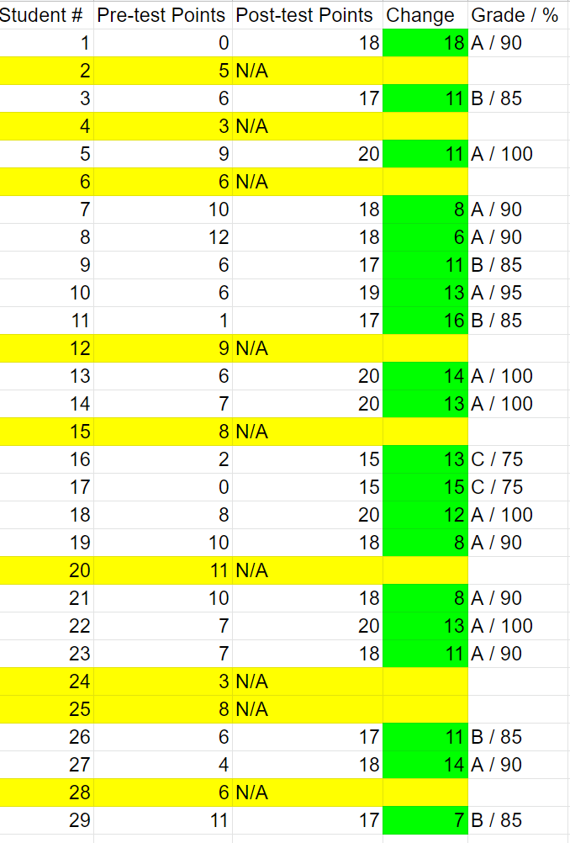

Reflective Essay

Throughout teaching this unit I learned several things about myself as a teacher. The first is my ability to teach my students beyond the content. I made a goal to encourage my students to be kinder, thoughtful, and empathetic thinkers. I saw a huge shift in the way my students interacted with one another during this time. I also found joy in my unit planning. Although sometimes I found myself feeling overwhelmed during this time, I was so pleased by the result. I am proud that I pushed myself to create the lessons I did. I strived to make each one unique and engaging and I believe I achieved that. To say my unit did not go as planned would be understatement. Never did I think that I would have to teach half of my capstone online. With, it was fun to take the skills and tools learned in my New Literacies track and switch to the role of remote learning. However, it was slightly disheartening to spend months crafting a unit to have several students not complete it. I am proud of my students who stepped up and gave just as much effort as they would have if I were instructing them in person. It was rewarding to see my students' faces light up (over zoom) when I told them how proud of the work they did. I only wish I could celebrate their successes in person.

This next section will be dedicated to how I met the performance-based standards for Colorado teachers.

Standard One: Knowledge of Literacy
Although this was a “science” capstone, literacy was greatly integrated throughout the unit. This standard asks students develop skills in “reading, writing, speaking, viewing, and listening.”
- Reading: Students read articles in lessons 1, 2, and 3. Students also had to read directions and view examples in all lessons.
- Writing: Students had to do some form of writing in all lessons. Writing can be seen in the form of taking notes, writing paragraphs, filling in vocabulary, exit tickets, labeling graphs, and creating their brochure. Writing took place both physically on paper and electronically.
- Speaking: In lessons 2 and 3 students had to communicate their thoughts to other group members.
- Viewing: Students watched videos in all lessons. Students also viewed pictures and examples in all lessons.
- Listening: In lessons 1, 2, and 3 students were asked to listen to in-person directions. In lesson 3 students listened to two speakers tell personal accounts about the 2013 flood.

Standard Two: Knowledge of Mathematics
Both lessons 1 and 4 had math concepts integrated into the lessons. In lesson 1, students were asked to understand the geometry concept of triangles being the strongest shape. In lesson 4 students learned how to create bar graphs, place data on them, and interpret conclusions based on the data.

Standard Three: Knowledge of Standards and Assessment
Each one of my lessons has one or more standards that are being assessed throughout the lesson. All four of my standards are assessed using pre-assessment, formative assessments, and summative assessments. These assessments look different in each lesson. Some examples are the use of sticky notes, exit tickets, aggressive monitoring, and project-based assessment. (Click here for more details)

Standard Four: Knowledge of Content
Aside from mathematics and literacy I have integrated other content areas within this unit. Some examples are
- Science: As this is a science capstone, there is science ideas and concepts in every single lesson
- Geography: During lesson 1 and 2, the idea of tectonic plates and their movement were discussed
- Visual arts: In every lesson, students were asked to create something in one form or another to display their learning in a creative outlet.

Standard Five: Knowledge of Classroom and Instructional Management
As mentioned earlier, my students struggled with several behavioral issues. Throughout my unit I believe I helped students address these problems and begin to see our classroom as a safe place again. I implemented a behavior reward system to help encourage students to do the right thing.

Standard Six: Knowledge of Individual Instruction
Every lesson included in my unit has a unique set of adaptations and extensions to support every student's needs. I also created a word wall for my students. Students chose which words they wanted to add and were encouraged to draw and define them in ways that helped them to learn. (Click here for more detailed information)

Standard Seven: Knowledge of Technology
I addressed this standard in two different ways.
In-class lessons: Technology was used to provide students videos and articles to assist in their understanding. Students also used technology to create their flood PSA slides.
Online lessons: Due to COVID-19 school closures, I had to rely completely on technology to provide my students these lessons. I used Schoology, Seesaw, Padlet, Google Forms and Slides, and Zoom to support my students in an online format. Without a strong sense of technology and the SAMR model, I do not believe I would have been able to support my students to the level they needed.

Standard Eight: Democracy, Educational Governance and Careers in Teaching
During this strange time in education, it was more important than ever to communicate with students and parents why and how I was doing the things I was. I had to understand my role as a student teacher and what I was allowed to do.

This next section will address how I met the Colorado academic standards in my unit.

Standard: 4) Fourth Grade 3) Earth and Space Science 5) A variety of hazards result from natural processes; humans cannot eliminate natural hazards but can reduce their impacts’ effect.

This particular standard was addressed in three different lessons throughout my unit.
In lesson 1 this standard was met by students creating earthquake resistant buildings. In lesson 2 students learned all about volcanoes. Students read about how to reduce the impacts of a volcanic eruption and created an evacuation plan. In lesson 5 students summarized the three natural hazards they have learned about and created an impact solution.
Standard: 4)Fourth Grade 3) Writing and Composition 2) Write informative/explanatory texts using text structures appropriate for the purpose and developed through facts, definitions, concrete details, precise language, and domain-specific vocabulary
This standard was met in lesson 5. Students created an informative brochure that summarized what they have learned about natural hazards. They learned about appropriate text features to be used in a brochure.

Standard: 4) Fourth Grade 4) Research Inquiry and Design 1b) Recall relevant information from experiences or gather relevant information from print and digital sources
This standard was addressed in lesson 3. Students used a mix of primary resources, accounts from guest speakers, and their own research to understand how the 2013 flood impacted their community.
Standard: 4) Fourth Grade, Standard 3. Data, Statistics, and Probability b) Measurement & Data: Represent and interpret data
This standard was addressed in lesson 4. After learning about the purpose of graphs and how to properly create a bar graph, students created their own graphs. In addition to each graph, each student was asked to make two conclusive statements about the data represented.

