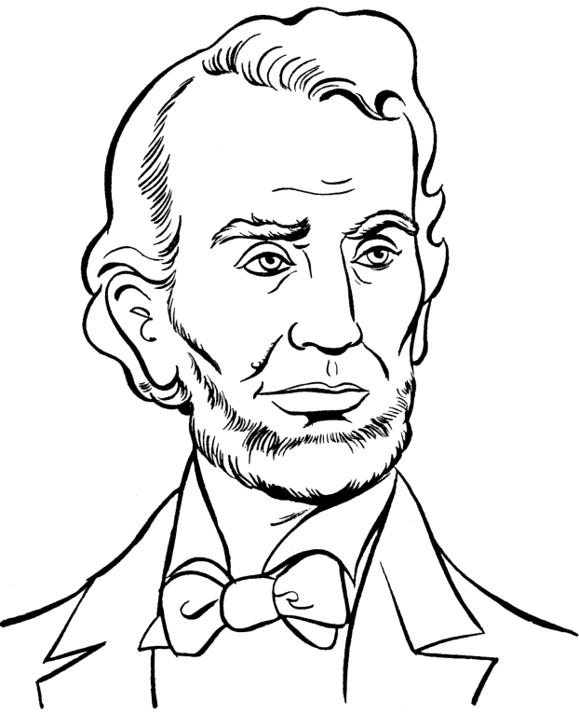

Final Capstone Project: The U.S. Civil War
2nd Grade
Teacher Candidate: Madeline Wall
Cooperating Teacher: Kimberly Lewis
February 22-March 17, 2021
Flagstaff Academy Charter School
St. Vrain Valley School District
Table of Contents

Part One: Title Page and Table of Contents
Part Two: Rationale Statement
Section 1: Introduction
Section 2: Community, School, and Classroom Setting
Section 3: Meeting the Colorado Model Content Standards
Section 4: Assessing Student Learning
Part Three: Unit Goal
Part 4: Lesson Plans
Lesson 1: Harriet Tubman
Lesson 2: The Division of the United States
Lesson 3: The War Begins / Ft. Sumter
Lesson 4: The Emancipation Proclamation
Lesson 5: The End of the War
Part 5: Extension, Modification, & Adaptive Activities
Part 6: Instructing Students and Supporting Learning
Part 7: Resources Used
Part 8: Evaluative Essay
Part 9: Reflective Essay

[Jump to Table of Contents]
Part Two: Rationale Statement
Section 1: Introduction
History has always been my favorite subject, as I think it is for many students. As a student, I find the past fascinating, and as a teacher, I appreciate the beauty of history’s ability to complement other subjects. Often, incorporating a writing lesson into a history lesson (or vice-versa) is quite simple. Math, reading, art, technology, music, and even science and physical education are all subjects that can be combined with history for an even more engaging activity. More learning takes place as well. Because of the efficiency of this concept, it seemed odd to learn that history was taught alternately with science at my school and that the 40 minutes allotted for it at the end of the day was often--necessarily-- eaten up with “catch-up” with other subjects. So, I thought my Capstone unit would be a wonderful opportunity to share with my students my love for history-- and the Civil War-- and perhaps inspire them to seek history out elsewhere, or at least take advantage of it in school.

Lesson 1, Part 1: While I did want students to have a good understanding of some of the key players of the Civil War, like Harriet Tubman, more important was that they knew why she and others were important. In this lesson, the focus was Harriet Tubman’s perseverance through hardship for the sake of others’ freedom, so I had students complete a note catcher and challenged them with a written-response question.

Lesson 1, Part 2: For this lesson, I wanted students to express another important Civil War element-- the Underground Railroad-- in a more individual way. To help them really understand how passengers on the Underground Railroad worked through conflict to promote equality, I asked students to imagine they were a passenger and create a mental image about what that experience might have been like.

Lesson 2: The second lesson served as an introduction to primary and secondary sources as well as to incorporate physical activity for kinesthetic learners. The main activity included students being assigned a state and sorting themselves into the Union and Confederacy based on primary and secondary sources.

Lesson 3: For this lesson, the focus was on art. Not only is art an important part of history, but it is also useful for engaging students who are more interested in non-literary media. This lesson was designed to engage those students and to allow all students to investigate the role of art in the Civil War by participating in Visual Thinking Strategies sessions.

Lesson 4: In order to solidify students’ understanding of primary and secondary sources, this lesson focused more heavily on instruction using Whole Brain Teaching, as well as an activity in which students sorted a variety of primary and secondary sources. Students also went more in-depth with the Emancipation Proclamation to practice interpreting primary sources.

Lesson 5: The purpose of this lesson was for students to practice identifying key details in a read-aloud. They did this by completing a web diagram using the 5 W’s (Who, What, Where, When, and Why) based on a read-aloud about the end of the Civil War.

[Jump to Table of Contents]
Section 2: Community, School, and Classroom Setting –

Community
Flagstaff Charter Academy is a charter school located in Longmont in the St. Vrain Valley School District. It is a pre-K through 8th-grade school that opened its doors in 2012, and since then has received several awards, including the John Irwin School of Excellence award. It is in southwestern Longmont and is surrounded by several technology businesses as well as Front Range Community College. In the ZIP code in which the school is located, the median household income is $45,799 and most of the people identify as White/Caucasian.

School
Most students are dropped off and picked up by their parents, and there are a select few who take a school bus. However, since Flagstaff is a charter school, the school bus is a special circumstance. Due to the pandemic, all of Flagstaff is in-person four days a week and provides asynchronous learning for students on Fridays, although families have the option to be completely online (one teacher per grade level teaches fully online). Because Fridays are asynchronous for everyone, students must have a device available to them. Many students use their parents’ and guardians’ computers, and others were allowed to check out Chromebooks from the school for the entire school year. As for curriculum, Flagstaff uses Core Knowledge for literacy, history, and science instruction, and uses Envision for math instruction. History and science are taught alternately throughout the school. Flagstaff also has a greenhouse, which each class visits once per week. For behavior, the school has adopted the PBIS (Positive Behavior Intervention and Supports) program, including the CHAMPS framework (Conversation, Help, Activity, Movement, Participation, and Success), as well as their school motto: PRIDE (Perseverance, Respect, Integrity, Dependability, and Empathy).

Classroom Description and Physical Setup/Technologies
The COVID-19 pandemic has affected Flagstaff and my classroom in countless ways. Due to social distancing requirements, student desks must all face the same direction and cannot be touching. This means that there are no desk groups (photos here), and it also means that students stay in their desks for most of the day since they cannot gather together on the carpet or in other areas of the classroom. The desks all face the SHARP board at the front of the classroom, which is essentially a computer with a very large screen that is also connected to a document camera. During my Capstone unit, the ratio of available Chromebooks to students was 1:1. At the time of my Capstone unit, there were 18 students in my class: seven boys and 11 girls. My class is somewhat diverse in terms of ethnic background and very diverse in terms of socioeconomic background. There is one English language learner (ELL) in my class who is a Limited English Proficient (LEP), and one student on an IEP, and there are four students on a READ plan who receive services. There are also two students identified as gifted and talented in my class. About half of the students regularly get hot lunch from the school cafeteria, although I do not know how many students are on free and reduced lunch since all lunches are currently free due to the pandemic. Three students in my class present significant behavior concerns: one is regularly defiant and sometimes aggressive towards peers and teachers, one struggles with executive functioning, and the third’s home life is quite unsettled which causes her to act out in many ways. Additionally, shortly before my Capstone unit began, the class shifted to use Whole Brain Teaching, which included a new reward system that has both class and individual incentives.

[Jump to Table of Contents]
Section 3: Meeting the Colorado Model Content Standards

2nd Grade Social Studies, Standard 1. History
GLE 1: Ask questions and discuss ideas taken from primary and secondary sources
- Evidence Outcomes: Students Can…
  - b. Explain the past through primary and secondary sources. For example: images, and oral or written accounts.
Objectives:
- Lesson 2: Students will give 3 examples of why the United States was divided based on information from primary and secondary sources. Students will be assessed based on their completion of an activity using a check plus, check, check minus scale.
- Lesson 4: Students can differentiate between primary and secondary sources. Students will be assessed using an exit ticket worth 3 points.

2nd Grade Social Studies, Standard 4. Civics
GLE 2: Identify and compare multiple ways that people understand and resolve conflicts and differences
- Evidence Outcomes: Students Can…
  - a. Analyze ways that diverse individuals, groups, and communities work through conflict and promote equality, justice, and responsibility.
Objectives:
- Lesson 1, Part 1: Students will demonstrate their knowledge of how important people (Harriet Tubman and those involved in the Underground Railroad) worked through conflict in the Civil War as measured by 6 out of 8 correct points on a graphic organizer.
- Lesson 1, Part 2: Students will demonstrate their knowledge of how important people (Harriet Tubman and those involved in the Underground Railroad) worked through conflict in the Civil War as measured by a check, check plus, check minus on their poster.

2nd Grade RWC, Standard 1. Oral Expression and Listening
GLE 1: Engage in dialogue and learn new information through active listening
- Evidence Outcomes: Students Can…
  - b. Recount or describe key ideas or details from a text read aloud or information presented orally or through other media.
  - c. Ask and answer questions about what a speaker says to clarify comprehension, gather additional information, or deepen understanding of a topic or issue.
Objectives:
- Lesson 5: Students can demonstrate understanding of key pieces of a read-aloud by illustrating the who, what, where, when, and why of the read-aloud in a web organizer. Students will be scored on completion of the web with the 5 W’s (5 points) with 80% accuracy (4 out of 5).

2nd Grade Visual Arts, Standard 4. Relate and Connect to Transfer
GLE 1: Observe and discuss how visual art and design are evident in the everyday life of communities.
- Evidence Outcomes: Students Can…
  - c. Investigate the role of art and design in our communities and world.
Objectives:
- Lesson 3: Students can analyze how pieces of art from the Civil War era were influenced by concurrent events. Students will be assessed based on their participation in Visual Thinking Strategies (VTS) sessions and their ability to articulate how a certain piece of art is related to events of the Civil War.
  - Participation = 3 checks:
    - 1: at least one comment
    - 1: comment relates art to ideas/events in the Civil War
    - 1: comment relates to vocabulary words

Section 4: Assessing Student Learning – [Jump to Table of Contents]

Link to Pre/Post Assessment

Pre-Assessment
Since my class includes learners with a wide range of reading and writing abilities-- and since I did not address reading and writing standards in this unit-- I wanted to limit opportunities in which reading, and writing might occlude students from accurately expressing their understanding of the topic. To do this, I delivered the written part of the pre-assessment orally to the whole class and put a blank version of the assessment under the document camera as an additional student support. When delivering the pre-assessment, I read each question aloud and clarified expectations, waiting for every student to give a thumbs up before moving on. For the read-aloud portion of the written test, I asked students to track the paragraph as I read. Each question was worth one point for a total of 16 points on the written assessment.
The VTS portion of the pre-assessment was given individually. For this section, I pulled students out into the hallway and showed them the image on a computer as well as how to zoom in, zoom out, and move it. I then asked the student the three questions typical of a VTS session:
- What’s going on in this picture?
- What do you see that makes you think that?
- What more can you find?
Using these three questions as a basis, I facilitated a discussion with each student about the image. These brief discussions were recorded so that I could transcribe them. I also took notes on what each student said and later used the recordings and my notes to score students: they received one checkmark for at least two relevant comments on the artwork, and one checkmark for at least one of the comments being related to the Civil War.

Formative Assessment
I embedded at least one formative assessment into each of my five lessons, and most had more than one. In Lesson 1, students completed a graphic organizer about Harriet Tubman’s life that included a question that required them to use higher-order thinking. In Part 2 of Lesson 1, students created a mental image graded using a check plus, check, check minus rubric. Lesson 2’s formative assessments included a check plus, check, check minus rubric based on a class checklist as well as an exit ticket. In Lesson 3, students were assessed on the quality of their participation in a discussion about Civil War art. Lesson 4’s formative assessment was an exit ticket that measured their understanding of primary and secondary sources as well as challenged them to use higher-order thinking to write a response. Finally, in Lesson 5, students were assessed based on their ability to complete a web organizer that included the 5 W’s about the read-aloud for that lesson.

Additionally, I included an “objective self-check,” in which I reviewed our objectives at the end of each lesson and asked students to give a thumbs up, down, or middle to show if they thought we reached our objective.

Summative Assessment
To evaluate what students learned, I delivered the same assessment as I did for the pre-assessment. I tried to make the conditions as similar as possible to the pre-assessment (including individual oral responses for the VTS portion of the test). To see what students learned, I aligned each question on the assessment with a standard and objective.

Part Three: Unit Goal [Jump to Table of Contents]

The Civil War is a broad topic for second graders to understand. Though its causes and important figures are complex, this unit will serve as a foundation for future exploration about the Civil War. Students will learn about the key players and major events of the Civil War. They will explore the causes of the Civil War using primary and secondary sources and will learn how to differentiate between primary and secondary sources. Students will also analyze how Abraham Lincoln influenced the preservation of the union and the end of slavery, especially via the Emancipation Proclamation. They will analyze the influence of Lincoln, Ulysses S. Grant, Robert E. Lee, and Harriet Tubman on equality in the United States. They will also successfully recount key ideas about the end of the Civil War from a read-aloud and investigate the art and design as they relate to the Civil War.

Through whole-brain teaching of key points (see information about Whole Brain Teaching here), video explorations, and the creation of mental images, students will investigate how Harriet Tubman and the Underground Railroad helped end slavery. As students practice identifying the 5 W’s (who, what, where, when, and why), they will apply their knowledge to a read-aloud about the end of the Civil War. They will also participate in movement activities to learn about the division of the United States during the Civil War and will discuss Civil War art using Visual Thinking Strategies (see info here).
Part Four: Lesson Plans
Lesson 1: Harriet Tubman [Jump to Table of Contents]
PART ONE: The Life & Impact of Harriet
Academic Standards:
2nd Grade Social Studies, Standard 4. Civics, GLE 2: Identify and compare multiple ways that people understand and resolve conflicts and differences
Evidence Outcomes: Students Can…
a. Analyze ways that diverse individuals, groups, and communities work through conflict and promote equality, justice, and responsibility.

Specific Objectives to Attain Learning Goals:
Part 1: Students will demonstrate their knowledge of how important people (Harriet Tubman and those involved in the Underground Railroad) worked through conflict in the Civil War as measured by 6 out of 8 correct points on a graphic organizer.
Part 2: Students will demonstrate their knowledge of how important people (Harriet Tubman and those involved in the Underground Railroad) worked through conflict in the Civil War as measured by a check, check plus, check minus on their poster.

Materials Needed:
- Chart paper with vocabulary words
- Objectives listed
- Graphic organizer (20 copies)
- TAG Graphic organizer (5 copies)
- PBS video: Harriet Tubman
- BrainPop: Civil War Causes
- Chromebooks for early finishers
- Book recordings
- VTS image (extension)
- Document camera
- SHARP board

Anticipatory Set:
- Remind students of the Teach, Okay piece of WBT
- As students watch, ask them to think about 3 things they notice about the causes of the Civil War
- BrainPop on the Causes of the Civil War: https://www.brainpop.com/socialstudies/ushistory/civilwarcauses/
- Discussion:
  - Draw sticks & discuss what students noticed/learned from the video
Procedures for Lesson
- Review vocabulary for the lesson with Whole Brain Teaching: (also written on board)
  - Plantations: large farms where crops are raised
  - Slavery: the practice of forcing people to work without pay as enslaved people. And denying them the freedom to decide how to live their lives
  - Underground Railroad:
    - Just introduce today, we will go more in-depth about the Underground Railroad in the next lesson!
- Split students into partner groups
- Teach information about Harriet Tubman using Whole Brain Teaching (have students mirror, then teach their partner)
  - Born on a plantation in 1822
  - Born into slavery (both parents were slaves)
  - In 1849, her owner passed away.
    - Not wanting to be sold, she escaped North on the Underground Railroad
  - From 1850-1860, she became a conductor
    - She went back to the South about 19 times (very dangerous!)
  - Was later a spy in the Union Army
- Introduce graphic organizer & model how to fill out
  - See graphic organizer below
- Hand out organizer and instruct students to put their name on it
- Show PBS Video (4:22) and instruct students to fill out what they can of the graphic organizer
  - Don’t have them do the final question until the end!
- Finish filling out organizer as a class
  - Draw sticks to help fill in blanks
Closure:
- Review Harriet Tubman information taught with Whole Brain Teaching with quick trivia questions
  - Draw sticks to answer
- Instruct students to answer the final question on their graphic organizer: How did Harriet Tubman help end slavery?
- Collect graphic organizer as assessment

Homework/Assignments/Extension Activities
- Individually on Chromebooks (uploaded to Google Classroom):
  - Read-aloud of Domain 9, Lesson 1
  - Civil War Choice Board (Chromebooks)
- Whole-Class VTS Session:
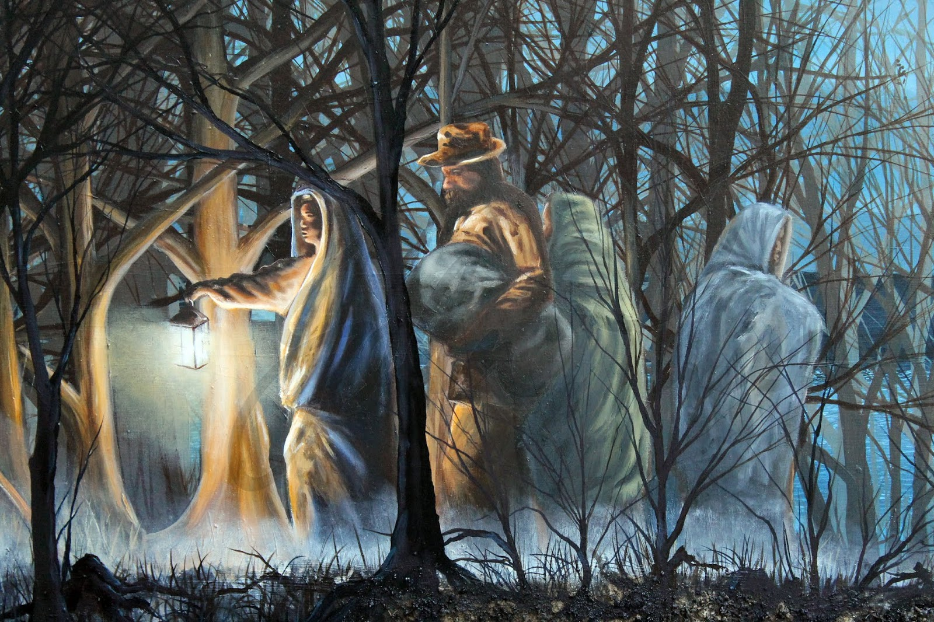

https://1.bp.blogspot.com/-_ISluuXySWI/XRYNZnWzSbI/AAAAAAAAEAc/m2TNXfdRGNoQZcHKMMxBFk_unoCwLDBRgCLcBGAs/s1600/HarrietTubmanCloseup2.jpg

Assessment:
- Formal:
  - Graphic organizer: 8 points total (1 point per blank, 2 points for extended answer question)
- Informal:
  - Trivia presented as true/false: thumbs up/thumbs down

Adaptations:
- ESL/SPED/READ Plans/General:
  - Vocabulary written on board
  - Mirroring & teaching partners key points (WBT)
  - Graphic organizer with fill-in-the-blanks and a word bank
  - Sentence starter on graphic organizer
  - Whole class completion of graphic organizer
  - Whole class trivia review of key points
- TAG:
  - Graphic organizer with less scaffolding
  - Extension activities for early finishers

Resources:
Original CW packet
PBS Video
PBS Graphic Organizer (adapted)
D9L1 (CK)
https://www.brainpop.com/socialstudies/ushistory/civilwarcauses/
https://www.history.com/topics/black-history/underground-railroad
https://1.bp.blogspot.com/-_ISluuXySWI/XRYNZnWzSbI/AAAAAAAAEAc/m2TNXfdRGNoQZcHKMMxBFk_unoCwLDBRgCLcBGAs/s1600/HarrietTubmanCloseup2.jpg

Harriet Tubman Note catcher
Iconic American Video (PBS)

Word Bank:
freedom  injury | disguises  escape | south  slavery

Obstacles Harriet Overcame: | Harriet’s Accomplishments:
-Harriet was born into ________ in Maryland.  -She was beaten and had a bad head ______, which led to seizures.  -She risked her life many times to help others ______ slavery on the Underground Railroad. | -Harriet escaped to ________ in the North in 1849.  -She used ________ to sneak people out of the South.  -Harriet returned to the ______ 19 times to lead 100s of people to freedom.

How did Harriet Tubman help end slavery? Write 1-2 complete sentences.

Harriet Tubman helped end slavery by:_____________________________________________________
____________________________________________________________________________________________________________________________________________________________________________________________________________________________________________________________________________________________________________________________________________________
Harriet Tubman Notecatcher
Iconic American Video (PBS)

Word Bank: You may use these words in your responses!
freedom  injury | disguises  escape | south  slavery

Obstacles Harriet Overcame: | Harriet’s Accomplishments:

How did Harriet Tubman help end slavery? Write 1-2 complete sentences.

_____________________________________________________________________________________
____________________________________________________________________________________________________________________________________________________________________________________________________________________________________________________________________________________________________________________________________________________
Lesson 1: Harriet Tubman [Jump to Table of Contents]
PART TWO: The Underground Railroad
Academic Standards:
2nd Grade Social Studies, Standard 4. Civics, GLE 2: Identify and compare multiple ways that people understand and resolve conflicts and differences
Evidence Outcomes: Students Can…
a. Analyze ways that diverse individuals, groups, and communities work through conflict and promote equality, justice, and responsibility.

Specific Objectives to Attain Learning Goals:
Part 1: Students will demonstrate their knowledge of how important people (Harriet Tubman and those involved in the Underground Railroad) worked through conflict in the Civil War as measured by 6 out of 8 correct points on a graphic organizer.
Part 2: Students will demonstrate their knowledge of how important people (Harriet Tubman and those involved in the Underground Railroad) worked through conflict in the Civil War as measured by a check, check plus, check minus on their poster.

Materials Needed:
- Chart paper with vocabulary words
- Objectives listed
- Google Slides presentation
- “Follow the Drinking Gourd” worksheet
- Exemplar
- Underground Railroad BrainPOP
- Notecards
- Chromebooks for early finishers
- Book recordings
- VTS image
- Document camera
- SHARP board

Anticipatory Set:
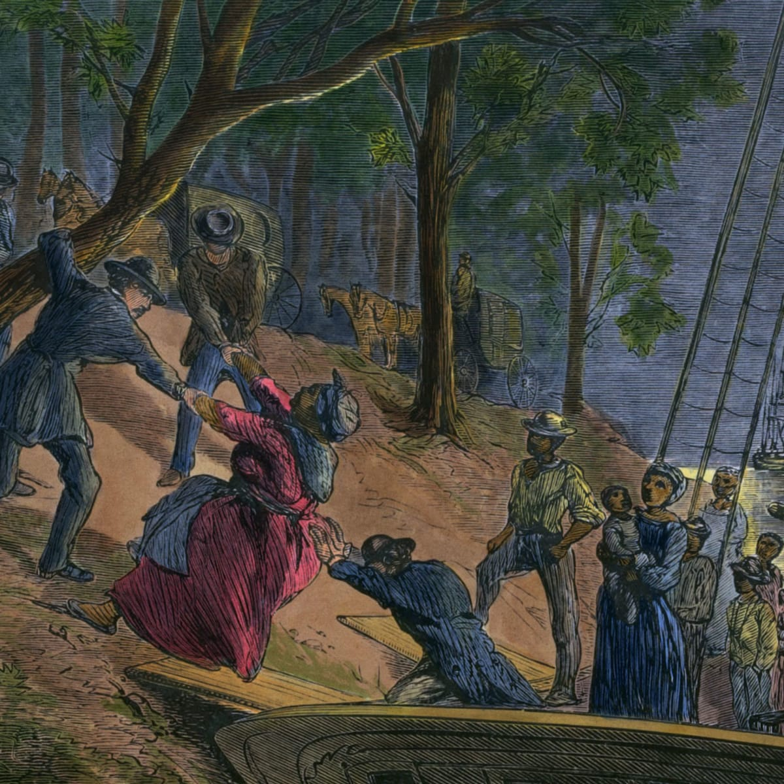
Visual Thinking Strategies Session:

https://www.history.com/.image/ar_1:1%2Cc_fill%2Ccs_srgb%2Cfl_progressive%2Cq_auto:good%2Cw_1200/MTY3OTgxNzczNzMxNDA3MjMy/underground-railroad-clra001_bz098.jpg
- What do you notice?
- What do you see that makes you think that?
- What more can we find?

Procedures for Lesson:
- Review vocabulary from previous lesson on
- Introduce Vocabulary using Whole Brain Teaching:
  - Conductor: a person who led or directed enslaved Africans to freedom during the Civil War using the Underground Railroad
  - Gourd: a plant whose hard-shelled fruit is sometimes dried and hollowed out to be used as a tool
  - Passengers: Enslaved Africans who traveled to freedom on the Underground Railroad

- Whole Brain Teaching on Underground Railroad
  - Project map of Underground Railroad routes:
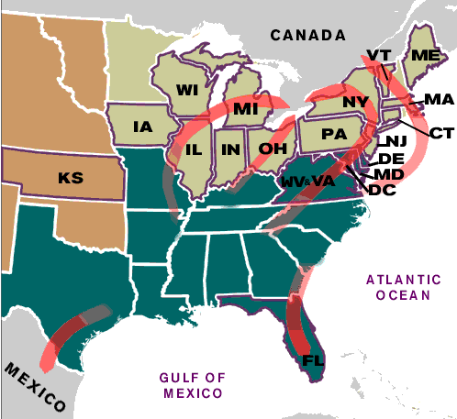

  - https://www.nps.gov/nr/travel/underground/graphics/ugrr215d.gif
  - 1: Conductors guided people trying to escape slavery to freedom in the North, or to Mexico and the Caribbean
  - 2: Along the way, they stayed in “stations,” or safehouses
    - Here, they were protected from people trying to catch them & bring them back to slavery
- Follow the Drinking Gourd Activity:
  - Read p. 33-35 of Domain 9, Lesson 2 read-aloud (3 mins)
  - “Follow the Drinking Gourd” Song & brief discussion
- Pass out blue paper with Drinking Gourd constellation & place for mental image on notecard (see below)
- Mental image from perspective Underground Railroad passenger
  - “Imagine you are one of the people trying to escape slavery using the Underground Railroad. Our next task is to create a mental image as if you were a passenger on the Underground Railroad.”
    - Share exemplars of mental image
    - Explain criteria:
      - Picture must be relevant to the Underground Railroad
      - Picture must be drawn from the point of view of someone involved in the Underground Railroad (Harriet Tubman or another passenger)
      - Picture must be fully colored and fills up most of the notecard
  - Once students have finished their mental image, they will poke holes where the stars are in the constellation
    - Model how to do this & how to hold it up to the light
  - Image will go on notecard, which will be pasted into box on Drinking Gourd sheet (below)
Closure:
- Watch Underground Railroad BrainPop
- Ask, give 20 seconds think time, then draw sticks to answer:
  - Think to yourself: What are 2 things you learned about Harriet Tubman and the Underground Railroad?
  - Think to yourself: What was the hardest part of traveling on the Underground Railroad?

Homework, Assignments, Extension Activities:
- Individual: (on Chromebooks)
  - Read-aloud of Henry’s Freedom Box
  - Domain 9, Lesson 2 read-aloud
  - Write a short story to go along with your mental image on the back of your notecard. Include:
    - The name of your character
    - Why your character is traveling on the Underground Railroad
    - Where he/she is going
    - What your character thinks of the journey so far
- Whole Class:
  - In-person read-aloud of Henry’s Freedom Box

Assessment:
- Drinking Gourd mental image:
Check + | Check | Check -
Image is clearly related to the Underground Railroad, is fully colored, & fills the notecard | Image is clearly related to the Underground Railroad, but is not fully colored/does not fill the notecard  Or  Image is colored/fills the notecard but is not clearly related to the Underground Railroad | Image is not clearly related to the Underground Railroad and is not fully colored/does not fill the notecard

Adaptations:
- ESL/SPED/READ Plans/General:
  - Vocabulary written on board
  - Exemplars of picture/story
  - Realia: maps
  - Modeling of how to poke holes in constellation
- TAG
  - Extensions for early finishers: write a story to go along with mental image

Resources:
- https://www.brainpop.com/socialstudies/ushistory/undergroundrailroad/
- Follow the Drinking Gourd: https://youtu.be/DDNEODGbDTg
Follow the Drinking Gourd
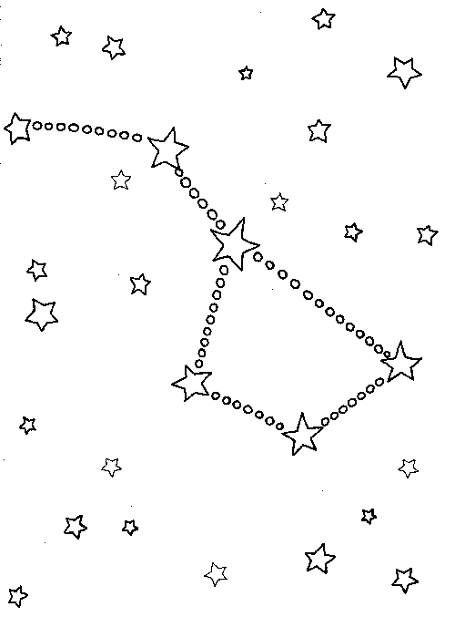

Lesson 2: The Division of the United States [Jump to Table of Contents]
Academic Standards:
2nd Grade Social Studies, Standard 1. History, GLE 1: Ask questions and discuss ideas taken from primary and secondary sources
Evidence Outcomes: Students Can...
- b. Explain the past through primary and secondary sources. For example: images, and oral or written accounts.

Objectives:
Students will give 3 examples of why the United States was divided based on information from primary and secondary sources. Students will be assessed based on their completion of an activity using a check plus, check, check minus scale.

Student-Friendly Objective: I can understand the differences between the North and South during the Civil War.

Materials Needed:

- Primary sources
- Secondary sources
- Jump rope/tape
- Nametags
- Tape for spots on floor
- Notecards
- Google slides presentation
- Document camera
- SHARP Board
- Printed exit tickets (20)
- Chromebooks (extension)
- Pull-down map

Anticipatory Set
- VTS Session (3 mins): Primary Source Map (ideally students will notice that this map is “old”)
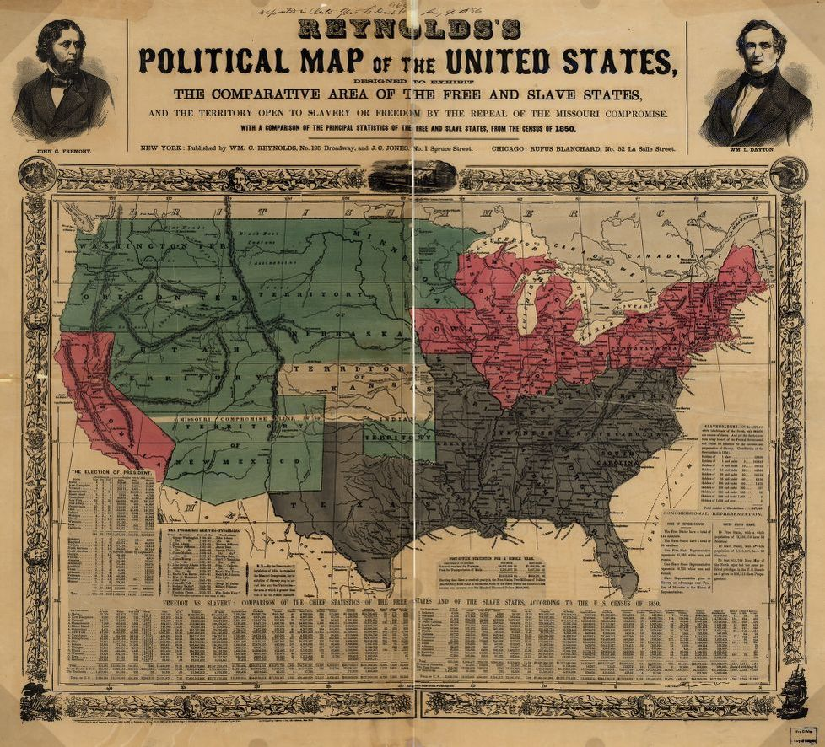

Credit: Library of Congress

Procedures for Lesson
- Conduct VTS
- Move desks & assign students spots to sit in oval
- Set timer for snack & introduce vocabulary (WBT)
  - Confederacy: the government formed by the states in the South after they withdrew from the United States
  - Seceded: withdrew membership from an established group
  - Union: the northern states that did not secede from the United States
  - Abolish: to get rid of or eliminate
  - Primary source: an original document or other material that has not been changed in any way; written or made by witnesses of the historical events
  - Secondary source: documents based on primary sources
- Key Points (Google Slides/WBT):
  - Reiterate primary vs Secondary Source
    - Introduced here, but reinforced in Lesson 4 (Emancipation Proclamation)
    - Primary source: an original document or other material that has not been changed in any way; used as an original source of information about the topic
    - Secondary source: documents based on primary sources
  - Key Points:
    - The Confederacy wanted to secede from the United States
      - Remind students of definition of secede
    - The Mason-Dixon Line was the boundary between Maryland and Pennsylvania
      - It divided slave states south of it and free-soil states north of it
    - Reasons the country was divided (T-chart):
      - Union wanted Lincoln for president, Confederacy did not
      - Union wanted to abolish slavery, Confederacy did not
      - Union thought central government should be more powerful, Confederacy thought state governments should be more powerful
- Movement Activity:
  - Show students a map of the divided United States & point out the Mason-Dixon Line
  - Assign each student a state (nametags) & give them a handout with primary/secondary source excerpts from each state (see below)
    - Union: New York, Pennsylvania, Kansas, Massachusetts, Maine, Iowa, Vermont, New Jersey, Illinois
    - Confederacy: Maryland, Tennessee, Mississippi, Alabama, Georgia, Florida, South Carolina, North Carolina, Virginia
  - Bring students outside or move desks for bigger space
  - For each of the remaining states, read the excerpt from the primary/secondary source document (model this entire process once)
    - 1) First, ask students to share their source, and ask class to decide if they think the source is a primary or a secondary source (thumbs up)
    - 2) Second, ask the student to decide based on the excerpt whether their state was part of the Confederacy or the Union and have them walk to that side of the “Mason-Dixon Line”
      - Each “state” should answer for his/herself, but they have the option to “phone a friend” to help them decide
    - ***Have students assigned to Maryland and Pennsylvania go first
      - Once separated on opposite sides of the field, have them place the “Mason-Dixon Line” (jump rope) between them
Closure
- Model/explain exit ticket
  - Pass out exit ticket and have students fill out

Homework/Assignments/Extension Activities
- Individual: (on Chromebooks)
  - Civil War Board
  - Domain 9, Lesson 5 read-aloud
  - On notecards for activity: more challenging primary/secondary sources for students at higher reading levels
- Whole-Class:
  - In-person read-aloud of Nettie’s Trip South

Assessment
- Check +/Check/Check - recorded on checklist as students complete outside activity
Check + | Check | Check -
Student decides correctly whether their state lies North or South of the Mason-Dixon Line without help from peers | Student decides correctly whether their state lies North or South of the Mason-Dixon Line with help from peers | Student decides incorrectly whether their state lies North or South of the Mason-Dixon Line with help from peers / does not participate

- Score of exit ticket (see below):
  - 3 points (1 per question)

Adaptations
- ESL/SPED/READ Plans/General:
  - Vocabulary written on board
  - Sentence framing in exit ticket
  - Realia: maps
  - Modeling of how to participate in movement activity
  - TPR method: movement activity included in lesson
  - “Phone-a-friend” option during movement activity
- TAG
  - More challenging primary/secondary sources on notecard during main activity
  - Early finisher extensions

Resources
https://kids.kiddle.co/Primary_source
D9L5: The Division of the United States
https://www.britannica.com/place/Mason-and-Dixon-Line
https://www.loc.gov/resource/g3701e.ct000604/?r=0.176,0.623,0.823,0.358,0
https://www.iowapbs.org/iowapathways/mypath/iowa-civil-war
https://digitalarchives.powerlibrary.org/papd/islandora/object/papd%3Asstlp-reg_207
https://thomaslegioncherokee.tripod.com/marylandcivilwarhistory.html
https://msa.maryland.gov/msa/mdmanual/01glance/html/symbols/lyricsco.html
https://www.kialo.com/manumission-was-not-approved-in-the-union-capital-of-washington-dc-until-april-16-1862-19208.8?path=19208.0~19208.1-19208.8
https://encyclopediavirginia.org/entries/virginia-soldiers-confederate-during-the-civil-war/
https://www.loc.gov/collections/civil-war-maps/?sp=4
Union vs. Confederacy:
Which states were part of which?

Maryland (MD)  Huzza! she spurns the Northern scum!  She breathes! she burns! she'll come! she'll come!  Maryland! My Maryland!  -“Maryland, My Maryland,” Maryland state song | Iowa (IA)  “General Grenville Dodge is perhaps the most famous Iowa soldier in the Civil War. He was put in charge of rebuilding railroads for the Union (North) army. He also hired spies to learn information about the Southern army.”  -Iowa PBS, 2020
Pennsylvania (PA)  “[The Pennsylvania Volunteers] are the solid foundation of our American Nationality… only asking for a free and undivided nation”  -Captain Moore, Sept. 12, 1889 | South Carolina (SC)  “Slavery became widespread as a way to provide free labor for picking cotton on the plantations (large farms).”  -Encyclopedia Britannica Kids, 2021
Kansas (KS)  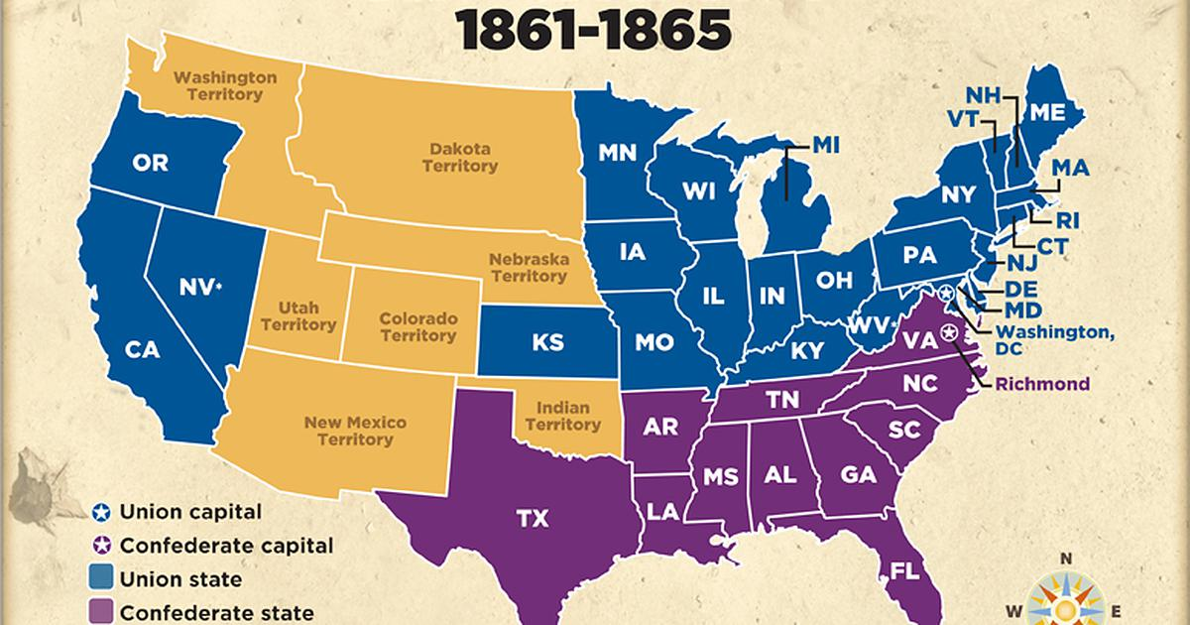 | North Carolina (NC)  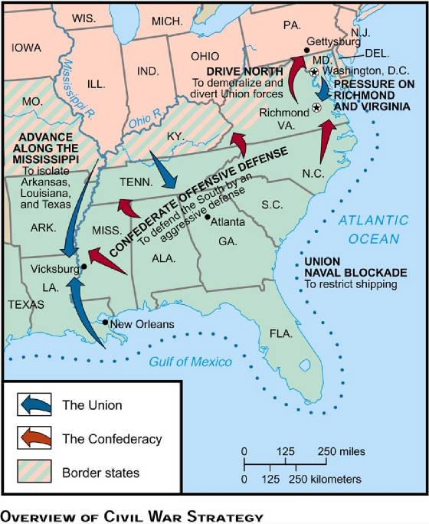
Tennessee (TN) | Vermont (VT)
Florida (FL)  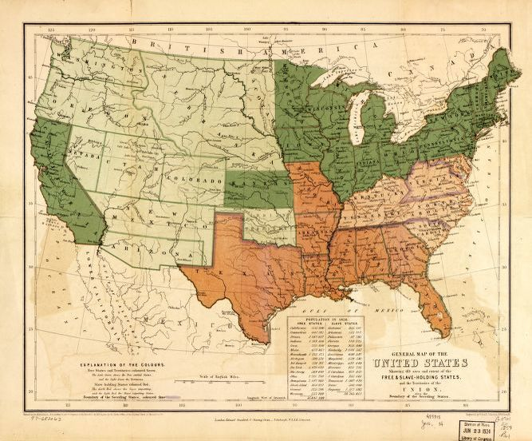 | Virginia (VA)  Virginia sent more men to fight for the Confederacy than did any other state.  -Encyclopedia Virginia
New Jersey (NJ)  Away down South in the land of traitors,  Rattlesnakes and alligators,  Right away, come away, right away, come away.  Where cotton's king and men are chattels,  Union boys will win the battles,  -Union Dixie (song) | Illinois (IL)
Massachusetts (MA) | Mississippi (MS)
Georgia (GA) | Alabama (AL)
Maine (ME) | New York (NY)

Lesson 2 Exit Ticket

Name: __________________
Exit Ticket: North vs South
Directions: For each question, circle “did” or “did not” to complete the sentence.

- The Confederacy (did / did not) want Abraham Lincoln to become President

- The Union (did / did not) want slavery to be abolished or gotten rid of.

- The Confederacy (did / did not) think each state should have more power than the central government in Washington, D.C.

Name: __________________
Exit Ticket: North vs South
Directions: For each question, circle “did” or “did not” to complete the sentence.

- The Confederacy (did / did not) want Abraham Lincoln to become President

- The Union (did / did not) want slavery to be abolished or gotten rid of.

- The Confederacy (did / did not) think each state should have more power than the central government in Washington, D.C.

Name: __________________
Exit Ticket: North vs South
Directions: For each question, circle “did” or “did not” to complete the sentence.

- The Confederacy (did / did not) want Abraham Lincoln to become President

- The Union (did / did not) want slavery to be abolished or gotten rid of.

- The Confederacy (did / did not) think each state should have more power than the central government in Washington, D.C.

Lesson 3: The War Begins / Ft. Sumter [Jump to Table of Contents]

Academic Standards
2nd Grade Visual Arts, Standard 4. Relate and Connect to Transfer, GLE 1: Observe and discuss how visual art and design are evident in the everyday life of communities.
Evidence Outcomes: Students Can…
- c. Investigate the role of art and design in our communities and world.

Specific Objectives to Attain Learning Goals
Students can analyze how pieces of art from the Civil War era were influenced by concurrent events. Students will be assessed based on their participation in Visual Thinking Strategies (VTS) sessions and their ability to articulate how a certain piece of art is related to events of the Civil War.
Participation = 3 checks:
- 1: at least one comment
- 1: comment relates art to ideas/events in the Civil War
- 1: comment relates to vocabulary words

Materials Needed
- SHARP Display board
- Student checklist
Anticipatory Set
- Video: Importance of Art in Society
Procedures for Lesson
- Introduce vocabulary
  - Civilians: people who are members of society and are not part of the military or police force
  - Civil war: a war between different groups or regions in the same country
  - Clash: to collide in intense disagreement
  - Devastated: destroyed
  - Flee: to run away quickly from danger
  - Rebels: the nickname given to the Confederate soldiers
- Whole Brain Teaching of Key Points
  - Google Slides
- Art Activity
  - **Pull sticks so everyone responds**
  - 1) Show an image
  - 2) Ask students to think about what they notice & how it connects to one of our vocabulary words
  - 3) Give 30 seconds think time
  - 4) Pull sticks and ask:
    - How does this image relate to the Civil War?
    - How does this image relate to one of our vocabulary words?
- Art pieces to be used: Google Slides
Closure
- Review objective & conduct self-assessment (thumbs up, down, or middle)
- Thank students for their hard work

Homework/Assignments/Extension Activities
- Individual: (on Chromebooks)
  - Civil War Board
  - Domain 9, Lesson 6 read-aloud
- Whole Class:
  - In-person read-aloud of Nettie’s Trip South

Assessment
- Oral participation = 3 checks on checklist:
  - 1: at least one comment
  - 1: comment relates art to ideas/events in the Civil War
  - 1: comment relates to vocabulary words

Adaptations
- ESL/SPED/READ Plans/General:
  - Vocabulary written on board
  - Sentence framing in exit ticket
  - Realia: maps
  - Modeling of how to participate in movement activity
  - TPR method: movement activity included in lesson
  - “Phone-a-friend” option during movement activity
- TAG
  - More challenging primary/secondary sources on notecard during main activity
  - Early finisher extensions
- Different learning types:
  - Art more conducive to visual learners

Resources
- https://ideologicalart.com/war/american-civil-war-gallery/#jp-carousel-135
- https://www.battlefields.org/learn/articles/civil-war-and-american-art

Lesson 4: The Emancipation Proclamation [Jump to Table of Contents]
Academic Standards
2nd Grade Social Studies, Standard 1. History, GLE 1: Ask questions and discuss ideas taken from primary and secondary sources
Evidence Outcomes: Students Can...
- b. Explain the past through primary and secondary sources. For example: images, and oral or written accounts.

Specific Objectives to Attain Learning Goals
Students can differentiate between primary and secondary sources. Students will be assessed using an exit ticket worth 3 points.

Student Friendly: I can tell the difference between primary and secondary sources.

Materials Needed
- SHARP Display
- AB Clonts Letter
- Primary and Secondary sources (cut out)
- Masking tape
- Exit ticket (20)

Anticipatory Set
- A.B. Clonts letter read-aloud & discussion
  - Do you think Clonts was happy to be fighting the war in Georgia? Why?

Procedure for Lesson
- Introduce vocabulary
  - Abolished: did away with, ended
  - Emancipation: the act of releasing, or setting free
  - Proclamation: an official announcement
  - Emancipation Proclamation: said that slavery would be abolished (ended) in the Confederate states
  - Primary source: an original document or other material that has not been changed in any way; written or made by witnesses of the historical events
  - Secondary source: documents based on primary sources
- Whole Brain Teaching of Key Points
  - Google Slides
- Sorting Activity
  - Students will be in teams (rows)
  - During each round, one person from each team will choose a source from the pile at the front of the room
  - Then s/he must decide if that source is primary or secondary, and add it to the appropriate list (in the middle of the room or on the whiteboard)
    - Students may use their team for help deciding
- Once sorting activity is complete, briefly review what is in each category as a class

Closure
- Read Emancipation Proclamation excerpt aloud
- Pass out exit ticket and conduct assessment

Homework/Assignments/Extension Activities
- Individual: (on Chromebooks)
  - Civil War Board
  - Domain 9, Lesson 9 read-aloud
- Whole-Class:
  - In-person read-aloud of Moses

Assessment
- Exit ticket (3 points)
- Objective self-check

Adaptations
- ESL/SPED/READ Plans/General:
  - Vocabulary written on board
  - Sentence framing in exit ticket
  - Realia: maps
  - Modeling of how to participate in sorting activity
  - TPR method: sorting activity includes movement
  - Ability to ask team for help during sorting activity
- TAG
  - Harder primary/secondary sorting
  - Early finisher extensions
- Different learning types:
  - Visual: Google slides presentation, vocabulary and objectives posted
  - Auditory: read-aloud of A.B. Clonts letter and Emancipation Proclamation
  - Kinesthetic: movement during sorting activity
  - Tactile: Using realia during sorting activity

Resources
Library of Congress

Exit Ticket
- Is the Emancipation Proclamation a primary source or a secondary source? Circle one:
Primary Secondary
- If you were a slave and you heard Lincoln read the Emancipation Proclamation, how would you feel? Write 1-2 complete sentences:
____________________________________________________________________________________________________________________________________________________________________________________________________________________________________________________________________________________________________________.

Exit Ticket
- Is the Emancipation Proclamation a primary source or a secondary source? Circle one:
Primary Secondary
- If you were a slave and you heard Lincoln read the Emancipation Proclamation, how would you feel? Write 1-2 complete sentences:
____________________________________________________________________________________________________________________________________________________________________________________________________________________________________________________________________________________________________________.

Exit Ticket
- Is the Emancipation Proclamation a primary source or a secondary source? Circle one:
Primary Secondary
- If you were a slave and you heard Lincoln read the Emancipation Proclamation, how would you feel? Write 1-2 complete sentences:
____________________________________________________________________________________________________________________________________________________________________________________________________________________________________________________________________________________________________________.

Lesson 5: The End of the War [Jump to Table of Contents]
Academic Standards
2nd Grade RWC, Standard 1. Oral Expression and Listening, GLE 1: Engage in dialogue and learn new information through active listening.
Evidence Outcomes: Students Can…
- b. Recount or describe key ideas or details from a text read aloud or information presented orally or through other media.
- c. Ask and answer questions about what a speaker says to clarify comprehension, gather additional information, or deepen understanding of a topic or issue.

Specific Objectives to Attain Learning Goals
Students can demonstrate understanding of key pieces of a read-aloud by illustrating the who, what, where, when, and why of the read-aloud in a web organizer. Students will be scored on completion of the web with the 5 W’s (5 points) with 80% accuracy (4 out of 5).

Materials Needed
- SHARP Display
- 5W Worksheet (20)
- CKLA Domain 9
- Writer’s notebooks (individual)

Anticipatory Set
- Brainstorm web
  - On a piece of chart paper, write & circle “The U.S. Civil War” & ask students to brainstorm everything that comes to mind when they read those words
  - Record their answers as spokes from the main circle

Procedures for Lesson
- Introduce vocabulary
  - Equality: the state of being the same; fairness
  - Monument: a structure, such as a building or sculpture, built as a memorial to a person or event
  - Prosperity: financial success or good fortune
  - Ransacked: searched through to steal goods; looted
  - Rival: a person who is competing for the same object or position as another
  - United: joined together as one
- Read-Aloud of Domain 9, Lesson 11
  - Tell students to listen carefully to find out which side won the war & what happened to the North and South after the war
  - Tell them to pay close attention to the 5 W’s as they listen
    - Students may take notes on note catcher: Model how to set up in writer’s notebook
      - Remind them that they are not required to take notes, but students making smart choices do all they can to improve their learning
- Web Activity
  - Remind students of what the 5 W’s are
  - Explain and model how to complete 5W Organizer
    - Write more specific questions near each bubble and leave so students can see
  - Instruct students to use their note catcher to help them fill out their 5W Organizer

Closure
- Review objective & conduct objective self-check

Homework/Assignments/Extension Activities
- Individual: (on Chromebooks)
  - Civil War Board
- Whole-Class:
  - In-person read-aloud of Moses

Assessment
- 5W Organizer: 5 points (one for each W)

Adaptations
- ESL/SPED/READ Plans/General:
  - Vocabulary written on board
  - 5W Organizer modeling & more specific questions to guide students
  - Notecatcher
- TAG
  - Complete sentences on 5W worksheet
  - Early finisher extensions

Resources
- CKLA Domain 9

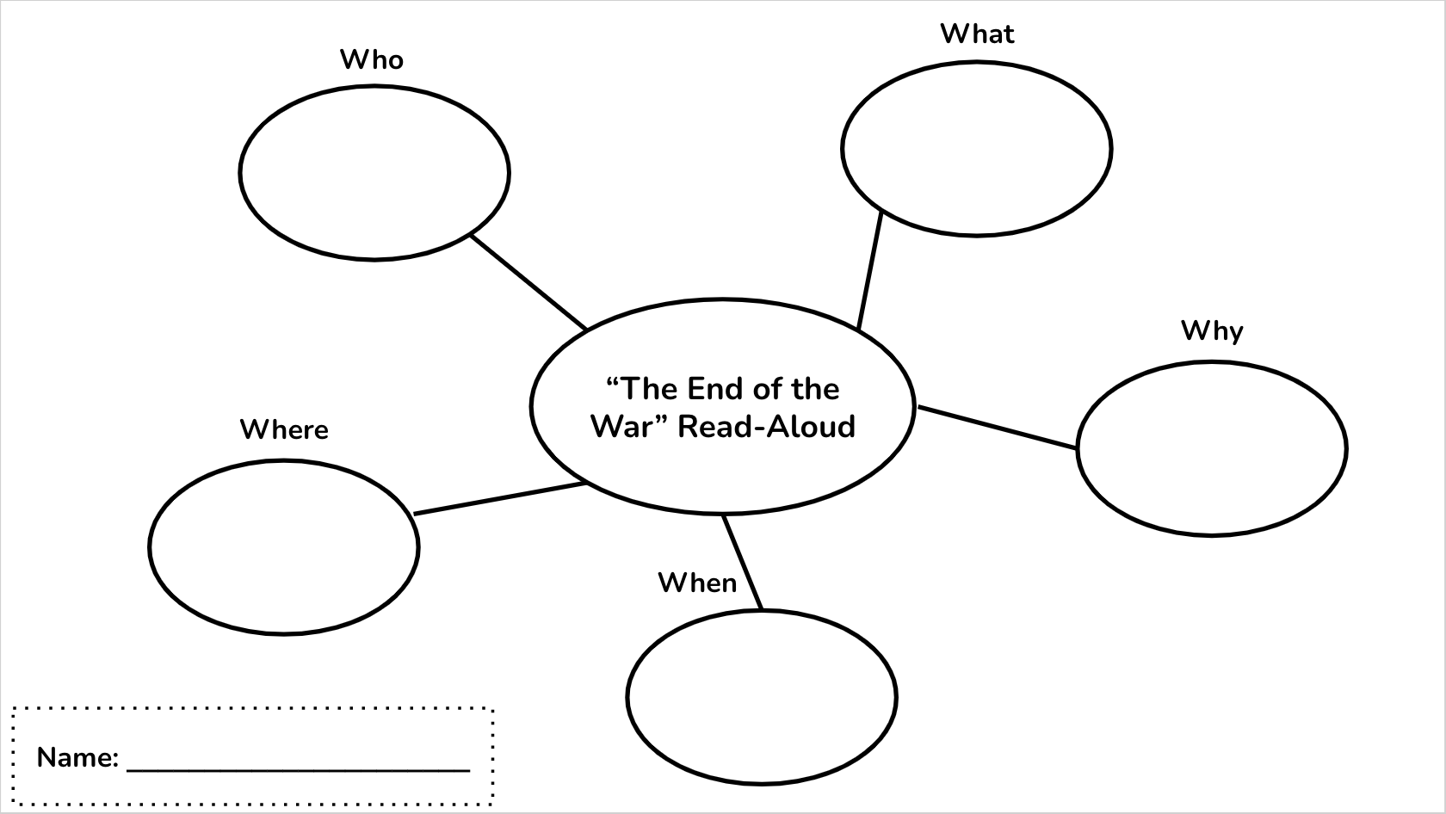

[Jump to Table of Contents]
Part Five: Extension, Modification, & Adaptive Activities

Extensions
A few extensions I included in the unit were applicable to more than one lesson. These were CKLA read-alouds, BrainPop videos, and children’s books about the Civil War. Because I adapted the Civil War unit from the CKLA curriculum, it normally would have included a lengthy read-aloud as the basis for every lesson. Instead of using these in this way, I set them up as extensions. If the whole class finished early, we had the option to read the “domain” (read-aloud) for that lesson, except for Lesson 5, in which the domain was part of the lesson activity. If students finished early individually, most of the domains were recorded and available to them using Chromebooks. The children’s books available to them included Henry’s Freedom Box by Ellen Levine, Moses by Carole Boston Weatherford, Nettie’s Trip South by Ronald Hilmer, Follow the Drinking Gourd by Jeanette Winter, and Before She Was Harriet by Lesa Cline-Ransome. These books and the BrainPOP were available on the Civil War Choice Board I created, and a few copies of the books were available in person as well. Since the students in my class are avid readers. Additionally, for Lesson 1, I had a VTS image related to the Underground Railroad. I also allowed students who finished creating their mental image in Part 2 to write a story to go along with their image.

Modifications/Adaptations
The approach I take for all my lessons is to make them accessible for all types of learners. Each student comes to class with a different fund of knowledge, and teachers must do their best to enable their students to access their fund of knowledge and apply it to the content they are learning. This approach includes students with IEPs, ELLs, and TAG students, but it also addresses the needs of students whose strengths are in different areas (i.e., Gardner’s multiple intelligences theory). Because the learners in my classroom have such a wide range of needs, I found myself including as many adaptations as possible. Fortunately, many of the adaptations I included made a difference in the learning of more than one set of students. In every lesson, vocabulary was written on chart paper and left as a reference for students, and every learning activity was modeled before students completed it individually (e.g., the movement activity in Lesson 2, web organizer in Lesson 5). I also included realia as much as possible, usually in the form of maps (e.g., primary/secondary sources in Lesson 2, Emancipation proclamation in Lesson 4), which not only aided visual learners but also allowed ELLs to connect what they saw with the oral instruction (visual/auditory connection). When appropriate, I provided sentence frames and starters for students (e.g., Lesson 1 note catcher), and provided an exemplar for everything I expected students to complete (e.g., mental image and constellation in Lesson 1). As additional support, I encouraged interaction strategies like “phone-a-friend” when possible, which also helped build relationships. All these things help scaffold student learning, so they are challenged and able to access their fund of knowledge but not impeded by differing skill levels in areas like reading and writing.

Since my class has students who are identified as gifted and talented, I also focused on including adaptations that would challenge them without necessarily giving them more work. In Lesson 1, I modified the note catcher so that it had fewer sentence starters and challenged students to take notes on Harriet Tubman’s life without fill-in-the-blank questions (see the note catchers here). In Lessons 2 and 4, the primary and secondary sources I gave the TAG students were more challenging to discern. For every lesson, extension activities were also available to these students.
[Jump to Table of Contents]
Part Six: Instructing Students and Supporting Learning

Question 1: What happened immediately prior to and/or after the lesson that is important to know to understand and interpret the interactions between and among your students
Due to the COVID-19 pandemic, specials classes push into the classroom, so immediately before the lesson, students were involved in their art specials class and the art teacher had them clean up. Then, my mentor teacher helped move desks so there was an open space in the middle of the classroom. I also set up the Mason-Dixon line on the floor using tape, which piqued students’ interest. Using choral call-and-responses, I had students go by color group to get their snack from their backpacks in the hallway and come sit down in an oval in the large space just created. Considering this transition is different from their usual transition from specials (sitting at desks and eating snacks), most of the students handled it well and were able to sit quietly eating as I began the lesson. At one point, I “caught” a student sitting quietly to reinforce expected behavior. This strategy worked well and a few students who were chatting quieted down.

Since history is taught at the end of the day, students often get distracted and restless as they anticipate packing up and going home after a long day of school. Towards the end of my lesson, students started losing interest. I attribute this to two things. First, the lesson involved a movement activity in which students used their source to decide whether their state was part of the Union or the Confederacy. Once they decided, they moved to that side of the Mason-Dixon line on the floor. I had students coming up individually, which was a slow process and I think may have worn out students’ attention. This might not have happened if I gave everyone their source at once and had them sort themselves out at the same time. Secondly, I think students started losing interest because it was the end of the day; it is typical for them to lose focus during the last 20 minutes of the school day.

Question 2: How did you further the students’ knowledge and skills and engage them intellectually in understanding the subject matter? Provide examples from the lesson to show that you addressed the needs of all students.
In this lesson, I addressed the needs of all the different types of learners in my classroom. To engage visual learners, I began the lesson with a VTS session that required students to analyze a piece of artwork. I also included realia such as maps and other primary and secondary sources, as well as a review of important vocabulary used in the lesson to scaffold students as the lesson progressed. I used a Google Slides presentation to cover the key points of the lesson, which were taught to students using choral response. To further help students understand the differences between the Union and Confederacy, I included a T-chart that compared the two. At the end of the lesson, I intended to review the key points from the presentation with trivia questions but did not have time to do so.

Additionally, the lesson activity included cards with a primary or secondary source that gave a clue as to whether that state was part of the Union or Confederacy. This required students to practice differentiating between different types of sources and analyzing those sources, all while moving and interacting with classmates if they needed help with their source.

Question 3: Describe the strategies you used to monitor student learning during the lesson as shown. Cite one or two examples of what students said and/or did in the lesson or in assessments related to the lesson that indicated their progress toward meeting curriculum standards at a proficient level of performance.
During this lesson, I monitored student learning in several different ways. As students completed the movement activity, I monitored their progress on a class checklist using a check plus, check, check minus rubric (see Lesson 2 Assessment). I also used thumbs up, down, and middle for students to self-assess a few different times. Once was during the lesson to make sure they understood the key points before we moved on, and once was at the end of the lesson when I asked students to show me if they thought we reached our objective. For this final “self-assessment,” a large majority of students gave a thumbs up. I also scored students’ exit tickets to monitor their learning, and their scores averaged a 2.⅓ (70%). Student examples of exit tickets: Student 6 (high), Student 17 (medium), Student 9 (low).

More informally, I made note of a few comments students made throughout the course of the lesson that were indicators of their learning. As I reviewed the lesson objective (I can understand the differences between the North and South during the Civil War) with the class, one student said, “I think I know why you have that line,” referring to the tape on the floor that represented the Mason-Dixon line. During the VTS session at the beginning of the lesson, several students made comments about the map shown that indicated they have a foundational understanding of the division of the United States during the Civil War, which made it that much easier for me to add to their understanding during the lesson. For example, one student said, “Green is probably not considered states yet,” about the land consisting of territories. Another student guessed that the “red” was probably the states who wanted to keep slavery, and the “brown” was states that wanted to get rid of it. While this student mixed up the north and south, this comment shows that this student has foundational knowledge about the lesson topic. Therefore, I came to the conclusion that teaching her about the division of the United States would consist of more correction of her previous notions than an introduction of brand-new information, which presents its own challenges.

Question 4: Reflect on your instruction and children’s learning, discussing how the instruction and learning reflect your philosophy of how children learn (example – Vygotsky, Piaget, Montessori, constructivism, Skinner, etc.
Since my lesson catered to a wide variety of learning styles, it is an appropriate reflection of Gardner’s multiple intelligences theory, which I find to be especially applicable to my classroom. The students in my class are all quite unique and bring many different strengths to the table; a few students are very strong in terms of their visual-spatial abilities, and some have very strong linguistic capabilities. I can think of one student in particular whose intrapersonal intelligence far exceeds many of her classmates’. So, I tried to build in as much variation as possible. For visual learners, I included the VTS as well as a Google slides presentation to accompany verbal instruction. For verbal and linguistic learners, much of the lesson activity was based around oral participation, and the lesson included a large amount of choral response. The ability to share and/or ask their classmates for help also gave these learners a platform for expression. In requiring students to determine if their source was primary or secondary and to identify connections between the source and what is meant for the state they were assigned, the lesson appealed to students whose strength is logical-mathematical intelligence.

Question 5: Explain how you scaffold (applying differentiation, modeling, and support of student learning) curriculum, instruction and assessment in ways that contribute to understanding and facilitate students’ construction of knowledge.
I also try to create my lessons based on the SIOP (Sheltered Instruction Observation Protocol) model as proposed by Jana Echevarria, MaryEllen Vogt, and Deborah Short. Sheltered instruction focuses on scaffolding for English learners throughout the whole lesson. However, there is no scaffolding technique that does not benefit a greater population than English learners, and for this reason, I tried to include as many of these techniques as possible. I built up students’ background knowledge and accessed their funds of knowledge via the vocabulary introduction and VTS session. The “input”-- in this case, the key points-- was made comprehensible thanks to the choral response of Whole-Brain Teaching as well as the separation of information into a few key points. As far as specific strategies, I included vocabulary written on board, sentence framing in the exit ticket, realia (maps), modeling of how to participate in the movement activity, and the “phone-a-friend” option during the movement activity. Additionally, the movement activity itself was a scaffold for learners who may struggle with language-based instruction, and I paired auditory and visual elements to help English learners and others connect to the key points.

[Jump to Table of Contents]
Part Seven: Resources Used

Teacher Resources
https://vtshome.org/
https://www.flagstaffacademy.org/apps/pages/about-us-mission-vision
https://www.unitedstateszipcodes.org/80501/
2nd Grade Civil War Packet 2019-2020
https://www.nga.gov/education/teachers/lessons-activities/uncovering-america/civil-war.html
https://tfelatnps.edublogs.org/files/2018/03/Pre-assessment-Strategies-19fbz59-1k7ad85.pdf
Wayne Eckstine, A.B. Clonts letter
https://www.verywellmind.com/gardners-theory-of-multiple-intelligences-2795161
https://wholebrainteaching.com/wbt-basics-2/
https://www.cde.state.co.us/sites/default/files/documents/cdeprof/download/pdf/li_perfbasedstandards.pdf
Making Content Comprehensible for Secondary English Learners: The SIOP Model, by Jana Echevarria, MaryEllen Vogt, and Deborah J. Short

Student Resources
Google Classroom
Henry’s Freedom Box by Ellen Levine
Moses by Carole Boston Weatherford
Nettie’s Trip South by Ronald Hilmer
Follow the Drinking Gourd by Jeanette Winter
Before She Was Harriet by Lesa Cline-Ransome.

Teacher and Student Resources
https://ideologicalart.com/war/american-civil-war-gallery/#jp-carousel-129
PBS Video: Harriet Tubman
PBS Graphic Organizer (adapted by me from PBS)
CKLA Domain 9: The US Civil War
https://www.brainpop.com/socialstudies/ushistory/civilwarcauses/
https://www.history.com/topics/black-history/underground-railroad
https://1.bp.blogspot.com/-_ISluuXySWI/XRYNZnWzSbI/AAAAAAAAEAc/m2TNXfdRGNoQZcHKMMxBFk_unoCwLDBRgCLcBGAs/s1600/HarrietTubmanCloseup2.jpg
https://www.brainpop.com/socialstudies/ushistory/undergroundrailroad/
Follow the Drinking Gourd: https://youtu.be/DDNEODGbDTg
https://kids.kiddle.co/Primary_source
https://www.britannica.com/place/Mason-and-Dixon-Line
https://www.loc.gov/resource/g3701e.ct000604/?r=0.176,0.623,0.823,0.358,0
https://www.iowapbs.org/iowapathways/mypath/iowa-civil-war
https://digitalarchives.powerlibrary.org/papd/islandora/object/papd%3Asstlp-reg_207
https://thomaslegioncherokee.tripod.com/marylandcivilwarhistory.html
https://msa.maryland.gov/msa/mdmanual/01glance/html/symbols/lyricsco.html
https://www.kialo.com/manumission-was-not-approved-in-the-union-capital-of-washington-dc-until-april-16-1862-19208.8?path=19208.0~19208.1-19208.8
https://encyclopediavirginia.org/entries/virginia-soldiers-confederate-during-the-civil-war/
https://www.loc.gov/collections/civil-war-maps/?sp=4
https://www.loc.gov/collections/civil-war
https://www.brainpop.com/socialstudies/freemovies/civilwar/
https://www.brainpop.com/socialstudies/ushistory/undergroundrailroad/
https://www.brainpop.com/socialstudies/famoushistoricalfigures/abrahamlincoln/
https://www.brainpop.com/socialstudies/ushistory/civilwarcauses/
https://jr.brainpop.com/socialstudies/biographies/harriettubman/
https://1.bp.blogspot.com/-_ISluuXySWI/XRYNZnWzSbI/AAAAAAAAEAc/m2TNXfdRGNoQZcHKMMxBFk_unoCwLDBRgCLcBGAs/s1600/HarrietTubmanCloseup2.jpg

[Jump to Table of Contents]
Part Eight: Evaluative Essay
*Note: All assessment data can be found in one place here.
Figure 1:
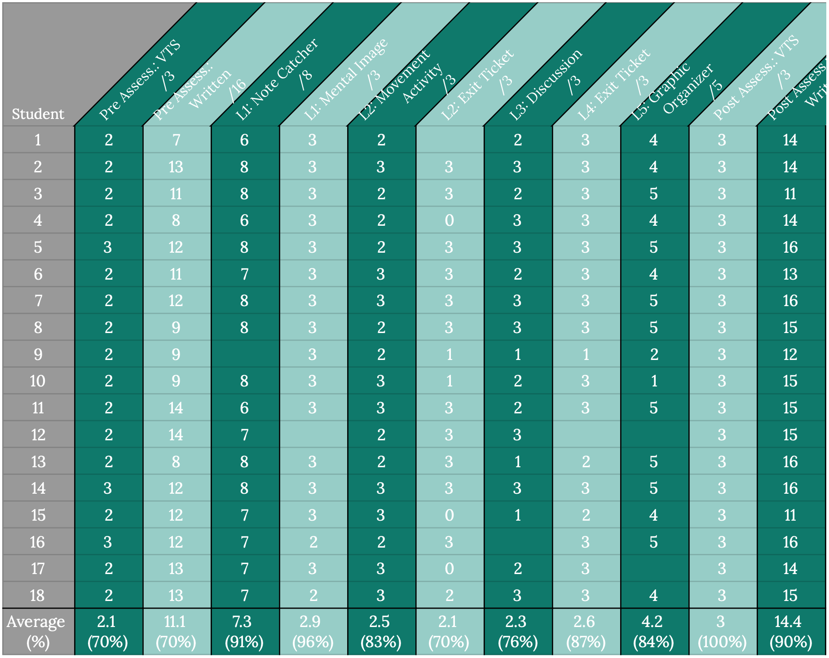
*Check, check plus, check minus data was converted into a score out of 3 points (check plus = 3, check plus = 2, check minus = 1)
Figure 2: Figure 3:
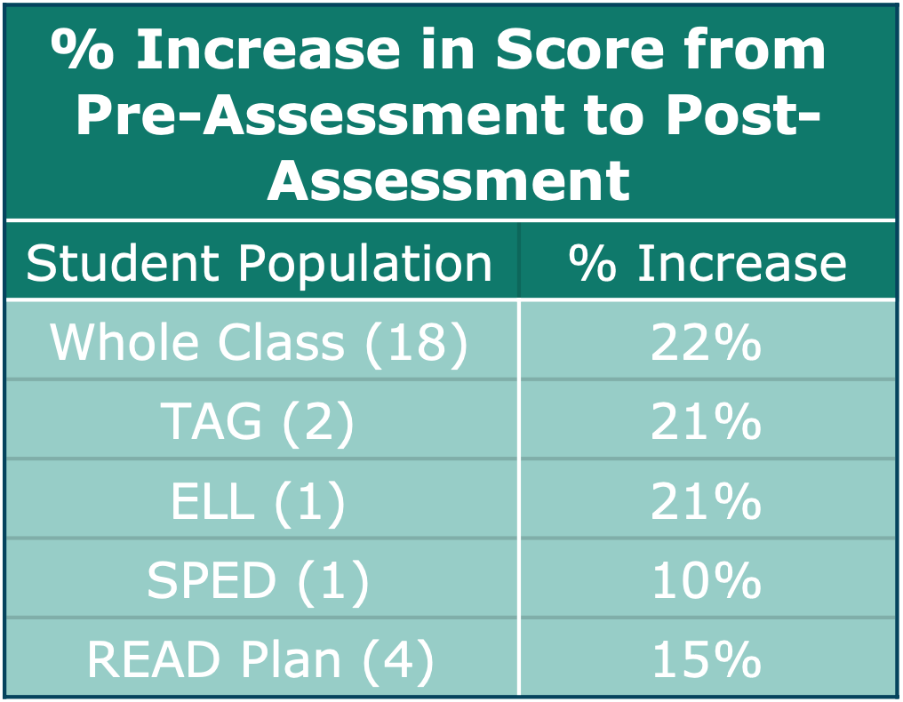
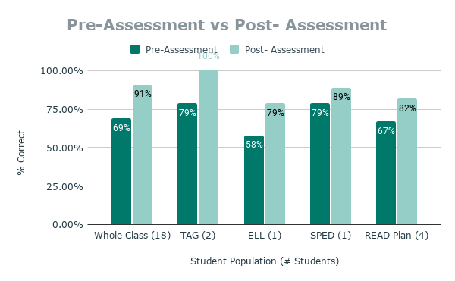

Figure 4:
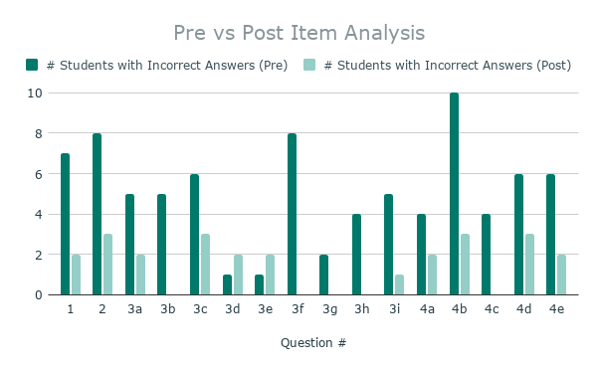

Whole Class Analysis, including Different Populations
When analyzing whole-class data, I first looked at students’ scores on their pre-assessment (Figure 1), and then looked more in-depth at which topics they missed most often (Figure 4). On the written pre-assessment, Questions 1, 2, 3f, and 4b were missed most often. Questions 1 and 2 asked about primary and secondary sources, Question 3f asked about Harriet Tubman’s role in the Civil War, and Question 4b asked students to tell who was involved in the Civil War based on a read-aloud.

With this knowledge, I knew that I needed to spend more time teaching students about primary and secondary sources, which translated into two lessons focusing on that standard/objective instead of one. Ultimately, I decided to introduce primary and secondary sources in Lesson 2 and reinforce the concepts in Lesson 4. Then, based on the formative assessment data from Lesson 2, I altered Lesson 4 further so that the primary focus would be on differentiating between primary and secondary sources instead of knowledge of the Emancipation Proclamation. The number of students who got Questions 1 and 2 incorrect decreased significantly in the post-assessment.

To address misconceptions about Harriet Tubman based on Question 3f, I split Lesson 1 into two parts. That way, I could take more time to drive home important information about the Underground Railroad, Tubman, and other conductors. On the post-assessment, no students got this question incorrect, when eight of them did before. I am incredibly proud of my class for making such a significant improvement.

A total of 10 students got Question 4b incorrect on the pre-assessment. This question asked about who was involved in the Civil War, and most students selected “the British and Americans” instead of “Americans only.” At the time of the pre-assessment, our class had recently finished learning about the War of 1812, so I expect that is where some of the confusion came from. To address these misconceptions, I made an effort to make sure students knew the causes of the Civil War (Lesson 2), and in Lesson 5 trained students to listen for key information in read-aloud. I believe both things contributed to only three students missing this question in the post-assessment.

Addressing the needs of different groups of students was, and always will be, one of my main goals when planning lessons. For this analysis, and when developing adaptations, I focused on four main populations of students: ELLs, SPED students, students who receive services for READ Plans, and TAG students. In Figures 2 and 3, each different group made significant growth between pre- and post-assessments. For more information about the adaptations, I made toa address each of these groups, see Part 5: Extension, Modification, & Adaptive Activities.

As for formative assessment data, I am overall quite proud of how my students performed. When the average score was above 80% on a formative assessment, I bolstered understanding by reviewing that lesson’s objective and key points briefly the following day. When it was below 80% (which only occurred in the Lesson 2 activities), I took note that students were losing points when differentiating between primary and secondary sources. To accommodate for this, I restructured Lesson 4 (which addressed the same standard) to focus more instruction on the differences between primary and secondary sources, and students’ scores improved.

There are a few things to note when interpreting this data that may have affected its integrity. First, there were some student absences which meant those students were unable to complete that particular lesson activity. One student was absent more than once. Second, classroom conditions while students were being assessed varied; it was not possible to create a testing environment free from distractions. Third, two students (Students 9 and 12) had to take the post-assessment after Spring Break, since the unit ended just before Spring Break and these two students were absent from school that week. Finally, while I did my best to create assessments that would give accurate pictures of student learning, it is possible that the assessment design affected how well students did on each one. Three student samples of pre- and post-assessment data will be discussed in more depth below.

Student Samples of Pre- and Post-Assessment:
Student 15:
- Written Pre-Assessment
- Written Post-Assessment
- VTS Assessment Quotes: Pre vs Post
Student 2:
- Written Pre-Assessment
- Written Post-Assessment
- VTS Assessment Quotes: Pre vs Post
Student 5:
- Written Pre-Assessment
- Written Post-Assessment
- VTS Assessment Quotes: Pre vs Post

Analysis of Student 15
Student 15 scored an 11/16 on the written post-test and a 3/3 on the oral post-test. Compared to his pre-assessment score (a 12/16 and a 2/3), this student made improvements in the VTS section, but actually decreased in points in the post-assessment. He is the only student whose score went down, which was quite disappointing.

However, based on anecdotal evidence and his responses for the VTS portion of the assessment, I feel that this score may not accurately reflect his knowledge of the content. The questions he missed on the post-assessment were different from the questions he missed on the pre-assessment, meaning he answered questions he originally got incorrect correctly on the post-assessment. This student often struggles with attention issues, so it is possible he was distracted at the time of assessment. Also, his comments in the VTS portion indicated that he understood key ideas related to the Civil War. Student 15 made far more comments about the artwork relevant to the Civil War during the post-assessment (compared to none in the pre-assessment). When viewing a portion of the artwork that depicted Robert E. Lee and Ulysses S. Grant shaking hands, Student 15 said, “they’re shaking hands to agree to something, or maybe to end slavery… maybe they are the one that wanted to keep slavery and the one that wanted to abolish slavery.” He also mentioned that a different portion of the picture looked like the subjects were “coming out of the Underground Railroad, ‘cause it looks like maybe it’s a safe building ‘cause I think I saw messages on the window,” referencing the secret messages found on safehouses. While this evidence points to a greater understanding than his score on the written post-assessment reflects, his score did decrease, which means I need to reflect on my practice.

Analysis of Student 2
Student 2 scored a 13/16 on the written pre-test, and a 2/3 on the oral VTS portion, compared to 14/16 and 3/3 on the post-test, respectively. Student 2 made improvements in both the written and oral portions of the assessment, and a closer look at these sections provides good insight about her learning across the unit. On the written portion, there were some inconsistencies in Student 2’s answers about primary and secondary sources specifically. This is one of the only two areas she lost points on in the post-test; the other area was a question about one of the causes of the war. It can be inferred that Student 2 gained skills in analyzing information from a read-aloud, since her score on that section of the assessment increased the most. When comparing this data to her oral responses in the VTS portion of the assessment, it seems that Student 2 understands much about the important figures of the Civil War (i.e., the Social Studies standard addressed by this unit).

Additionally, the quality of her responses in the VTS portion of the assessment indicates growth related to the art objective. In the pre-test, Student 2 made observations about the content of the artwork but included very little analysis or application to real-world topics. Then, in the post-assessment, Student 2 not only took the extra step of interpreting her observations, but also analyzed them through the lens of the Civil War. For example, when viewing a piece of the artwork that depicted Lee and Grant shaking hands, Student 2’s analysis changed between pre and post. Initially, her comments on this image included, “That looks like two people greeting each other… But that thing [might] be like someone that doesn’t want them to greet each other or become friends.” Her comments on the same image in the post-test were as follows: “That looks like… they are joined together now. It’s Americans and Americans… Abe Lincoln and the other guy… the Confederacy.” This change from simple observation to in-depth analysis represents growth in the art objective as well as in Student 2’s understanding of Civil War key ideas.

Analysis of Student 5
Student 5 scored a 12/16 on the written pre-assessment, and a 3/3 on the VTS portion of the pre-assessment-- one of only three students to do so. On the post-assessment, Student 5 scored 16/16 on the written portion and 3/3 on the VTS portion. On the written pre-test, this student missed both questions related to primary and secondary sources as well as questions related to the Social Studies standard (influence of important historical figures on communities) but did not miss any questions assessing his ability to draw key information from a read-aloud. Student 5 did not miss any questions on the written post-test, indicating growth in knowledge of primary and secondary sources as well as the influence of important historical figures on communities. This same growth can also be seen in his scores on the formative assessments that addressed these same objectives (Lessons 2 and 4).

While Student 5’s score did not change between the VTS pre- and post-assessment, a closer look at his comments shows real growth. Initially, Student 5’s observations about the artwork were surface level, focusing more on the form of the piece rather than its function (e.g., “There’s a lot of tiny pictures on the side… and there’s also other pictures on the sides, and then there’s like ‘the union forever’...There’s also more words up here: ‘the blessings of victory’.”) He did, however, mention that the piece was probably about the Civil War, earning him full points. Later, on the post-assessment, Student 5’s comments were much more interpretive and analytical. Instead of just noticing the words “Union Forever,” Student 5 noticed them and interpreted them, saying “it means like being ‘Union forever.’ Like the Union side won the war so they would be ‘union’ forever.” Instead of just noticing the words, “victory will bring us peace,” Student 5 analyzed the words: “For the Civil War it would bring peace so there wouldn’t be any slavery.” Additionally, Student 5 noticed that the two main figures in the image (women symbolizing victory and peace) were holding items of significance to the Civil War, a minor detail that no one else picked up on. He said, “I think this one [figure] is the Union and this one is the Confederacy because this one is holding up green--like what they planted and stuff. And it looks like this one might be the Union because they, like, have all the factories, not really the planting grain stuff,” referring to the Confederacy’s strength in agriculture as compared to the Union’s in industrialism.
[Jump to Table of Contents]
Part Nine: Reflective Essay

Standard 3: Knowledge of Standards and Assessment: The teacher shall be
knowledgeable about strategies, planning practices , assessment techniques, and
appropriate accommodations to ensure student learning in a standards-based curriculum

At Flagstaff, the lesson planning process was made a bit more complicated since the school uses the Core Knowledge curriculum for history and science. Initially, my biggest challenge was figuring out how to align the curriculum with Colorado Academic Standards. The advice of my supervisor made the biggest difference in this area: she reminded my cohort and me to start with the standards, write objectives that address those standards, and then build lesson activities that support those objectives. Leading up to my student teaching experience, I often approached the lesson planning process with an idea already formed of what I wanted the lesson to look like, and then forming objectives and aligning them to standards-- essentially doing this process backward. Changing my perspective on this was not easy but grew easier as I planned each lesson and worked with the 2nd grade team to align curriculum once I solidified standards and objectives.

During this unit I also became much better at creating viable assessments and using those assessments to adjust my teaching. At the end of Lesson 1, I asked students to do a self-assessment. I asked them to show a thumbs up, down, or in the middle to see if they thought they had met the day’s objective. Most students gave a thumbs up, which was not entirely accurate based on what I had observed throughout the lesson. However, I loved this method of seeing the student perspective of their accomplishments, so I asked my mentor teacher for advice on how to adjust it. She suggested I have them hold their thumbs close to their chest instead of up in the air. In doing so, students were no longer worried about what their peers would think of them if they did not give a thumbs up, resulting in more accurate self-assessments. I tried this method in Lesson 2, and it worked: I got mostly thumbs up, some in the middle, and a few thumbs downs. When comparing this to their scores on the exit tickets (which averaged 70%), I knew I needed to review some of the content in Lesson 2 later, and I did. It felt good to be able to take informal assessment data like this combined with formal data assessment from their exit tickets in Lesson 2 and use it to inform my instruction in Lesson 4. In Lesson 4, I adjusted it so there was more focus on primary and secondary sources, which was the largest point of confusion in Lesson 2.

Standard 4: Knowledge of Content: The elementary teacher is knowledgeable, in
addition to literacy and mathematics in the following content areas: civics, economics,
foreign language, geography, history, science, music, visual arts, and physical education

Having passion for a subject I think makes it easier to become knowledgeable about that subject, and fortunately, I have passion for learning about the Civil War. Of course, I have passion for learning in general, but American history and the Civil War are favorites of mine. When planning, I used my understanding of the timeline of the Civil War to organize the flow of the lesson topics, and I used my understanding of each of the important people in the Civil War to focus instruction. In other words, since I knew exactly what I wanted students to learn about these important people, it was easier for me to plan lessons that helped them reach that goal. For example, in Lesson 1, I originally planned on having students fill out a notes page about Harriet Tubman. The sheet, adapted from the 2nd grade team’s packet used for the Civil War unit last year, was packed with information about Harriet Tubman and students were to fill in blanks based on a filled-out teacher example. While it was all good information about Harriet Tubman, I decided to eliminate the notes sheet and have students focus on two things instead: obstacles Harriet overcame, and her accomplishments. I did this because I knew enough about her that I was able to condense the information to far fewer key points. I later did this same process with Lesson 4: rather than requiring students to read the lengthy and complex Emancipation Proclamation and risk them feeling overwhelmed and lost, I instead pared it down to a few lines that I knew would communicate the essential information students should know. At one point, one student told me they found the Drinking Gourd (Big Dipper) constellation with their parents the day after she learned about it in Lesson 1, Part 2. Once this happened, I tried to connect the unit with other subject areas whenever possible. For example, one student found a Magic Treehouse book called Civil War on Sunday, and I read a portion of it aloud to the class. Though the connection seems small, exposing students to the Civil War in a narrative context as opposed to the informational context they get during history makes their understanding of it more whole.

Standard 5: Knowledge of Classroom and Instructional Management: The
teacher is knowledgeable about classroom practice to successfully manage time,
communications, and record keeping procedures that will support and enhance student learning.

Classroom and instructional management are the area in which I think I made the most growth throughout this unit and student teaching. With a class that had so many behavioral challenges, I was myself challenged to be ready for almost anything to happen. Most often, this manifested as integration of Whole Brain Teaching. In Lesson 2, I planned a movement activity that I thought would engage students, and that I thought would possibly mitigate some of the behavior concerns we had been seeing prior to the lesson. One student had been struggling with following directions and with very disruptive and sometimes aggressive behavior (hitting the teachers, grabbing another student’s face, rolling around on the floor). In practice the lesson was less engaging for students than I had planned, and the student in question spent part of the lesson rolling on the floor and distracting others. My supervisor suggested that if I were to teach it again, I should have students sort themselves out all at the same times instead of one at a time in front of the whole class. That way, every student is actively engaged. Lesson 4 included a similar “sorting” activity, and this time, I had groups of students come up to sort their primary and secondary sources at the same time. I also included more WBT techniques to keep students, especially that particular student, engaged the entire time. These changes seemed to work better, as that student successfully participated in the entire lesson.

I also grew in my ability to document and report ongoing student achievement both academically and behaviorally, especially as I realized the impact this has on the classroom. On the behavior and classroom management side, went from writing students’ names on the board (which meant they earned a PRIDE ticket, a sticker, and an entry to our weekly prize box drawing) with no additional comment, to announcing that that student had earned a PRIDE ticket, being careful to tell the class specifically how they earned it. This positive reinforcement and praise of good behavior almost always resulted in other students correcting their own behavior. I found that once I started doing this, I also used it as an opportunity to remind students that each time they earned a ticket, they also earned a sticker on their Super Improvers chart. The combination of these things made the learning experience more viable for all students since everyone was on task and engaged more and more often, including the students with greater behavioral concerns. On the academic side, I noticed that when students felt more successful, they were more successful. In Lesson 2, there was a period of time when students started to lose interest in the activity, and part of the reason was, I think, because some were confused and therefore felt like they were not successful, especially when they saw a few of their peers (the two TAG students) easily complete the activity. So, in Lesson 3, in which students practiced analyzing art related to the Civil War, I made a conscious effort to recognize each comment a student made as insightful and viable. It was not fake praise; it was only me giving praise more often than I was used to. The effect was those students making more insightful comments.

