Fall 2020 Capstone Unit of Instruction
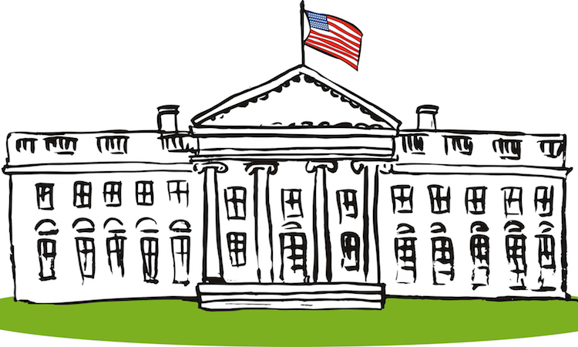
Government
Dates Taught: October 7, 2020 - October 28, 2020
Grade Level Taught: XXX
School: XXX
University of Northern Colorado
Cooperating Teacher: XXX
UNC Supervisor: XXX
St. Vrain Valley School District

Table of Contents
Title Page 1
Table of Contents 2
Rationale Statement 3
Introduction 3
Community, School, and Classroom Setting 4
Meeting the Colorado Model Content Standards 10
Assessing Student Learning 13
Unit Goal 15
Lesson Plans 16
Lesson 1 16
Lesson 2 25
Lesson 3 31
Lesson 4 36
Lesson 5 46
Extension, Modification, and Adaptive Activities 52
Instructing Students and Supporting Learning 55
Resources Used 61
Evaluative Essay 64
Reflective Essay 80

Rationale Statement
Introduction
In this unit, students will be learning about roles and functions in United States government and civil discourse. These topics give young learners the opportunity to begin to understand the way their country is run. By learning about roles and functions of the three governments found in the United States, students will gain insight on those who govern them and what those people do for the country. These discussions will include federal, state, and local governments, legislation, and voting in the United States. Having an understanding of how the country, state, and community is governed will act as a foundation for more in depth discussion of civics as students continue in their academic careers.
The other portion of this unit contains civil discourse and understanding respect in a certain way. Learners are raised to understand the importance of respect, and, throughout this unit, they will have multiple opportunities to show what they know regarding this idea and can grow. The concept of respect is simple enough to understand and acknowledge throughout your life but developing ways to implement respectful speaking and actions in everyday life can be a challenge for some. Throughout this unit, students will be involved in discussions regarding civil discourse and practice with their peers. The discussions and social interactions will be a platform for students to learn and grow as global thinkers who can use their voice and actions to impact the world around them.

Community, School, and Classroom Setting
This school year has been looking different to those of the past with COVID-19. St. Vrain schools turned to virtual learning for the beginning part of the school year. My class utilized Schoology as a platform for students to receive and hand in assignments. Along with Schoology, SVVSD implemented Cisco Webex as a virtual meeting platform for classes to meet each day for instruction. This was a change from what was seen at the end of last school year when the stay-at-home mandate was first introduced. Class meetings were not a requirement and most instructional assignments were given to make sure students were retaining what they had already learned throughout the year. Now, with professional development courses created and more time to plan, teachers and schools have been able to create a functioning classroom virtually.
As of October 5, schools in St. Vrain have created a hybrid model where students are split into three separate groups. One group attends school, in person, on Mondays and Wednesdays, with the other group attends school, in person, on Tuesdays and Thursdays. On the days students are not in person, they participate in at-home learning, with two synchronous meetings throughout the day for direct instruction. The third group in this model consists of students with Individualized Education Plans (IEPs) or staff students. This group attends in person school Monday through Thursday. With this shift in learning, there have been challenges with participation, attendance, and motivation.
Alpine Elementary School IB World School is in the St. Vrain Valley School District. Found in the northeastern part of Longmont, Colorado, the population is estimated to be about 97,261 as of July 1, 2019, as stated by the Census. This population percentage has grown 12.7% since April 1, 2010, and continues to see growth in 2020. As stated by the Census, an estimated 88.1% of the population identifies as white alone, with other race origins being black or African American alone, American Indian, and Alaska Native alone, Asian alone, two or more races, and Hispanic. Alpine has many of their students coming from low-income families. More than half of the student population is on the free and reduced lunch program.
Looking into Alpine Elementary, this school holds a great deal of diversity in its students. With an estimated 68% of the student population identifying as white, approximately 33% identify as Hispanic, with the remainder being considered “other.” With a student enrollment of PK-5 in 2018-2019, the attendance rate as stated by the Colorado Department of Education, came out to be 94.27% with a truancy rate of 1.04%. Alpine is a school that struggles with attendance and behavior in their students. Alpine Elementary and St. Vrain have begun to combat these student absences with attendance policies, such as weekly attendance goals and monitoring by attendance liaisons, put in place to hope for increased attendance from these students. This has been an issue so far in the school year seeing as students have been at home participating in virtual learning. The attendance policy states that if students have logged on for their class meetings, submitted work on the class's instructional platform or a parent has marked them as present then they are considered present. As we transitioned into a hybrid learning environment, the same attendance policy has been in place for days students are at home engaging in virtual learning; however, with students returning to the classroom for a part of the week, these attendance issues have been addressed and are continually being worked on.
In my classroom, we currently have twenty-seven students - fifteen males and twelve females. Among those twenty-seven, eleven students receive reading support, six students are English Language Learners (ELL), six students are currently on Individualized Education Plans (IEP), one student is Gifted and Talented (GT) and one student with a 504 plan. Having this large of a class with various needs for support, many students are pulled out of class to work with paraprofessionals, special education teachers, and ELL instructors. Many accommodations and modifications are given to students who are pulled from the classroom, as they are missing instructional time that is necessary for completing assignments and activities. Accommodations have also been made for students who are working at a lower grade level. It is common to see many students with IEPs working on lower grade-level work than what is being taught in the general education classroom. As opposed to having students completely sit out on activities and learning opportunities when they return to the general education classroom, worksheets and assignments have been created at their grade level to provide multiple learning opportunities throughout the day.
With virtual learning, these students were required to log on to Webex to meet with other educators to gain needed support. This gave students the opportunity to not miss out on any general education content, as meeting times were outside those of general education. However, with returning to school through a hybrid model, students with an IEP have the option to come to school Monday through Thursday. This allows students to meet with support instructors throughout the day but pulls them out of the general classroom. As the change to instruction has appeared, students attend two Webex meetings per day. One in the morning for direct math instruction and one in the afternoon for direct language arts instruction. These meetings ensure students are getting the direct instruction necessary to complete assignments and grow in their learning. Unfortunately, synchronous learning times do not lend themselves to one-on-one support with students. If students require clarification or support on topics and skills, it is encouraged that they come to school the following day with any questions or concerns they have. This is slowly turning into a struggle, as St. Vrain has recently announced students may choose to learn at home while only attending synchronous learning meetings. Yet another challenge that we are face to face with and we must think fast to provide support for students who choose this method of learning.
Each student has an iPad, where they can access Schoology for all their assignments and Webex to tune into class meetings while they are at home. Many assignments are completed through Schoology as opposed to the traditional pencil and paper.
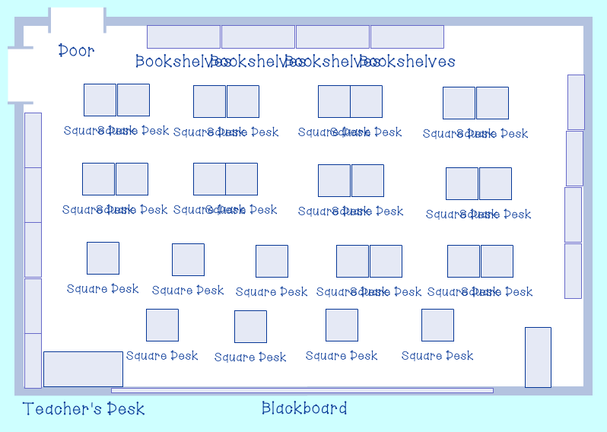
COVID-19 restrictions have made it difficult for such a large class to function all together in the classroom, but it has been made possible. Students sit around two feet apart from one another, each facing the board as shown in the diagram and pictures below.

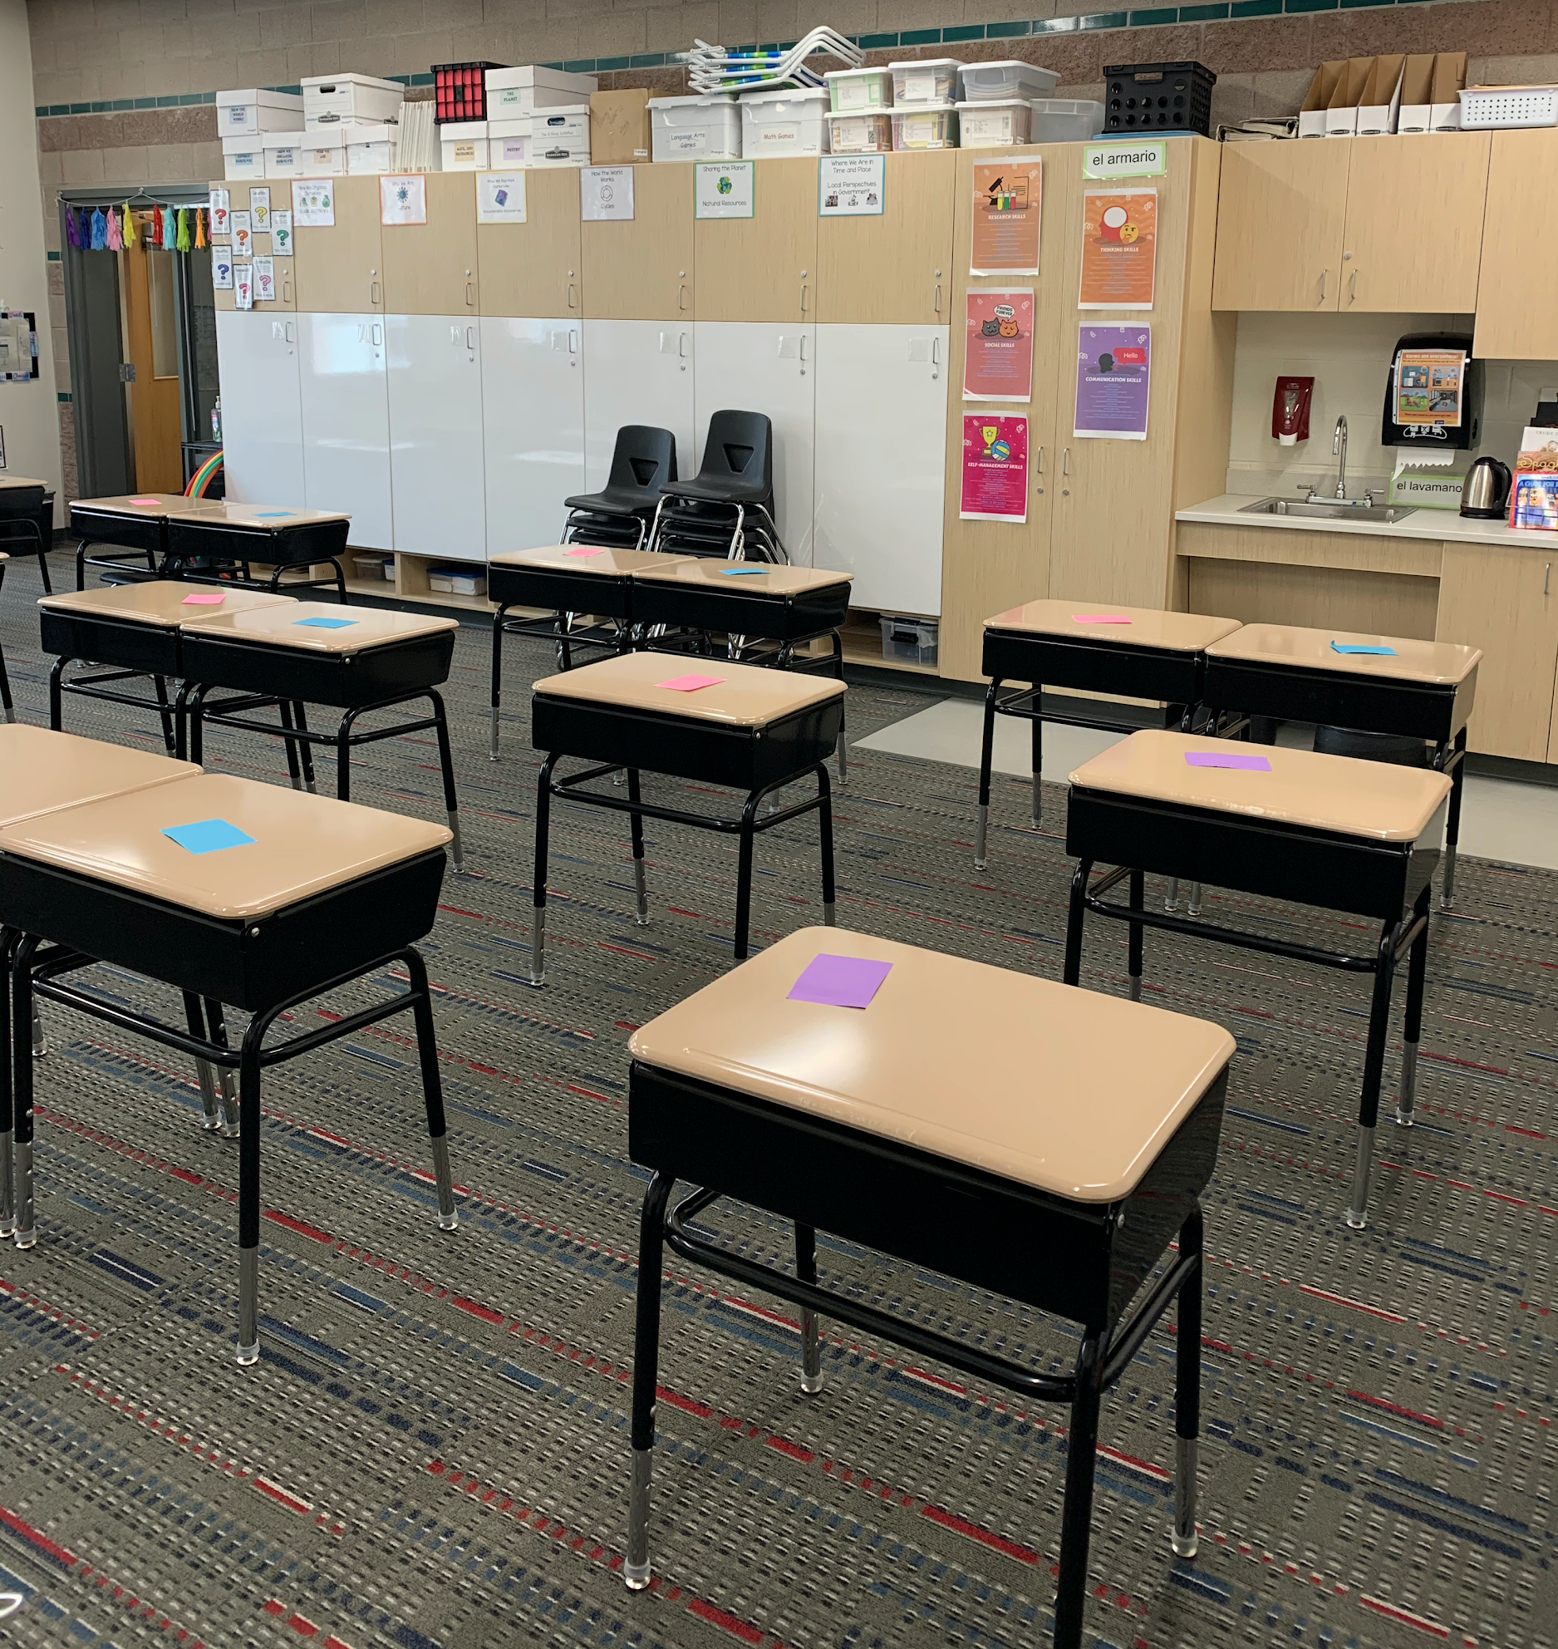
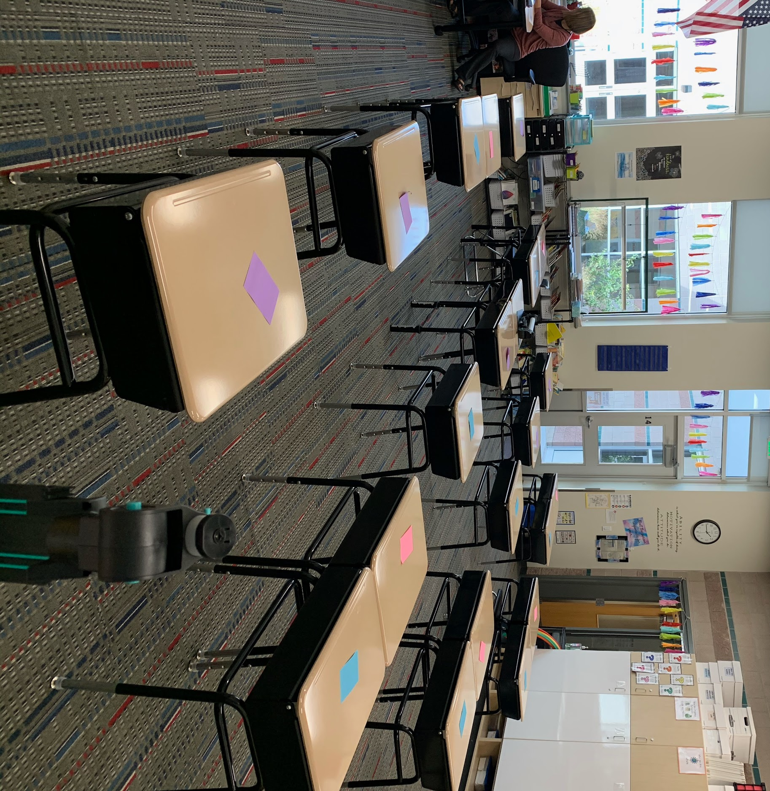
It is clear to see through the diagram and pictures that this classroom is relatively crowded. Fitting twenty-seven desks, two teacher desks, and multiple bookshelves was a challenge, but we managed to make it possible. No two students sit directly next to each other on a given day. With students being split up into groups, we were able to make sure students on separate days had their desks next to one another, while students who attend in person school every day have their own desk isolated from others. The layout of the classroom has proven difficult to ensure students have partners to “turn and talk” to during class discussions, as students must remain socially distant from each other. Working with a partner while being “socially distant” is a common phrase used in class, and students have grown used to having to stand and talk with a group or finding a space on the floor to spread out and talk.
To provide accommodations, understanding needs based on previous years of school was in the forefront of mine and my cooperating teacher’s mind when creating the seating chart. All students who attend school each day are closer to the front, which aligns with many needs found on their IEPs and 504 plans. Changes have been made to our initial seating chart to ensure students are set up for success.
Meeting the Colorado Model Content Standards
Content Area: Social Studies
Standard 4. Civics
- 4.1a Identify and apply the elements of civil discourse. For example, listening with respect for understanding and speaking in a respectful manner.
Learning Objective:
Students will be able to construct respectful responses to at least 2 student’s posts on a discussion board using a teacher created checklist.
- 4.1b Identify important personal rights in a democratic society and how they relate to others’ rights.
Learning Objective:
Students will be able to explain the importance of personal rights using a video or audio recording, as measured by 2/3 on a teacher created checklist.
- 4.1d Restate the view or opinion of others with their reasoning when it is different from one’s own.
Learning Objective:
Students will be able to restate at least 2 other student’s ideas they agree with and 2 other student’s ideas they disagree with on a discussion board as measured by a teacher created checklist.
- 4.2a Identify the origins, structures, and functions of local government.
Learning Objective:
Students will be able to identify origins, structures, and functions of local, state, and national government by filling out a graphic organizer with at least 2 accurate statements per section.
- 4.2d Describe how the local government provides opportunities for people to exercise their rights and initiate change.
Learning Objective:
Students will be able to identify three ways to initiate change in their local government with 2/3 accuracy on an exit ticket.
Content Area: Reading, Writing, and Communicating
Standard 1. Oral Expression and Listening
- 1.1a Engage effectively in a range of collaborative discussions (one-on-one, in groups, and teacher-led) with diverse partners on grade 3 topics and texts, building on others’ ideas and expressing their own clearly.
Learning Objective:
Students will be able to compose 4 responses to different students that build on other’s ideas and express their own ideas clearly, with ¾ accuracy using a teacher created rubric.
Content Area: Mathematics
Standard 3. Data, Statistics, and Probability
- 3.MD.Ba Draw a scaled picture graph and a scaled bar graph to represent a data set with several categories. Solve one- and two-step “how many more” and “how many less” problems using information presented in scaled bar graphs.
Learning Objective:
Students will be able to identify features of a bar graph as measured by writing 3 true and accurate statements about the graph on an exit ticket.

Assessing Student Learning
Pre-Assessment
To understand the full scope of what my students understand moving into my unit, I will be administering a pre-assessment. This assessment will be given to each student in the form of a Google Form. This form will resemble that of a traditional pencil and paper test, utilizing multiple choice questions and short answer questions.
The pre-assessment will include eight questions, all of which will directly correlate with the standards each lesson is based on. This assessment will be out of sixteen points. Students will receive partial credit for questions that require multiple answers. This will allow me to understand what ideas and concepts students know beforehand to better my instruction and deepen any pre-existing understanding they have beforehand.
Students will be given the pre-assessment on Tuesday, October 6. Please find a Google Doc version of my pre-assessment here and the worksheet for question one here.
Formative Assessment
Throughout the unit, many opportunities for formative assessment will be given. An example of this is students will be asked to write any questions or wonders they have so further instruction or reteaching may be given. Exit tickets will also be a way to assess students to make sure students have met the lesson objective for the day.
Students will also be using Fist of Five to self-assess throughout lessons. This is a tool student are familiar with and will give a better idea of how students are feeling regarding material or a certain concept to drive any reteaching or clarification that may be needed.

Summative Assessment
Students will be given the same Google Form assessment they took as a pre-assessment. The data given from this post assessment will allow me to see how students have grown throughout the unit. Students will have met their objectives and standards if they score 70% or above on the assessment, which is eight out of eleven points. The scoring of this summative assessment will mirror that of the pre-assessment to ensure that students are accurately assessed.
Students will be given the post assessment on October 29 and November 2.

Unit Goal
The overall goal for exploring this unit is for students to build an understanding of the United States government, especially local government, that utilizes any background students have regarding their community while developing skills rooted in reading, writing, and mathematics. By constructing lists of ideas and background knowledge, learners will engage in activities that require them to identify parts of federal, state, and local government. This will provide students the opportunity to acquire and examine information that will guide them towards a better understanding of what the United States government does for citizens. Through transdisciplinary content, students will understand their role in the government and ways they can continue taking action in the world.
As students continue to develop an understanding of what those in government do for the country, they will engage in social practices that allow for them to practice utilizing respectful language in their own lives. Students will be given the opportunity to put into action how they can use civil discourse in various situations, along with building an understanding of how those in government converse. Students will be able to take this concept further by developing an understanding that they can restate others’ ideas in their own words to respond and build on with their own thinking.

Lesson Plans
Lesson Plan XXXX
Lesson Title: Introducing the Branches of Government
Academic Standard/Learning Goals:
4.2a Identify the origins, structures, and functions of local government.
Specific Objectives:
Students will be able to identify origins, structures, and functions of local, state, and national government by filling out a graphic organizer with at least 2 accurate statements per section.
Materials Needed:
Teacher Materials:
Learning Goal & Opening Activity Slide Show
Anchor Chart Paper
Markers
Venn Diagram
Schoology app
Student Materials:
Tablet
Schoology app
Whiteboard
Dry Erase Marker
Anticipatory Set:
The teacher will begin the lesson showing students a PowerPoint, asking them to pair up with a partner. The teacher will have a question on the board, asking students to brainstorm a list of people in a school and what their primary duties/jobs are. After 2 minutes of thought time, the teacher will have students share ideas they came up with in their groups. The teacher will write these ideas on the board during the whole class discussion. The teacher will explain how different jobs in the schoolwork together to ensure that the school is run successfully and how this is the way our governments are run.
Procedure:
- The teacher will ask students to pair up with a partner.
- The teacher will introduce a discussion question and have students come up with at least 2 ideas per group.
  - Brainstorm a list of different people in a school and their primary duties/jobs.
    - Ex: teachers, principal, dean of students, health clerk/nurse, counselors, custodians, cafeteria workers, etc.
- After 5 minutes, students will return to their seats and be asked to share ideas they came up with.
  - The teacher will write down these ideas on the whiteboard.
  - The teacher will keep a class checklist to record students who share during the lesson.
- The teacher will introduce how different jobs in the schoolwork together to ensure that the school is run successfully.
- The teacher will explain how the government works in a similar way.
- The teacher will explain that today the class will be learning about different roles and functions of government!
- The teacher will create an anchor chart and begin discussing roles and functions of the federal government.
  - The teacher will include these main points:
    - The three branches of government - legislative, executive, and judicial
  - The teacher will introduce each branch of the federal government and ask students if they have heard of it or not by giving a thumbs up or a thumbs down.
      - If students give a thumbs up, the teacher will ask students to share what they know about that branch.
  - The teacher will introduce roles and functions of each branch of the State government.
    - The roles in those branches: legislative includes the Senate and House of Representatives (Congress), executive includes the President and Vice President, and judicial includes the United States Supreme Court
    - The functions of those roles: Congress creates laws, the President and Vice President carry out laws, and the Supreme Court interprets laws
  - The teacher will ask students if they have ever heard of any of these roles before.
    - Students will share if they have heard the terms before and what they know about the roles.
  - The teacher will ask students to think about the verbs in each function carefully to see if they know what the function means.
    - The teacher will have students share with an “elbow” partner what they think the function means.
    - As a class, the teacher and students will explain what each function means.
- Students will be asked to give a Fist of Five to personally assess how much they understand the content discussed so far.
  - Students will give a 1 if they do not feel they understand the material at all.
  - Students will give a 2 if they feel they are somewhat understanding the material but need reteaching and clarification.
  - Students will give a 3 if they feel they understand the material but have some clarification questions.
  - Students will give a 4 if they feel they understand the material adequately.
  - Students will give a 5 if they feel they comprehend the material completely and would be able to teach another student the material.
  - The teacher will take into account how well students understand the material so far and go back to further explain as needed.
- The teacher will create another anchor chart for the roles and functions of state government.
  - The teacher will include these main points:
    - The three branches of state government and important roles:
      - Legislative: the state legislature
      - Executive: the governor
      - Judicial: the Colorado Supreme Court
  - The teacher will introduce each branch of the State government and ask students if they have heard of it or not by giving a thumbs up or a thumbs down.
    - If students give a thumbs up, the teacher will ask students to share what they know about that branch.
  - The teacher will introduce functions of each branch of the State government.
    - The functions of these branches/roles:
      - The state legislature creates state laws
      - The governor carries out these laws
      - The Colorado Supreme Court interprets laws
    - The teacher will ask students to think about the verbs in each function carefully to see if they know what the function means.
      - The teacher will have students share with an “elbow” partner what they think the function means.
      - As a class, the teacher and students will explain what each function means.
  - Students will be asked to give a Fist of Five to personally assess how much they understand the content discussed so far.
  - The teacher will take into account how well students understand the material so far and go back to further explain as needed.
- The teacher will create a third and final anchor chart for the roles and functions of a local government.
  - The teacher will include these main points:
    - The important roles:
      - The mayor
      - The city council
  - The teacher will ask students if they have heard of either of these terms before by standing up if they have.
    - The teacher will ask students to share what they know about these roles.
  - The teacher will introduce the functions of each role of Local government.
    - The functions of these roles:
      - The mayor is like a governor or president but with less power. They help lead meetings and votes for city council.
      - The city council is made up of many members. Together these members oversee police departments, fire departments, schools, and create schedules for things like garbage pick-up and how often roads are cleared from snow.
  - Students will be asked to give a Fist of Five to personally assess how much they understand the content discussed so far.
  - The teacher will take into account how well students understand the material so far and go back to further explain as needed.
Closure:
- The teacher will show students the slide with the day’s learning goals on it.
- The teacher will ask students to reflect on the lesson and to think about what the goal was for the day. Then students will be asked to give a final Fist of Five - do you feel you understand different roles and functions in a Federal, State, and Local government?
  - The teacher will record any students who give a 2 or lower.
- The teacher will introduce students to a Venn diagram assignment.
  - The teacher will explain that students are going to think about the different governments and come up with similarities and differences between them all.
  - Students will be asked to complete this worksheet by writing at least 2 ideas in each section.
- The teacher will give students time to work in class. If students do not complete the assignment at school, they will finish the worksheet at home and turn it into the Schoology assignment.
Assessment:
To check for understanding and assess students, students will be asked to give a Fist of Five to show how well they feel they are understanding the material. This is an informal assessment that will drive the teacher to reteach or explain concepts further if needed. Students will be given a formative assessment to assess students' understanding regarding the standard and objective, where they will be asked to complete a Venn diagram worksheet on Schoology. Students must include at least 2 accurate statements in each section of the Venn diagram.
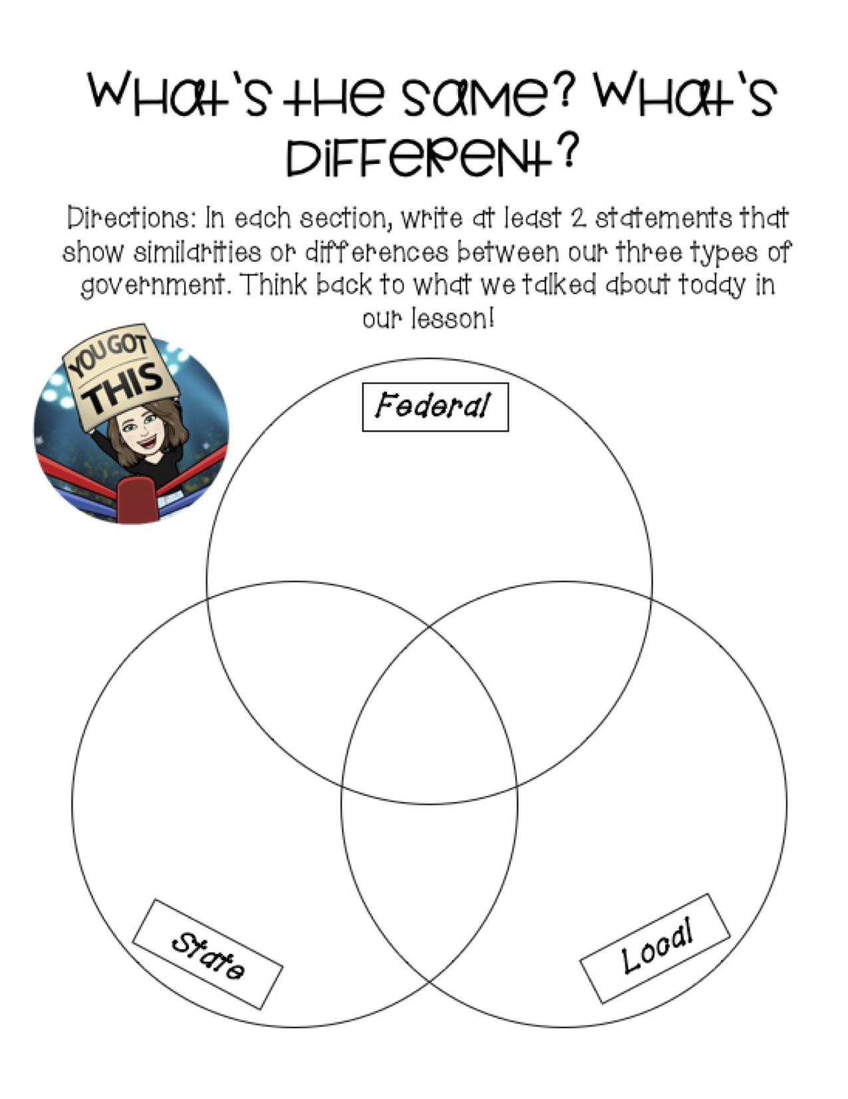
Extensions, Modifications, and Adaptive Activities:
If students feel as though they are confident in the material and want to challenge themselves, they will be directed toward https://www.icivics.org/games/counties-work to explore the functions of local government and what it takes to run a county.
Students who are in need of modifications will be asked to fill in the Venn diagram with at least 1 statement per section as opposed to 2 statements. Students will be provided with visuals during the lesson to allow for better understanding. This will allow for students to see a picture of the concept at hand to better connect and understand the idea.
Resources - Technology Links & References:
“Counties Work.” ICivics, https://www.icivics.org/games/counties-work.
“City of Longmont, Colorado.” City of Longmont, Colorado | Home, www.longmontcolorado.gov/.
“Local Government for Kids.” Miacademy Learning Channel, 25 June 2020, www.youtube.com/watch?v=gs6lqZEe4Rk.
Understanding Our Government. Macmillan/McGraw-Hill, 2009.
“Virtual Campaign Google Slides Theme & PowerPoint Template.” Slidesgo.Com, 2020, slidesgo.com/theme/virtual campaign. Accessed 7 Oct. 2020.
‌

Lesson Plan #2
Teacher: Alison XXX
Lesson Title: R-E-S-P-E-C-T
Academic Standard/Learning Goals:
4.1a Identify and apply the elements of civil discourse. For example, listening with respect for understanding and speaking in a respectful manner.
Specific Objectives:
Students will be able to construct respectful responses to at least 2 student’s posts on a discussion board using a teacher created checklist.
Materials Needed:
Teacher Materials:
Schoology app
Padlet
“Respect” by Mini Pop Kids
“Bridge” video
Respect Slideshow
Express Your Opinion: Agree & Disagree Sentence Frames Chart
Student Materials:
Tablet
Schoology app
Anticipatory Set:
The teacher will begin the lesson by playing the song “Respect” by Mini Pop Kids as students come in from recess and get settled in their seats. Once students are in their seats, the teacher will explain that the class will be talking about respect today. The teacher will introduce the objective students will be working towards - Students will be able to construct respectful responses to at least 2 student’s posts on a discussion board using a teacher created checklist.
Procedure:
- The teacher will show students the short film “Bridge.”
  - Before playing the video, the teacher will ask students to be thinking about the word respect - what does it look like? What does it sound like?
- Once the video ends, the teacher will direct students to a Padlet on Schoology.
  - Students will be asked to post on the Padlet their ideas of what respect is, what respect looks like, and what respect sounds like.
- As the students begin to post their ideas, the teacher will begin a discussion with the class about the student's ideas on what respect is.
- The teacher will pull up the Respect slideshow. Together, the class will go over various scenarios in which respect can be shown.
  - The teacher will introduce each scenario and ask students to take a moment to think about ways they could demonstrate respect for each situation.
  - Once students have shared ideas for the respective situations, the teacher will have students practice different ways they could speak and act respectfully with an “elbow” partner.
- The teacher will introduce ways to respectfully share opinions - whether they disagree or agree with someone’s idea/opinion.
  - The teacher will show a variety of sentence frames for agreeing and disagreeing respectfully.
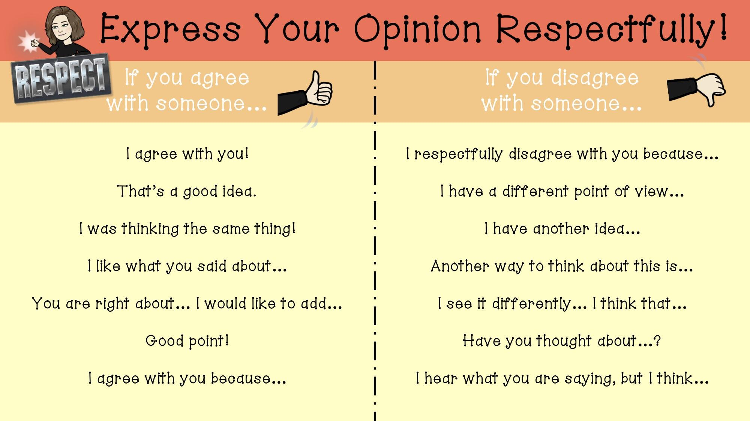
- The teacher will pose a question to the class.
  - Is it okay to disagree with someone?
  - The teacher will ask students to share thoughts and guide a discussion on how differing opinions are okay, but it is important to always be respectful no matter if someone agrees or disagrees with an idea.
Closure:
- The teacher will ask students to give a Fist of Five to how confident they feel in their ability to utilize the sentence frames and skills practiced during the lesson to respectfully speak to others.
  - Students will give a 1 if they do not feel they understand the material at all.
  - Students will give a 2 if they feel they are somewhat understanding the material but need reteaching and clarification.
  - Students will give a 3 if they feel they understand the material but have some clarification questions.
  - Students will give a 4 if they feel they understand the material adequately.
  - Students will give a 5 if they feel they comprehend the material completely and would be able to teach another student the material.
- The teacher will show students a discussion board on Schoology.
  - The teacher will introduce an assignment for students to complete.
    - Students will be asked to make a post on the discussion board answering the question “You accidentally ate some radioactive pizza. The good news is it tasted wonderful! However, you wake up the next morning and find out you can read people’s minds! Is this the best superpower you could get?” They will also be asked to reply to one person whom they agree with and one they disagree with. They must respond respectfully, using skills and ideas learned in the lesson.
- The teacher will discuss the rubric being used for this assignment.
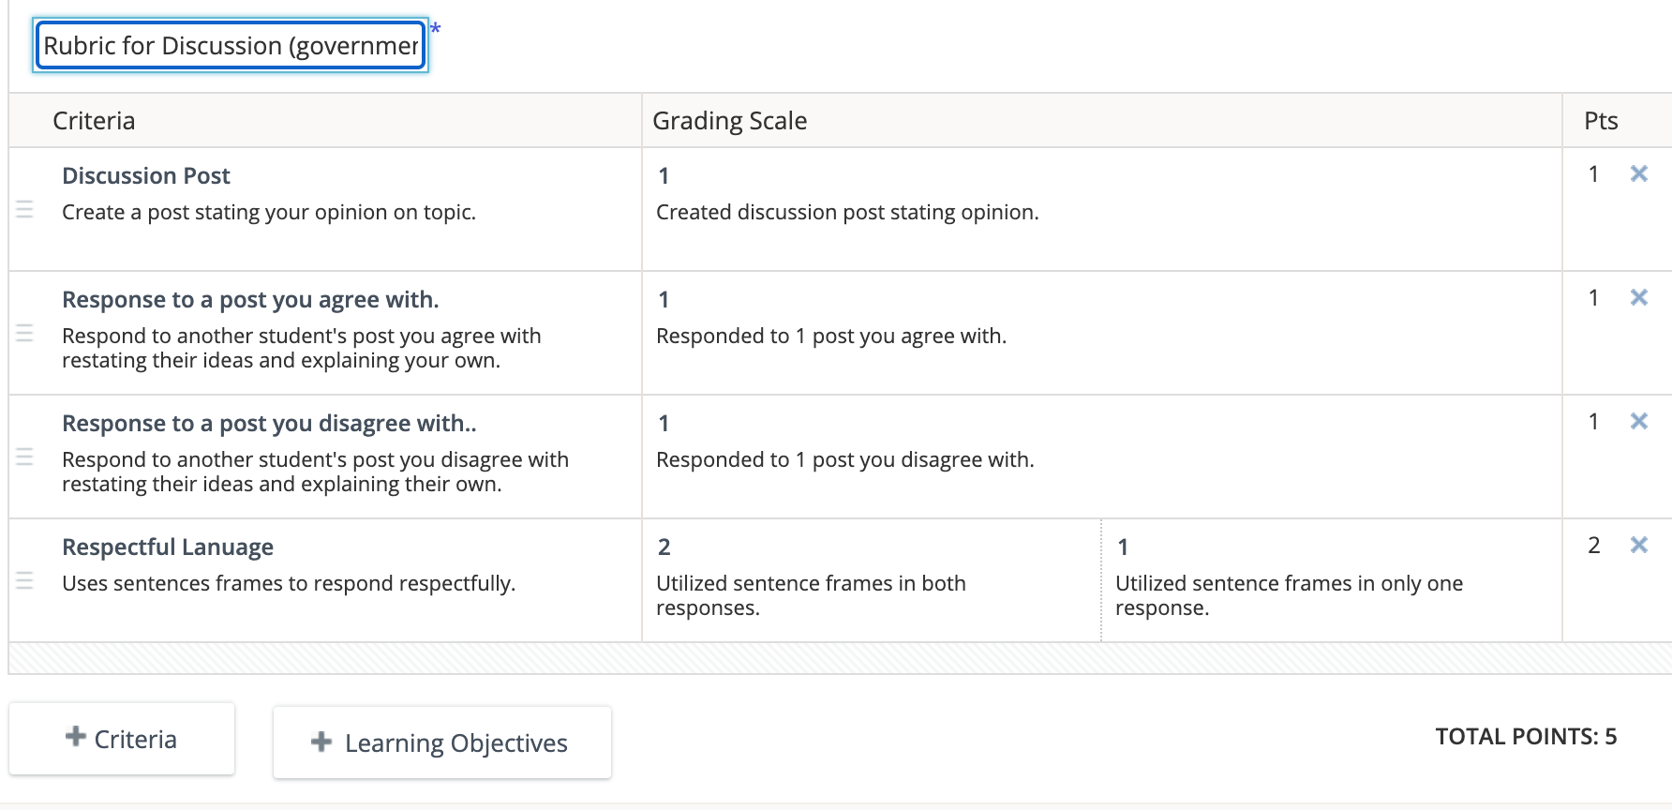
- Students will have remaining time in class to work on their discussion board post. Any work not completed in class will be available for them to work on at home.
Assessment:
To check for understanding and assess students, they will have multiple opportunities to show what they know. For example, students will be asked to post on a Padlet examples of respect that they saw while watching the short “Bridge.” This will allow the teacher to see what students’ background knowledge of respect is and what they deem to be respectful. Students will orally practice concepts discussed in class. For example, during the Respect slideshow, students will have the opportunity to practice various ways they could demonstrate respect with an “elbow” partner.
As a formative assessment, students will be asked to post one post on a discussion board sharing their opinion from the question “You accidentally ate some radioactive pizza. The good news is it tasted wonderful! However, you wake up the next morning and find out you can read people’s minds! Is this the best superpower you could get?” Students will then be expected to respond to at least one post they agree with and one they disagree with. They will be expected to respond respectfully, using skills and sentence frames discussed in class.
Extensions, Modifications, and Adaptive Activities:
Students who need an extension will be asked to write a journal entry on why they believe respect is important in government. Thinking back to various roles and functions of systems of government, students will think of ways in which it is important to use respectful language and actions in those roles. This will allow for students to think ahead at potential conflict that may arise in government and how those in the roles of government jobs use respectful techniques to solve problems. Students are encouraged to discuss this topic with family members at home. This journal entry will be completed in the student’s composition notebook. Students will be asked to upload a picture of their response to an assignment in Schoology.
Students will be given sentence frames for the assignment, to allow students to focus on their ideas regarding restating and explaining. Some students will also have the option to use the speech to text feature on their tablet, as deemed appropriate by the teacher.
Resources - Technology Links & References:
“School Assignments Google Slides and PowerPoint Template.” Slidesgo.Com, 2020, slidesgo.com/theme/school-assignments.
Tey, Ching Tian, director. Bridge. Youtube, 2017, www.youtube.com/watch?v=_u1vQ7Mh4Sk.
Youtube, Mini Pop Kids, 15 Nov. 2018, www.youtube.com/watch?v=n0PGwhf8pMc.
Lesson Plan #3
Teacher: XXXX
Lesson Title: What’s a bill? What’s a law?
Academic Standard/Learning Goals:
4.1d Restate the view or opinion of others with their reasoning when it is different from one’s own.
1.1a Engage effectively in a range of collaborative discussions (one-on-one, in groups, and teacher-led) with diverse partners on grade 3 topics and texts, building on others’ ideas and expressing their own clearly.
Specific Objectives:
Students will be able to restate at least 2 other student’s ideas they agree with and 2 other student’s ideas they disagree with on a discussion board as measured by a teacher created checklist.
Students will be able to compose 4 responses to different students that build on other’s ideas and express their own ideas clearly, with ¾ accuracy using a teacher created rubric.
Materials Needed:
Teacher Materials:
Schoology app
“How a Bill Becomes a Law” Video
Express Your Opinion: Agree & Disagree Sentence Frames Chart
Agree/Disagree Signs
Padlet
Student Materials:
Tablet
Schoology app
White Board
Dry Erase Marker
Anticipatory Set:
The teacher will begin the lesson by asking students to think about different rules the school and classroom has. Students will get two minutes to think of any rules and write their ideas down on a white board. The teacher will ask students to share their ideas. The teacher will write down different rules on the board from student suggestions. (Examples could include no running in the halls, masks must be worn at all times except for mask breaks and recess, raise your hand in class, etc.)
Procedure:
- The teacher will ask students to think about one of the rules and decide whether they agree or disagree with it.
- The teacher will use one of the topics and ask Mrs. Drangeid to state whether she agrees with the rule and why, with the “Express Your Opinion” chart projected on the board.
  - The teacher will model how to restate the opinions and ideas of others by responding to Mrs. Drangeid’s opinion, restating the idea, and then explaining whether they agree with it and why.
- The teacher will choose another rule from the list of student created school/class rules.
- The teacher will ask students who disagree to move to a designated side of the classroom, while those who disagree will move to the opposite side of the classroom.
  - The teacher will ask students to discuss with their groups about why they agree or disagree and come up with 5 reasons.
- After students have had time to discuss, the teacher will ask students in both groups to choose two spokespeople to share their explanations.
- The teacher will ask one student from the “agrees” side to restate the rule and explain why they agree or disagree.
  - The teacher will have the Express Your Opinions Sentence Frames Chart up on the board for students to refer to.
- After one student from the “agrees” side shares their reasoning, the teacher will ask one student from the “disagrees” side to restate what they heard from the student on the “agrees” side and explain why they disagree.
  - The teacher will ask one more student from each side to share their opinions, while restarting the other side’s ideas.
- The teacher will ask students to return to their seats and begin to discuss what a bill is and what a law is.
  - The teacher will show the class “How a Bill Becomes a Law” video and ask students to be looking for what a bill is, what a law is, and what the differences between the two are.
    - Before the video plays, the teacher will ask students to be thinking about how restating opinions could be useful as we discuss bills and laws.
    - A bill is an idea that has not been voted on yet, a law is a bill that was voted on and is a rule. The difference between them is that a bill turns into a law, they are both ideas, but one has been voted on while the other has not been.
- The teacher will lead a discussion on what students heard in the video and what they believe a bill and a law are.
  - The teacher will write down the student definitions of a bill and a law on this slide's presentation.
- The teacher will pose a question to the students.
  - How do you think restating an opinion, like we practiced earlier with our school rules, would be important when discussing bills and laws?
  - Students will take some time to think and then write their ideas on a Padlet.
    - Ex: It is important to recognize others’ ideas especially when it could affect the whole state or country.
Closure:
- The teacher will show students the objective for the lesson and have students reflect on the lesson. Students will be asked to show a Fist of Five with how comfortable they feel with the content.
  - Students will give a 1 if they do not feel they understand the material at all.
  - Students will give a 2 if they feel they are somewhat understanding the material but need reteaching and clarification.
  - Students will give a 3 if they feel they understand the material but have some clarification questions.
  - Students will give a 4 if they feel they understand the material adequately.
  - Students will give a 5 if they feel they comprehend the material completely and would be able to teach another student the material.
  - The teacher will take account of any students who give a 2 or lower - this will aid in any reteaching or support needed from the teacher.
- The teacher will introduce the assignment. Students will be asked to post on a discussion board one problem or issue they believe should be changed in the school.
  - Students will be asked to respond to two students with whom they agree with and two with whom they disagree with.
    - Students will use the discourse modeled during class to restate the idea of their classmate and respond with their reasoning on why they agree or disagree.
  - The teacher will review and discuss the rubric for this assignment, giving students specific directions and expectations for the discussion board.
Assessment:
To check for understanding and assess students, they will have an opportunity to post on a Padlet why restating opinions is useful when discussing bills and laws.
As a formative assessment, students will be expected to respond to four students on a discussion board - two they disagree with and two they agree with. Students will use respectful language and explain their thinking. Students will be scored based on the checklist below.

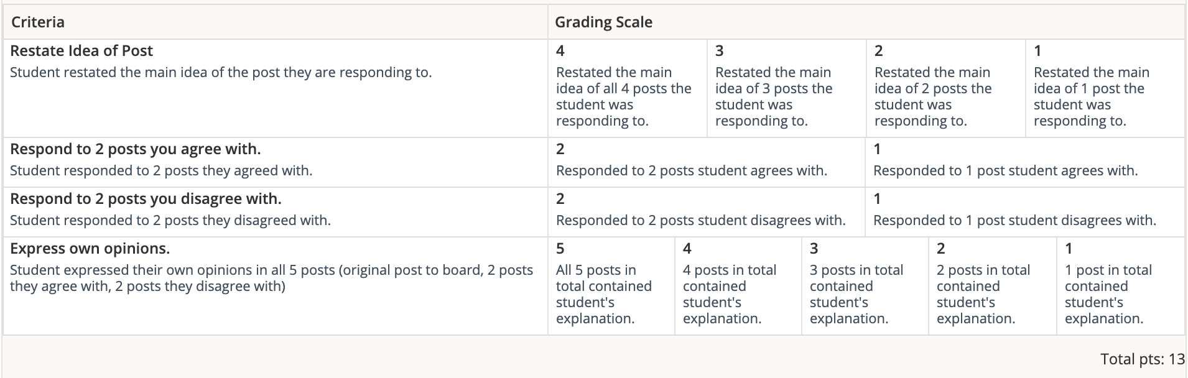
Extensions, Modifications, and Adaptive Activities:
Students who need an extension will be instructed to visit https://www.icivics.org/games/branches-power and play the game. This game will further explore the process in which a bill becomes a law.
Sentence frames will be provided for students to use during class discussion and the discussion board assignment to help focus on ideas for the discussion board. Some students may use the speech to text feature on their tablet, as deemed appropriate by the teacher.
Resources - Technology Links & References:
“Branches of Power.” ICivics, www.icivics.org/games/branches-power.
“Schoolhouse Rock - How a Bill Becomes a Law.” Youtube, 30 May 2010, www.youtube.com/watch?v=Otbml6WIQPo.

Lesson Plan #4
Teacher: XXXX
Lesson Title: Vote!
Academic Standard/Learning Goals:
4.1b Identify important personal rights in a democratic society and how they relate to others’ rights.
3.MD.Ba Solve one- and two-step “how many more” and “how many less” problems using information presented in scaled bar graphs.
Specific Objectives:
Students will be able to explain the importance of voting using a video or audio recording, as measured by ⅘ on a teacher created checklist.
Students will be able to identify features of a bar graph as measured by writing 3 true and accurate statements about the graph on an exit ticket.
Materials Needed:
Teacher Materials:
Schoology app
Choice Board
Voting! by Eileen Christelow Read Aloud Video
Voting! Note Catcher
Padlet
Graphs
Exit Ticket
Traffic Light Self Reflection
Sticky Notes
Student Materials:
Tablet
Schoology app
Voting! Note Catcher
Voting! by Eileen Christelow Read Aloud Video
Anticipatory Set:
The teacher will begin the lesson by asking the students to vote on ideas. “Is pizza the best food in the world?” Students who agree will raise their hand, those who do not will keep their hand down. The teacher will continue to ask these questions. The teacher will explain how the students just participated in voting!
Procedure:
- The teacher will introduce station rotations to the students.
  - Students will be split into 2 groups. Groups will explore each station for 20 minutes each.
Day 1:
Group 1 | Group 2
1  11  5  13  14  15  16  17 | 2  3  4  6  7  8  9  10  12

Day 2:
Group 1 | Group 2
18  19  22  24  27 | 20  21  23  25  26

Station #1: Vote! | Station #2: Exploring Polls
- Students will listen to Vote! by Eileen Christelow.  - Read aloud video  - While listening, students will be expected to write notes, wonderings, and questions on a note catcher.  https://docs.google.com/document/d/1ixO-WoRLXApijS0usTeKRXrmJQkt1wolLyaJ4LZLJUA/edit?usp=sharing  - As students finish, they will be directed to a Padlet where they will post 1 interesting fact and 1 question/wonder they have.  - https://padlet.com/waara_alison1/20g5fdov39x2l0a9 | - Students will join the teacher and begin analyzing bar graphs.  - The teacher will have students look at a graph and take a moment to analyze and think about what they notice.  - Different words, colors, shapes, etc.  - The teacher will provide guided questions for students to understand graph features better.  - What information do the colors tell us? What information do the numbers on the side tell us? What information do the words on the bottom tell us? What types of things will this graph give us information on?  - The teacher will introduce students to these various features of a graph, based on student knowledge.  - Once students are familiar with graph features, they will explore data the graph is showing.  - The teacher will be providing guided questions.  - How many females voted? How many males voted? About how many more females voted than men? How many less men who were registered to vote but didn’t are there than women?  - Students will participate in a group discussion about the pieces of data they see.  - The teacher will guide students to wonder why this data is important  - Students will be asked to share aloud and discuss with one another.  - Students will complete an exit ticket on Schoology.  - Students will be shown another bar graph where they will be asked to look at various pieces of information.  - What types of people is this bar graph showing information on? Which group has the greatest amount of people who voted? Which group has the least amount of people who voted? What does the color purple represent in this graph?

- Each station will last 17 minutes.
- Once both groups have gone through each station, the teacher will have students do a self-reflection and introduce the assignment for the night.
Closure:
- The teacher will place a sticky note on each student’s desk and have them reflect on how well they understand the concepts learned in this lesson. The teacher will present this presentation.
  - Students will write “Stop!” if they are still confused about all the concepts in the lesson.
  - Students will write “Go” if they feel they understand the concepts.
  - Students will write “Caution” if they feel they need further clarification and will be asked to write “I need help with _____.”
- Students will leave their sticky notes on their desk so the teacher can look at them after school.
- The teacher will open Schoology to show students their assignment.
- Students will be asked to create a video or audio recording stating why voting is important and why they believe people should vote.
  - The teacher will instruct students to look through their note catchers and the Padlet they posted on to find evidence on why people should vote in elections.
  - Students will also have access to the video recording of Vote! for them to look back on.
  - The teacher will go over the teacher checklist to explain specific expectations.
Assessment:
To check for understanding and assess students, they will complete an exit ticket where they are asked to identify 3 pieces of information from a bar graph. Students will also create a video or audio recording where they explain why voting is important and why people should vote. This will be measured using a rubric created by the teacher.
During the lesson, students will post on a Padlet questions and wonders they still have regarding voting. This will allow the teacher to see what ideas are still unclear for students to help with reteaching concepts, if necessary.
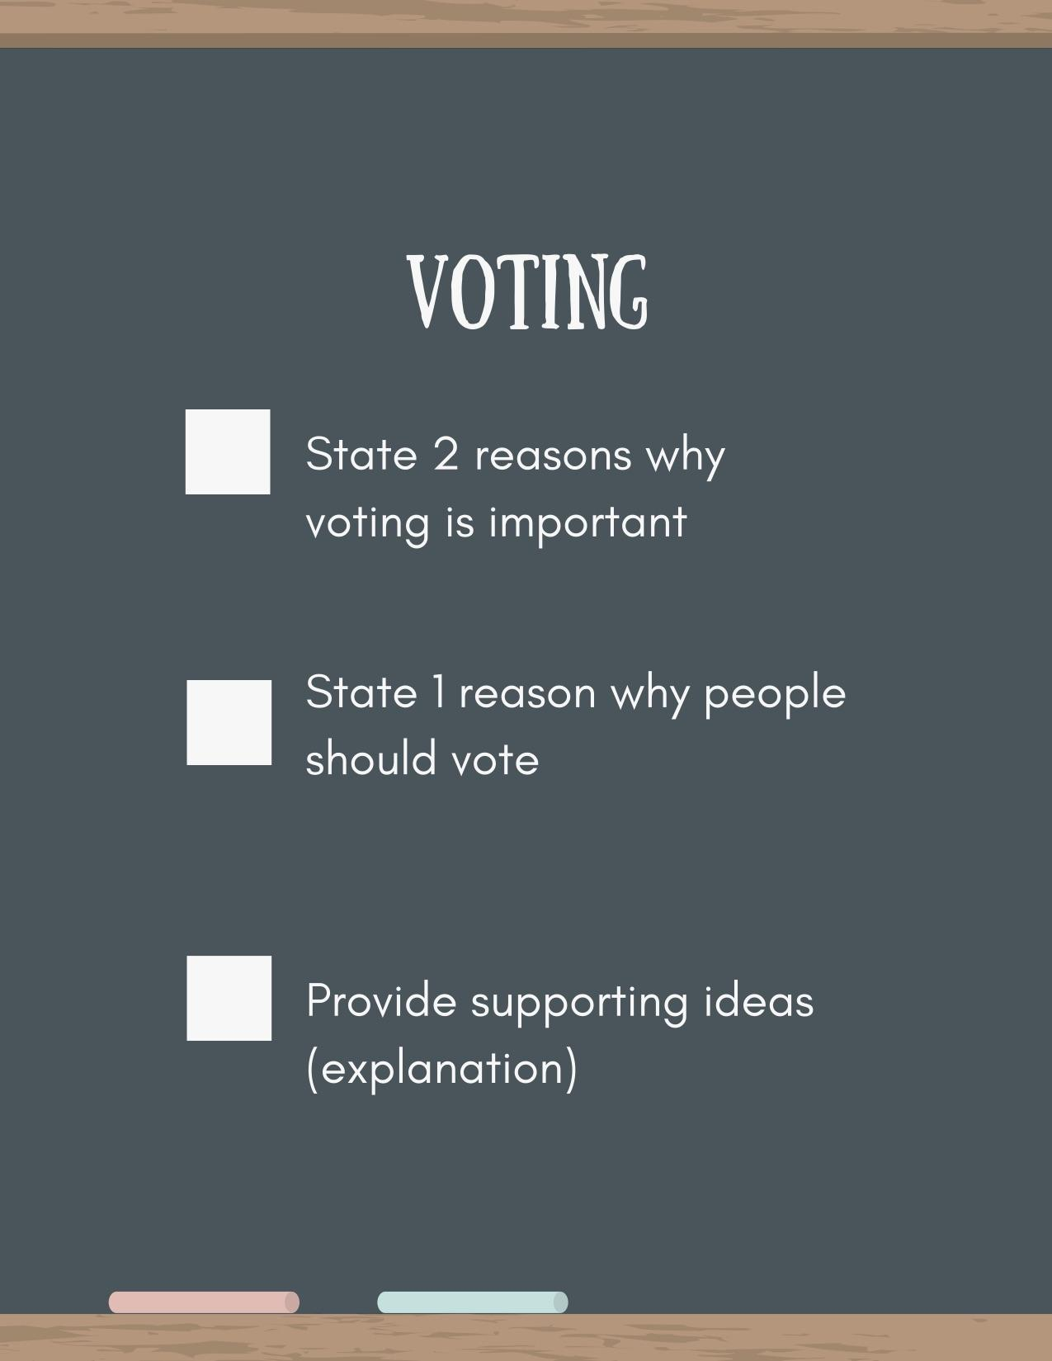

Extensions, Modifications, and Adaptive Activities:
Students who need an extension will be asked to complete a worksheet on bar graphs.
Students who want further exploration on voting can visit https://www.icivics.org/games/cast-your-vote and play the game. This game will further explore the process of voting.
Students will be split into groups where differentiation can be provided by the teacher.
Resources - Technology Links & References:
“Cast Your Vote.” ICivics, https://www.icivics.org/games/cast-your-vote.
Census Data. “Voting Trends in America, 1964-2014.” US Census, www2.census.gov/programs-surveys/sis/activities/history/eh-5_teacher.pdf.
Christelow, Eileen. Vote! Boston, Houghton Mifflin Harcourt, 2018.
“Traffic Lights Infographics for Google Slides and PowerPoint.” Slidesgo.Com, 2020, slidesgo.com/theme/traffic-lights-infographics. Accessed 10 Oct. 2020.
‌Truman, Michelle. “Driving Digital Learning.” Https://Sites.Google.Com/View/Drivingdigitallearning/Home, drivingdigitallearning.com/. Accessed 30 Aug. 2020.

‌

Lesson Plan #5
Teacher: XXXX
Lesson Title: Your Role in Local Government
Academic Standard/Learning Goals:
4.2d Describe how the local government provides opportunities for people to exercise their rights and initiate change.
Specific Objectives:
Students will be able to identify three ways to initiate change in their local government with 2/3 accuracy on an exit ticket.
Materials Needed:
Teacher Materials:
Menu Board
Tablet
Schoology app
Anchor Chart Paper
Student Materials:
Tablet
Schoology app
Anticipatory Set:
The teacher will begin the lesson by posing a question to the students. How can you initiate change and exercise your rights in local government? The students will be directed to a Padlet where they will create a response. The teacher will go through some responses on the Padlet for students to hear. The teacher will introduce the day’s topic of exercising rights and initiating change in local government.
Procedure:
- The teacher will ask students to think about what rights are and what a citizen is?
  - The students will receive a moment to think about these terms, then as a class, students will share ideas on the definition.
  - The teacher will write ideas down on the board and collaborate with students to define these terms.
    - Rights are the freedoms we have that are protected by the law.
    - Citizens are members of the community. For example, all students are citizens of Longmont and Colorado.
- The teacher will explain how citizens can use their rights to initiate change in their community. The teacher will explain that if there is a problem or issue in the community, citizens can exercise their rights to help change the problem.
- As a class, the teacher and students will create a list of ways citizens can initiate change and exercise their rights in a local government.
  - This list may include voting, volunteering, researching/keeping up to date with current events, signing petitions, protesting, etc.
  - The class will discuss this list of exercising rights and initiating change.
- The teacher will introduce the menu board to students.
  - Students will be directed toward the menu board on Schoology.
    - Link to menu board
  - The teacher will explain how students will be exploring three ways they can participate in their community and initiate change.
    - Students will explore volunteering, petitions, and researching as ways to initiate change in their community.
    - Students will have 7 minutes (subject to change) for each section of the menu board. Students can choose where they start and will follow instructions found on the menu board.
- The teacher will walk around and answer any student questions and help with students as they see fit.
- Once students have gone through all the sections of the menu board, the teacher will ask students to listen for their assignment.
- The teacher will show students their assignment on Schoology.
- Students will be asked to write a letter to the mayor, which is another way the class discussed to initiate change in their local community.
  - This letter will include at least 3 questions they have about what the class has been learning throughout the lesson.
    - This could include voting, respect in government, roles and functions of local government, bills, and laws, and exercising rights in local government.
  - Letter to mayor - October 26 group
  - Letter to mayor - October 27 group
- The teacher will explain how these questions they ask will be sent to the mayor of Longmont, Brian Bagley. The teacher will send these questions to the mayor to (hopefully) get answered and shared with students later.
- Students will submit their letter to the assignment on Schoology.
Closure:
- The teacher will give students one sticky note each and ask them to write down 3 ways citizens can initiate change in their local community. Students will leave their sticky notes on their desk for the teacher to collect.
Assessment:
During the lesson, the teacher will be able to observe students and evaluate if there is a need for clarification or reteaching when necessary. Students will also have an opportunity to write down interesting facts or questions they have as a result from researching current events. This will allow for the teacher to monitor what students deem to be important information.
To check for understanding and assess students on the standard, they will be asked to write 3 ways citizens can initiate change in their community on an exit ticket. This will be measured with a ⅔ accuracy on the exit ticket.
Extensions, Modifications, and Adaptive Activities:
If students feel as though they are confident in the material and want to challenge themselves, they will be asked to consider ways in which change can be initiated in a larger scope - the entire state. Students will be asked to do research through kidrex.com to find out more about current events in the state. Once students have researched and read 2-3 resources, they will compose a petition in which they will explain an issue that needs to be addressed in the state. Students will be expected to use evidence from their resources to support their issue.
The teacher will write definitions generated by the class on the board. Students will be asked to write at least one question they have for the mayor, as deemed necessary by the teacher. Students will also be able to use the voice to text feature on their tablet to write their letter, as deemed necessary by the teacher.
Resources - Technology Links & References:
“Activate.” ICivics, www.icivics.org/games/activate.
“Indoor and outdoor and virtual activities keeping older adults in Longmont engaged, active.” The Longmont Leader, 2 Oct. 2020, www.longmontleader.com/local-news/indoor-outdoor-and-virtual-activities-keeping-older-adults-in-longmont-engaged-active-2762023. Accessed 3 Oct. 2020.
“Kidrex.Com.” Www1.Kidrex.Com, kidrex.com/. Accessed 1 Oct. 2020.
“News | St Vrain Valley School District.” Svvsd.Org, 2016, www.svvsd.org/updates/st-vrain-valley-school-district-using-video?page=3. Accessed 3 Oct. 2020.
“Local program feeding families impacted by COVID gets cash infusion from state.” The Longmont Leader, 3 Oct. 2020, www.longmontleader.com/local-news/local-program-feeding-families-impacted-by-covid-gets-cash-infusion-from-state-2763905. Accessed 3 Oct. 2020.‌
“SVVSD to spend nearly $1M on cleaning crews when students, staff return to schools.” The Longmont Leader, 24 Sept. 2020, www.longmontleader.com/schools/svvsd-to-spend-nearly-1m-on-cleaning-crews-when-students-staff-return-to-schools-2740118. Accessed 3 Oct. 2020.
‌“Treat for downtown businesses, some Main Street barricades will remain in place until Halloween.” The Longmont Leader, 24 Sept. 2020, www.longmontleader.com/local-news/treat-for-downtown-businesses-some-main-street-barricades-will-remain-in-place-until-halloween-2739460. Accessed 3 Oct. 2020.

Extensions, Modifications, and Adaptive Activities
Extensions
In each lesson, extension activities were provided to students who desired further
practices on the ideas being taught. These extensions were provided to students through Schoology and were available for the remainder of the week the lesson was taught. Many activities consisted of games through icivics.org where students could go through processes we had discussed in class. These consisted of how bills turn into laws, functions of local government and what makes up a local government, and how to vote. Each of these activities included three reflection questions to evaluate what pieces of information they practiced and learned through these extensions. Other extensions given to students included journal entries based on actions they can take in their own life to practice skills of civil discourse and ways they can initiate change.
Each extension activity was encouraged to be done on the days students were learning from home, where they could discuss with their families’ topics of government and respect. All extension activities provided students the opportunity to further their thinking and explore the lesson content in engaging ways that promoted higher order thinking. An example of this collaborative type of extension was a reflection writing piece students regarding respectful speaking and actions in government. Students who desired an extension on civil discourse were asked to think about various roles and functions of systems of government and how the skill of respectful speaking could help those in these roles. This type of extension gave students the freedom to inquire and research more about respectful speaking and the way that translates into government roles. Setting up an opportunity for collaborative work and an open discussion with families on these topics creates a time for reflection and action in a student’s own life.
Another example of an extension was the Counties Work icivics game. These games not only promoted an engaging learning environment for students, but also required deeper thinking on the ideas presented in the lessons. Students would run a community as the mayor or city council member. This specific game enabled students to see various parts of a local government and explore the departments within each community. With such a limited amount of time in the classroom to teach social studies, these types of ideas were not explored at great length - instead, as a class, we built our understanding on the basic concept. This extension gave students the opportunity to explore on their own time what being a leader of a local government was like. In addition to simply playing the game, students were required to complete a reflection stating what concepts they learned from the game, what wonderings they still had regarding local government, and any comments or questions they wanted to share with me. These icivics games provided an exciting and informative learning experience for students looking to deepen their understanding of local government.
Modifications and Adaptations
The hybrid learning model has proven modifications and adaptations are necessary for many students. At Alpine, attendance and participation are an ongoing issue but more so now that a hybrid environment is in place. These types of changes are vital to set students up for success. With many students being pulled out of the general education classroom for small groups with special education teachers, I quickly realized changes needed to be made. For many assignments where students filled in answers, whether that be facts that they learned during a lesson or questions and wonderings they had, certain students were asked to provide fewer examples or questions. In certain cases where student participation proved to be difficult, having a verbal response or discussion with a student gave me a clearer picture of what a student was retaining from the lesson. Throughout the unit, sentence frames were given to all students to support successful learning. This became an increasingly important adaptation seeing as many assignments involved responses to classmates or teacher-given prompts. In the general classroom, sentence frames for reading responses were already implemented to support students so they could explain their thinking and ideas better. Another adaptation I made available to students who needed it was the speech to text feature on their tablet. With technology being such a necessary tool this school year, giving students the ability to utilize a tool that would allow them to state their ideas was impactful.
Instructing Students and Supporting Learning
- Other than what is stated in the lesson plan(s), what occurred immediately prior to and after the lesson that is important to know to understand and interpret the interactions between and among your students?
Prior to the lesson, I took time to introduce my supervisor who called in to watch and listen to the lesson being taught. Students currently were cleaning up from snack time to transition into learning time. Before getting into the lesson with students, I asked students various questions regarding which option they preferred. Students would raise their hands to signal which choice they prefer. For example, is pizza the best food in the world? This provided a way for students to be engaged in the conversation and introduced to a basic concept of voting. From here, I was able to introduce lesson goals in the form of “I can…” statements. This allowed students to have an understanding of what it was we would be discussing and learning throughout the lesson.
During the lesson, there were moments that I believe improved the understanding of interaction between myself and the students. Technical complications created a need to adapt the lesson and extend it into the next day. I thanked students for their patience and as a class we were able to discuss how lessons can go adrift and turn into something that was unplanned by the teacher. Along with these technical issues, a student lost their tooth in the middle of the lesson. This led to more adaptations for my teacher-led group, as I needed to help with that student.
As the transition to the end of the lesson began, I had students self-reflect on their learning for the lesson and how well they understood the material. This was a time where students oversaw their own learning and had the freedom to tell their teacher what they felt they needed help with or if they felt they understood the material discussed during the lesson. My goal of this exit piece was to empower students and show them they can say what they need revisited if anything at all.
- In this lesson, how did you further the students’ knowledge and skills and engage them intellectually in understanding the subject matter? Provide examples from the lesson to show that you addressed the needs of all students.
To further students’ knowledge and skills during the lesson, I split the class into two separate groups. These groups were designated stations where independent and teacher-led learning were engaged. To do this, explicit directions and expectations were given to limit confusion or student’s becoming off task. The use of technology is a staple in a hybrid learning model, and this was the way in which both stations functioned. One station was completely independent, where students were completing a note catcher while watching a video assigned through schoology. In the teacher-led station, students were expected to complete an exit ticket through Schoology.
In the teacher-led station, where students analyzed and explored bar graphs based on voter turnout, multiple guided questions were given to students. Some of these inquiry questions included: what did you notice? What was the same or different between the graphs? In this station, students oversaw the discussion and choosing what parts of the graph the group would explore.
- Describe the strategies you used to monitor student learning during the lesson as shown. Cite one or two examples of what students said and/or did in the lesson or in assessments related to the lesson that indicated their progress toward meeting curriculum standards at a proficient level of performance.
Students who were engaged in independent learning were monitored and observed throughout the lesson. Having the teacher-led station created a challenge for me to ensure all students were remaining on task in the activity; however, I was able to provide clear and concise directions for students who were engaging in the read aloud and note catcher to ensure students remained on task. Students at this station were also given the opportunity to explain their thinking regarding voting in either a video or audio recording. This was subjectively assessed by a teacher checklist to ensure students understood big ideas from the read aloud they listened to during the independent station.
In the teacher-led station, students were regularly given guiding questions to observe student understanding. This drove me to revisit concepts students were unclear on and provide opportunities for students to inquire for themselves.
Ms. XXXX: “What else do you notice?”
Student: “I see there’s male and a female.”
Student: “I also noticed the way the numbers move up.”
Interactions such as this ensured student understanding toward meeting curriculum standards. As students began inquiring about various parts of the graphs, we were able to discuss more in depth ideas such as “how many more” and “how many less” problems by using information that was presented in the bar graphs. This clearly met the standard of the lesson and led me to engage in more discussion regarding this idea.
- Reflect on your instruction and children’s learning, discussing how the instruction and learning reflect your philosophy of how children learn.
The crafting of my lesson plans and the actual delivery of the lesson aligned with a constructivist philosophy. As I created my lessons, I wanted to find a way where students would be able to interact and collaborate with one another. Seeing as this school year is much different than those in the past, I had to get creative with the way students could collaborate. With strict social distancing guidelines, it was hard to have students work together; however, I tried my best to make that happen. Vygotsky speaks of guiding students to their own understanding by bringing them close to what has been learned and the next step being within their reach independently through problem solving under guidance or in collaboration with capable peers., also known as Zone of Proximal Development. To do this, I gave students the opportunity to turn and talk and collaborate with other students on different occasions. I strive to create a learning environment where students are the drivers of their learning. Constructivism sees learning as an active process and within my lesson I supplied students with opportunities to engage in social experiences with their classmates and create real world connections to concepts being taught. As the anticipatory set for multiple lessons, I had students think about ideas they already knew. This created a pathway for students to have that background information as they explored a new concept. Building upon ideas and collaborating with one another were two of the most important aspects of my unit.
- Explain how you scaffold curriculum, instruction and assessment in ways that contribute to understanding and facilitate students’ construction of knowledge.
Again, utilizing those real-world connections students must present new information to them was incredibly useful during many lessons. Students were asked to “vote” on various things that they already had a connection to, such as pizza, dogs versus cats, movies, etc. My biggest use of scaffolding was the use of a note catcher during the read aloud activity. This gave students an opportunity to be present in their learning and showed the development of ideas they were learning. During this read aloud station students were at, the video they were watching held instructions, so they knew their expectations and directions in a clear and concise way. Utilizing the station rotation model, it meant a group of students would not have that direct instruction from myself for the whole lesson so creating a video where directions were embedded into it gave students the opportunity to remain in their learning mentality as they completed the note catcher.
For students in the direct instruction station, the use of turn and talk was paramount. Allowing for students to collaborate with one another and build on each other’s ideas created a more engaging learning environment and allowed students to drive their own learning. I was able to take cues from students and change the direction of the lesson to focus on ideas or concepts they were focused on.

Resources Used
Teacher Resources
- Types of Government Opening Activity & Learning Goal
- Respect Slideshow
- www.longmontcolorado.gov
- www.youtube.com/watch?v=gs6lqZEe4Rk
- Understanding Our Government. Macmillan/McGraw-Hill, 2009.
- www.slidesgo.com/theme/virtual-campaign
- www.slidesgo.com/theme/school-assignments
- www.slidesgo.com/theme/traffic-lights-infographics
- www.drivingdigitallearning.com/
Student Resources
- Pre & Post Assessment Google Form
- Respectful vs Disrespectful Pre/Post Assessment Question
- Types of Government Venn Diagram
- Voting! Note Catcher
- Bar Graph Exit Ticket
- Bar Graph Extension Activity
- Voting! Read Aloud
- www.icivics.org/games/branches-power
- www.youtube.com/watch?v=_u1vQ7Mh4Sk
- https://www.icivics.org/games/counties-work
- https://www.icivics.org/games/cast-your-vote
- www.icivics.org/games/activate.
- www.longmontleader.com/local-news/indoor-outdoor-and-virtual-activities-keeping-older-adults-in-longmont-engaged-active-2762023
- www.svvsd.org/updates/st-vrain-valley-school-district-using-video?page=3
- www.longmontleader.com/local-news/local-program-feeding-families-impacted-by-covid-gets-cash-infusion-from-state-2763905
- www.longmontleader.com/schools/svvsd-to-spend-nearly-1m-on-cleaning-crews-when-students-staff-return-to-schools-2740118
- www.longmontleader.com/local-news/treat-for-downtown-businesses-some-main-street-barricades-will-remain-in-place-until-halloween-2739460
Teacher and Student Resources
- Schoology
- Google Slides
- Google Doc
- Padlet
- Express Your Opinion Respectfully
- Self-Reflection Traffic Lights
- Rights & Initiate Change Menu Board
- www.youtube.com/watch?v=n0PGwhf8pMc
- www.youtube.com/watch?v=Otbml6WIQPo
- www2.census.gov/programs-surveys/sis/activities/history/eh-5_teacher.pdf
- Christelow, Eileen. Vote. Boston, Houghton Mifflin Harcourt, 2018.
- www.kidrex.com

Evaluative Essay
Student # | Pre-Test Points Scored | Points Possible | Pre-Test % | Post Test Points Scored | Points Possible | Post Test % | Ability/Level - H/A/L | Assessment Improvement Score %
1 | 0 | 16 | 0% | 0 | 16 | 0% | L | 0%
2 | 5 | 16 | 31% | 13 | 16 | 81% | A | 50%
3 | 5 | 16 | 31% | 10 | 16 | 62% | A | 31%
4 | 12 | 16 | 75% | 14 | 16 | 87% | A | 12%
5 | 4 | 16 | 25% | 6 | 16 | 37% | A | 12%
6 | 7 | 16 | 43% | 0 | 16 | 0% | A | -43%
7 | 5 | 16 | 31% | 13 | 16 | 81% | H | 50%
8 | 7 | 16 | 43% | 11 | 16 | 68% | H | 25%
9 | 0 | 16 | 0% | 10 | 16 | 10% | A | 62%
10 | 9 | 16 | 56% | 6 | 16 | 37% | A | -19%
11 | 0 | 16 | 0% | 0 | 16 | 0% | L | 0%
12 | 14 | 16 | 87% | 14 | 16 | 87% | A | 0%
13 | 0 | 16 | 0% | 0 | 16 | 0% | L | 0%
14 | 0 | 16 | 0% | 2 | 16 | 12% | L | 12%
15 | 0 | 16 | 0% | 4 | 16 | 25% | L | 25%
16 | 6 | 16 | 37% | 9 | 16 | 56% | L | 19%
17 | 0 | 16 | 0% | 0 | 16 | 0% | L | 0%
18 | 4 | 16 | 25% | 14 | 16 | 87% | A | 62%
19 | 7 | 16 | 43% | 14 | 16 | 87% | H | 44%
20 | 0 | 16 | 0% | 3 | 16 | 5% | L | 5%
21 | 11 | 16 | 68% | 6 | 16 | 37% | L | -31%
22 | 7 | 16 | 43% | 13 | 16 | 81% | A | 38%
23 | 0 | 16 | 0% | 10 | 16 | 62% | A | 62%
24 | 10 | 16 | 62% | 0 | 16 | 0% | L | -62%
25 | 0 | 16 | 0% | 3 | 16 | 5% | A | 5%
26 | 6 | 16 | 37% | 8 | 16 | 50% | A | 13%
27 | 0 | 16 | 0% | 14 | 16 | 87% | H | 87%
Class Average | 4 | 16 | 25% | 7 | 16 | 43% |  | 15%

Through the process of teaching my unit and students learning, it has become increasingly clear that participation and accountability of completing work while at home is not a guarantee. Although I tried my best to allot enough time for students to complete assignments in the classroom, many instances occurred where this was not possible. Students who continue their learning at home twice a week are expected to complete and turn in any assignments they were not able to complete at school. Completing this capstone was difficult in the learning environment presented to us this year; however, this group of third graders showed they value learning and did their best in completing these assignments.
The class was given the pre-test during the first week of hybrid learning. This created a challenge for student participation, as many students were pulled for small groups and multiple classroom expectations were still being set. Many students with 0 grades were not present during the pre-assessment and failed to complete it at home. Looking back, this was a common occurrence for many assignments throughout the unit and our time back in the classroom. Although some students were not able to participate in this pre-assessment, it gave me the inclination that these class disruptions were something these students were used to and could lead me to thoroughly teach students during their time in the classroom.
Another unique aspect of hybrid learning is the fact that I taught each lesson twice, once for students in the “red group” and once for students in the “blue group.” Those students in the “purple group” would participate with either group depending on the day, and complete other activities on the other day. This created an opportunity for me to tweak anything in my lessons that may not have worked for the first group. Overall, I was determined, when I saw the class average, to ensure student participation during my time teaching my unit.
Within this third-grade class, there is one student who is considered GT, multiple students on READ plans, and many IEPs. This group of students requires many accommodations and reteaching to complete assignments and gain a better and deeper understanding of the lessons. This creates wonderful class discussions, but independent work can prove to be difficult with reading and writing.
In the data presented below for three students, students 7, 2, and 16, in their posttest, there was a range of background knowledge apparent, but mostly these students were - in my opinion from observing the types of learners these students are - guesses. The pre-assessment and post assessment contain the same questions, allowing students to show what they know in the beginning and show their improvement in the month between. I was pleased with the growth these specific students exhibited. With my first two students, who are considered high and average, I was able to see what information they thought related to government and respect. This was an enlightening experience, as I have seen these students shine in multiple areas of content. This gave me a good picture of what information students have been taught about government beforehand, which was very little. This allowed me to adjust my lessons to be more exploratory for students, where they were the leaders of their learning.
Through scaffolding, targeted instruction and differentiation these students were able to show significant improvements in their scores. It was a wonderful learning experience to build on the student's background knowledge and build on it through class discussions and higher order thinking. These two students showed that growth throughout the unit and are examples of many other high and average students who also showed that increase in understanding.
As for my student who is considered low, they have an IEP directing accommodations for visual aids and direct instruction in a one-on-one setting. This student had to complete their pre-assessment in a shortened amount of time, as they were pulled for a small group during our social studies time. From the pre-assessment, I could see two ideals immediately: this student did not have much background knowledge regarding government, and they rushed through, as shown by multiple answers of “I don’t know.” This gave me a great basis on what type of learners I had in my classroom who are on IEPs. Time management is a struggle across the board and repetition is required. By doing these things throughout my unit, I was able to see a steady increase in this student’s engagement and understanding in class as well as on their post assessment. This student’s improvement score was around 19%, which truly reflected on one question that regarded the three types of governments in the United States. Although no other growth was present in the post assessment, from assignments and discussions this student has given me the confidence to say they developed a foundational understanding of the unit.

Student Examples of Pre and Post Assessments:
High Level Student - Pre-Assessment
- Post Assessment
Average Level Student - Pre-Assessment
- Post Assessment
Low Level Student - Pre-Assessment
- Post Assessment
Looking at the entire class, I was pleased to see a 15% improvement score. Again, participation remained an issue even one month into hybrid learning. Students who are pulled during class have difficulty making work up at home. With this factor in place, the data of the post assessment does show students either making no improvement between the assessments or a decreased score. It is like a broken record, but hybrid learning is a difficult environment for teachers and students to be engaged and motivated. Holding students accountable at home is near impossible with me not being there with them. Although a small amount of improvement was made, there was an increase in scores which gave me the inclination that students did learn and retain information regarding roles and functions of government as well as civil discourse - both of which are the main skills and concepts targeted in this unit.
Below, there are multiple student examples of assignments completed by students throughout the unit. These assignments each correlated with standards rather well. Utilizing mathematics in this unit created a bit of a stretch between the objective and standard, but it gave a transdisciplinary way students could analyze and explore voting data. Alpine is an IB school, which means transdisciplinary curriculum is a vital component. Albeit, the objective was not as directly related to the standard, it provided students with an opportunity to continue their inquiry learning in my unit.
Lessons were taught through scaffolding and many group discussions. Allowing students to socialize and collaborate on different ideas created questions and inquiries students had. For example, in the first lesson taught, students discussed with one another what types of governments and any roles in government they knew. This allowed students to build on each other’s background knowledge and led into engaging whole group discussions as we explored federal, state, and local governments and roles. Accessing a student's background knowledge was in the forefront of my mind while teaching this unit. When students are passionate about what they are learning it allows for them to become accountable and responsible for their own learning. Acting as a guide to students, I was able to access anything students knew on a topic before discussing that topic in the lesson.
Many assignments were graded based on teacher created rubrics or checklists. These allowed for me to directly assess the concepts I wanted students to learn throughout the unit. For example, in the respect discussion board, students were graded based on their use of respectful language which stemmed from a sentence frame anchor chart. They were also graded based on responding to classmates utilizing these sentence frames by agreeing or disagreeing with them. This allowed students to practice expressing their opinions in a civil manner.
Nearly all assignments in this unit were to be completed through student’s tablets. Whether that be through Schoology, Padlet or Google Slides, students were able to access activities on their tablet. Few assignments were given to students on paper, and if they were, students were to submit pictures of their completed work on Schoology. This coincides with hybrid restrictions. Most application of knowledge throughout the unit was through formative assessments, small group or whole group collaboration and note-taking. The following student work examples include student work from note-catchers, discussion board posts, bar diagram analyzing, and letter writing. Note that the students’ numbers in the work examples correlate to the data in the table above.

Student Examples of Assignments during unit:
Three Types of Governments Venn Diagram - Student #8 (H)
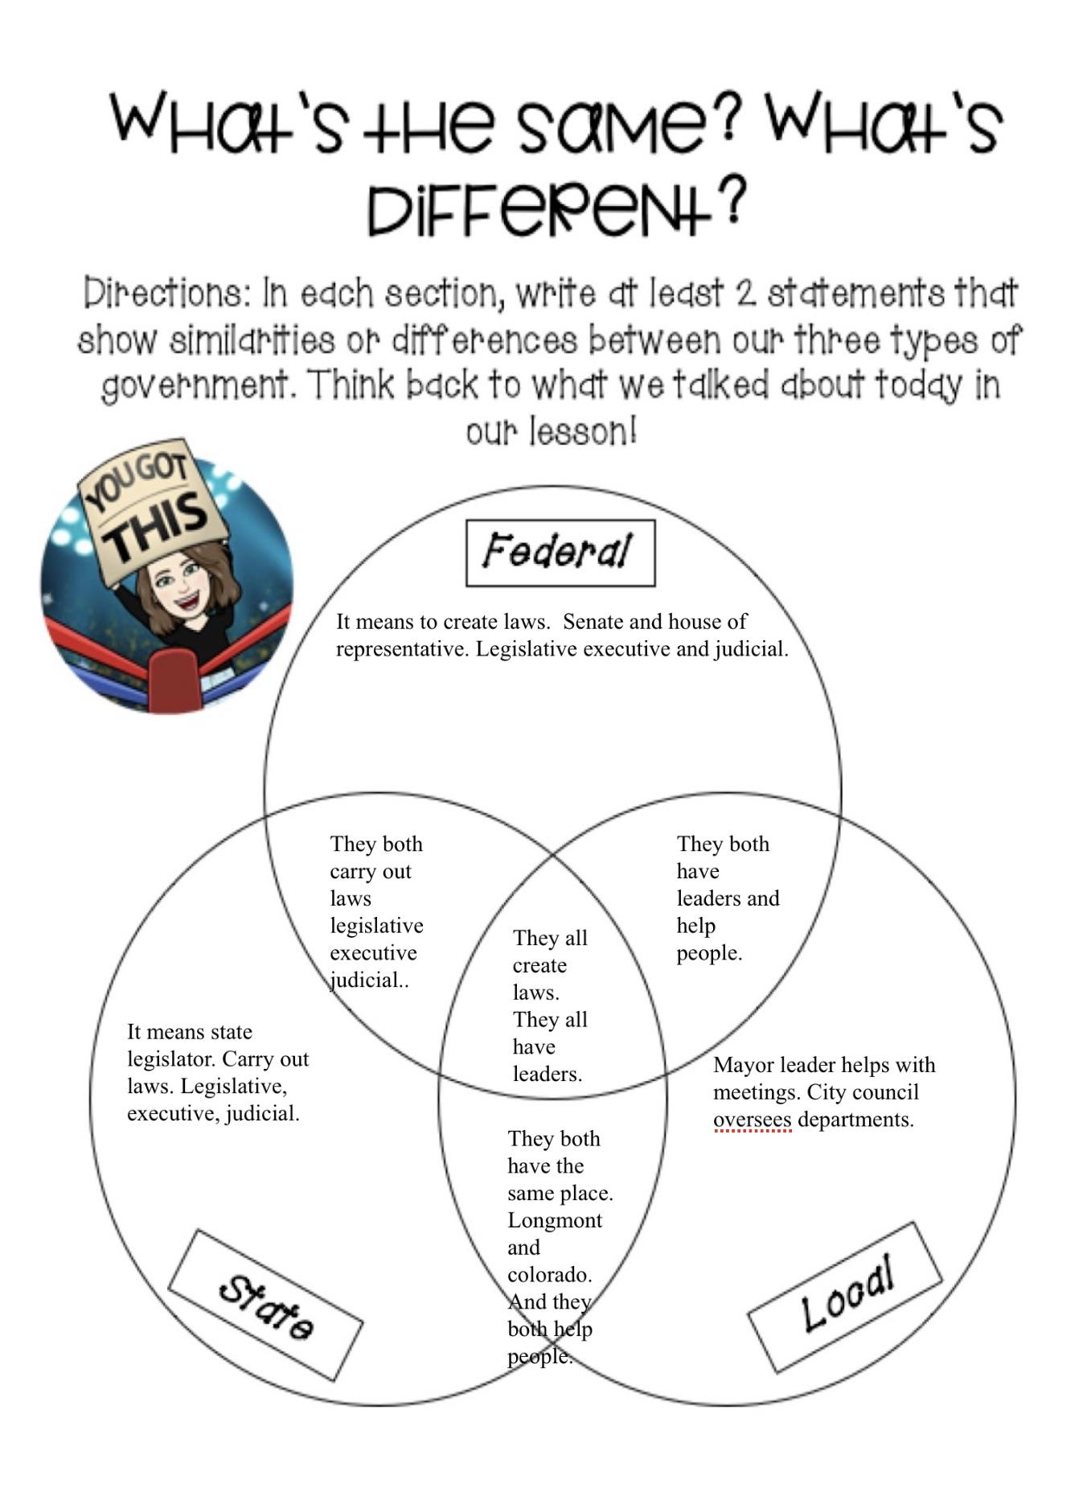
Three Types of Governments Venn Diagram - Student #20 (L)
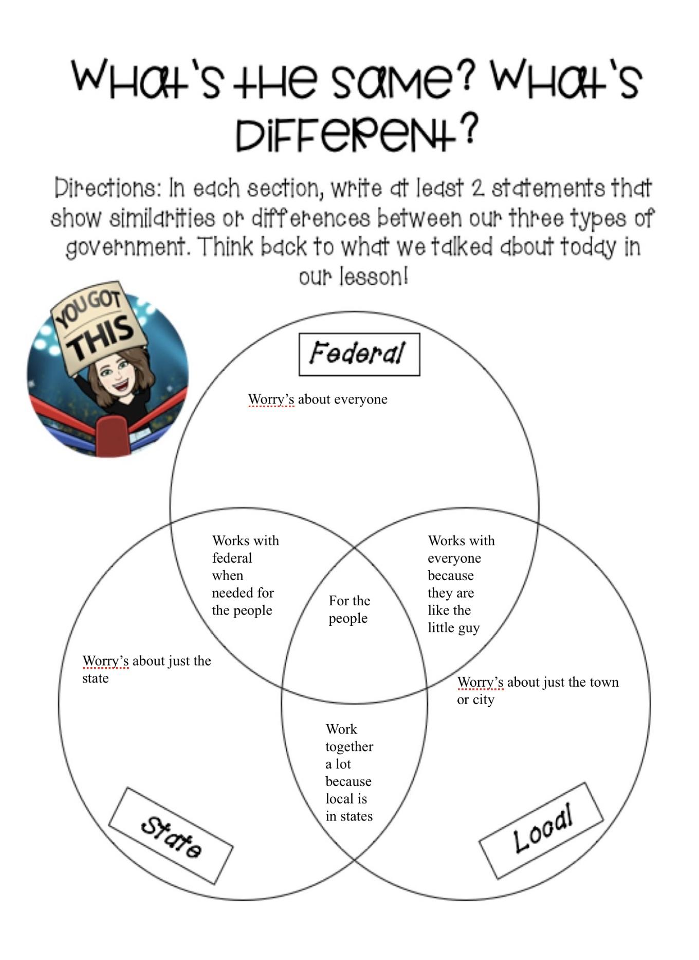
Respectful Speaking Discussion Board - Student #5 (A)
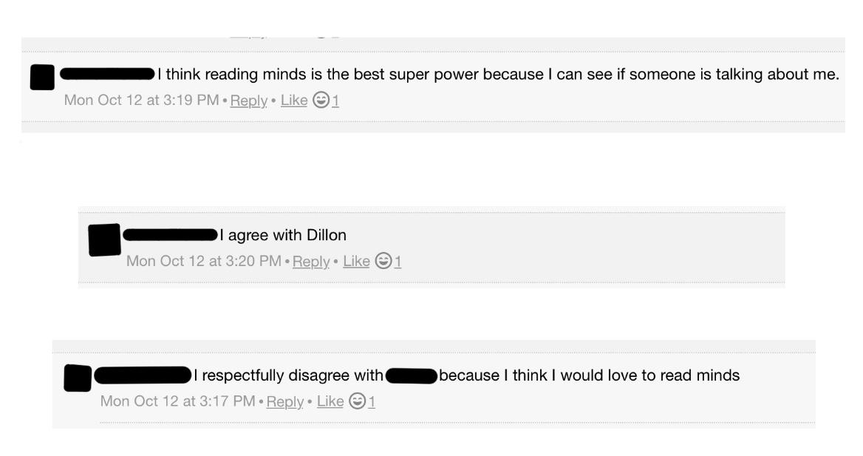

Voting! Note Catcher - Student #24 (L)
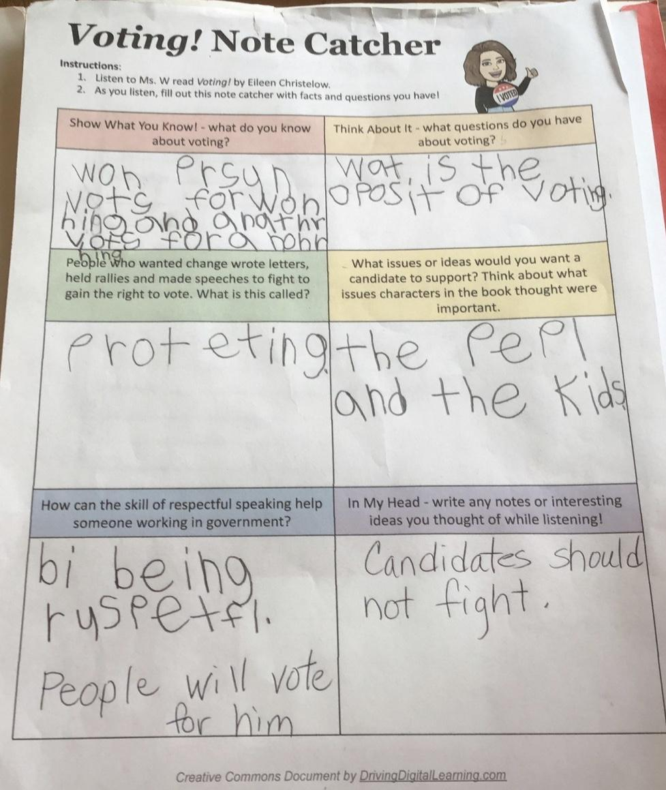

Voting! Note Catcher - Student #26 (A)
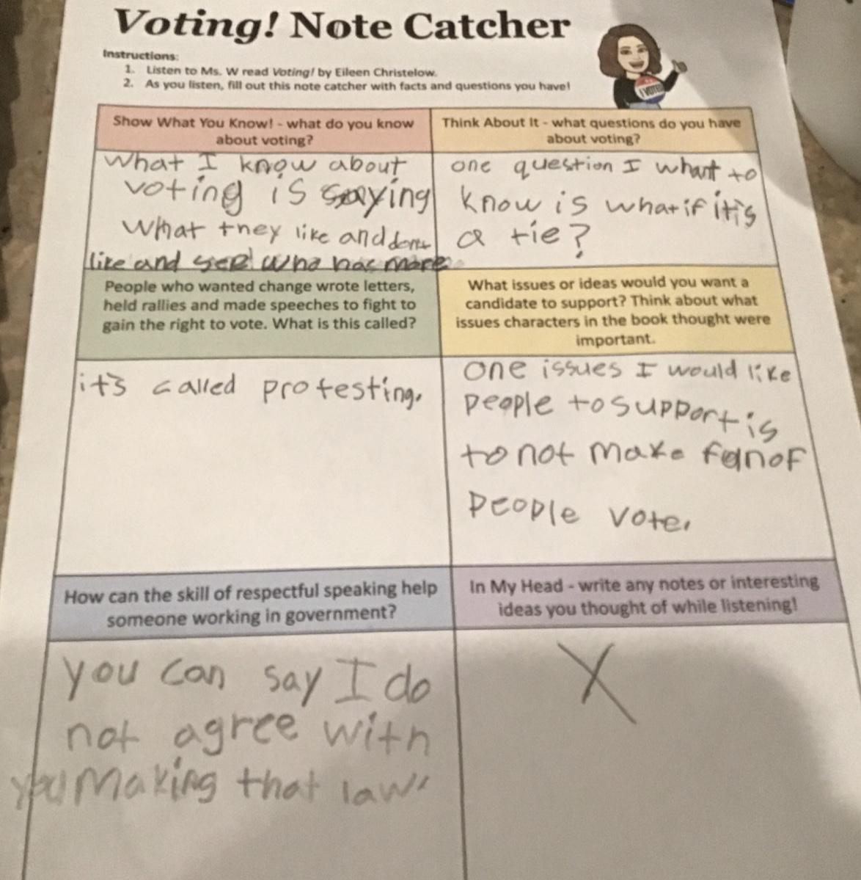

Bar Graph Exit Ticket - Student #6 (A)
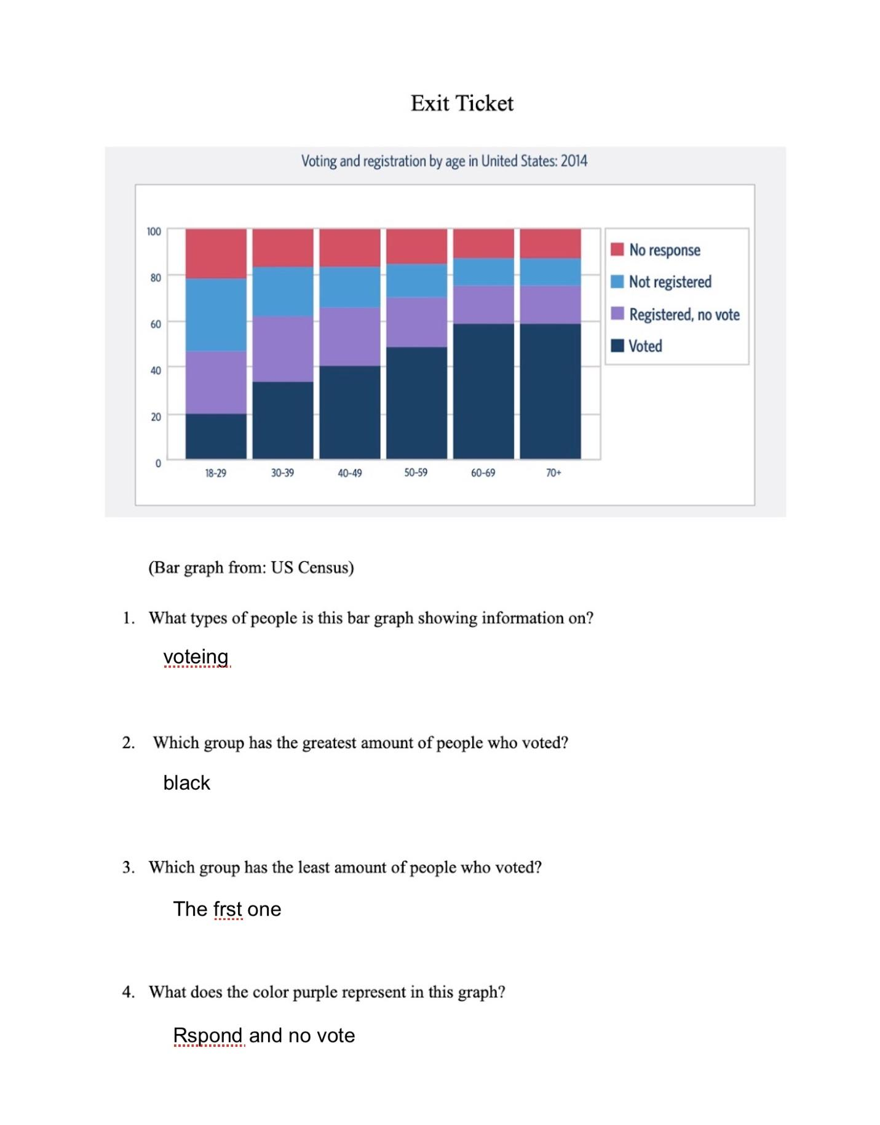
Bar Graph Exit Ticket - Student #3 (A)
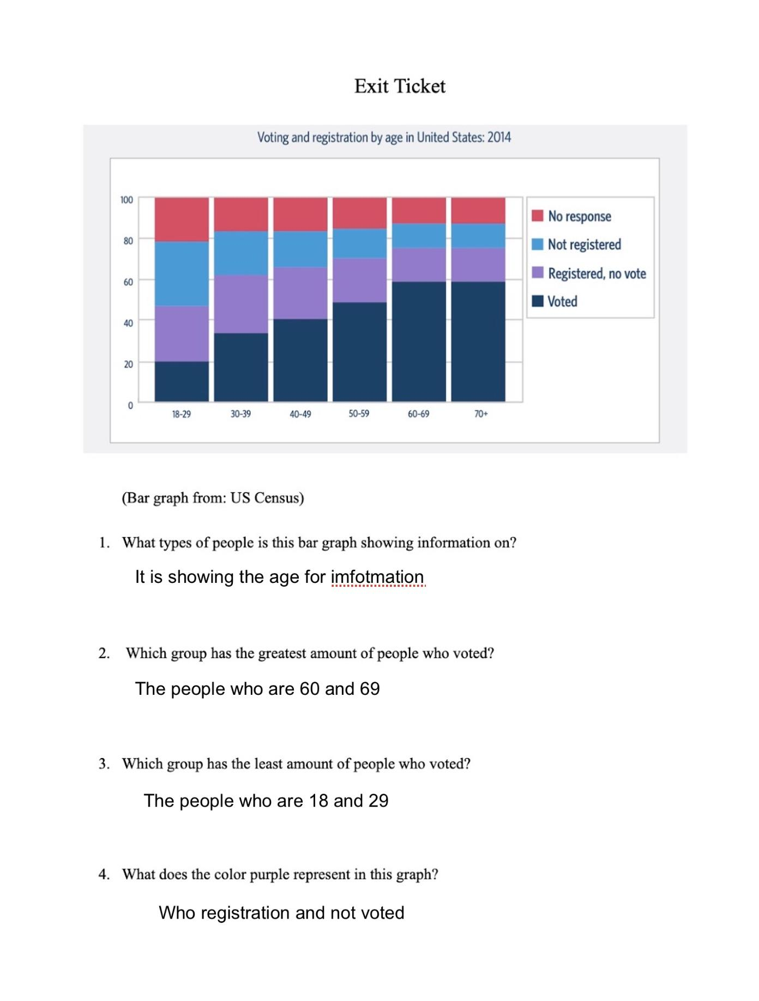
Letter to the Mayor - Student #19 (H)
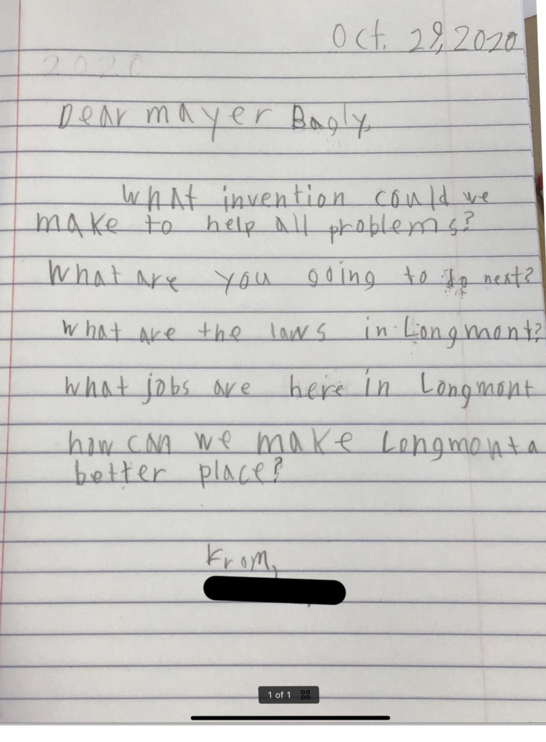
Letter to the Mayor - Student #23 (A)
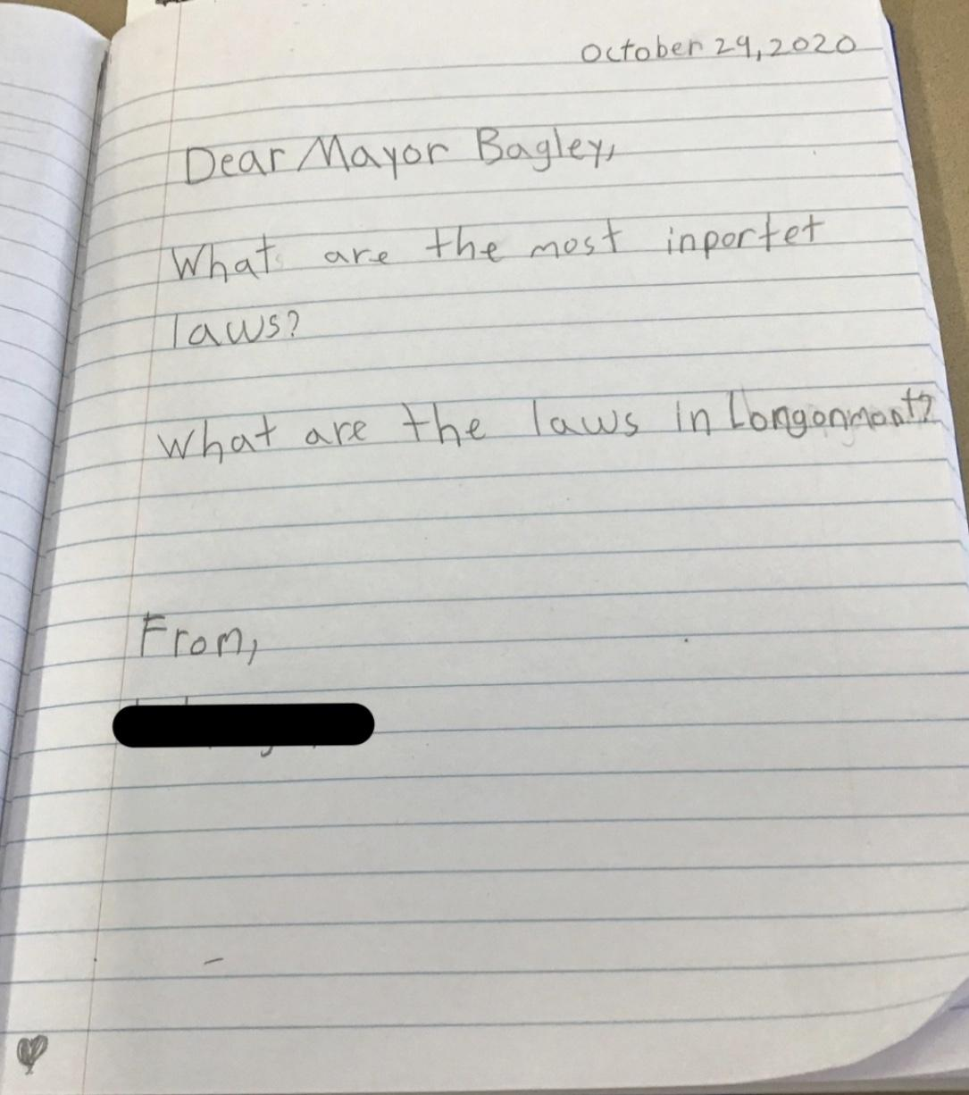

Reflective Essay
Through the process of creating this unit, there have been struggles and hardships. Even still, I have created a better understanding of what it means to be an educator and what it means to meaningfully teach students. Of course, many of these difficulties aligned with the new teaching environment schools are seeing this year. Hybrid learning is a challenging environment. There are not many people who can model what needs to be done in this situation, and with that comes trial and error. When creating the lessons in my unit, I struggled to find a way to make the learning meaningful and engaging for students who were synchronously learning at home. Upon hybrid’s arrival, I was able to teach my lessons twice as synchronous learning was not something that would be in place at Alpine. What I found through teaching lessons twice was how much I could learn from the students. The first group who learned the lesson often changed because of days off school or interferences with assessments. This gave me an opportunity to find what students found most helpful in a lesson and what I could do better. There was much self-reflection throughout my experience teaching, which gave me many opportunities to speak with my cooperating teacher about what I could change in the upcoming lesson. This experience was not available to everyone, and I am grateful I had the chance to do it.
A piece of the Capstone I was worried about was the integration of multiple content areas into social studies. Reading and writing was not a difficult concept to build into my lessons, but math was. Going through the process of having standards picked out and then creating lessons around those standards was a skill I can say I have grown into during this experience. Understanding what I need to teach is so different from what I want to teach. Being able to build that bridge to meaningfully teach student’s concepts with a real-world application was a goal of mine during my student teaching experience.
Overall, my unit went as planned. I was able to teach the standards and content I wanted to, but that did not come without some bumps in the road. Time management was a factor of teaching I began to struggle with. Finding the balance between whole class and small group collaboration and independent work time on assignments was something I came out of this unit knowing I need to work on. At the beginning of my unit, I found myself sending students home with assignments I had envisioned them doing in class. Towards the end of my teaching, I realized I could make the decision as the teacher to extend lessons on. This became apparent during one of my final lessons where students were in two separate stations. I found that there was no way I could ask students to rush their work to meet the time limit I was initially hoping for. Thinking in the moment during my teaching, I decided I needed to extend a lesson into two days. This was not groundbreaking nor was it a negative. It gave students the opportunity to truly dive into concepts and explore at a pace they were more equipped with. Time management is a skill I will take from my unit and proceed to work on as an educator.
The whole class average was a positive increase, which I was content with. There were students who did not make that increase or even decreased their score. Seeing this allowed me to reflect on the hybrid environment again, but also gave me a clue as to what ideas I was focusing on in my lessons and perhaps what I should instead focus on. Utilizing technology in the way we have been this year has been overwhelming, but it has made me much more aware as to what students are capable of and what they may not be able to do.
Through the process of planning, teaching, and assessing this unit, I have been able to meet multiple standards for Colorado teachers. One standard was relatively easy to meet this semester - technology. The entirety of school now is run based on technology. From teaching in a virtual setting to teaching hybrid, utilizing tablets, websites, applications, and virtual meeting platforms, technology has been at the forefront of tools to teach with. Throughout my time in classes, specifically those in New Literacies, I have gained the understanding to best support and engage my students in their learning. Each assessment that utilizes technology effectively assesses students on standards throughout this unit. Having tools such as video, audio, speech to text, and typing being used in each activity, I was able to enhance student’s learning and create accessible learning opportunities.
While looking through the Performance-Based Standards for Colorado Teachers, I reflected on my knowledge of standards and assessments. During the creation of this unit, lightbulbs began going off in my head. Understanding the purpose and importance of objectives and assessments based on standards is vital for student learning. I have created assessments that directly correlate with Colorado State Standards and enhance student learning. Taking into account student data is also a skill I have begun to grow during my time as a student teacher. Understanding where students are at in their own learning and what does or does not make sense to them drives teaching in a way, I did not realize beforehand. At Alpine, I have been able to practice a more inquiry-based learning approach, and with that I was able to move forward in my unit paying close attention to student’s natural curiosities and needs.
Standard six of the Performance-Based Standards discusses knowledge of individualization of instruction. Within this third-grade class, multiple types of learners are present and engaged. Knowing the differences in student learning, I have been able to differentiate and address student needs as they come up. Having seven IEPs in a class has taught me the importance of developing and applying individualized plans for students. Knowing the needs and expectations of each student, I was able to create lessons, and even add on the fly, adaptations and modifications for students who were pulled in the middle of my lesson or were struggling with various parts of the learning. The most important part of this standard I have come to understand and make a personal goal for myself as an educator is to collect data on individual achievement and be accountable for each child’s learning. It is so easy to see most of the students understanding a lesson and feel content with my own teaching. However, when there are students who are struggling with even just one part of a lesson or assessment, I need to realize that my job is not done until I tend to and support those students. Taking into account each student’s learning needs can be overwhelming, but in the end, it is what needs to be done for student’s to be successful. I am proud of myself for putting this into practice during my own unit and know it will be something I continue to practice and address as I move forward in my teaching career.
As I reflect on my time creating, teaching, and assessing my unit, I take into account the moments that were magical - when things fell into place and students were creating that understanding right in front of my eyes. The other factor I take into account is the number of times where lessons do not go the way you want them to. Understanding my student’s learning is a bigger priority than making it through all the activities and portions of the lesson plan was an eye opener for me. I have gained so much knowledge through this unit and the feedback from my cooperating teacher and supervisor. I have created an insight into my own teaching that will push me towards growing into an even better educator. Taking this experience of completely creating lesson plans based on standards and executing them to my students, I will strive to meet the needs of my students as I move forward in this profession.

